MANDATE 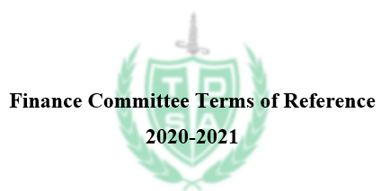
To review the Trent Durham Student Association (TDSA) budgets and spending as it relates to the values and needs of its members.

MEMBERSHIP
The Chair will appoint the members of the Finance Committee (FC) at their discretion after a public call for interest, and additional members (i.e. TDSA executives and directors) may be included under the recommendation of the President and/or with the advice of the TDSA Board of Directors. The positions of the FC are as follows:
- The Chair, which will be headed by the Director of Finance;
- President to the TDSA;
- 2-3 students at large.

EXPECTATIONS
It is expected this committee will meet at least once per term, with notice of a meeting given at least 7 days in advance.
Minute-taking will be tasked to a member at the top of the meeting, with minutes being physically handed to or digitally sent to the Chair upon adjournment.

REPORTING RELATIONSHIP
The committee is an advisory body and working group to the TDSA Board of Directors. Committee meetings are an opportunity for members to freely comment, ask questions, seek clarity, and critically analyze the TDSA executives’ budgetary decisions, past and present.
Should a student at large feel uncomfortable openly criticizing the President’s decisions and plans, anonymous queries will be presented to the committee through the Chair and given fair consideration in the meeting.
At the academic year’s completion, all notes will be turned in to the President to serve as reference for the next Director of Finance.

