2018/2019 Trent Durham Student Association Meeting Minutes

Contents
May 9 th , 2018 -- Board of Directors Meeting Minutes 2
BOARD MEETING MINUTES June 26, 2018 5
BOARD MEETING MINUTES July 31, 2018 8
BOARD MEETING MINUTES August 21, 2018 11
September 19th , 2018 -- Board of Directors Meeting Minutes 16
BOARD MEETING MINUTES September 28, 2018 17
Board of Directors Meeting October 19th, 2018 24
Annual General Meeting November 29, 2018 34
Board of Directors Meeting November 30th, 2018 35
Board of Directors Meeting December 14th, 2018 40
Board of Directors Meeting January 18, 2019 54
Board of Directors Meeting February 23rd, 2019 61
Annual General Assembly March 7th, 2018 66
Board of Directors Meeting March 27, 2019 67
Emergency Annual General Meeting Minutes Thursday April 4th, 2019 72
Emergency Board of Directors Meeting April 12, 2019 82
Board of Directors Meeting April 30, 2019 86

May 9 th , 2018 -- Board of Directors Meeting Minutes

Meeting Held Entirely in Closed Session, no Minutes Taken

May 24 th , 2018 -- Board of Directors Meeting Minutes
Present:
Absent: Mackenzie, Julia, Alyssa, Hema
1. Call to order at: 9:11 AM
2. Call for new business:
Motion to add by Karen
Upcoming dates
Grad Ceremony and Dinner
Seconded by Rayna
Passes Unanimously
Note from Chair
Hours tracking for extra work done by Chair
3. Approval of the last meeting’s minutes
Motion to approve April minutes
Moved by Karen
Seconded by Nick
Motion passes unanimously
4. Approval of the agenda
Motion to approve the agenda with the changes
Moved by Nick
Seconded by Christy
Passes Unanimously
5. Declaration of conflict of interest: No Conflict Of Interest
6. Executive Updates: Exec updates (available upon request)
6a. President
Karen presented
b. VPCL
Nick presented
7. Club De-ratification
7. a) Motion to de-ratify Trent Gainz
Moved by Karen
Seconded by Christy
Passes Unanimously
7. b) Motion to de-ratify Business at Trent
Moved by Karen
Seconded by Nick
Passes Unanimously
7. c) Motion to de-ratify Fight Back
Moved by Christy
Seconded by Nick
Passes Unanimously
ACTION ITEM: Revamp club policy by August
8. Sexual Violence Prevention Policy Paper
Motion to adopt the policy paper on SVP&E with the assumption on the body text addition
Seconded by Nick
Passes Unanimously
ACTION ITEM: Train club execs about the quiet room and provide resources for them to be
prepared for dealing with potential circumstances
9. September Bi-election: Timeline Approval
Motion to discuss election timeline Karen
Seconded by Christy
Passes Unanimously
NEW MOTION: Motion to set elections withdrawal as Aug. 31st Nick
Seconded by Christy
Passes Unanimously
Motion to approve Karen
Seconded by Nick
Passes Unanimously
Motion for recess Taryn
seconded by nick
passes Unanimously
10 min recess
Call to order @ 1022am
Motion to let Jade sit on the library advisory committee
Seconded by everyone
Passes aggressively unanimously
ACTION ITEM: Create google doc for committees and members
Motion to adjourn Nick
Seconded by Karen
Passes Unanimously
Meeting Adjourned @1044

BOARD MEETING MINUTES June 26, 2018

Present: Karen Nick Chandra Alyssa Rayna Mackenzie Sabeela Christy Don
Absent: Jessica Julia, Taryn, Hema
1. Call to order at: 10:17 AM
2. Call for new business:
No new business
3. Approval of the last meeting’s minutes
Motion to move to email vote
Moved by Nick
Seconded by Alyssa
Motion passes unanimously
4. Approval of the agenda
Motion to move article 12 to article 7
Moved by Karen
Seconded by Christy
Passes Unanimously
5. Declaration of conflict of interest: No Conflict Of Interest
6. Executive Updates: Exec updates (available upon request)
Sent out online
7. Policy Expansion
7. a) To Adopt Accessibility as the next policy paper
Motion to discuss by Nick
Seconded by Christy
Passes Unanimously
Motion to approve Alyssa
Seconded by Christy
Passes Unanimously
8. Emotional Support Animal
Motion to discuss by Nick
Seconded by Karen
Motion passes unanimously
Motion to table by Karen
Seconded by Nick
Passes Unanimously
9. TDSA Ambassador
Motion to discuss by Nick
Seconded by Christy
Passes Unanimously
Motion to approve new TDSA ambassador positions pending 2 TWSP and a required discussion at the board level for Plan of Action
Seconded by Alyssa
Passes Unanimously
Motion for recess Rayna
seconded by Alyssa
passes Unanimously
10 min recess
Call to order @ 11:29am Alyssa absent
10. Annual Budget
Motion to discuss Karen
Seconded by Nick
Passes unanimously
Alyssa returned 11:46
Motion to Approve Budget by Nick
Seconded by Christy
Passes unanimously
11. Reorder Agenda
Motion by Karen to Discuss Grad Photographer
Seconded by Nick
Passes unanimously
Motion to call the question by Nick
Seconded by Rayna
Passes unanimously
Motion to approve by Nick
Seconded by Sabeela
Unanimous with the assumption to have a envelope with the grad composite for students
Makenzie left @ 12:00
12. OM UPDATE
13. Sweaters
Action Item: Add question about departmental hoodies in the clothing survey and design a plan
14. July Board Meeting proposed dates
Week of 22nd to 28th
26th after 11
Evening meeting for July
25th evening Chnandra can’t make it for birthday
Motion to adjourn
Motion by Christy
Seconded by Alyssa
Passes Unanimously
Meeting Adjourned @12:34pm

BOARD MEETING MINUTES July 31, 2018

Present: Chandra Narra, Sean Ardis, Don Pierre Burnett, Nick Ryan, Rayna Porter, Mackenzie Prine, Karen Albrecht, Alyssa Petsinis, Chistry Chabassol, Sabeela Bakridan
Absent: Jessica Waters, Julia Derdaele, Taryn Gilchrist, Hema Tikaram
1. Call to order at: 12:18 AM
2. Call for new business
Motion to add Executive Evaluations
Moved by Rayna
Seconded by Alyssa
Motion passes unanimously
3. Approval of the last meeting’s minutes
Motion to Approve
Moved by Christy
Seconded by Rayna
Motion passes unanimously
4. Approval of the agenda
Motion to table board swag
Moved by Alyssa
Seconded by Christy
Passes Unanimously
Motion to approve
Moved by Alyssa
Passes Unanimously
5. Declaration of conflict of interest: Executives declare on performance evaluations Karen declares on Computer Science Club
6. Executive Updates: Exec updates (available upon request)
Motion to discuss past executive Facebook Group
Motioned by Alyssa
Seconded by Nick
Passes Unanimously
7. Executive Evaluations
Nick and Karen exit the room 12:53
Motion to recess 1:26pm
Motioned by Rayna
Seconded by Alyssa
Passes Unanimously
8. Call to order 1:48pm
9. Motion to ratify Trent Computer Science Club
Motion to discuss
Motioned by Nick
Seconded by Alyssa
Passes Unanimously
Motion to Ratify
Motioned by Rayna
Seconded by Alyssa
Passes Unanimously (Karen COI)
10. New Space Plan
Motion to move to next item
Motioned by Rayna
Seconded by Alyssa
Passes unanimously
11. Elections Policy
Motion to Recess 2:39
Motioned by Chair
Seconded by Christy
Passes unanimously
Call to order 2:53 note: Alyssa absent
Motion to approve
Motioned by Christy
Seconded by Karen
Passes unanimously
12. Clubs Policy
Narra enters 3:01
Alyssa enters 3:10
Alyssa leaves 3:11
Wording edits on the “Don Pierre rule” definitions and preamble
Motion to approve
Motioned by Karen
Seconded by Christy
Passes Unanimously
13. ESA
Motion to table
Seconded by Christy
Passes Unanimously
Motion to adjourn
Motion by Don
Seconded by Christy
Passes Unanimously
Meeting Adjourned 3:56

BOARD MEETING MINUTES August 21, 2018

Present: Don Pierre Nick Ryan Rayna Porter Karen Albrecht Alyssa Petsinis Chistry Chabassol
Absent: Jessica Waters, Julia Derdaele*, Taryn Gilchrist, Hema Tikaram Sabeela*
*Proxy provided to chair
1. Call to order at: 9:22 AM
2. Call for new business
Motion to Discuss evaluations in open session
Moved by Nick
Seconded by Christy
Motion passes unanimously
Nick raises concern about discussion of evaluations being made public Don can, as chair, edit the recording for confidentiality sake. Some people not comfortable having them made public. Even though persons discussed are ok with them being public, some board members feel uncomfortable. Because they are elected, the performance reviews public record anyways. Organizational precedence is physical review is available but voice recording including discussion around review not typically available. If in open session it could be available. Would only a member of the organization be able to request or because it is public can anyone be able to access? No policy, should there be? In policy it does not say we must have transcribed minutes, just minutes. Can be used for minute maker and as evidence for due diligence.
-motion to remove the performance review from open minutes recoding - Rayna
-seconded Christy
-COI Nick and Karen
Passed unanimously
3. Approval of the last meeting’s minutes
Motion to Approve
Moved by Karen
Seconded by Christy
Motion passes unanimously
4. Approval of the agenda
Motion to approve
Moved by Alyssa
Seconded by Karen
Passes Unanimously
5. Declaration of conflict of interest: None
6. Executive Updates:
Nick- took vacation, updates on orientation, vendors all ready for vendors week, almost all items purchased, best practice sharing day, finer touches on orientation, coupons VR gaming and crafting place, lindor chocolates, candles, bath and body works, cineplex, sky zone, buffalo wild wings, kernals popcorn, Johnnys. 28th Meeting with Nona on student charter of rights and responsibilities, Alyssa attending, Don would like to join. Karen to send out time to Board

Action item- Karen to send out time and date for meeting with Nona to everyone

Karen- many meetings, town and gown, OUSA meetings, preparing for OUSA training day sept 25 on our campus, full day event, can do some not all if you have classes, meeting with Jen, Lunch with Joe Muldune Tomorrow, TDSA and finance committee meetings scheduled, crewnecks, Bonnie settled, banked hours taken

7. Election committee appointment
Karen offered position of chief electoral officer
Karen accepts No objection heard
Nick offered the position of deputy chief electoral officer
Nick accepts No objections heard
Christy offered possiton on electoral committee
Christy accepts No objection heard
Action Item: Ask Nilo to be student at large and find one other for the committee to form.
8. Yearbooks
Yearbooks- Christy thinks might be a good idea because we are a small campus with a community feel, might be successful, 1st and second years might be interested. New paramount studios can do yearbooks, 20-30$ minimum 200 yearbooks, tons of companies available online, most can provide samples, 20-40$/student, 200 books minimum, 100 pages min, Future book year books, and tree ring, in mind that have environmental policies including tree planting and water based inks, bamboo paper, tree ring offers student personalization, get two pages to personalize how they want, might be good for more introverted students, might be able to do fundraising to lower cost for students, is there any way we can survey students to find out interest? Already talking about it with Karen, there will be a survey going out and will include a question about yearbooks, make sure to include margin of error as mot everyone who says they will purchase may not actually, yearbook is intensive, who will create the yearbook. Will need to create committee. Nick feels it might land a lot on VPCL portfolio, need a lot of pictures for it, can ask university for yearbook as well. Not expected to be Nicks job. Very expensive and time consuming. Christy’s sister in law is graphic designer, should be low cost if any at all. Digital yearbook.
Action Item: Table the topic until results of survey are retuned with a yearbook question included.
9. Custom Department swag
Department swag- sweater that we have in TDSA already and add department underneath with customization on shoulder. About $55 per sweater. Only per order, not bulk order. Can we do somehitng for people who have more then one major, ask Ray. About $7 for embroidery, will increase if student wants more, no financial risk to TDSA as it’s a per order basis. TDSA should make money off of sweaters as well. $3.60 per sweater profit to TDSA, Better to do large grouped orders, maybe twice per year. Near the start of year, get involved week. Double line longer degree tittles.

Motion to approve karen and alyssa to start working on the idea
Motioned by Rayna
Seconded by Christy
Motion passes unanimously
10. Convocation referendum-
university has to increase the price so they are not in deficit. Jen is working on the price, may be about 3-4$. Currently 2.50 per credit. Charged Per .5 credit when you take the credit.
Alyssa is stepping out at 10:16 am
No firm number yet as to how much it will be. It will be on the same election ballot already running. School is under no obligation to run Durham graduation. Can have everyone go up to Peterborough.
Action item- karen to keep Board updated on what is going on, will keep up with Jen.
11. Group photo for holiday card
New paramount needs the photo and text, included in contract to have 100 cards. Hard to get everyone together so wanted to discuss early. Jayben has volunteered to take the photo. Missing a lot of people still so might be too early to discuss date. October board meeting might be a better time to discuss

Action item- discuss in October once we have all members hired

12. OUSA training day-
September 25th, learn more about OUSA and get trained. Preparation for fall general assembly. Might be nice to introduce BOD to OUSA.

Action item- Karen to send out times and dates, for OUSA training day
Action item- Get a cake for Dons birthday on sept 25th, no cupcakes
13. Final business
Volunteer list available on google docs
Class schedules received from Rayna and Christy.

Gave out BOD jackets, thank you for all your upcoming work, helps you be visible to students. Alyssa is taking Julia’s.
Karen under the assumption there was supposed to be a date on them.

Motion to adjourn-
Motioned by Rayna
Seconded by Nick
Passed Unanimously
Meeting adjourned 10:30am

September 19th , 2018 -- Board of Directors Meeting Minutes

Meeting Held Entirely in Closed Session, no Minutes Taken

BOARD MEETING MINUTES September 28, 2018

Present: Don Pierre Nick Ryan Rayna Porter Karen Albrecht Alyssa Petsinis Chistry Chabassol Julia Derdaele, Taryn Gilchrist, Hema Tikaram Sabeela
Absent: Jessica Waters,
1. Call to order at: 3:10

2. Call for new business
Memorandum of Understanding from TGSA for ex-offcio member on the Board of director
Motion to add- Alyssa
Seconded by- Julia
Passes unanimously
3. Approval of the last meeting’s minutes
Motion to Approve
Moved by Alyssa
Seconded by Taryn
Motion passes unanimously
4. Approval of the agenda
Motion to approve
Moved by Alyssa
Seconded by Karen
Passes Unanimously
5. Declaration of conflict of interest: Don on honorarium (Karen will become chair)
6. Executive Updates:
Karen- Karen wants to add information from Alisia into her update, secondary data and statistics and trends going into paper, Karen will email out
Action item Karen to email out paper
Nick – September hard, about 40 club executives trained, calendar set out for sememster, assist training on Nov 24 and 25 9:30-3:30, $130/person. Child and Youth group was helped with events, speaker from first peoples house of learning, 4 new clubs. OUSA training day, blanket exercise, stress busting week, free speech, college system, money stuff, club and events stuff. 69.3 banked hours Plan is reading week and two exam weeks off, as well as occasional day off.

Bonnie: was not emailed out. Bonnie will read off to group.

7. TUNA phone call:
TUNA phone call: Karen to call Rhode, co-president of Trent University Native Associaiton, 3rd year business student, open to all students, various events throughout year to support students, vision statement, purpose of TUNA, help students find community within campus understanding that they are potentially coming from far away, organized into circles, Rayna: how can we make this relevant to topic of TUNA? Unsure, this will be purpose of the phone call. Karen: start relationship, campaigns and causes. Ex-Officio from TUNA or board member, either voting or non-voting depending on decision, get students more involved. TUNA can help facilitate events on campus, do have funds, maybe three way collaboration with TCSA as well. TCSA has an indigenous commissioner position, that he holds. What kind of events would you like to hold or have held before. Depends on what members ask to have run. Doesn’t have to be cultural, can be meet and greet. Mackenzie: Can start with asking Profs of courses on campus what they are interested in and any students in those classes that. Rhode: Meet TUNA. Small speakers panel. Rep on campus? Karen will email with wrap up, Rhode will send about us info, and promotional material to post around campus.

Motion to discuss
Motioned by Rayna
Seconded by Alyssa
Passes Unanimously

8. Yearbooks
Yearbooks- Christy thinks might be a good idea because we are a small campus with a community feel, might be successful, 1st and second years might be interested. New paramount studios can do yearbooks, 20-30$ minimum 200 yearbooks, tons of companies available online, most can provide samples, 20-40$/student, 200 books minimum, 100 pages min, Future book year books, and tree ring, in mind that have environmental policies including tree planting and water based inks, bamboo paper, tree ring offers student personalization, get two pages to personalize how they want, might be good for more introverted students, might be able to do fundraising to lower cost for students, is there any way we can survey students to find out interest? Already talking about it with Karen, there will be a survey going out and will include a question about yearbooks, make sure to include margin of error as mot everyone who says they will purchase may not actually, yearbook is intensive, who will create the yearbook. Will need to create committee. Nick feels it might land a lot on VPCL portfolio, need a lot of pictures for it, can ask university for yearbook as well. Not expected to be Nicks job. Very expensive and time consuming. Christy’s sister in law is graphic designer, should be low cost if any at all. Digital yearbook.
- Not sure point of phone call. Jen would like to see more indigenous representation on campus, more events, more involvement.
- What should we discuss, do we want to have a member sit on our board to ehlp with events. Can have a member sit as non-voting, or can have one as voting and they would sit on both boards and liase between campus. How do we determine who sits holds position. TDSA cares member or ex-oficcio member (non-voting but speaking). Why not voting? Current layout is major based, current criteria. It would be a demographic based position. Where do we then draw the line, which groups get representation like that. Other Associations want something similar. Collaboration within groups is better. Might be a good idea to help drive socialization. Student Associations what reps at our campus to rep constituencies. If we offer ex-ficcio spots to the three SA in Peter, TCSA, TGSA, TUNA, they rep organizations, won’t need for quarum, get better perspectives from those demographics. Exficcio for TUNA or board position or position on TDSA cares commissioner (any students from our campus) and TUNA can work with them. Point of phone call was to find out where we were at with working with TUNA. Could we have both TDSA cares and exficcio? Table until a firm proposal created?
Motion to table
Motioned by Alyssa,
Seconded by Julia,
Passes unanimously
9. Byelection ratification results
election meeting this morning, went over results. Karen will tell us who won. VP UA Beth won, First Year: Holley won, History: Alexander won, Sociology: Jameela won. May need bigger board room.
Motion to discuss
Motioned by Sabeela,
Seconded by Julia,
Passess unanimously
Action item: re-evaluate timeline for next election for nomination period
Motion to ratify results
Motioned by Nick
Seconded by Rayna
Passes Unanimously
Motion to recess
Motioned by Mackenzie
Seconded by Taryn
Unanimous
Resume 3:59pm
10. Honorarium and budget
Motion to enter closed session,
Motioned by nick,
Seconded by heema,
Passes unanimous
Closed session
4:22 motion to end close session,
Motined by alyssa,
Seconded by Christy
Passes unanimously
Heema left room at 4:23
11. Yearbook
Yearbooks: motion to table
Motion by Christy,
Seconded by nick,
Passes unanimous
Table until next meeting
Motion to Recess,
Motioned by Taryn,
Seconded by Christy,
Passes unanimous
Resumed 4:27

12. Daycare
looking to get a childcare on campus. Emailed 5 other universities, no responses. Meeting yesterday with Joe Muldoon about funding, space, staffing, He will allow us to put in questions into a survey that will be going out to students, because people with children are busier it might not be the best way to gather data, might do a table instead to catch people and fill out survey while it is running. Anyone want to volunteer to help?
Motion to discuss
Motioned by Alyssa
Seconded by Nick
Passes Unanimously
What is your plan for the facility? Tried to get into contact with private facility at Peterborough campus, no luck. Joe helped with information about the building, grants? Scotia too expensive, civic a possibility. How are you trying to go about making it happen, what is your plan of action? Meeting with Alba in Child and Youth to discuss possibility, her students as placement/volunteer as staffing along with some full time. Would love to have 7-7, food handling- safe snacks, parents send food with children, if private then we would have agreement to hold set amount of spots for Trent students children, not in the new building as there is no room. Will take a long period of time to get off the ground. Trying to get statistics to show it is a worthwhile endeavor, payment? Student levies, at western the levies change every year to support it. About $6/student, Taryn would like to help with the initiative, Rayna loves the idea, how do we support you? Volunteering time to help with survey, help with posters, sit at table, spread word, etc. No number from Joe as to what would be acceptable. Hours would go towards volunteer hours needed for board hours, not sure when survey going out yet. Craig gave some questions, Do you have Children, which best describes your situation, would you make use of a daycare if one exists on campus. Can we ask for a break down of ages as a question. If 2 and older don’t have to worry about cribs, or potty training.
Action item: Karen to send out google docs link for board documents
Action Item: Mackenzie to let us know when survey going out
13. TGSA: memorandum of understanding
read out by Karen.
Motion to discuss,
Motioned by Mackenzie,
Seconded by Nick,
Passes Unanimously
Interesting idea, a lot of experience to board, give information on what they are dealing with. Wondering can we use this language for all other such discussions like this. Table this until we can take time to discuss, how we want to go about this.
Motion to table,
Motioned by Alyssa,
Seconded by Julia,
Passes unanimously
Action item: Karen to figure out what it will look like in terms of bylaws and contracts
14. Updates and reminders:
October Board Meeting, Oct 19, November 30th for meeting.
Skyzone- free 1 hr of jumping as team building with new board members
Motion to adjourn,
Motion to adjourn-
Motioned by Nick
Seconded by Heema
Passed Unanimously
Meeting adjourned 5:02pm

Board of Directors Meeting October 19th, 2018

Procedural Items
- Call to Order
  - Board Meeting CALL TO ORDER: 3:14 pm
Attendance
  - Mackenzie Prine
  - Sabeela Bakirdan
  - Christy Chabassol
  - Holly Mcalpine
  - Taryn Gilchrist
  - Hema Tikaram
  - Nick Ryan
  - Alex Rookes
  - Jessica Watters
  - Karen Albrecht
  - Beth Lindsay
  - ON PHONE Rayna Porter
  - DON PIERRE HAS ALYSSA PETSINIS PROXY VOTE
  - ABSENT: Julia Deraele, Bonnie Caruana

- Approval of Minutes
  - Yearbooks were not discussed last meeting, remove from minutes. Nick explains how motions and discussions flow.

  - Motion to discuss: Strike discussion of yearbook from previous minutes
  - Motioned by: Rayna
  - Seconded: Christy
  - Motion passes

  - Nick used previous months minutes to create September minutes. Clarity Error

  - Motion: Strike yearbook portion from minutes in September
  - Motioned by: Nick
  - Seconded by: Hema
  - Motion Passes

  - Motion: Approve minutes with changes
  - Motioned by: Rayna
  - Seconded by: Nick
  - Motion Passes

- Call for New Business
  - Motion: Add club matters discussion as number 11
  - Motioned by: Nick
  - Seconded by: Rayna
  - Motion passes

  - Motion: Table number 8.
  - Mackenzie unsure of why. Rayna and Sean have had discussion and need to do more work on proposal. Not at the stage to look for approval. How will it change the board makeup etc.
  - Motioned by: Nick
  - Seconded: Hema
  - Motion passes

- Approval of Agenda
  - Motion: Approve agenda with changes
  - Motioned by: Nick
  - Seconded by: Jamilla

- Declaration of Conflict of Interest
  - No conflict of interests declared

Update
- Executive Updates
- President
  - Met with ORD, created strategic plan which will be presented today, MOUs with TUNA, TCSA, and TGSA, which are presented today as well. Photographer here on Nov 5-7, directors can sit and get picture taken for composite, 9-4. Don’t need an appointment or to pay. Compiled a list of events but lost so needs to be recreated.
- VPCL
  - Wild couple of months. Conducted performance reviews with Mel and Audrey. Can discuss in closed session if you would like. Contacted Skyzone, Nov 8 3-4 pm free hours of team building and bouncing at Skyzone. Please post lots of social media stuff while there. Finished Stress Busitng week. 2 tubs of ice cream in 45 minutes. Using up banked hours. Not in the office next week. Can email if needed. Mental Health week in November ironed out. Puppy rooms, massage, mental health first aid, assist training. Club relations, training.
- VPUA
  - Declared a second job on campus as campus photographer. Confident it will not interfere with VPUA position. Nick, Karen and Bonnie have been helping me train. Working on Freedom of Speech policy for start of next year. Asks board of directors reach out to departments for input from students. Also planning on researching policies from other universities, what those students think and what government it looking to do and how they will be acting on disciplinary side, as currently they are stating that they will be withholding funds from schools who are in violation. Speaking with Alisia about accessibility paper, looking to have ready for next board meeting. No smoking policy on campus, and student concerns. Students not really consulted in decision.
  - Nick needs a group picture of board so please make sure you stay for that

- Operation Manager
  - Please feel free to read her report, as she is at a wedding. What do we do with books that are old and not picked up after the 6-month window given to students to pick up the books? Bonnie investigated a company that will buyback books. She likes the first company mentioned. They buyback books and then plant a tree for every book they buy.

  - Motion: to approve Bonnie’s idea to sell unused books not picked up students
  - Motioned by: Rayna
  - Seconded: Christy
  - Motion passes

Discussions/Decisions
- Creation of Ex-Officio Positions & Memorandum of Understanding (Albrecht) Approval
  - Context for those who are newer. Ex-officio means they can speak at a board meeting but cannot vote. They also do not count towards quorum, which is 50%. Memorandum of understanding is basically like a contract on their obligations between the organizations. TGSA brought it to us, they would like the position to help fill the position of grad student representative, and to create a relationship with TDSA. We also have our first cohort of grad students this year. They will also sit on the TGSA board. We also decided to also extend this to TUNA and TCSA. We will offer ex-officio to each organization.

  - Motion: To discuss MOUs
  - Motioned by: Mackenzie
  - Seconded: Karen
  - Motion passes unanimously

  - If we bring in an ex-officio, in that they cannot vote, how does that speak on behalf of the populations on campus? Major difference here is that if we have a voting member, we cannot discriminate on who that is, so anyone can run to represent the native community, but if they are an ex-officio then TUNA will appoint as a recognized member of the community, asking the community rather then opening it up to the whole community and have representation that may mot be from the community. Can we not put a requirement that the person who runs for the position needs to be part of the demographic, ie needs to be carribean if we have a caribbean director? Should be a discussion when we speak about the director positions if and when we start speaking about that. It would also contradict our current by-laws as we cannot discriminate based on creed, colour etc. A step towards having voices on the board which is what Trent prides itself on. A good idea because appointed by TUNA. If a full board board member is created then it opens it up to anyone taking a major or minor in those studies. The program directors run as majors run with priority, then it can go down to minors. Separate discussion, not related to MOUs. MOUs allows them to put experts in the field that would be at our disposal. What does at our disposal mean? Means that they are known entities to us, we would know who to talk to if we need or want help and input. They will have full speaking rights, so they can come to us if they have issues or questions or need help and vice versa. At disposal sounds so cruel though. It means you are available when the association needs you. Will we have a member of our board sitting on their board. No. So we would have one member sitting on both boards. Would help with joint ventures and would work together. Representative would be a go between. They would have voting rights on the other board they represent. Would help us maintain communication lines with those organizations, and allow them to have a voice, until we figure out how to include those voices more permanent solution found. Would we have access to the minutes form the other organizations? Karen can add that in. Before we approve can we add in the access to the minutes? We can add it in then send it out as an email vote and then you can review the MOUs and approve that way. TGSA, TUNA and TCSA would choose their representative that sits as ex-officio.

  - Motion: table item 7
  - Motioned by: nick
  - Seconded: hema
  - Motion passes unanimously
  - Action Item: Karen to send out MOU once revised for email vote

- Proposal of Indigenous Position on Board (Sean) Approval
  - Tabled before approval of agenda

- Strategic Plan and Report Procedure (Albrecht) Approval
  - We currently only have goals and missions and values. This would help for long term goals. Would also add executive reports, help keep and institutional history and transition

  - Motion: discuss strategic plan
  - Motioned by: Karen
  - Seconded: Christy
  - Motion passes unanimously
  - Having a plan is a good idea.

  - Motion: approve strategic Plan creation
  - Motioned by: Karen
  - Seconded: nick
  - Motion passes unanimously

- Year Books (Christy) Discussion
- Results from the survey. Digital had about 2% in favour so off the table. Fair number of maybes, some yes, some yes if >$30, some no. Based on results went back to companies and did further research. Narrowed down to tree ring, which had customized pages. We have sample books to show board. Each student would get 2 free unique pages to fill however they want. One tree would be planted for every yearbook sold, they only print however many we order/sell. Printed on recycled paper, no commitment, no minimum order. They can order on tree ring directly. We have access to their software with templates, demos available as well as videos. Hard cover books are laminated, softcover are uv coated, ability to add a fundraiser amount, no processing charges, 100% comes to us. Eg. If we added $2 to cost of book, we would get that money to us. Optional only, don’t have to do it. 4 week turnaround. Collaborative as well, easy to source photos. Student creates account and they can have access to a shared photo album to add their own photos which may go into the overall book. Tree ring handles sales. Can add portraits. 100 full colour pages soft cover, $27.33/ book. Hard cover $32.91/book. Pick a deadline, any order placed before deadline, no shipping fee, all sent to school, anything afterwards there is a small shipping fee as book sent directly to home. Website is secure. Beth says great job in all the research. Did you approach the school at all for funding or position to create the yearbook? No, have not got there yet. For the portraits, which do you envision it including? Events, clubs, graduate photos. Not every student photo like high school, unrealistic and time consuming. Mackenzie asks how many people are interested in purchasing the yearbook, although it doesn’t cost us anything, as we would need to devote time and effort, and potentially money if person gets paid, into creation and promotion. Is it worth it? The results were not in favour of yearbooks. 27% said yes if under $30, 10% said yes flat out, 29% said maybe, 31% said no. Not as great a response as hoped, not as bad as could have been. Might be more of a draw for younger students, not necessarily mature. What if had photo taken for grad but did not want to have photo in yearbook? Can exclude those people. Would you be putting out a survey to ensure all people consent to photo in yearbook? Yes. Holly likes the one sample too thick for school our size, other sample is a better size. As a first year, would be very excited to have a yearbook, happy that it does not to cost organization any money, put in close clubs and teams. Jessica asks would the students provide all the photos and set up or would school provide some as well? The hope is that school would help us with photos, could have students submit them as well. Hema feels that it is a good idea. Graduates have a composite that goes out to all grads anyways, so might not have an issue with photo in yearbook, likes the idea of customized pages. Beth thinks good idea to promote clubs and events to help interaction between club events and campus. Good avenue for student photographer as well, as usually doesn’t get many hours as not need a whole lot, only for promotional shots for social media, more of an opportunity for work for that student. Would there be a committee of students to create the yearbook, or run by the directors? Put out a request for students who were interested, hopefully about 3-4 students. Karen concerned about copyright from grad photos being given to use the photos in the yearbooks

- Action item: Karen to ask grad photographer about permission to use images in yearbook.

- Motion: recess
- Motioned by:hema
- Seconded: taryn
- Motion Passes

- Recess at 4:06 pm
- Meeting call back to order 4:21pm
- Nick is absent

- Mackenzie wonders if other universities had been looked at to see what they did? Looked at Trent University in Peterborough. Was given as a grad gift when Christy graduated. They still do it. Beth asks do we know who does it at the Peterborough campus? Unsure.

- Action item: find out who looks after yearbooks in Peterborough- Christy

- Sabeela thinks it is a good idea. Good to showcase events, helped people to participate, showcase clubs. Mackenzie, still too much missing information, do not have a full understanding

- Motion: table yearbook until next meeting
- Motioned by: Mackenzie
- Seconded: Taryn
- Motion passed
- Nick Ryan enters at 4:26pm

- Club Matters (Nick) Discussion
- Motion to move into closed session
- Motioned by: Nick
- Seconded: Hema
- Motion passes

- Meeting moves into closed session

*This was a prank pulled by the VPCL, no serious matter discussed.

Reminders:
Next Meeting November 30th, 3pm
Skyzone teambuilding November 8th, 3pm-4pm

Please see other Document for upcoming events for October and November

Motion to adjourn
Seconded
Meeting adjourned 4:32pm

** Minutes lost

Annual General Meeting November 29, 2018

- Welcome

- Executive Updates
- President, Karen Albrecht
- VP of University Affairs, Beth Lindsay
- VP of Campus Life, Nick Ryan

- Review of Finances/Audit

- Proposed Bylaw Changes
- Bylaw III Execution of Instruments; allow all officers of the corporation to sign
- Bylaw IV Non-refundable Student Ancillary Fees – removal of Athletic fee as the University now holds this fee
- Bylaw V Board of Directors – Name change; Director of Human Resources to Director of Post graduate studies
- Bylaw V Board of Directors – Remunerations of expenses; removal of honorarium
- Bylaw VI Executive Transition – Shadow Executive; increase training hours from fifteen (15) to thirty-five (35)

Please come by the TDSA Office, room 122, for more information and meeting materials.
If you have a question, please email Karen at president@mytdsa.ca

Board of Directors Meeting November 30th, 2018
Present: Rayna Porter, Julia Derdaele, Nick Ryan, Bonnie Caruana, Alexander Rookes, Holley McAlpine, Mackenzie Prine, Jessica Watters, Christy Chabassol, Taryn Gilchrist, Jamila Alleyne, Don-Pierre Burnett, Karen Albrecht, Alyssa Petsinis, and Hema Tikaram (call in)
Gallery: Michael Degeus
Absent: Sabeela Bakridan and Elizabeth Lindsay

Procedural Items:
- Call to Order
  - 3:06pm
- Approval of Minutes
  - Will be approved via email vote as not sent out prior to meeting
- Call for New Business
  - Speed limit sign off of Thornton attached to metal light post is not clear or easy to see, people are not obeying maybe because they do not see it.
  - Action item: Karen to look into it with City and Bylaws and school
  - Performance reviews
    - Motion to discuss by Nick, seconded by Jamila, unanimously passes
    - Add to end because as part of closed session items
    - Motion to approve Nick, seconded by Alex, motion passes unanimously
- Approval of Agenda
  - Motioned by Don, seconded by all, passed unanimously
- Declaration of Conflict of Interest
  - Karen, Nick, Bonnie, Don in regard to respective evaluations
Updates
- Executive Updates
  - President
    - TDSA cares event, evaluations, Fashion show help. Graduations photo session, Food services committee meeting, survey in January evaluating food services on campus, Sky Zone, Lobby Con, Helped with Open Mic Night Bar, Finance meeting, AGM. Will update website with updated bylaws. Meeting with TCSA. Elections prep. Strategic plan meeting with Don and will develop new questions based on meeting. MOUs were approved via online vote. TGSA has a student how is interested but has classes on Friday so cannot attend this semester. TCSA had a language change from ex-officio to speaking right but non-voting. Karen will send out for Director approval. TCSA has extended the same position to us as well. Structure and nomination period was overlapping. Addressed at September meeting, will be bringing a proposal
    - Action Item- bring forward changes to dates for election in regard to nomination and running periods
  - VPUA
    - Karen to read as Beth absent. Attended fall GA, ORD meeting, Community Advisory Meeting, Lobby Con, Senate meeting, Sean on Freedom of Speech, Smoke Free Survey, Plan of action with Alisia and Execs.
  - VPCL
    - OUSA fall GA, Holiday Market, mental health week, hoping to have massage therapist back next semester, reconciled budget, approved 2 new clubs (Trent Gay Club, Trent Indigenous Circle Club), SCC meeting, emails, getting banked hours down. 80 banked hours coming out of GA, down to 60 or so now. Organization re-organization.
  - Operations Manager
    - Pulled old books and notified students to pick up old books. Organized storage room and VPCL club and craft storage. 2 HST returns. Digital evaluation form creation. Assisted with events. Worked on LGBTA and Indigenous items. Evaluations. Minutes from last board meeting. Updated website including interactive event calendar. Draft budget to auditors sent and received feedback. Inquired if we could get a discount with Weebly as we are non-profit, yes we can, 33% discount when we renew next year. ORD meeting. Called Moneris to increase debit refund limit from $0 to $200.
Discussions/Decisions:
- Yearbooks (Christy Chabassol)
  - Does not have report that was hoping to have. Family issues. Requests to table issue until she can do the research she wants to do.
- Freedom of Speech (Beth Lindsay)
  - Being looked at by the university, looking to collect info from students, Policy will be coming either way.
- Non-smoking Policy (Beth Lindsay)
  - Survey went around, still waiting on data to be released to VPUA, what are the security or measures based on if people break the rule of non-smoking? Nothing currently in place, security not allowed to ticket as a by law issue, we are private property so we cannot enforce fines. We can make recommendations to university about how security should handle the issue. Concern that if person not smoking when bylaw shows up then no ticket. Directors can send concerns or questions to Beth. Note, that we are allowed to disagree with the University. Is it a waste of time to even worry about it? Background: Durham Region heavily suggested that all campuses go smoke free, all three campuses were to meet, however DC and UOIT released a plan before speaking to Trent Durham, Trent therefore released a statement saying will be smoke free as well. We did a survey to get student opinion on new policy as we are worried about smokers feeling not welcome at campus. Is there any way to get the policy changed? If there is a Durham region mandate there may be little choice, if we can negotiate with Durham Region then we may be able to get them to reconsider. Considering number of smokers, would only need 1 area.
- Mandate for the Action of the GIC (Karen Albrecht)
  - Karen reads out mandate from meeting materials. 2 years ago executives put $30,000 in GIC. Mandate would be to put ½ money towards move of office in 2020 (approximately), and ½ money to student services/ special projects spent over 3 years. Should we put a small portion back into a GIC? Doesn’t make enough money generally, $30,000 only makes about $250 in interest per year. Is important to have a set amount saved in the bank but we are financially healthy enough that GIC as a backup necessary.
  - Motion to call the questions by Karen, seconded by Rayna, motion passes unanimously
  - Motion to approve the mandate by Karen, Rayna seconds, motion passes unanimously
Alex motions to recess 3:57, Rayna seconds, motion passes
Back to order 4:15
Motion to enter closed session by Don, Seconded by Mackenzie, motion passes unanimously
Don calls Heema back, Michael asked to leave as closed session not open to students at large
- Policy Paper Update: Closed Session (Karen Albrecht)
Alyssa exits meeting at 4:24pm
Recorder turned off for discussion of evaluations,
- Evaluations: Closed Session (Karen Albrecht, Don-Pierre Burnett)
Upcoming Dates
- December Meeting and Holiday Potluck December 14th, 3-6pm
Please bring a dish or dessert! Plates, cutlery and cups will be provided.
Please be conscious and accommodate other’s dietary restrictions.
We have: a gluten allergy, a mushroom allergy, a tomato allergy and vegan diets to accommodate.
- Google doc to determine what people are bringing

Reminder: Please send your Winter Class schedules to Don-Pierre, to establish meeting times for next semester.

Board of Directors Meeting December 14th, 2018

Present: Bonnie Caruana, Nick Ryan, Karen Albrecht, Don-Pierre Burnett, Rayna Porter, Jamila Alleyne, Holley McAlpine, Alexander Rookes, Mackenzie Prine, Julia Derdaele, Christy Chabassol, Taryn Gilchrist, Hema Tikaram,
Absent: Sabeela Bakridan, Jessica Watters, Alyssa Petsinis
Gallery: Sigfrid Belemsaga, Nicole Whyte

Procedural Items:
- Call to Order at 3:18 pm
- Approval of Minutes
Motion to approve by Nick
Seconded By Christy
Motion passes

- Call for New Business
  - Vote for number 10, adding in referendum questions should the previous items pass
Motion to discuss: nick
Seconded by Don
Motion passes

  - If we approve the changes, we then have to approve the wording of how we are asking students, which should have a good amount of discussion
Friendly motion passes
- Approval of Agenda
Motion by Jamila
Seconded by Taryn
Motion passes

- Declaration of Conflict of Interest
  - None brought forward
Updates
- Executive Updates
  - President
    - Durham CASSC committee needs 3 bord of directors and 1 student at large to sit on committee. Approval for compulsory non-tuition fees that apply for students. Karen has volunteered. Alex and Mackenzie volunteer to sit on it. Need a part time student to sit as well. Mackenzie knows some people who might be interested that are part time.
  - VPUA
    - LGBTQ+ consultations, freedom of speech survey, students not educated enough to answer questions. So started an education campaign to better inform students of the issue. PowerPoint and posters posted around campus. Survey for food insecurity, asked for by OUSA affiliated meal exchange program in regards to food banks, food insecurity and accessibility of these services to students. Transit meeting with Jen Richardson, research ongoing. Karina hired and will start in new year. No smoking survey will be circulated in new year, freedom of speech in the spring.
  - VPCL
    - Took some time off for exams. Club wrap up emails and catch up on paperwork. Reorganization work. Bell Let’s Talk Week. Michael Lansberg from TSN will be here
  - Operations Manager
    - Water bottles have been approved. Headphones and pens for store. Catch up. Taking next week off.
Discussions/Decisions:
- OUSA LGBTQ+ Policy Paper (Beth Lindsay)
  - Coauthoring a paper for OUSA, which will be used to lobby government for change. Will be speaking to as many members of the community as possible to get as many views and identities. If you have any contacts within the community please have them contact Beth for an informal conversation about their experiences at University as a member of the LGBTQ+ community. Thinktanks January 9, 10, 11. Will be taking at least one student with me, but asking for one more as well. Very important to get voices so please help with that if you can.
  - Asked to speak louder from livestream as audio is a little quiet
- Elections Policy Amendment (Karen Albrecht)
  - Karen reads amendment. Changing nomination period from 10 days to 5 days

Motion to discuss by Karen
Seconded by Don
Motion passes
    - In first iterations it was 10 days to make it longer so it was 5 just nominations and 5 during campaigning. Because we have such a quick turnaround time and the amount of confusion it caused asking to remove the nominations period that overlap with campaigning.

Motion to approve: Rayna
Seconded by Alex
Motion passes, 1 abstain (Mackenzie)

- Elections Committee (Karen Albrecht)
  - Karen volunteers self as CEO as not running. Any disputes? No. Other roles are Deputy CEO, 1 other BOD, 2 students at large, University Liaison (if no disputes, Chris Nelan), Electoral Trustee. Deputy offered to UA first. Beth is interested. If you are interested in running you should not sit on the committee. Alex and Heema are not running so would like to sit on the committee.
- Restructuring Board of Directors: Proposal (Nick, Rayna & Jamila)
- Vote to Restructure – is there a problem with our current model
  - Is the size of BOD is getting too large to function? With more programs coming in it will only get larger. After many meetings etc. we have come up with some proposals to remedy. First we have to agree that there is a problem with current model and then look at solutions, then look at referendum taken to student body the winter elections. Why would expanding the BOD be a problem? Disproportionately represented as well. Currently 17 voting spots, will be expanding, at least 2 next year, in the next 3-5 years could be 19, would then have to get at least 10 members together to make quorum for the meeting. Demographics are not also well represented. Will help accountability and accessibility of directors and help with directing engagement with students. Need to streamline roles.
Motion to state that there is a need restructure: Nick
Seconded by Mackenzie
Motion passes

- Option 1 vs. Option 2
  - Option 1: Would like to see implemented going forward so we can take to referendum to put into election this winter term. Flawed system currently, looked at other OUSA schools to see what their models are. 8 Elected director positions with each specialization. Any student could take any position. Finance, Student Engagement, Academics, Policy, Equity, Health and Wellness, Human Resources, and Community Outreach. Currently 10hrs per month of volunteering in any fashion. Wanted new model to include consultation with students. Each position would chair a committee so would have to consult students and engage them in the committees. Would also then chair the committees that are seen as oversight instead of current model where often executives chair their own oversight committees. Would still have the 10hrs/ month including committee meetings, Board Meetings and hopefully consultations with Executives. There are Options A and B as well with this, A students would run for general positions then be assigned after election, B students run for specific specializations, like current model. Consultations, what does that mean? Because the director chairs their respective committee they then have to get students at large to sit on committee then help make decision making and bring to board meeting to communicate decisions. Consultations could be one on one with students informally or formally in the committee meetings. There is a good amount or responsibility given to directors. Can use it as an opportunity to develop professional skills to then be able to demonstrate them in the future to employers etc. Good resume building opportunity. Good direction to as to what the roles of the director will be. Will solve issue of oversight committees being chaired by position that is being overseen. Ex. VPCL chairs clubs committee, if there is a complaint about VPCL in relation to clubs, it goes to this committee, if the VPCL, as chair, does not call a meeting of the committee then they will not meet and the complaint is not dealt with. To solve this the exec are no longer chairing any committees. Helps with workload as well as a more tangible way of being involved in organization, and helps with any BOD that may want to transition to executive as they have more of a stepping stone into the amount of responsibility.
  - Option 2: reasoning for both a BOD and a student council is because role of BOD is not meant to chair a committee, it is to oversee the organization, not be so involved. “Manage the affairs of the TDSA making sure that missions and values are being advanced, oversee services and advocacy of TDSA activities, oversee and approve an annual operating budget for the TDSA, oversee all assets and liabilities of the TDSA, review and vote on policies, bylaws and other such regulations for the conduct of TDSA affairs, appoint and or approve members of any or all committees for the TDSA, and abide the rules and regulations as established by the bylaws and policies of the TDSA.” Therefore the role of the BOD is not too do all of this, as mentioned in option 1. I think the specializations are a good idea as they have important roles but would be better placed in the council, as the execs should not be chairing their oversight committees, also interacting with students. A council would provide a better opportunity for more students to be involved in the school. When Jamila ran she didn’t realize what it involved, and how much responsibility it involved. If she had seen this chart she would have been intimidated and might not have wanted to run, however a council position would be a good way to introduce the organization on a smaller scale. Also a good way to get involved without being so involved.
  - Both help to define what a BOD is for our organization. Currently there is not a great understanding of what a BOD should do or what their purpose is with students. There is also a training gap in that because it is unclear what BOD are meant to do, they are not being trained thoroughly. Option A seems more clearly defined so this might help solve the problem better. Will help narrow down the perception of the BOD with students as well. Should elections committee speak to helping students understand what we are and what they are running for? BOD should not be interested persons, and option 2 helps that, but we have a very limited number of students that involve themselves with the campus workings. Option 2 might be creating a power imbalance. BOD should not be too invested in the organization, only oversight. We can cut down the number of students on each council and BOD to ensure not too many students. Option 2 is the most accountable system, and should be where we should end up when we have approx. 2000 to 3000 students when we have enough business to need 2 chambers to deal with it. Option 1 is a good carryover system to hold us until we are that large. Once we get a residence it will need a council as well and where will that lay. Problems with growing into a systems instead of growing with a system. BOD definition is an ideal definition. Again worried about the amount of people in Option 2. Why 2 over 1? BOD is there to oversee the organization, more student involvement, and more opportunities for students. Having a BOD sit on the committees will make them more engaged with students and their voice, they have to directly engage with students who are not as politically involved. Current model is more like an echo chamber where we just re-voice our own opinions, if the BOD does not engage students, like in option 2, they move back to voting on own conscience like the current model. In other research I have done, 7-10 members, ideally an uneven number to avoid ties. If there are too many people, quieter voices might not be heard. Option 2 might be too radical of a change. Option 2 BOD is same as option 1. The council would discuss students and committee business but not have a vote overall on the BOD. It will be easy to change Option 1 into Option 2 in the future by taking the committees and turning them into a council, specializations just move from BOD to council. Cannot mandate when the switch happens but can leave recommendations and paperwork for whoever is on the Board then.
Friendly motion to recess at 4:24
Resume at 4:32

  - What is the purpose of the council? Thee vote on events, 2500-4999, monthly meetings to talk about what is going on in school, advertising events, more day to day activities. If they have anything out of their purview would that issue go to BOD? Yes, and after BOD approval it would go back to council. How do that BOD consult the student body in Option 2? AGM, semesterly townhalls with students, make sure council is taking care of it. Current structure is 10/month volunteer, what does this look like with Option 2? 10hr/ month would be good, but not mandatory. Maybe a certificate if they did it as a thank you. Council would not be held to 10 hr/ month either. Expected to run committees. Would any decision that needs to be made have to run from committee to council to BOD? Does this mean that there would be a significant delay in decision making process? BOD would be in charge of governance of the organization, so it would skip the council. Is a longer process of making decisions such a bad idea? Do we have enough engagement to fill the positions? Option 2 has at least 20 positions and then committee spots for students at large, if we already struggle with that at our current level of involvement, does that not speak to how Option 2 will fare? Accessibility and accountability will be difficult, with two different organizations doing two different things. Miscommunication or lack of common purpose if there are two chambers. We need to make sure we give students a reason to get involved with the organization, example, something to put on a resume or money. In Option 1 we have that. In Option 1 the people who are voting are responsible and accountable to the students they are engaging with. In Option 2 the only reason that a decision would go back and forth would be big events or decisions (months long planning). We currently do not have many events or decision (4 currently) that the BOD would need to be involved in in Option 2, also budget is approved by BOD, would only have back and forth if changing or adding to a budget or other larger issue. Many issues would not need to go between the two, BOD technically highest, but many issues don’t need to get to them, could easily be visualized beside the Council. What is the council’s responsibility to not spend under 5000 on several events? Have to stick to the budget line. Would they have their own council budget? Because we already allocate lines to most of their areas no, maybe just make a few new lines in budget. Student council is day to day ethical voice of corporation, direct accountability, any large projects or multiyear finance goes to BOD as well check on executive and council. Are we going to be asking too much of a board of director if they are chairing a committee, coming to the board meeting, consulting with students, and participating in events? Committee meetings are short, always expected to attend board meetings. Currently if we look at what the volunteer hours are going to it is mostly events, while it is awesome that they do this and it helps the executive, is it meaningful? Its not really the intention of making the executive jobs easier. Option 1 will allow more interaction with students and resume building, meaningful member of committees instead of just being present. Option 2 student council will allow for resume building as well. BOD itself looks good regardless of duties. Current expectation is 10hr/ month and sit on two committees which is counted towards their hours, however the majority of committees are standing which means they only meet when needed, ie not each month, so then they have to get hours by sitting at tables. In Option 1 the BOD are then chairing the committees so not putting in the work or facetime at tables which should be reserved for employees and volunteers. They would outreaching to friends, collecting views and bringing them to the board. On TDSAcares, the volunteers are called commissioners, group is an advocacy based group. TDSAcares is an official committee, and would not put them on the council. In Option 2 you have council members chairing committees and then a set number of BOD that meet outside of that, and in Option 1 you have BOD that chair the committees. In both options the committees are the same. In Option 2 the council members have the titles that the BOD have in Option 1 but with councilor instead of BOD, and the BOD would be untitled positions.
Motion to call the question 1 vs. 2: Karen
Seconded by Mackenzie
Motion passes

  - Recorded versus anonymous
  - Recorded means each person is asked individually and they answer out loud individually. This vote is important and needs to be accountable. Could you do a blind recorded vote to mitigate influence of majority vote? Ie if the majority are voting one way, you would change your vote to go with the masses. Time might be a factor currently, and all voices have been heard so there might not be any influence. Some are concerned about the influence. We are all acting free agents and should be held accountable to and be able to stand up for our choices. Either way the votes are recorded. Suggested that we write our names and vote on a paper and then hand to Don to record and announce.
Vote option 1 vs. 2, 11 for option 1, 1 for option 2, no abstain
1: Rayna Porter, Taryn Gilchrist, Elizabeth Lindsay, Alex Rookes, Christy Chabassol, Hema Tikaram, Mackenzie Prine, Holly McAlpine, Nick Ryan, Karen Albrecht, Julia Derdaele
2: Jamila Alleyne
Abstain: none
Option 1 passes

Motion for recess by Don
Karen seconds
Motion Passes

Recessed at 5:31pm
Meeting resumed at 5:41pm

Julia Derdaele leaves meeting, giving her proxy to Nick Ryan

  - A: appointing vs. B: Electing
    - A: nominees run for blank positions and then are appointed by either previous BODs or president/chair. President and chair might have bias as would be appointing person to sit on their oversight committees
    - B: similar to current system. Nominees run for specific specializations. If a vacant position it would be appointed and if not appointed then duties dispersed to other BOD
    - If done as appointment, incumbents can be assigned to something they do not want. Voting could also be a popularity contest for top spots. We know what our strengths are so we should be able to run for what we want and would be good at. Option A there would be an interview process so there should not be someone going into a position that they do not want. What if there is a position that no one runs for? If you are not picking a specialization how do you campaign? Everyone who is running should be able to speak to most points. If appointed to a position that they don’t want they can say no. Option A may cause a lot more problems then it solves. If you run for what you want you are more invested in your role. If you back out it would be similar to how it is run now, and then the position is vacant just like fears for option B. Should we raise more awareness for positions to avoid the issue of empty positions? If people are super attached to a specific portfolio are they then biased? Could you have the incumbents choose three top specializations so they would not be forced to take something they didn’t want.
Motion to amend option A to include the choice of top three
Motioned by Mackenzie
Seconded by Beth
6 for 5 against, 1 abstention

  - Meeting moves rooms because of conflict with an exam at 6 pm
    - Should we make it a third option instead of amending. How we distribute the positions once they are elected can be changed without needing to amend. Doesn’t help with campaigning. As a student if we don’t get to pick what the person is my voice is not heard.
Move to reconsider amendment of option A as it is already defined in the option and does not need to be specified.
Motioned by Mackenzie
Seconded by Taryn
7 for, 2 against, 3 abstention, motion passes

Motion to call the question by Karen
Seconded by Taryn
Motion passes

Alex Rookes gives vote and exits meeting at 6:13

A: 3, B: 9
A: Alex Rookes, Beth Lindsay, Hema Tikaram
B: Karen Albrecht, Holley McAlpine, Nick Ryan, Julia Derdaele, Rayne Porter, Taryn Gilchrist, Mackenzie Prine, Jamila Alleyne, Christy Chabassol

  - Referendum question edits
    - Discussion on wording of the question
  - Election Timeline
    - Referendum Advertising including 1 public forum (TBD): Jan 7-11
    - Referendum Voting: Jan 14-16
    - Referendum Ratified: Jan 18
    - 2019 Elections Timeline (To be approved based on Election Committee Amendment)
    - Advertising Period: January 21-25
    - How to Expert: An informational session on the TDSA Executive positions Tuesday January 22nd and Thursday January 24th
    - Nomination Period: January 28th – February 1st @ 2pm
    - Candidate Information Sessions: TBD
    - Campaign Period: February 4-13th
    - Debate: Thursday February 7th Time TBD
    - Voting Period: February 11th - 13th @ 7pm
    - Results: February 15th
    - Continued discussion involving wording of referendum question
Karen motions to call the question
Taryn seconds
Motion passes

Karen motions to approve
Christy seconds
Motion passes

  - Election timeline revisited
    - Referendum forum: consult class schedules and move to email vote to decide on date
Nick Exits at 6:45 pm
- Should a current BOD speak at the How to Expert about what a BOD does if we change the meaning of BOD? Event not mandatory for BOD, mostly for Executives and as advertising for election and TDSA

Motion to adjourn by Don
Seconded by Heema
Motion Passes
Meeting Adjourns at 6:49 pm

Upcoming Dates
- Please send your Winter Class schedules to Don-Pierre, to establish meeting times for next semester.

Upcoming Events:

Frost Week: January 7-11
Get Involved Week: January 14-18
Bell Let’s Talk Week: January 28-31
- Email Nick if you’re interested in helping!

TDSA Cares Multi-Cultural Fashion Show: February 7th Time TBD
- Email Sabeela if you’re interested in helping!

Board of Directors Meeting January 18, 2019

Present: Julia Derdaele, Holley McAlpine, Christy Chabassol, Nick Ryan, Karen Albrecht, Bonnie Caruana, Rayne Porter, Hema Tikaram, Jamila Alleyne, Mackenzie Prine
Phoning In: Alexander Rookes, Beth Lindsay
Absent: Taryn Gilchrist, Alyssa Petsinis, Sabeela Barkidan, Jessica Watters

Procedural Items:
- Call to Order at 3:15pm
- Approval of Minutes
Motion to approve previous minutes
Motioned by Nick
Seconded by Hema
Motion passes

- Call for New Business
  - Alex would like to discuss changing director of equity changed to director or equality, add as item number 11
  - Nick would like to add in affirmation of Karen Albrecht as chair until end of year, add in as first discussion item, number 7
- Approval of Agenda
Motion to approve Agenda
Motioned by Jamila
Seconded by Holley
Motion passes

- Declaration of Conflict of Interest
  - Karen conflict with all voting as acting chair so she will not be voting on any items

Updates
- Executive Updates
  - President
    - Elections work, transition work
  - VPUA
    - Both internal and external game plans. Looking to get student input in how OSAP helps them and what their fears are with the announcement. Will post a document with strategy to all directors. Senate meetings, very worried about ultimate impact of cuts to budgets.
  - VPCL
    - January Orientation, went very well, bell let’s talk planning, lot’s of events planned, raffle to raise money for mental health, if we reach certain amounts there are incentives, if BOD wants to participate please do so, or if want to volunteer to help out more then welcome. Referendum, club events, student things.
  - Operations Manager
    - Website updates, filmed referendum video, sent in TWSP submissions, new items in for the store, headphones and water bottles, store busy with sales, Minutes from last BOD meeting created
Discussions/Decisions:
- Affirmation of Chair (Nick Ryan)
  - Don-Pierre has resigned as chair. According to bylaws president assumes position until BOD appoints replacement. Executive committee recommends Karen hold position until end of semester as there are not a lot of meetings left
Motion to discuss
Motioned by Rayna
Seconded by Nick
Motion passes

  - Could the new chair take the position? First meeting they can chair is March, will they have enough experience to take over fully for April. Can shadow in March, take primary with support in April, then take over fully in May as per usual. Make sure they understand Robert’s Rules.
Motion to approve keeping Karen as Chair until end of winter semester
Motioned by Nick
Seconded by Holley
Motion passes

- Referendum Results (Nick Ryan)
  - 19 abstain, 16 no, 183 yes, 218 total votes. Made quorum.
Action item: add descriptions to job description policies for election packages and publicly post
  - A line was missing from what the BOD approved versus what was put on the pole. Need to make sure that next time it is exact.
Motioned to approve referendum results
Motioned by Karen
Seconded by Holley
Motion passes

- Elections Policy Edits (Nick Ryan)
  - Sent out ahead of time.
  - Change 2.2.2 executive committee to elections committee
Motion to approve change in section 2.2.2
Motioned by Karen
Seconded by Julia
Motion passes

  - 3.1.3 subject to bylaw and termination from office to removal from committee and further disciplinary action determined by BOD depending on severity of infraction.
Motion to amend to termination or removal from committee
Motioned by Nick
Seconded by Jamila
Motion passes

Motion to approve amendment and change in 3.1.3
Motioned by Karen
Seconded by Christy
Motion passes

  - 4.1.1 CEO(s) (chief electoral officer), remove the s, as can be ambiguous as in the current policy there is no option for more then 1 CEO
Motion to approve change in 4.1.1
Motioned by Jamila
Seconded by Holley
Motion passes

  - 5.2.2 add and from for emails from CEO

Motion to approve change in 5.2.2
Motioned by Nick
Seconded by Julia
Motion passes

  - 6.2.2 added during the voting period, so we can know when quorum reached
Motion to approve change to 6.2.2
Motioned by Julia
Seconded by Christy
Motion passes

  - 8.1.1 remove possess a clear criminal record, we do not do this, so does not need to be in there
Motion to approve change to 8.1.1
Motioned by Alex
Seconded by Hema
Motion passes

  - 10.3.9 remove entire section as redundant, mentioned in next section
Motion to approve 10.3.9
Motioned by Christy
Seconded by Julia
Motion passes

  - 19.0.5 remove section as some stated before.
    - Removes persons rights, maybe just edit. This section speaks to organizational precedence. Cannot force someone to resign.
Motion to amend to if the party refuses to resign they must undergo impeachment procedures.
Motioned by Rayna
Seconded by Nick
Motion passes

Motion to amend to add “affected” before position to “the position will have the opportunity”
Motioned by Nick
Seconded by Christy
Motion passes

Motion to recess
Motioned by Julia
Seconded by Rayna
Motion passes
Recess at 4:15pm
Resumed at 4:25pm
- Executive Evaluation- Beth’s 3 month (Bonnie Caruana)
  - Tabled as not completed

- Change Director of Equity to Director of Equality (Alexander Rookes)
  - Equity has too much association with finance and equality would fit position better. Other organizations use Equity in this term. Equity definition fits better. In social work they use the term equity in meaning to give equal things to all people. In legislature they use Equity in terms of women and gender rights. Job description can help to determine what the position will entail. There is a finance director as well so that will help.
4:28 nick exits
Reenters at 4:30

Action item: ensure that jobs description clarifies equity
  - Alex withdraws motion to amend

- Additional business: (Mackenzie) Else Knudsen has stated that if TDSA wants to reach out to her in regard to PC announcement and tuition she is willing to help. Also, student voices can be sent to Toronto Star reporter.
Upcoming Dates
Upcoming Events:
Bell Let’s Talk Week: January 28-31
- Email Nick if you’re interested in helping!

TDSA Cares Multi-Cultural Fashion Show: March 14 Time TBD
- Email Sabeela if you’re interested in helping!
Semi-Formal March 15th, 2019
Is there a better time for meeting? Please send schedules to Karen.
Action item: Karen to send out email to ask for schedules
Friendly motion to adjourn
Meeting adjourns at 4:39pm

Board of Directors Meeting February 23rd, 2019

Present: Karen Albrecht, Beth Lindsay, Nick Ryan, Sabeela Bakridan, Jamila Alleyne, Rayna Porter, Julia Derdaele, Mackenzie Prine, Bonnie Caruana (on phone), Christy Chabassol (arrives at 10:39am)
Absent: Alex Rookes, Hema Tikaram, Taryn Gilchrist, Jessica Watters, Holley McAlpine, Alyssa Petsinis

Procedural Items:
- Call to Order
  - 10:18am

- Discussion of Last meetings minutes/action items
  - Addition of new director positions for job descriptions and election policy for election purposes. – Completed
  - Ensure description of Equity Director fully defines what the role entails. – not completed
    - Can we get some input from directors to help with creation of job descriptions?

Motion to approve previous meeting minutes by Nick
Seconded by Mackenzie
Motion passes

- Call for New Business
  - Multicultural Fashion Show, Sabeela
  - Name Change for Director of Equity, Jamila
  - Referendum Question (closed session)
  - Report to the Board of Directors (closed session)

- Approval of Agenda

Motioned by Sabeela
Seconded by Beth
Motion Passes

- Declaration of Conflict of Interest
  - Rayna, Nick, Mackenzie, Jamila- for elections Ratification
  - Beth- for Beth Evaluation
Closed Session
- Beth Evaluation Karen

Christy Enters at 10:39am
Bonnie Exits at 11:00 am

Motion to Recess by Sabeela
Seconded by Julia
Motion Passes
Meeting Recessed at 11:34 am
Meeting resumed at 11:41am

Motion to recess by Mackenzie
Seconded by Rayna
Motion Passes

Meeting Recessed at 11:50am
Meeting resumed at 12:21pm
Beth Exits at 11:50am

- Referendum Question Jamila
Action Item: TDSA to create a bylaw regarding what guidelines external organizations must adhere to in order for them to run a referendum along side a TDSA referendum or election/byelection. Include stipulations for advertising, consultations, and labelling that separates the question(s) as being asked by the external organization.
Action Item: TDSA BOD to approve any referendum question(s) from external organizations that is run in conjunction with TDSA elections or referendums noting that the BOD is under no obligation to accept the question and that acceptance of the question does not signify support of the question. Add into bylaws/policy
Action Item: TDSA or Elections Committee will remove any question presented without proper implementation (see above). Add to bylaw/policy

- Report to the Board of Directors Nick

Motion to leave closed by Nick
Seconded by Rayna
Motion Passes

Friendly motion to recess

Meeting recessed at 1:11pm
Meeting resumed at 1:14pm

Updates – Not read out as digital copies are provided with the meeting materials ahead of time. If there are any questions, please ask that person or bring up at next meeting.
- Executive Updates
  - President
  - VPUA
  - VPCL
  - Operations Manager
Discussions/Decisions:
- Ratification of Election Results Karen
  - Declaration of conflict of interest- Rayna, Nick, Jamila, Mackenzie
  - No discussion

Motion to approve by Karen
Seconded by Julia
Quorum is 5 directors
Passes with 3 yes and 4 abstentions

- Student Clubs Committee Name Change Mackenzie
  - Change from Student Clubs Committee to Student Engagement Committee, would be the same as it is now but add in how to engage students as well as club business.
  - No discussion

Friendly motion to approve
All in favour
no abstentions

Action Item: change name of committee in committee policy from Student Clubs Committee to Student Engagement Committee

- Director Transition Training Karen
  - 2 events in April. If anyone has any input about how they were or were not trained, please let Karen know so she can work on it

- Multicultural Fashion Show Sabeela
  - Going well. Poor attendance to first meeting, but social media has been helpful to keep everything organized and everyone connected. Lots of feedback from student body. Anyone who wants to participate can. Next meeting Tuesday the 26th, everyone welcome to attend or voice input. Many students and cultures participating. People feeling more comfortable, school is increasing multiculturalism over its life.

- Director of Equity Name Change Jamila
  - Tabled

Motion to Adjourn
Motioned by Rayna
Seconded by Nick
Motion passes
Meeting adjourned at 1:33pm
Upcoming Dates:
March Meeting: TBD
April Meeting: TBD
Board (of Director) Games!
- A fun event for both incoming and outgoing Directors.
Policy 101: Board Training
- Both incoming Directors and outgoing Directors are welcome. We will be going over TDSA policies, Robert’s rules, functions of a meeting, etc.

Annual General Assembly March 7th, 2018

3pm, Front Atrium
** Minutes Lost
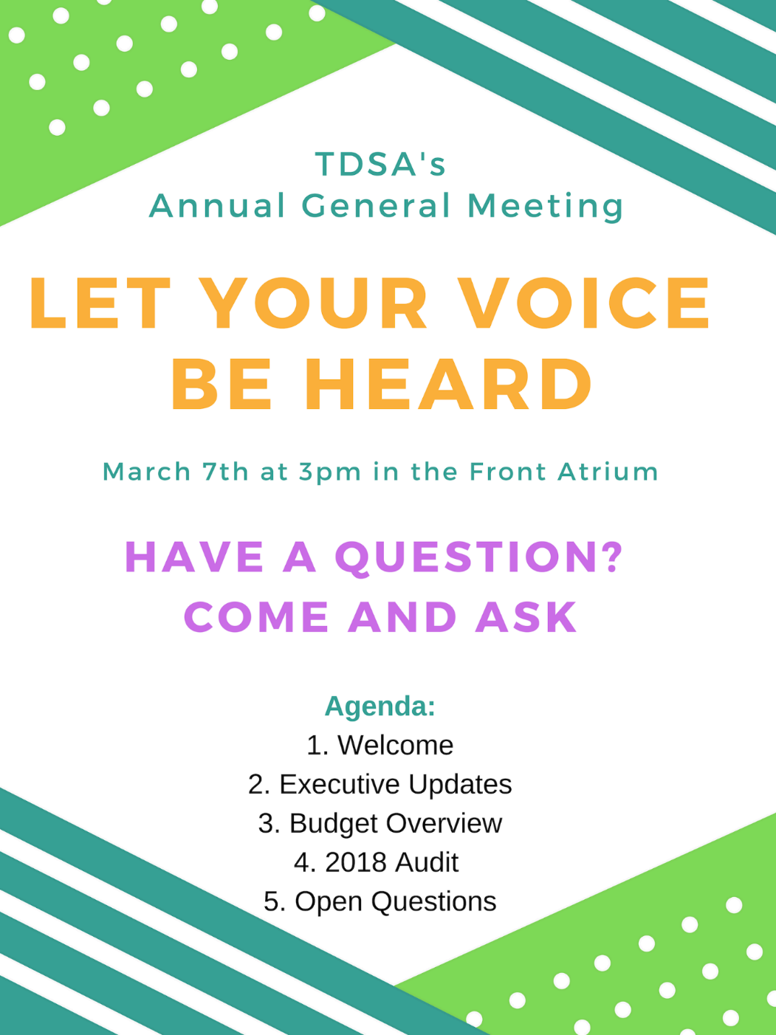

Board of Directors Meeting March 27, 2019

Present: Alyssa Petsinis, Hema Tikaram, Jamila Alleyne, Mackenzie Prine, Nick Ryan, Sabeela Barkidan, Alex Rookes on phone
Nick has Christy Chabassol Proxy
Rayna Porter joining at approximately 2:15pm
Gallery: Aleah Simmons, Neelab Almasak
Absent with Regrets: Taryn Gilchrist, Jessica Watters, Julia Derdaele, Holley McAlpine, Karen Albrecht, Beth Lindsay, Bonnie Caruana

Nick Ryan acting as chair
Procedural Items:
- Call to Order at 1:08pm
- Discussion and approval of last meetings minutes/action items
- Read off Action Items from Minutes (not completed)
- Call for New Business
  - New #6- Jamila take over as chair
  - New #11- Disciplinary Committee
- Approval of Agenda
Motion to approve the agenda
Motioned by Alyssa
Seconded by Hema
Motion is Unanimous

- Declaration of Conflict of Interest
  - Nick for Disciplinary Committee #11
  - Jamila for Chair #6
- Confirmation of Jamila as Chair starting in March 26, 2019
  - Be it resolved that the 2018/2019 confirm Jamila Alleyne as the chair retroactive as of March 26, 2019. Whereas the current, temporary, chair Karen Albrecht has been made temporarily unavailable and it is an honourous duty and whereas there is currently no oversight for the executive committee.
Motion to approve Jamila assume role of chair moving forward
Motion by Alyssa
Noting Abstentions of Jamila for conflict of interest
Motion passes unanimously

Jamila Alleyne assumes duties of chair

Updates
- Executive Updates
  - VPCL
    - Mandated to take a week off
    - Semiformal for the last month. Went well. Caterers were good. Events team helped a lot. Ways to cut costs, keep money in house. Working on TDSA response to Student Choice Initiative, meeting with Leo and Joe tomorrow. Currently have 49 banked hours. Can take more time off, roll time over into new position, pay out, or board mandate time off. Keeping office open.
  - President
    - Discussion with University about Student Choice Initiative, government has made all student union fees non-mandatory. Working with University to find a solution. Opt-out rates estimated at 30% as per research. TDSA expecting 30% decrease in fee revenue/budget for next year. Spring GA, AGM, Open House, Semi-Formal setup. Health benefits meeting where we found out usage was up so fee will be going up by $22.74, $1.82 will be going to admin costs. Multicultural show, Durham CASSC, Drag Show, OUSA Steering Committee. Will be taking over OUSA duties for remainder of year. BOG luncheon, transition documents, grad photos, and composites, Trent U names committee, met with Chris Glover. Must now charge tax on events and locker sales, still only 5% on used books.
    - What happened with conversation with Chris Glover yesterday? It was what the NDP’s take in on current Provincial PC government decisions. Rayna will be here later and can update then.
Action Item: Ask about Chris Glover Meeting
  - VPUA
    - Attended Town and Gown and talked about restructuring of Board, no smoking policy, and Student Choice Initiative. AGM, Semi-Formal, Open House, GA, talk with Derek Giberson about forming a coalition in regard to transit, talks with Metroland about news piece on Student Choice Initiative
Rayna Porter joining meeting on phone at 1:23 pm
  - Operations Manager
    - Hours update: Pres- under 35, VPUA- Under 35, VPCL- over, OM- under 35
    - Completed safetalk training, completed T4s and sent to government, help with Semi-Formal, Open Mic Night, AGM, HST issue, ORD Meeting, Epson issue, Open House, Display Case, Inventory, Health Benefits Meetings, Student Choice Initiative research and work on proposal for Trent University, meeting Minutes from BOD meeting.
Discussions/Decisions:
- Equity Name Change Jamila
  - It was previously suggested that Director of Equity change name to Equality. Instead suggest that use Director of Inclusion
  - Equity can be confused with financial term, should we consider speaking with the incumbent to see what they think?
Motion to approve name change pending consultation with Nathan Barnett and pending AGM in fall from Director of Equity to Director of Inclusion
Friendly Motion
Motion Unanimous
Action Item: Consult Nathan Barnett about name change
Action Item: Pending consultation, add as agenda item on Fall 2019 AGM

- Budget Update Karen
  - Update on how we are looking, but Karen absent so should we table
Motion to table until April Meeting as Karen absent
Friendly Motion
Motion passes

Action Item: Budget update on April Meeting Agenda

- Locker Charge Amounts Bonnie & Karen
  - Karen and Bonnie absent so should be tabled

Motion to table until April meeting
Friendly Motion
Motion passes

Action item: Locker Charge Amounts on April Meeting Agenda

Motion to move into closed session
Motioned by Jamila
Seconded by Hema
Motion passes

Entered Closed Session at 1:41pm
- Disciplinary Committee
- Evaluation Update Karen
Upcoming Training:
April 24th, 3-7pm: Board (of Director) Games!
- A fun event for both incoming and outgoing Directors. Special guest coming in to give workshop on leadership skills. Dinner will be provided.
April 25th, 1-4pm: Policy 101: Board Training
- Both incoming Directors and outgoing Directors are welcome. We will be going over TDSA policies, Robert’s rules, functions of a meeting, etc. Snacks will be provided.
Upcoming Events:
March 28th , 6pm: Take Back the Night Walk
March 29th, 7pm: Improv Show
April 1-4: Environmental Week
April 4th, 3-4pm: Hang out with the Head Open Discussion with Joe Muldoon (Trent Durham Event)

Emergency Annual General Meeting Minutes Thursday April 4th, 2019

Meeting called by Nicholas Ryan in accordance with Bylaw II and IX

Call to Order at 3:04pm

17 Students present including Nick Ryan as Chair of Meeting, as well as Operations Manager Bonnie Caruana

Call for Declaration of Proxies
- Matthew Gilmour has Proxies for Trinity Koyana-Asada and Puvitha
- Hema Tikaram had Proxies for Rayna Porter and Christy Chabassol
- Jac Gibson has Proxies for Scott Boulton
- Phuong Nguyen has Proxies for Melissa Matthews and Roxanne Miller
- Audrey Lindsay has Proxies for Sean Ardis, Jade Gauthier, Morgan Namek, Inza Akram, and Jamila Alleyne
- Julia Daerdale has Proxies for Kayleah Brown
- Mikayla Wilkinson has Proxies for Chanel Dewell
- 14 total proxies presented

Nick Ryan reads agenda and goes through presentation of program
- Peer Support Group Adoption
  - WHEREAS this fee will be allocated to the development and maintenance of a peer support group on campus providing non-life-threatening mental health supports and events for all students attending the Trent Durham Campus;
  - AND WHEREAS this group will provide logistical support for students in navigating the mytrent portal;
  - AND WHEREAS any and all Trent Durham Student Association personnel involved in the facilitation of the program will be mandated to receive all training required by Trent University provided that it does not negatively impact their personal mental health;
  - AND WHEREAS this program will be developed with trained mental health professionals on campus and be supervised by a full time staff member appointed by Trent University to ensure the program remains in scope and best practices are maintained;
  - AND WHEREAS $15.00 of the current $32.60 fee will be allocated to this service subject to yearly increases/decreases consistent with our bylaws and undergo regular reviews as laid out by the board of directors.
  - THEREFORE, be it resolved that the Trent Durham-GTA student body amend Bylaw IV under the “Non-Refundable Student Ancillary Fees” subheading to include a “Peer Support Group” fee and strike the words “external” from the bylaw language.
  - Non-Refundable Student Ancillary Fees
  - The following fees are collected from the membership for the purposes of administrating services:. Said fees shall only be used towards the intended service and are subject to annual inflationary increases not to exceed five (5) percent.
Walksafe Fee
Peer Support Group Fee

Copy of Presentation
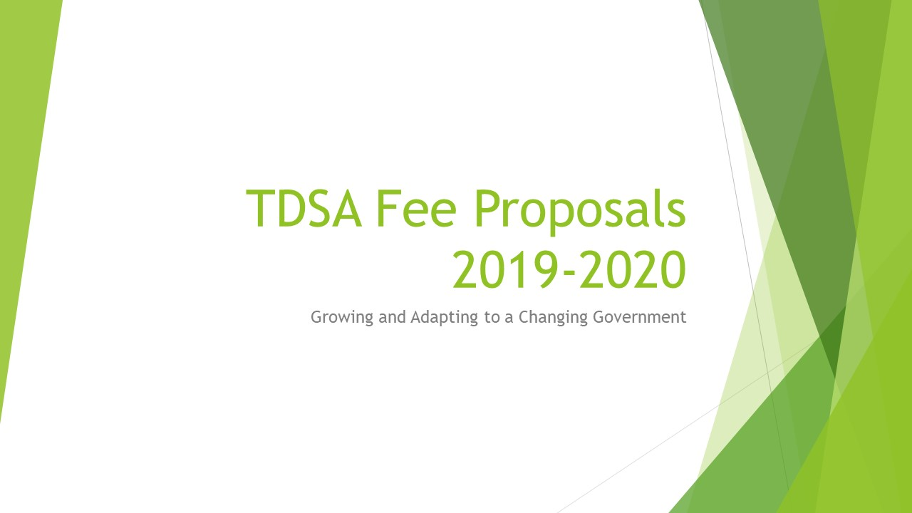
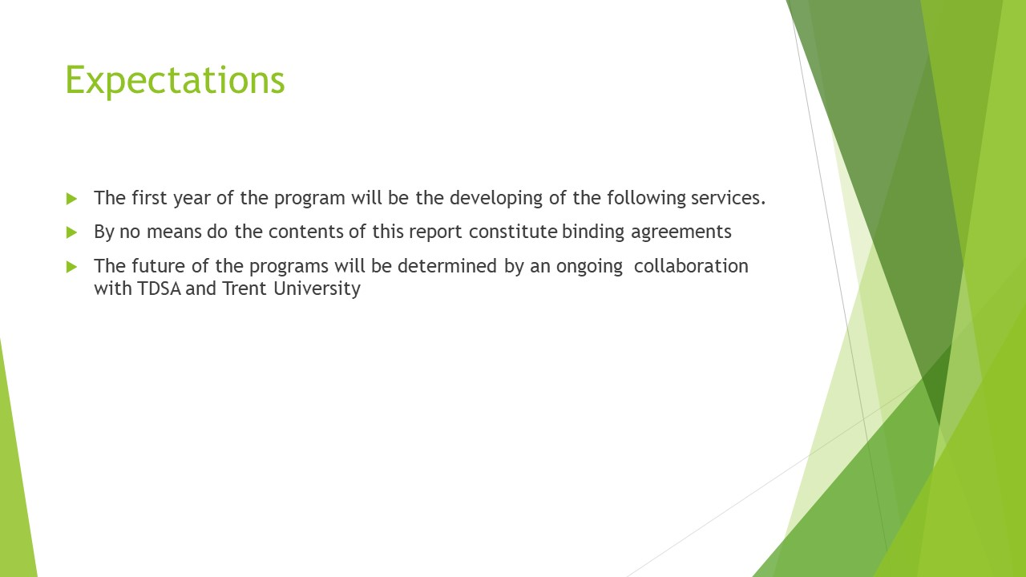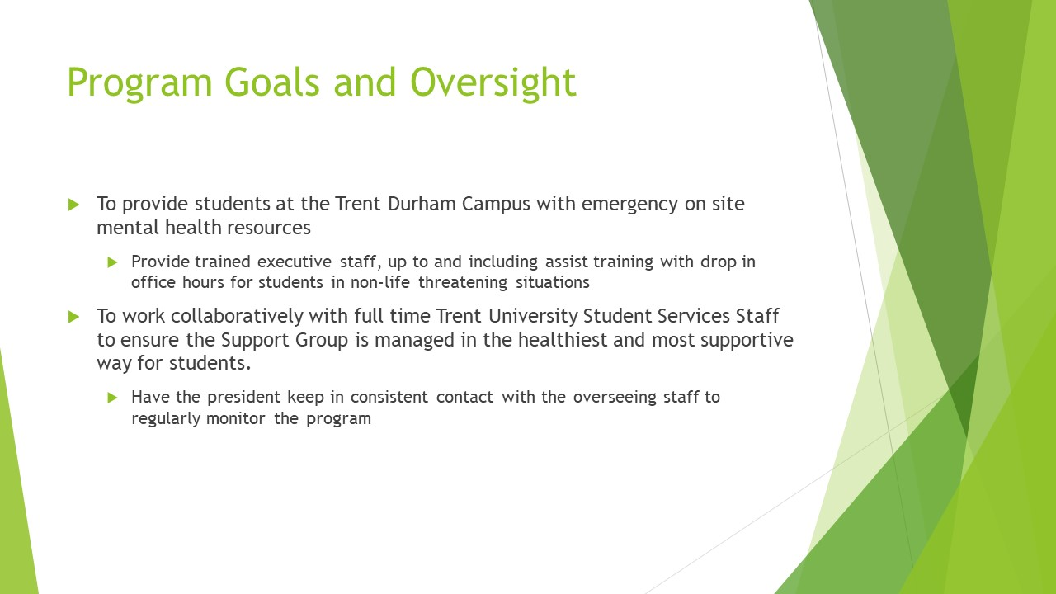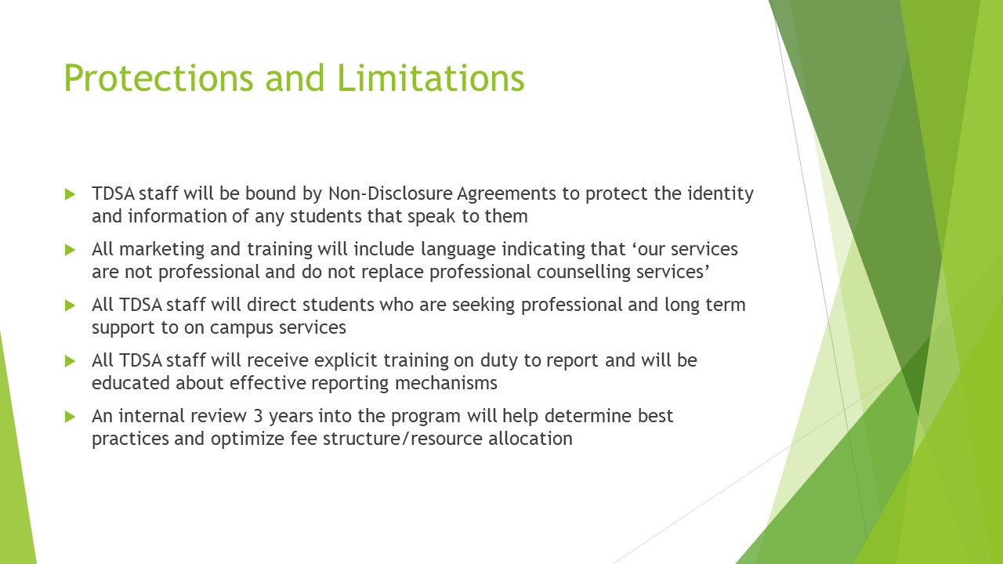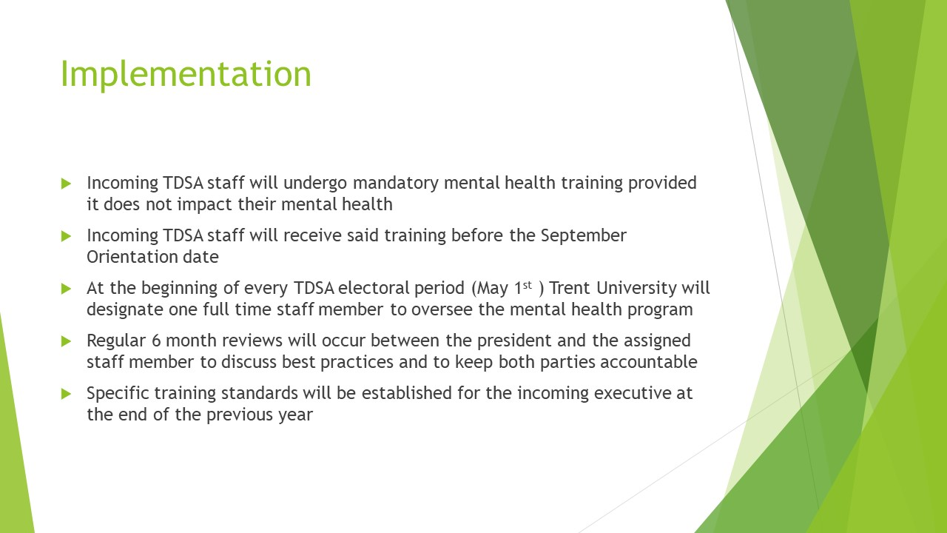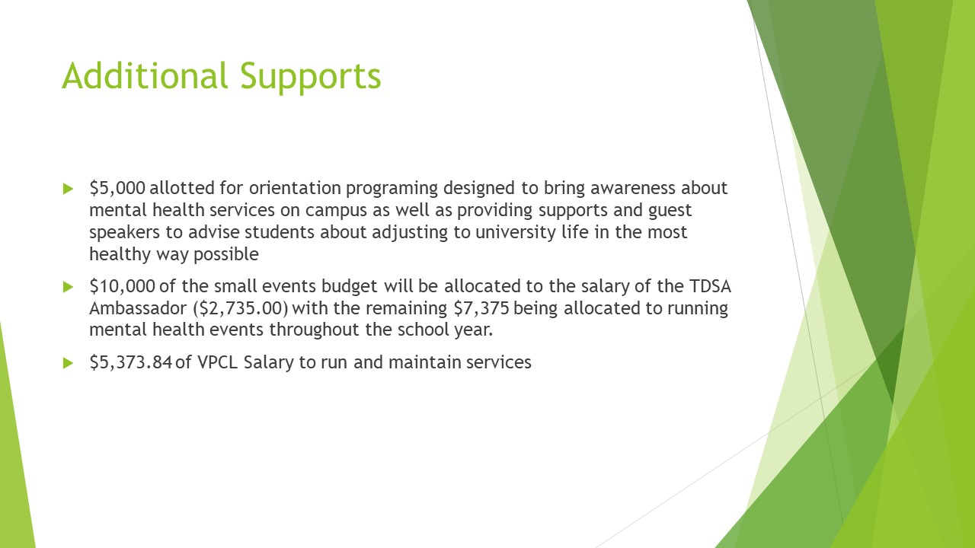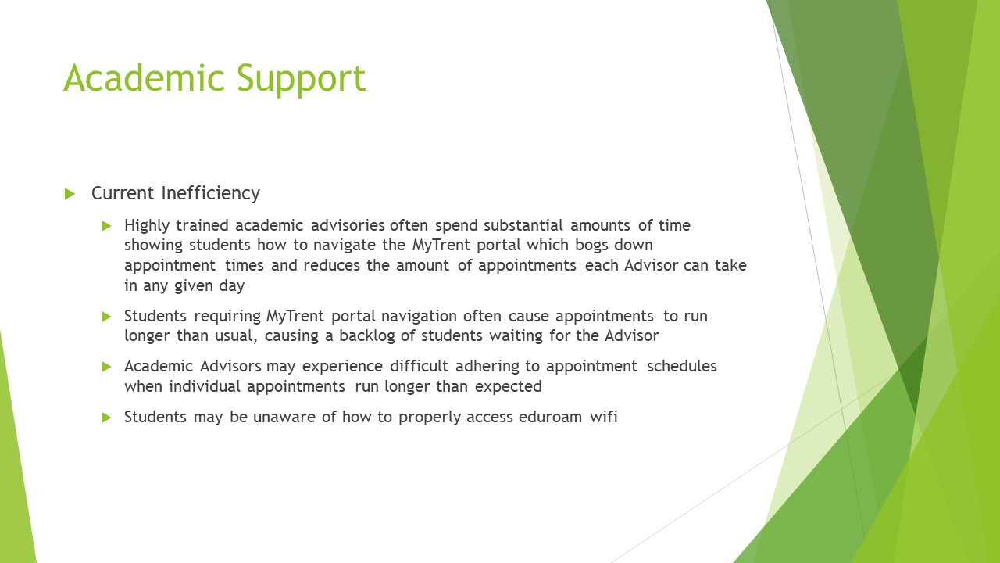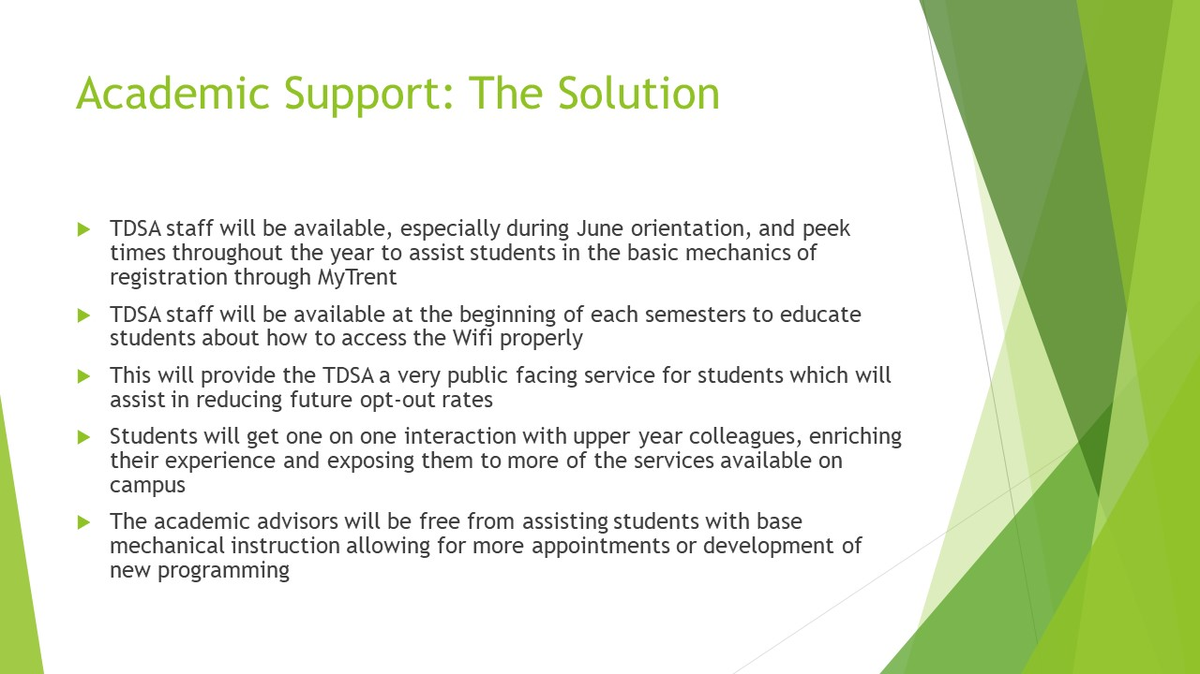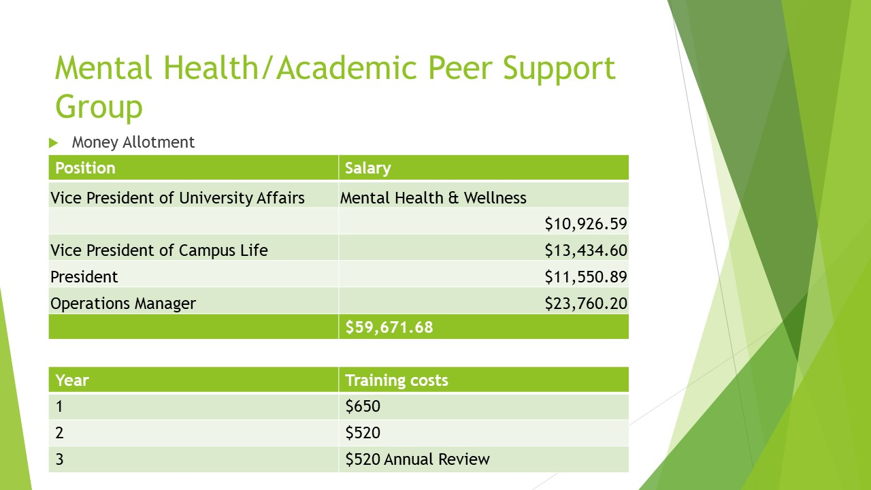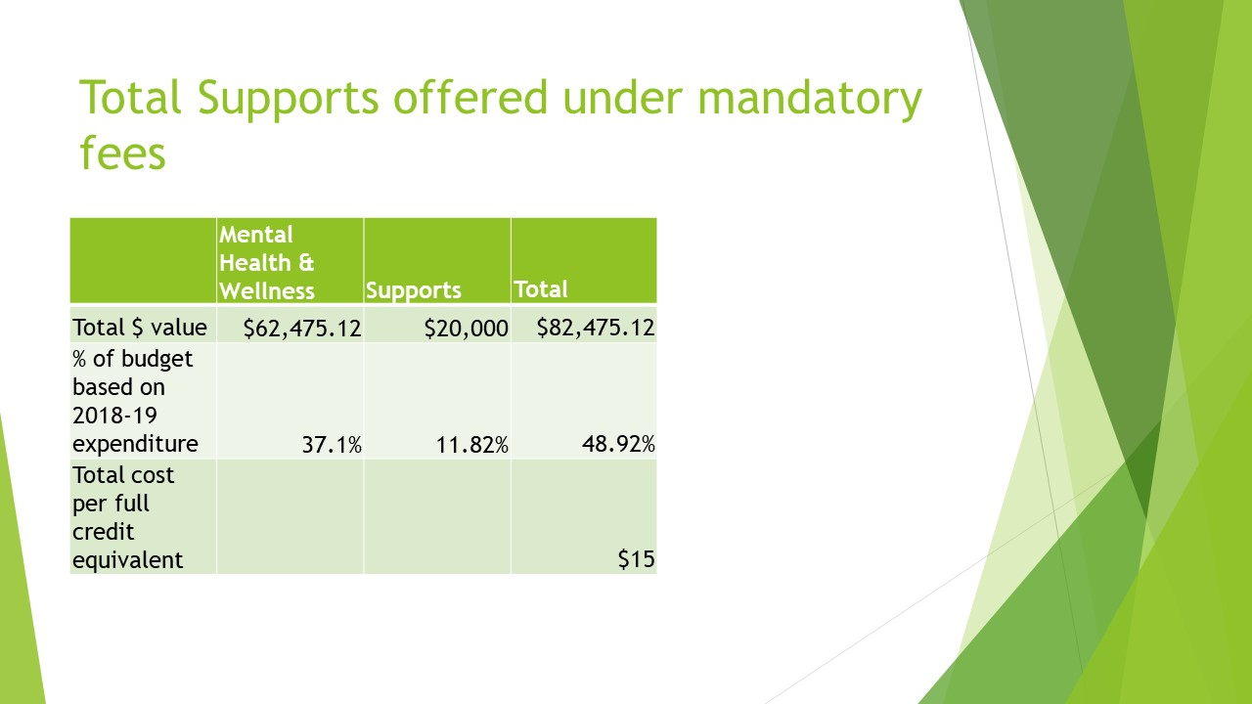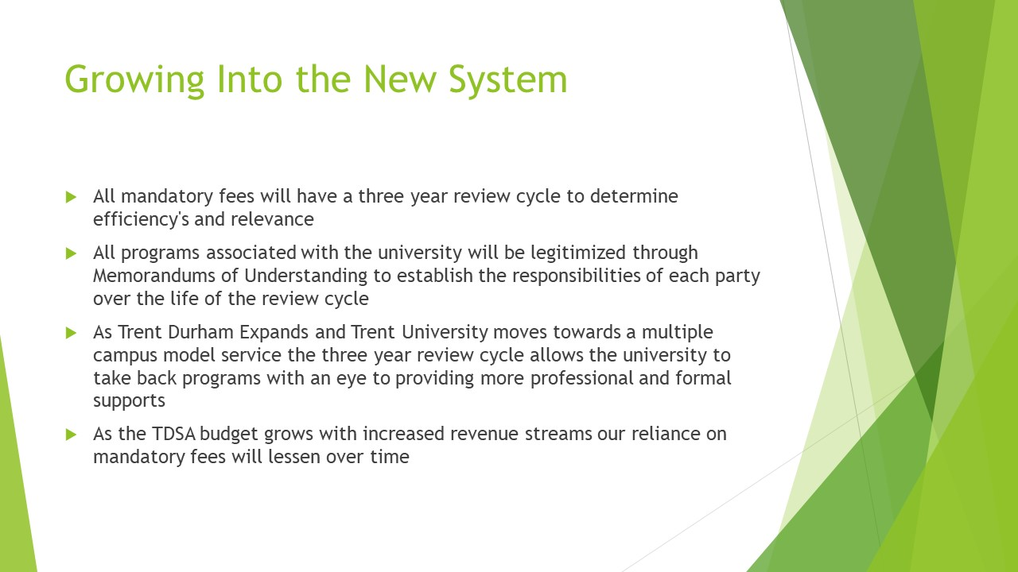

Call for questions from the Audience
- Kyle Hrushka had questions regarding: what are the expected time commitments and how will this effect already overloaded executive schedules? why we need to separate the fee and make it mandatory? what if a employee or executive objects to being a part of the program? how will times of conflict in the office and potential shortage of executives effect the program? mandatory training requirements? what will the oversight look like? All answered without further comment
- Suggestion for an anonymous comment location for questions/concerns/critiques on the program. Potentially online or via email or a physical location
- No further comments or questions

Call for Vote to Approve Motion to amend Bylaw IV, subsection Mandatory Anciliary Fees
30 Approve Motion (16 Present students in favour as well as all 14 Proxy votes)
1 Oppose Motion
0 Abstains
Motion passes

Call for New Business
- No New Business

Meeting Adjourned at 3:34pm

Emergency Board of Directors Meeting April 12, 2019

Present: Alyssa Petsinis, Hema Tikaram, Mackenzie Prine, Holley McAlpine, Jamila Alleyne, Bonnie Caruana, and Alexander Rookes on the phone
Absent:

Call to Order: 10:38am
- Any additional business to add to agenda? Might be best to keep to just this issue. All agreed.

- Jamila sends out the recommendations from the Disciplinary Committee to entire Board of Directors

Motion to Discuss Recommendations
Motioned by Alyssa
Seconded by Hema
All in favour

- Each piece went through and suggestions on how to change or reword or add to made as secondary bullets below.
Disciplinary Committee Recommendations:
· Expectations about co-worker vs friend relationships and modified within the TDSA
- Look at policies surrounding co-worker relationships and maintaining professional workplace
Action Item: OM to review policies and ensure wording reflects professional working environments and not personal relationships throughout bylaws and policies

· Job outline states that an executive should ask for a lighter workload or a leave of absence if workload is too stressful
- ensure added to Job Description Policy
Action Item: OM to go through Job Descriptions Policy and ensure that requesting light workloads and leaves of absences are added in to allow executives options if they are feeling overwhelmed
· Mental health support is not the role of an executive or operations manager (or any employee of the TDSA) as they are not trained professionals. Support can be received from other resources on campus or outside services
- List of resources made available in hiring packages including on campus resources and off campus resources.
Action Item: OM to create a list of mental health resources at the University and in the Durham Region and ensure all staff receive a copy upon being hired

· Deadlines need to be made formal through emails - follow up email after meetings to ensure the date and time discussed is agreed upon
- Training, Policy about committees
Action Item: OM to ensure any policies regarding training and meetings to include follow-up emails, as well ensure that all policies concerning committee meetings include the addition of follow-up emails.

· President of 2018-2019 has the authority to speak to OUSA on behalf of the TDSA as the President and OUSA representative

· VPUA is requested to take back OUSA responsibilities as it is majority of the role of this position. If this request is not manageable, it is advised that the VPUA take a leave of absence or resign.
- Instead: Ask if VPUA and President of 2018-2019 agree to finish the year working on senate and OUSA respectively as this is their previous agreement

· It is request that Beth and Karen continue working from home until mediation
- Option to arrange separate training if they do not do mediation
- Letting the people know that some people do not want to work together
- Individual mediation requested for mental health
- VPUA trains incoming VPUA about senate and her knowledge of OUSA President trains incoming VPUA on her knowledge of OUSA

· Since the mediation session has not been completed, we request that Beth and Karen do not attend the retreat of the 12-14th weekend in April as to avoid any personal disturbances that may conflict with team building and communication training being the main purpose for the incoming executives.
- BOD agrees that they should not attend however does not mandate only recommends and notes that both parties have agreed not to attend already

· It is recommended that current President and VPUA write a letter of recommendations for the TDSA in order to consider mental health more effectively in the future as well as any policy change suggestions that they may have.
- BOD agrees, also wants to include if either party have any other recommendations to include those as well.
Action Item: Disciplinary Committee has a wrap up note that is already drafted for each party and will include these requests in the letter to be sent out April 12, 2019 by 2pm

Motion to Approve Changes to Recommendations
Motioned by Julia
Seconded by Holley
Motion Passes Unanimously

Friendly Motion to Adjourn
Meeting Adjourns at 11:12am

Board of Directors Meeting April 30, 2019

Present: Bonnie Caruana, Nick Ryan, Karen Albrecht, Jamila Alleyne, Mackenzie Prine, Hema Tikaram, Jessica Watters, Alexander Rookes, Sabeela Bakridan, Alyssa Petsinis, Lindsay Gammon, Rayna Porter (calls in for a portion and enters during closed session)
Absent: Elizabeth Lindsay, Holley McAlpine, Taryn Gilchrist

Procedural Items:
- Call to Order at 10:22am
- Discussion of February and March meetings minutes/action items
- February Meeting
- Action Item: TDSA to create a bylaw regarding what guidelines external organizations must adhere to in order for them to run a referendum along side a TDSA referendum or election/byelection. Include stipulations for advertising, consultations, and labelling that separates the question(s) as being asked by the external organization.
- Not completed

- Action Item: TDSA Board of Directors (BOD) to approve any referendum question(s) from external organizations that is run in conjunction with TDSA elections or referendums noting that the BOD is under no obligation to accept the question and that acceptance of the question does not signify support of the question. Add into bylaws/policy
- Not completed

- Action Item: TDSA or Elections Committee will remove any question presented without proper implementation (see above). Add to bylaw/policy
- Not completed

- Action Item: change name of committee in committee policy from Student Clubs Committee to Student Engagement Committee
- Not completed

- March Meeting
- Action Item: Ask about Chris Glover Meeting
- Completed

- Action Item: Budget update on April Meeting Agenda
- Completed

- Action item: Locker Charge Amounts on April Meeting Agenda
- Completed

- Name Change for Director of Equity to Director of Inclusion, ask incoming Director if he is ok with the change
- Completed, he is ok with name change

Action Item: Add to Fall AGM Agenda

- March Emergency Meeting
- Action Item: OM to review policies and ensure wording reflects professional working environments and not personal relationships throughout bylaws and policies
- Not completed

- Action Item: OM to go through Job Descriptions Policy and ensure that requesting light workloads and leaves of absences are added in to allow executives options if they are feeling overwhelmed
- Not completed

- Action Item: OM to create a list of mental health resources at the University and in the Durham Region and ensure all staff receive a copy upon being hired
- Completed
- Action Item: OM to ensure any policies regarding training and meetings to include follow-up emails, as well ensure that all policies concerning committee meetings include the addition of follow-up emails.
- Not completed

- Action Item: Disciplinary Committee has a wrap up note that is already drafted for each party and will include these requests in the letter to be sent out April 12, 2019 by 2pm
- Completed

- Approval of February, March and March Emergency Board Meeting Minutes
Motion to approve February, March and March Emergency Meeting Minutes
Motioned by Hema
Seconded by Alex
Motion Passes, no abstains

- Call for New Business
  - Job descriptions for Board of Directors in Policy, add as number 14

- Approval of Agenda
Motioned by Alex
Seconded by Mackenzie
Motion Passes, no abstains

- Declaration of Conflict of Interest (COI)
  - Nick Declares for: Wages increase, closed session executive evaluations
  - Karen Declares for: Closed Session Evaluations
  - Bonnie Declares for: OM Wage increase, Closed Session Evaluations
  - Hema Declares for: Wage increase
Motion to Discuss if Nick and Karen have a Conflict of Interest in regard to Disciplinary Committee Recommendations
Motioned by Mackenzie
Seconded by Alyssa
Motion passes, Nick and Karen Abstain

- If Nick and Karen Declared for first session, why do they now feel comfortable that they are not COI? Nick wanted to distance himself from the proceedings as he had so much work and school work to finish up, did not want to be a part of it, was not adequately prepared for the meeting, now that he does not have exams and is supported in office he does not feel overwhelmed and can adequately prepare for discussion. Karen feels comfortable leaving and declaring a conflict of interest. Was it necessarily a conflict previously if the issue was only that Nick did not have time? Nick also wanted people to feel more comfortable, was worried that others felt he had a conflict, so I did it, but COI should be taken more seriously with a tighter definition, based on that he doesn’t feel that he has a COI, part about his written warning is not a discussion piece so no COI with that either unless it becomes a discussion piece. For consistency should we maintain his COI? Should Nick abstain, would not vote but can stay for discussion.
Motion to Call the Question
Motioned by Karen
Seconded by Alex
Motion passes, no abstains

Motion to for Nick to stay during discussion and abstain from voting
Motioned by Alex
Seconded by ?
Motion passes, Nick Abstains

Updates
- Executive Updates
  - President
    - Worked from home creating training manual, attended OUSA Partners in Higher Education Dinner (PIHED), Daniel Travers won the award this year, last OUSA SC Meeting, OUSA training day with incoming VPUA, Completed last evaluations, organized and hosted BOD games, organized past executives round table to connect past TDSA alumni with current executives to keep the relationships fresh, contracts for new executives, picked grad gifts, helped new Trent University Native Association (TUNA) rep, Lindsay Gammon, prepare for new term as ex-officio on our board, organized files
  - VPUA
    - Assisted with Drag show, debriefed from spring GA with OUSA director, proofread LGBTQ paper for OUSA, quote in paper article, contacted Trent departments that may have interest in content of LGBTQ paper, attended Academic and Planning Committee, administered Freedom of Speech and No Smoking survey, attended PACREA sub-committee, end of year review completed, researched grants and municipal policies, prepared material for transition and transition training, attended mediation with Karen, Past executive round table
  - VPCL
    - Took 2.5 weeks off, banked hours under 25, Mel and Audri’s reviews, Bonnie’s performance review, started going through bylaws and policies in preparation for next year, executive retreat, past executive round table, PIHED, cleaning up desk,
  - Operations Manager
    - President about 4 banked hours left, VPUA at 0, VPCL has approximately 19 hours, OM is over 40, installed new printer, sorted out till from scholar’s dinner and sent invoice to school, call with OUSA school’s GMs, Zoo to you, Emergency AGM, PIHED, programming for executive retreat, emergency board meeting, financial work, facilitated executive retreat, handled notice from CRA, sent SPC cards back, work with Auditors, peer support meetings with students, assisted Disciplinary Committee when requested, research on training, emailed and dealt with Lockers, evaluations

Discussions/Decisions:
- Equity Name Change (approval) Jamila
  - Just to make sure Nathan approved, as previously discussed it was, no further discussion needed other then to bring to Fall AGM to approve

- Budget update, wages and fee increase Karen
  - Total gross revenue $228,074, expenses were approximately $211,000, budget updated to March, incoming President will update with April numbers, Surplus of approximately $16,000, next year looking at a decrease in revenue with Government changes, new team is ready to deal with this, Office supplies went over by $703 (under $999 which is when we would need Board Approval), Conference fees under, travel a little over budget, VPCL lines were all under so contributed to surplus.
Motion to discuss increase the executive wages by $0.31, from $16.49 to $16.80
Motioned by Karen
Seconded by Alyssa
Motion passes

Nick and Hema Exit at 10:51am

  - So, every year executive wages go up by Cost of Living or CPI, this year the CPI was 2.6%, which is $0.31. If procedural then ok, but if the opt -out fees are too high then it could cause issues with budget, with the increase the President would see an increase of $500 by the whole year gross, $350 for the VPUA and less for VPCL, overall only about $1000 overall. With the emergency AGM we protected $15 of the fee which will go towards a portion of the executive salaries to cover the Peer Support Program. We also have to remember that this is still a workplace and we need to make sure we are sustaining our workers, but we also need to make sure that our students are taken care of first as well.
Motion to approve increase of Executive Hourly Wage from $16.49 to $16.80
Motioned by Alyssa
Seconded by Sabeela
Motion passes, no abstains

Bonnie Exits at 10:55am
Nick and Hema re-enter at 10:55 am

  - Operations Manager gets a yearly increase tied to their evaluation, Bonnie exceeded expectations, was in the bracket of a 5% increase, currently she is at $26.35/hour, a 5% increase would be $27.66, but there is a cap at $27.00
Motion to Discuss increasing OM Wage from $26.35 to $27.00
Motioned by Karen
Seconded by Nick
Friendly Motion

  - OM gets yearly performance raises based on performance review. Bonnie deserves to get up to the cap, has exceeded expectations, has undergone training, has kept the office going. Why is there an increase happening? Based on Job Descriptions Policy OM gets a yearly increase based on evaluation rating. This started a few years ago. Bonnie got a rating that put her in the 5% increase bracket but this would put her past the cap as decided on when the job was created. There is no other bonus for the OM. When the policy was created for the position of the time, Operations Co-ordinator, there was a want to increase the wage of the position to $20, but the budget was limiting, so a mechanism was put into place to get the position to that wage in a short time frame, the problem is that if we continue to raise the salary by 5% it will take up 1/3 of our operating budget in 2 years, we may want to move to a bonus system instead of an increase to make it more sustainable. It may not be fair to have one person tied to an increase and the rest getting a bonus. Bonnie also won’t be here forever, if we think about the future, and we have an OM who is not doing the job and would still be possibly getting a raise, we should make sure we are sustainable as an organization as well. Also, we need to look as mechanics, if you only get 50% on your performance review, why are you then entitled to a raise or bonus? If you are not doing your job, you should not be rewarded. Bring her to the cap and task executives next year with determining a bonus system for the OM position. Currently sitting at $26.35, CPI would bring her above the $27.00 so asking to keep her at $27.00.
Motion to increase wage of Operations Manager by $0.65/hour from $26.35/hour to $27.00/hour
Motioned by Karen
Seconded by Nick
Motion passes, no abstentions

Bonnie re-enters at 11:07am

Motion to discuss increase both TDSA fee and Peer Support Fee by 5%
Motioned by Karen
Seconded by Mackenzie
Motion passes, no abstentions

  - Increase to $15.75, approved at AGM at $15.00, for Peer Support and $18.06 for TDSA fee, previously $17.20 as per bylaws. TDSA fee will be opt-outable and Peer Support Fee is mandatory. TDSA fee covers travel, office expenses, most of salaries, OUSA membership fees, conference fees, clubs, certain events. Peer Support Group fee covers Peer Support Group and Health and Wellness Initiatives, mental health training for executives, salaries of executives and OM for time spent providing services, small events budget, transitional support programs (1/2 of what was orientation budget) (any health and wellness events run in September, 1st year, returning students, transfer students etc), salaries for potential student employees who would work the program. Peer support group will take time and resources so $0.75 will help maintain it, especially with the potential hit we may be taking in the fall with opt-outs
Motion to approve increase Peer Support Fee from $15.00 to $15.75 as per bylaws
Motioned by Karen
Seconded by Alex
Motion Passes, no oppose, no abstain

  - TDSA fee, will be opt-outable fee, currently $17.20, proposing to increase to $18.06. Covers events not concerning health and wellness, clubs, BOD expenses, advocacy work, OUSA membership, conferences and travel, approximately 55% of salaries,
Motion to discuss
Motion by Alyssa
Friendly motion, motion passes

  - The higher the amount the more likely people are to opt out. The amount is still low enough that most people won’t notice the amount. Should we put to $18?
Amendment to proposal, increase TDSA fee to $18 from $17.20.
Motioned by Karen
Seconded by Alyssa
Motion passes

Motion to discuss amended amount
Motioned by Mackenzie
Seconded by Sabeela
Motion passes, no oppose, no abstain

  - Does the $0.06 make a difference. $17.99 would be better from a retail point. $18 is more marketable then $18.06. From a marketing standpoint, $17.99 would be better, more likely to sell then something at $18. We need to make sure we are advertising and providing information to let students know what the fee does.
Amend the motion to, increase of the TDSA fee from $17.20 to $17.99
Motioned by Nick
Seconded by Alex
Motion approved, no oppose, no abstain

Motion to discuss the amendment
Motioned by Mackenzie
Seconded by Hema
Motion passes
    - Does the $0.01 difference cents make sense, if $18 was a nice flat number, more aesthetically pleasing, why do we want down to $17.99? The motion moved too fast and we were not able to get all information about $17.99 price point. From a retail and marketing standpoint people are more likely to buy something priced at $17.99 over $18 because they feel that they are only spending $17 instead of $18.
Motion to call the question
Motioned by Karen
Seconded by Alyssa
Motion approved, 1 abstain

Motion to approve amendment of $17.99
Motioned by Karen
Seconded by?
Motion passes, 2 abstain

Motion to call the question to vote on TDSA fee increase from $17.20 to $17.99
Motioned by Alyssa
Seconded by Nick
Motion passes, no oppose, 1 abstain

- Locker Charge Amounts Bonnie & Karen
  - Need to charge HST on locker rentals. Not deposits. Currently at $15 summer term, $25 single term, and $40 double term. How would the board like to proceed in charging the fees? Current price including tax, current price plus tax, or increase price and either include or add tax on. Should we keep the same and include tax in current price? To stay competitive, we should increase a bit, also a source of revenue which could be helpful. We did sell out this year, so as a compromise should we add tax to current amount. Students who use the lockers will not notice the tax amount change, and if they do we only say that we are charging taxes this year. Every product you buy in life there is tax, so keep same and add tax. Easy to make the change to add tax to current charge. We can adjust if we see that lockers are not selling.
Motion to call the question
Motioned by Alyssa
Seconded by Jessica
Motion passes, no oppose, no abstain

Motion to approve current fees plus tax
Motioned by Alyssa
Seconded by Hema
Motion approved, no opposed, no abstain

Motion to have a 5-minute recess
Motioned by Hema
Seconded by Mackenzie
Motion passes
Recess at 11:37am
Meeting resumed at 11:44 am, Alex not present

- Update about Chris Glover meeting Karen and Rayna
  - Went well. Chris glover is an MPP, representing Spadina and Fort York riding as a member of the NDP party, also the Training, Colleges and Universities Critic. Reaching out to all student unions across province about student choice initiative. Wants to hear from students, passionate about helping students. Wanted to do a private members bill to turn down student choice initiative, not sure how that went or when it will happen. Spoke with us and TCSA. Then TCSA had town hall with Peterborough students.

- Evaluation Update of Information Karen and Bonnie
  - Research on performance review styles.
    - Execs can set goals based on position and then rated on how well they achieve them, rewarded based on what they set, makes it more fulfilling for the exec, cons are that it could be easy for someone to set low goals and be rewarded better then someone who sets high goals, does not achieve them all but does an overall great job.
    - Goals based on values of corporation. Clearly defined categories, but not as motivating because execs have no say in categories.
    - Combination method, where there is a section of corporation values and then own set goals, graded by both OM and exec. Reflects corporation and what each exec wants to achieve but lengthy, difficult to understand potentially.
Alex re-enters at 11:49am
    - Create new categories and rate similarly to what we have now, fewer categories and fewer ratings. Simple and straight forward, but not motivating, subjective.
    - Create a job plan. Tailored to each position and personal, but very lengthy
    - Rating options? Numerical (less than 5 suggested), word based, progress based for goal based
    - Who will rate each employee? Have previously done it so that each executive rates all other execs, have done it so that OM and exec rate and then average, have done a collaboration so that OM and exec come up with score together.
    - Suggest that change name from Performance Evaluations to Progress Reviews, changes mind set to how am I doing now.
    - Bonuses?
    - Accessibilities and abilities need to be kept in mind. Form to divulge what accommodations needed and when to take them into account? What abilities are taken into account (ie. Only diagnosed, or others)
    - Currently using Trent’s Accessibility Policy and they use Individual Assessment Plans, according to AODA we are small and don’t need to use them, so do we follow AODA or Trent? This would give us a form to follow for divulging accessibility needs at beginning of term.
    - At YMCA they call Staff Appraisal, create a section about accessibility needs, not just for job related items. Should have a section in policies, add to email signature, website, and hiring packages.
Action Item: add accessibility to wording to email signatures, website and hiring packages
    - This past review was more successful then previous review. Was more cooperative, categories still hard to navigate, too many numbers for rating, didn’t have to prep much, just read the categories, OM and exec worked together on where did you do well, what could be improved, what rating do you think you should get. Talking about it was more collaborative. Got a lot of honest self-reflection. In old system felt as if defending work, justify how exec is a value, in new system felt more productive goal setting, better conversation and understanding, no justification of why your comments are more valid then the other persons, this system more collaborative, less confrontational. Execs took away more information from this type of discussion then in the past. More constructive. What if OM and person do not like each other will this system work. If person helps create goal and they have a hand in how their job is done, they will be more motivated in achieving the goals. It was recommended that we make a new way by the board, so if amount of categories and rating scale are too large how should we proceed? Should stick with an odd number to make it easy for there to be a middle ground.
Rayna joins via phone at 12:05pm
    - There is a lot of overlap in some of the current categories, can collapse down to at least 6 easily. Needs to be very clear that 3 is there is nothing wrong, you are doing your job, 4 you are doing more than expected, 5 you are otherworldly. Don’t think this will be completed today. Either exec committee or ad-hoc committee for the next board complete this. Feel that there should be a reflection part ahead of time to reflect on how you did in your role, then come together to talk about it, don’t think there should be numbers, not effective. No scale? Create goals in beginning, then determine if met expectations with no numbers, this is not school, don’t need to be graded numerically. Grading helps to understand how to improve, acts as motivation. Combine word and number-based systems. Word based helps to define what each category means. More numbers can mean more detail. If you don’t have an idea of how you are before going into the review it may influence how you rate during. Need more information. Number system is in place because execs get bonuses. Discussion is good, because they should be able to justify how they are doing, but only one person should make the rating. We can make any rating system work with bonuses.
Action Item: OM look at current categories and see how they can be condensed. Suggest a word rating system.
    - Should 3 be somewhat at standard, 4 at standard, and 5 exceeds standard? Exceptional unrealistic, unrealistic expectations, unhealthy to make that the standard. Replace 0 with NA. Make sure definition is very clear.
Motion to Table
Friendly motion
Karen Exits at 12:22pm

- Disciplinary Committee Recommendations Jamila
  - Secondary recommendations were as follows:
    - Mediation Training for OM
      - Operating Policy 5.8 - OM should receive mediation, mental health, and professional development training as she acts as the HR representative of the organization.
      - TDSA Employment and Job Descriptions Policy - Job Description - Operations Manager…. (13) The Operations Manager will be tasked [with mediating] any interoffice grievances that arise.
      - All other executives and chair should be well informed of this training.
      - OM should be clear about what she is trained in and the information that is available and a policy should be created when outside mediation is needed when OM is in conflict.
- Yes we should have a policy for outside mediation. Formal mediation training is quite expensive and lengthy, but there is free training on Lynda that is available. Full training might be unrealistic. If in OM job description and too expensive then strike the requirement. Should have some sort of training, as conflict will always arise. Need to be clear on depth of training. Should be a policy in place about how to go beyond what OM will be trained for.
Action Item: OM Undergo mediation training on Lynda.com
Action Item: Outline Lynda training in job description
Action Item: Create policy concerning when/how to go outside of OM mediation
Action Item: Outline timeframe and yearly refresher timeframes in Job Descriptions

Rayna no longer on phone as of 12:07pm

Action Item: Policy to handle conflict that arises before OM is trained

Mackenzie exits at 12:30pm

Action Item: OM to put together list of training to bring to board
Action Item: Work with Jen in regard to appropriate training and types of situations we should look at

Mackenzie Enters at 12:32pm

    - Professional communication through email
- Making sure confirmation emails are sent in regard to when meeting is, when next meeting is, and wrap up points are sent via email, create a paper trail.
Action Item: Procedure to be created in regard to professional communication and meetings

    - Being aware of exclusion within the workplace
- Being aware of exclusion and ensuring inclusion is a priority, make sure that everyone knows of meetings etc.
    - More staff/ volunteers, to achieve a work life balance, student life balance
- Not much of a work life balance, not enough money for staff, so look into more volunteers

    - Advising a lighter course load when working during the school year
- Already in policy that this is advised. Can we add to campaign materials? Higher workload, consider taking lighter workload? If its in the job descriptions is it not up to the candidate to read the job description package to make them selves aware. Will we discourage people if we stress the point too much. Can we add to candidate information session?
Action Item: include workload in candidate information sessions

    - Mandatory Board Training: Mental Health First Aid Training, ASIST Training
- ASIST training is at least $150 per person, do you really need it, should the corporation be responsible for paying for that for all directors. Mental Health First Aid and Safetalk are free and very good, most peer support programs do not require ASIST either. Because they are working with committees it was recommended by disciplinary committee. Because you are students and have schooling and personal and this to work on as well may not want to do ASIST as it can be very heavy and mentally exertive. It trains you to talk someone down out of committing suicide, might not be healthy for you. Safetalk and mental health first aid help deal with earlier steps but can send them to someone who professionally help them. Can we offer as an elective? Yes, already is. What is the difference between the three trainings? Safetalk is about identifying the signs of suicidal thoughts/suicide awareness and referring them to more professional or trained help. Mental Health first aid is more about mental health and how to support their mental health in the moment, covers a wide range of mental health topics, not just suicide. ASIST is someone is going to commit suicide and you are trained to talk them down from suicide, very intense and transformative. Mental Health First Aid is free once per year through Student VIP and Safetalk is free through school. Don’t have money for ASIST necessarily, not realistic.

Motion to Approve mandating Safetalk and Mental Health First Aid for all Board Members and Executives provided it does not negatively impact their own mental health
Motioned by Alyssa
Seconded by Alex
Motion passes, no oppose, Nick abstains

    - Self-care training
      - Paid Self-care hours: All staff (including part-time/ student staff) attend 2 self-care events at the school per semester and a form for them to get signed off. This must e reported by the OM at the end of every semester
- What kind of training sessions were you thinking? Colouring events? Yes, any destressing events run at the campus.

    - Weekly executive meetings to be mandatory. Operational Manager to be the organizer with a report back to the Board of Directors on if and how many meetings happened that month
- Executive committee already started doing this and found very helpful. The chair also attends, so does not need to be the OM to report. Make it both.

Action Item: Change bylaw to weekly executive meetings, chair or OM to report on execution of meetings
    - Professionalism and Communication training
- How to be professional in the workplace. Should they not have this already? But we are students, so may not as this may be a first experience in the professional environment. Who could give the training? Communications workshop through the leadership program, should be mandated to the executives? If they don’t run until later what do we do? When we pick we need to make sure we are not violating any union agreements, we need to do some research before we mandate who give the training. Can run our own separate training ahead of school year. If they have previously taken the training would they redo it? Should be redone every year to keep fresh in your mind.

Action Item: Do some research on this type of training and who can perform it.

    - Contracts states (personal life cannot interfere with the interactions between co-workers)
- Cannot necessarily mandate personal lives. Executives should be cognisant how personal lives can impact professional lives and have a list of resources available to assist. Point out in candidate information sessions or training that this is a professional workplace and that will need to be set aside and take best interest of corporation first. Include in the Professionalism and Communication training. Wording about this already in bylaws.

Mackenzie exits at 12:59pm

- We are already contractually obligated to follow bylaws and policies, so we should be covered. Best fit to have it included in the Professionalism training.

    - Disciplinary Action: The Disciplinary Committee has deemed it fit to impose a written warning to Vice-President of Campus Life, Nick Ryan. For any further questions please contact the Chair of the Board of Directors.
- Why was this given? A complaint was made within the disciplinary committee and the decision was made by disciplinary committee to give a written warning. In other companies the first step is the documented verbal warning, then written warning, then final written warning, then termination. There is nothing in policy to state how to give these type of warnings, only that if the disciplinary committee deems the offence to be a minor infraction that a verbal warning is given, and if a major then a written is given, and any greater then goes to the board for impeachment. How are proceedings supposed to go?
Hema and Sabeela exits at 1:05pm
- President can give out verbal warnings as part of mandate to oversee VPUA and VPCL. Disciplinary Committee Policy 13.1 states it. Did we follow the procedure? No. It happened within the complaint process, so if we are to issue a warning should we not follow the process again separately, even though it relates it should start its own formal procedures. So we not follow our policies in regard to this infraction and subsequent warning.
Sabeela and Hema re-enters at 1:08pm
Nick exits at 1:08pm
- We need to make sure it is dealt with properly. We should retract the warning and go through proper formal proceedings. We need both parties to have their voice heard as per policy. What complications are there because this is the Board of Directors is done today and a new Board starts tomorrow? Part of the process is that disciplinary committee gets updated on what happens. There are also student seats so anyone of the current board members could be on the new disciplinary committee. Also must remember that all members should be unbiased to ensure complaint dealt with in a fair manner. Board does not hear the issue anyways just approve the recommendations brought forward.
Motion to retract written warning against Nick Ryan and to have Disciplinary Committee follow formal procedures in regard to complaint, including forming a new committee with new members and same Chairperson.
Motioned by Alyssa
Seconded by Alex
Motion passes, no oppose, Karen and Nick abstain/ COI

Alyssa exits at 1:17 to get Nick and Karen

Motion to recess
Friendly motion
Meeting recessed at 1:18pm
Meeting resumed at 1:25pm
Motion to Open Agenda to add business
Motioned by Karen
Seconded by Alex
Motion passes, no abstain

Would like to extend chair contract, already completed, extended last meeting starting March 26, 2019, retract the motion

- Job Descriptions in Policy for BOD Positions Mackenzie
  - Would like to add job description for Board of Director positions as they are jobs. Would not be that big of a deal.
Motion to add job descriptions for the Directors of the Board to the Job Descriptions Policy
Motioned by Mackenzie
Seconded by Nick
Motion passes, no abstain

Motion to enter closed session
Motioned by Karen
Seconded by Sabeela
Motion passes

Bonnie, Karen and Nick Exit at 1:30pm

Meeting Enters closed session at 1:30pm

Closed Session
- Executive Evaluations Jamila
Upcoming Training:
TBD
Upcoming Events:
April 30th, 2019- Last Day of the Ninth TDSA Board of Directors, 2018-2019
May 1st, 2019- First Day of Tenth TDSA Board of Directors, 2019-2020

