2019/2020 tRENT DURHAM sTUDENT ASSOCIATION MEETING MINUTES

Table of Contents
TDSA Board of Directors Meeting May 27, 2019 3
TDSA Board of Directors Meeting June 27th, 2019 8
TDSA Board of Directors Meeting, July 26th, 2019 11
TDSA Board of Directors Meeting, August 13th, 2019 36
TDSA Board of Directors Meeting September 23rd, 2019 62
Email Vote sent to all directors on September 26, 2019 144
Email Vote sent to all directors October 8th, 2019 150
TDSA Board of Directors Meeting October 30th, 2019 151
TDSA Board Meeting November 14th, 2019 200
TDSA General Meeting November 26, 2019 213
TDSA Board Meeting December 5th, 2019 216
TDSA Board Meeting, January 29th, 2020 240
TDSA Board Meeting February 26th, 2020 269
TDSA Board Meeting March 27th, 2020 310
TDSA Digital General Meeting April 8, 2020 345
TDSA Board Meeting April 28th, 2020 346

TDSA Board of Directors Meeting May 27, 2019

Present: Nick Ryan, Rayna Porter, Hema Tikaram, Jamila Alleyne, Mackenzie Prine, Scott Boulton, Karina Mahabir, Lynch Alcala-Hao, Sigfrid Belemsaga, Nathan Barnett
Absent: Bonnie Caruana, Alisia Menegotti-Olivera, Aleah Symons

Procedural Items:
- Call to Order 3:24pm

- Chair remarks
  - Expectations for each meeting. We use Robert’s Rules to ensure meeting kept to order, flows, and everyone hears. Based on bylaws 9.81. Always address the chair. Quorum is 50%+1, so 6. Raise your name card and chair will acknowledge you and add you to speakers list. If you can answer a question that is raised, raise your card, and answer on your turn. Chair will limit the speakers list or amount of time that you can speak on item if the item is long or will have a lot of discussion to keep meeting moving along. Read the information ahead of time. If you are speaking about something not on topic, chair will cut you off.

- Approval last meeting minutes and reading of action items
Motion to defer approval of minutes and reading of actin items to next meeting
Motioned by Rayna
Seconded by Rayna
Motion passes, no abstains

- Call for new business
  - No new business

- Approval of Agenda
Motion to approve the Agenda
Motioned by Hema
Seconded by Rayna
Motion Passes, no abstain

- Declaration of Conflict of Interest
  - None

- Updates
  - President: normally sent electronically before meeting, but was not sent right away, sorry. Reading policies and bylaws to undergo reviews, some out of date, some need to be updated to follow laws. Read several student associations bylaws and corporations act. Request for Proposal for training for the Board training day. Booked grad flowers, wine for grad dinner purchased, agenda project with Bonnie. Spent Chris Yendt approx. $350, Chris Fernlund paid in a sweater, Eddy is part of his job so no cost. Fernlund performed training as a favour and refused payment. Very reasonable payment for Yendt considering experience and qualifications.
  - VPUA: Updates VPUA desk for transition. There was a lot of paperwork from 2010, which no longer needs to be kept. Also understand that there is a lot of documentation in that category in TDSA so developed method to scan and expunge old documents. Business cards. Attended senate. Trent University will now be paying for travel expenses for senate meetings. Website bio. Summer Café setup. Agenda. OUSA SC meeting. Slack how to guide. Google Drive for office. Bylaw work with Nick. Rough draft proposal for campus safety grant, and Nick presented in Peterborough and we will be getting $1700 from that. Durham Campus will be getting about $7000. Mental Health Commission of Canada Survey completed, will be sending out resources related to this. OUSA Welcome conference is tomorrow and Nick and I will be attending. Transit meeting with DRT, not as receptive as we were hoping for. Groundbreaking ceremony. Student complaint. CPR-C training. Cash register training. Declaration: I continue to work with Northumberland Hospital where I am a Clerical Admin. I do not foresee any interaction with VPUA position. On a rotation where I can pick up shifts as I see fit. I also worked on HR with Northumberland Hills. Looking to run for VPHR with OUSA, offers TDSA a chance to change the way GA are run and making sure mental health is a focus on OUSA.
  - VPCL: Settling in. going through emails. Ideas to help with social media. Looking to get Twitter up to similar level as intagram and Facebook. Went through desk and purged. Website bio. Set up Slack. Read Clubs policy and made note of changes I want to make. Also made changes to Club Application so it is in line with Clubs Policy. Conversations with Skyzone and will be doing a 1 hr jump at Skyzone as part of Board Fun Day. Call with magician that wanted to come do a show at school, not happening. Smart Serve training almost complete, just need test. Wish list walkthrough with Chris, what students would want to see in changes with school. Advertising for summer café. Trained on till. Designed business cards with team. Grad gifts. Emailed all clubs on campus to see if they want to remain active. Made an excel sheet with names and contacts info to keep organized. Ground breaking. First Aid training, now certified. Cleanup and inventory in 121. Orientation meetings. Advisory Committee meeting for new building. Ideas for September Orientation.
  - How are you keeping the documents and getting rid of the hard copies? Anything over 7 years we are scanning to save digitally and storing on a TDSA hard drive. Anything under 7 eyars we are keeping the hard copies.
  - Why is VPCL getting smart served? Who is paying for it? School has tokens left over so they gave us some. There are a lot of events that happen on campus that have alcohol so good idea to have it for those events.
  - How many people in the room have CPR or first aid training? (people raise hands)How many defibrillators on campus. 1

- Student Choice Initiative Nick
  - Current government wants Universities to divide up their fees into mandatory fees that are fees that must be charged for the institution to run. Came out with a very vague list of what is essential, have since released more specific lists and descriptions. Have deemed student association fees are non-essential. We are unsure what the mechanics of opt-out will look like but there will be a choice and a list at some point that says what you have to pay for and what you can choose not to pay for. We will have 150 words to describe our current $17.99 fee and why they should pay for it. What we did last year was meet with admin and get a $15.75 fee deemed essential. These parts of TDSA are essential to our students. Now known as the Peer Support Group. Making sure executives are there to provide mental health support and mental health events. So about 61% of our fee total is able to be opted out. We expect to see about 30% opt out. What that means is that our operating budget could shrink anywhere from $15,000 to $45,000. I have prepared 5 budgets, one at 0% opt out, and ones at 10%, 20%, 30%, and 40%. This year we will be fine with what cast reserve we have. We will be cutting back on what we can to help. Travel, Semi, clubs, not as many employees, possibly board apparel. Not sure what the following years will look like. In discussions right now to protect another 23% of our fee, which would make us ok, but still in negotiation. We need to make it known why TDSA fee is worth it. Lots of marketing this year. We will know the opt out rates by august this year. Looking at sponsorships, selling more consumables in the store, making sure we are financially viable. What this means for us as a governing body is that some students pay all of our fees and some students pay half. What will we do with this? How do we react to one student paying half and getting the same services as someone who pays full fee. Do we differentiate between those two types of students and how? Will have to adapt out bylaws and articles of incorporations as to what a member looks like. This BOD is more in touch with the students as you are now chairing a committee. Will work with Jamila to put together how to chair a committee material. Working with many other schools to make sure we are all on the same page. Will also have to figure out what the new committee look like. Would like constant feedback from directors on what is working, what doesn’t, what you have tried. Good opportunity to build legacy for yourselves, and so important that you give as much feedback as you can. Please note that BOD get Rack and Shelf items at cost as a thank you for your time. You cannot be paid, except for mileage, but we are always looking for ways to recognize you for your efforts. We recognize that you put in a lot of work and we are thankful
  - It would be beneficial for whole board to sit down and make suggestions for each role. Better to do as a whole to get varying perspectives, and all on the same page

- Decisions Jamila
  - From previous meeting so not happening today

- Upcoming Events Jamila
  - May 30th: Grad ceremony, office closed
  - May 31st: office open, closed at dinner
  - June 1: PC BBQ with Dave Piccinni who is MPP for Northumberland South. Works with Merrilee Fullerton, Cabinet Minister for Training, Colleges and Universities.
  - Will send email for next board meeting
Motion to adjourn
Motioned by Hema
Seconded by Scott
Motion passes, no abstains
Adjourned at 4pm

TDSA Board of Directors Meeting June 27th, 2019

Present: Jamila Alleyne, Hema Tikaram, Nick Ryan, Bonnie Caruana, Lynch Alcala-Hao, Mackenzie Prine, Nathan Barnett, Sigfrid Belemsaga, Aleah Symons, Lyndsay Gammon, Scott Boulton (phone), Karina Mahabir (phone), Rayna Porter (phone for part of meeting)
Absent: Alisia Menegotti-Olivera

Procedural Items:
- Call to Order at 8:18pm
Motion to move into move discussion of budget to agenda item 2
Motioned by Jamila
Seconded by Scott
Motion passes, no abstain

- Would we like to keep the recorder on during the closed session? Previously used to keep us protected in case of legal suit
Motion to accept have confidential voice recording taken during closed session
Motioned by Nick
Friendly motion
Motion passes, no abstain

Motion to move into closed session
Motioned by Jamila
Seconded by Scott
Motion passes, no abstain

Meeting moves into closed session at 8:21pm
Meeting exits closed session at 9:33pm
- should we table remaining items for next meeting. Not a lot left should be able to get through it before school closes. Would it be best to table for betterment of mental health of all involved? Many people looking to leave
Motion to adjourn and table remaining agenda items for next meeting
Motioned by Jamila
Seconded by Lynch
Motion passes, 2 oppose, no abstain

- Chairs Remarks - Tabled
- April and May meetings minutes/action items -Tabled
- Read off Action Items from Minutes
- Approval of Minutes -Tabled
- Call for New Business -Tabled
- Approval of Agenda -Tabled
- Declaration of Conflict of Interest -Tabled
Updates
- Executive Updates -Tabled
  - President
  - VPUA
  - VPCL
  - Operations Manager
Discussions/Decisions:
- Budget -moved to item #2, discussed in closed session
- Trent University committees -Tabled
- De-ratification of clubs -Tabled
Motion to adjourn the meeting
Motioned by Lynch
Friendly motion

Meeting adjourns at 9:37pm

Upcoming Dates:
July Board Meeting

TDSA Board of Directors Meeting, July 26th, 2019

Present: Jamila Alleyne, Bonnie Caruana, Hema Tikaram, Nathan Barnett, Lindsay Gammon, Aleah Symons, Mackenzie Prine (enters at 5:44pm), Karina Mahabir, Lynch Alcala-Hao
Absent: Rayna Porter (Proxy given to Hema), Nick Ryan (Proxy given to Hema), Sigfrid Belemsaga, Scott Boulton (Proxy given to Nathan), Alisia Menegotti-Olivera

Procedural Items
- Call to Order at 5:35pm

- Chairs Remarks
  - Not limiting the speakers list but will if need be.
  - Quorum is 50%+1, which is 6, so with proxies we have quorum
  - Using Robert’s Rules as much as possible
  - If you have a question raise your card and I will add to speakers list, same with answer to question
  - Any questions

- April and May meetings minutes/action items
- Read off Action Items from Minutes (Appendix 1)
- Many about bylaws and policies, will be fully updated during phase two of bylaw and policy overhaul, will be meeting with ORD soon to go over bylaw edits, then will be coming to board to pass, then to AGM, policies will be worked on after that, will go to ORD then approved at board level and put into effect.
- Accessibility wording now up on website and email signatures
- Evaluation proposal will be presented at the next meeting
- Operations Manager has been working on mediation/conflict training with Jen Richardson, will be sending suggestions, then proposal will be prepared and submitted to the board
Action Item: Bonnie to email action items to Jamila, who will send out to Directors
- Approval of Minutes
Motion to approve April Minutes
Motioned by Hema
Seconded by Karina
Motion Passes unanimously

Motion to approve May Minutes
Motioned by Lynch
Seconded by Nathan
Motion passes unanimously

Motion to approve June Minutes
Motioned by Hema
Seconded by Nathan
Motion passes unanimously

- Call for New Business
  - Put de-ratification of clubs twice, and should have been evaluation proposal, but will push that item as the proposal was not included in the materials sent out for July.
  - Scratch #13 as duplicated
  - No other new business

- Approval of Agenda
Motion to approve the agenda
Motioned by Hema
Seconded by Nathan
Motion passes

- Declaration of Conflict of Interest
  - None
Updates
- Executive Updates (Appendices 2-5), no questions asked
  - President
  - VPUA
  - VPCL
  - Operations Manager
Discussions/Decisions
Mackenzie Enters at 5:44pm
- Previous Board Bonuses – Discussion (Appendix 6)
  - Information piece read out, regarding previous executive bonuses
  - The previous board did say no bonuses at all
  - Why did the executives determine that a bonus should be given if the board did mandate no bonuses? There was no reason given for why the evaluations were declared invalid. No reason was given sighting fault of the executives, so it has to be assumed that it is the fault of the corporation therefore contractually the corporation is obligated to pay out the bonuses.
  - They have been paid out already so this is just a discussion
  - Is it not a conflict to have executives award a bonus to other executives? Only Hema and Rayna were involved in the decision, Nick left the room.
  - I don’t feel that the executives had the authority to change the bonuses outside of the board of Directors. Why was it not brought back to the Board. It was not the fault of the employees so it was determined that they were owed the money. The employees Record of Employment are due to the government within 10 days of their final day including any pay such as bonuses. Because it should not have brought to the board in the first place it was determined that it should not go back to the board.
  - If it was a board decision should it not come back to the board regardless of if it should have been with them or not. The role of the board is to ensure that the steps that the executive committee takes are sound.
  - The executive committee is allowed to dispense money that was approved within the budget as long as the line does not go over by $1000, so they are within their right to award this money.
  - If the board has made a decision on something then it should go back to the board. Also unsure how anyone can think that executives giving executives a bonus.
  - The executives who gave out the bonus have no gain from giving them out. And moving forward we realized there was an issue with the evaluations. The previous board made this decision on the last day of its tenure so we could not go back to them and ask. There are new performance evaluations being made as well as a proposal for bonuses.
  - Should the board of Directors have a say in it moving forward. Has never happened before. Bonuses are there to ensure executives work until the end of their term and as has been seen there are definitely issues. We will have the proposal for you to review later.

- Removal of Board Director
  - The Director of Policy has not attended any meetings, has not been an active member of the Board. Our policy states that if a director misses 2 board meetings without notice that they can be removed from the board. The next step of the process is to notify the member of the board via email and give them the opportunity to defend themselves.
  - What happens if the member is removed? You can do two things, last year was the first year the TDSA held a byelection. The normal procedure is an appointment through a hiring procedure. Potentially through the HR committee.
  - What if there was a person who ran I the election and lost? They could apply for the appointment.
Action Item: Jamila to send out email to Policy Direct to inform them of the next steps.
- Trent University committees (Appendix 7)
  - Currently the executives sit on the committees within the University, but if there are any interested directors that want to sit on the committees they are more then welcome. Some are in Peterborough and some are in Durham. We can release a list to you to allow you to go through and determine if you would like to sit on any of them.
Action Item: Jamila to send out list of committees with locations to all board members
  - There is also the TDSA committee selection process. Information read out.
  - Can we edit option 1 to change executive committee review to Chair of the board of directors to review?
  - Would option 2 be more professional? Yes but very time consuming and a lot of work put onto 1 person.
  - Who would oversee choices for the HR committee? The board. Is that a good idea? There has to be someone above the HR committee, which should be the board, should it not?
  - It is only a discussion now, if you feel there is not enough information, table the topic, provide more thoughts or ideas to the executive committee or put together a proposal or send to the chair for next meeting.
  - Option 1 is nice as the chair of each committee can screen their own picks and posting on social media is great.
  - What if a committee is co-chaired? Can put down both emails.
  - Back to university committees, is it first come first served? There is only 1 seat on each committee. If more then one want to sit on the same committee what is the process? Up to you guys.
  - What is a student wants to sit on more then one TDSA committee? Would they send preferences? How would that work? Should we have a limit on how many committees they sit on? Want to make it fair to other students so everyone gets a chance. If there is no competition it could be fine to sit on multiple.
  - Will we be advertising beyond social media? Yes we can do posters and notices on bulletin boards.
  - We will need to start specifying which chair is what on future items to avoid ambiguity
  - May be a bad idea to call the motion as many directors are missing. Also may need more clarification.
  - The board should decide if they want to hold HR committee with the same level as all other committees or if you want HR to have all other committees send in their decisions to them.
  - These are also just options, there are definitely other options that are possible.
Motion to Table Item #11
Motioned by Mackenzie
Seconded by Lynch
Motion passes

- De-ratification of clubs (Appendix 8)
  - 2 clubs have asked to be de-ratified and as there is no student engagement committee it has been brought to the board.
Motion to de-ratify Computer Science Club and Animation Appreciation Association
Motioned by Mackenzie
Seconded by Karina

- De-ratification of Clubs

- Chair pulls up list of University Committees for the Board.
- Can we can include where those committees are held?
Updated Action Item: Jamila and Nick to work on putting list of University Committees together including location of meetings and small description of what the committees do
Motion to Adjourn
Motioned by Mackenzie
Seconded by Hema
Motion passes
Meeting Adjourns at 6:20pm

Upcoming Dates
None Noted

Appendix 1: Action Items
- February Meeting
- Action Item: TDSA to create a bylaw regarding what guidelines external organizations must adhere to in order for them to run a referendum along side a TDSA referendum or election/byelection. Include stipulations for advertising, consultations, and labelling that separates the question(s) as being asked by the external organization.
- Not completed – looking at putting in elections policy, will update in phase 2 of bylaw and policy overhaul

- Action Item: TDSA Board of Directors (BOD) to approve any referendum question(s) from external organizations that is run in conjunction with TDSA elections or referendums noting that the BOD is under no obligation to accept the question and that acceptance of the question does not signify support of the question. Add into bylaws/policy
- Not completed, will update in phase 2 of bylaw and policy overhaul

- Action Item: TDSA or Elections Committee will remove any question presented without proper implementation (see above). Add to bylaw/policy
- Not completed, will update in phase 2 of bylaw and policy overhaul

- Action Item: change name of committee in committee policy from Student Clubs Committee to Student Engagement Committee
- Completed, will post when final document from bylaw and policy overhaul has been completed

- March Emergency Meeting
- Action Item: OM to review policies and ensure wording reflects professional working environments and not personal relationships throughout bylaws and policies
- Not completed, will update in phase 2 of bylaw and policy overhaul

- Action Item: OM to go through Job Descriptions Policy and ensure that requesting light workloads and leaves of absences are added in to allow executives options if they are feeling overwhelmed
- Not completed, will update in phase 2 of bylaw and policy overhaul

- Action Item: OM to ensure any policies regarding training and meetings to include follow-up emails, as well ensure that all policies concerning committee meetings include the addition of follow-up emails.
- Not completed, will update in phase 2 of bylaw and policy overhaul

- April Meeting

- Action Item: add accessibility to wording to email signatures, website and hiring packages
- Not Completed

- Action Item: OM look at current categories and see how they can be condensed. Suggest a word rating system.
- Not completed

- Action Item: Work with Jen in regard to appropriate training and types of situations we should look at
- In progress, sent email to Jen about meeting when back from holidays

- Action Item: OM to put together list of training to bring to board
- Not Completed

- Action Item: OM Undergo mediation training on Lynda.com
- Not Completed

- Action Item: Outline Lynda training in job description
- Not Completed, will update in phase 2 of bylaw and policy overhaul

- Action Item: Create policy concerning when/how to go outside of OM mediation
- Not Completed, will update in phase 2 of bylaw and policy overhaul

- Action Item: Outline timeframe and yearly refresher timeframes in Job Descriptions
- Not Completed, will update in phase 2 of bylaw and policy overhaul

- Action Item: Policy to handle conflict that arises before OM is trained
- Not Completed, will update in phase 2 of bylaw and policy overhaul

- Action Item: Procedure to be created in regard to professional communication and meetings
- Not Completed, will update in phase 2 of bylaw and policy overhaul

- Action Item: include workload in candidate information sessions
- Not Completed, part of elections in Winter Term

- Action Item: Change bylaw to weekly executive meetings, chair or OM to report on execution of meetings
- Completed, will post when final document from bylaw and policy overhaul has been completed, note that this is in policy, not bylaw

- Action Item: Do some research on this type (professionalism and communication) of training and who can perform it.
- Not Completed

- May Meeting

- None

- June Meeting

- 2 items tabled, push to next meeting (Trent University Committees, Clubs de-ratificaitons)

Appendix 2: President’s Updates

June Update:
Worked with Rayna on bylaw
Went to chancellor installation for two days in PTBO
Worked on Board Training
Met with New paramount
Attended campus climate survey
Got wisdom teeth out
Bank appointments
Worked on Student Choice Initiative inquiries
When to OUSA welcome Con
Held Meetings with other student association exec about best practices
Got a NDA from a more professional source
Worked on policy
Worked on agendas with bonnie

July Update:
So much bylaws
Much agenda work, such emails very sponsor
Ordered new merch for store
Got settled with the new dean
Meetings with staff at Trent Durham about peer support group
Scheduling training days for October
Met with UOIT about transit and SCI
Started working on policy
Started hiring process with the VP’s

Appendix 3: VPUA’s Updates

June Update:
- Signing authority confirmed with the bank and credit card ordered
- Store merch discussions
- OUSA Blog submitted and published
- Denise House flower donations
- Grad dinner and convocation
- By-Law reviews and finalized for Review Team Two
- ORD Committee requested
- Elected Vice-President of Administration and Human Resources for OUSA
  - Met with OUSA Executive Director about goals for the year
- Indigenous education resource gathering
  - Contacted campus indigenous services for input and guidance
  - Looking for input on land acknowledgements
- Confirmed key holder with Amber
- Currently developing a mental health resource package for student leaders
- Notes from Board Training Day
- Reviewed Nick’s presentation on TDSA History, Trent University history, and Robert’s Rules
- Food bank locker service discussion
- New TDSA space discussion
- Visit with a new professor
- Student Choice Initiative statement to OUSA President
- Office bulletin board updated
- Campus Impact Survey workshop
- TDSA Agenda idea sessions
- Meet and Greet with TCSA
- Prepped for OUSA Strategy Conference (StratCon)
- Attended OUSA StratCon

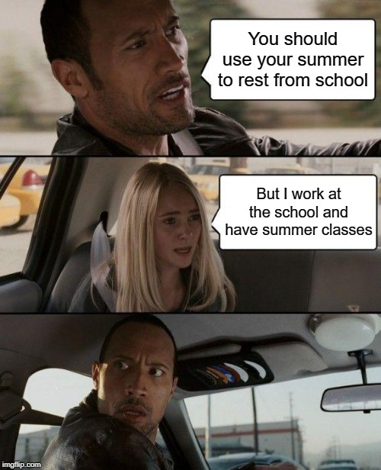

July Update:
- OUSA obligations
  - HR Performance Evaluations
  - FTE total submitted
  - Invoices forwarded
  - Minutes for SC Meeting
  - GOTV discussions
  - SCI discussions
- Agenda Meeting with Advertiser and Nick (still waiting on cheque)
- Agenda Blurb (pending)
- Connection with Indigenous representation re: land acknowledge
  - Shout out to Nick for support
- Job postings
- Hiring credentials and questions
- Performance Evaluation Model Research with Bonnie
  - Prepped proposal with Bonnie
  - Stuff
- Emails to directors
  - Please message me back
  - Seriously, guys
- LGBTQ+ Policy Paper
  - Research pack review
  - Think tank date decided
- By-Laws with Nick

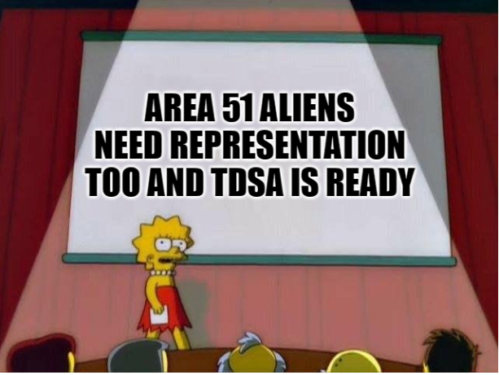

Appendix 4: VPCL’s Updates
June Update:
- Attended Convocation -Sold some stuff
- I was a bartender with Jamila for Grad Dinner
- Visited the Denise House - Donated bouquets and put smiles on faces
- Attended some Orientation Meetings
- Started and finished a services presentation about TDSA and How To Be a Student for June/July Orientation
- Cleaned Through the TDSA Drawers in rm 121 - Organized and did inventory
- Bank Meeting - Got Signing Authority and Credit Cards
- Club Stuff
  - Follow up emails and messages to those that didnt respond to my Active Club Check email
  - More emails for TDSA website update: Club name, Description, Possible events
- Made list of companies we could contact for Ads in agendas, Swagbags, Give-away-day
  - On-going database
- Went through the majority of documents on laptop for reference, ideas and help
- Worked on Advertisement for agenda with Bonnie, Nick and Rayna
- Created a project list (I scared myself with length of list)
- Angel locker discussion with Rayna
- Campaign Advisory Meetings and Projects
- Expansion Project Workshop
- Went through craft drawers, Made some crafts, and stencils
- Bought items and decorated/ designed bulletin board
- Taken some time off to help heal my back.
- Worked on some possible ideas for fun training day
- Worked on thoughts and ideas for September orientation
- TCSA lunch in peterborough
- Transfer Student Orientation on June 24th

WATCHED THE RAPTORS BRING HOME A WIN
July Update:
- Finished first bulletin board, working on second
- Finishing up Company Partnership database
- JULY ORIENTATION – Transfer & New Students
- Read over the By-Laws and had By-Laws team 2 meeting
- Working on Agenda Blubs
- Posted TDSA Jobs, made materials for promotion
- Talking with Chris and Aidan about orientation Week and plans
- Campaign Committee projects and assignments (For new building)
- Working on Residential details
- Sent out emails to companies for swag bag / Move in bags
- Lots of CLUB STUFF!
  - Sent clubs emails for confirmation of club name, description, and events, possible prize to be won if replied by certain date.
    - Congrats to Trent Pride Club for winning the draw!!
- Planning Board Team Building Day
  - Been postponed until September or October
- Marketing plan for social media?
- Took time off
  - Worked from home a little

I made 2 memes since I didn’t include one in my June Update
Appendix 5: Operations Manager’s Updates
June Update:
Month: May and June 2019
Banked Hours Update
President: Under 35
VPUA: Under 35
VPCL: Under 35
OM: Under 35

Weekly Exec Meetings: All completed

Update:
- ROE’s for previous employees and executives
- Went through books, pulled old contracts and sorted through all books
- BMO meeting to set up new signing authorities
- Convocation- creation of bouquets, preparation for the day, set up of booth and selling of flowers and merch during the event, bought too many flowers this year, ended up short about $130, sold a few grad bears and some grad gift packs and 1 sweater
- Grad Dinner- prepared grad gifts, attended and sold at grad dinner, a few more bears sold
- Website updates
- First Aid Training completed
- Usual financial work- reconciling 3 accounts, reconciling 4 credit cards, creating invoice for monthly sales, entering payment for those sales, payroll remittance, update salaries and sales in budget, prepare documents for president to update budget, monetary requisitions
- Agenda- started layup and now have semi finalized copy of weekly pages, cover, timetables, and year in view calendar,
- Summer Café- shopping and setup
- Cleaned office
- Denise House donation of leftover bouquets from convocation
- Went through old books and contracts and purged the shelf, scanned with Second Bind app

July Update:
Month: July 2019
Banked Hours Update
President: Under 35
VPUA: Under 35
VPCL: Under 35
OM: Over 35

Update:
- Closed till and accounted for sales in QB (Quickbooks)
- Monthly financial work
- July Orientation
- Lynda Training for QB
- Worked with Jen concerning OM conflict training, and started work on proposal, hoping to have complete by August meeting for presentation to the board
- Worked on evaluation proposal with executives, hoping to have ready for August meeting to present to the board
- Attended weekly executive meetings and prepared and sent meeting minutes and action items
- Worked on agenda draft some more
- Worked with auditors to get cost of audit down, started putting together paperwork
- Fixed Moneris machine: would not update, had to work with IT and Moneris to update properly
- Completed and sent June BOD meeting minutes
- Sent in work study applications
- Cleared out old bills and cheques in QB
- Created actions items list for July Meeting

Appendix 6: Performance Evaluations: Previous Year Reflections and Strategy Proposal

According to the executive employee contract, executives are entitled to a bonus based
on successful completion of a performance evaluation and the value of the bonus was
determined based on evaluation scoring. Historically, the board was only informed that the evaluations were completed . Last year, the board reviewed the performance evaluations in detail as they progressed and upon the final date of that board’s tenure, they deemed the performance evaluations invalid leaving the status of bonuses unclear.
As bonuses were a part of the employee contract and the reasoning for cancellation was
not disclosed (so personal liability on the fault of the executives could not be cited) it was left as a corporate liability to fulfill the agreement. The newly elected executives (excluding President Nick Ryan due to conflict of interest) awarded the full amount in the interest of protecting the corporation from potential legalities.
The method by which performance evaluations are conducted is currently under review
and a proposal is to be presented to the board to mitigate such issues in future.

Appendix 7: Committee Selection Procedure
So far in TDSA we have no set procedure about how committee’s are built (aside from election committee) So its been pretty much a wild west style thing where a lot of the time the executive filled committee’s that oversaw them… not great. This year the exec won’t be picking anything but we still don’t have a set way of doing things to where it is consistent person to person, so this is attempted to remedy that.

Step one
Hema advertising on social media with your director emails
Problems, how do we select the committee’s efficiently but accountably.

Option one
Chiar picks HR committee reviews
The chair of the committee picks the people who sit on the committee and then submits to executive committee for information, if the executive committee sees a problem or suspected COI they submit said inquiry to the HR committee for investigation. HR committee would be formed by Chiar and approved by the Board of Directors.
This way there is an accountability measure to selecting the committees, the executives merely screen but are by no means picking their oversight. Additionally if there is a problem there is a neutral body to investigate and regulate.
Quick, efficient accountable
If someone needs to be revoked it gets awkward.

Option 2.
The chair takes applications, submits their picks to the HR committee similar to a hiring process.
Accountable, no awkward removals
Very slow and a lot of work for HR com.

Appendix 8: De-ratification of Clubs

Issues as such normally go to the Students Engagement Committee (SEC), formally known as Student Club Committee (SCC), however since the SEC as not been formed yet, it goes to the board for approval.
As stated in Clubs Policy 19.11.3 (1) – The SCC has the right to suspend or de-ratify a club, based on a recommendation from the VPCL
There are two (2) clubs that I would wish to be de-ratify and the following reasons as to why:
- Computer Science Club
  - Executives with to de-ratify
  - No interested executives
  - No current interested members
    - As specified in 19.11.3 (b. ii) – Club membership fails to reach the five (5) active members
  - Failure to hold any meetings or events for the 2018-2019 academic year
    - As specified in 19.4.2 (3) – Holding a MINIMUM of one (1) event or activity per Academic Year(September – April)

- AAA (Association for Animation Appreciation)
  - Executives wish to de-ratify
  - Lack of members
    - As specified in 19.11.3 (b. ii) – Club membership fails to reach the five (5) active members
  - No ongoing executives

TDSA Board of Directors Meeting, August 13th, 2019

Present: Bonnie Caruana, Jamila Alleyne, Mackenzie Prine, Nathan Barnett, Lindsay Gammon, Hema Tikaram, Nick Ryan, Rayna Porter, Scott Boulton (on phone), Aleah Symons
Absent: Sigfrid Belemsaga, Lynch Alcala-Hao (proxy given to Hema), Karina Mahabir (proxy given to Mackenzie)
Procedural Items
- Call to Order 6:09pm
- Chairs Remarks
  - If you have a question or comment please raise card and I will call your name when it is your turn
- July meetings minutes/action items
- Read off Action Items from Minutes
- Minutes not completed so no action items
- Approval of Minutes
  - Not completed at time of meeting so tabled until September Meeting
- Call for New Business
  - Add Proxies as number 13
  - Add Appointment of Vacant Policy Director as number 15 and reading letter of resignation as number 14
- Approval of Agenda
Motion to Approve Agenda
Motioned by Nick
Seconded by Hema
Motion passes unanimously

- Declaration of Conflict of Interest
  - None
Updates
- Executive Updates (Appendix 1-4), no questions asked
  - President
    - Moving forward with a 20% budget as opt out numbers finalized at 17.5%
  - VPUA
  - VPCL
  - Operations Manager
    - TDSA office will be closed week of Aug 19-23 as the floors will be in the process of being waxed, Executive relocated to Multifaith space and Operations Manager will relocate to the Hub front desk during this time
Discussions/Decisions
- Performance Evaluation Proposal (Appendix 5) Decision
  - No discussion
Motion to approve “Be it resolved that the TDSA extinguish the previous performance evaluation model and replace it with the new progress review model which includes a value and goal-based rated system.”
Motioned by Rayna
Seconded by Nathan
Motion passes with 6 in favour, 0 oppose, 2 abstain

Motion to approve “Be it resolved that the TDSA modify employee bonuses from performance review completion to successful transitional training package checklist completion.”
Motioned by Rayna
Seconded by Hema
Motion passes unanimously

- OUSA Campus Visit September 23rd, 2019 (Appendix 6) Discussion
  - Have to schedule a meeting with OUSA, we can ask them questions, and so they can discuss what their goals are, what they mean to the campus, why we are partnered with them and allows them to check in with our students to see what life is like for them. Would like to speak with the board, so is it possible to have a board meeting that day? Would like to motion to have the meeting that day tentatively
  - Was this this only day available? OUSA has to meet with all other member school as well and only had 2 weeks available to do so. This was the date that was available to us. Can ask about changing the date but it would be short notice and may not be possible.
  - Could we have them back again a different day? May not be possible as they would be leaving the office and duties so might be a lot.
Action Item: Jamila to look at schedules and determine if a board meeting would be possible on that day.
  - Will also be setting up a table to talk about what they are and giveaway small items. Usually set up in Library Hall. If there are any issues with that or other questions or concerns email VPUA@mytdsa.ca

- TDSA Committee Member Selection Process (Appendix 7) Decision
  - We don’t currently have a method of filling these committees. In the past executives filled them, but there were issues. With the restructure we would like to formalize a method of filling these committees. Proposed method is that Hema advertises, applications are sent to chair of the committee, committee selections are sent to HR committee.
  - Last meeting we talked about this and tabled to think about it and bring back our ideas to this meeting.
  - Will there be any restrictions or rules on forming the committees? Currently there are only minimums concerning how many students are on the committee. Would like to a put in more of a range including minimum and maximums. No formal rules about who sits on the committees other then must be a member of the corporation.
  - Do we have opportunity to vet the candidates that they receive or is it first come first served? Up to the team, there is no criteria. If you feel that your committee would work best with vetting, it is suggested to bring forward the questions to the board first to ensure there are no liabilist questions.
  - When will the advertising campaign begin? When you are ready. We would like to get it up and running in September so that we have the most interest from students. If you would like specific groups of people represented on your committee might be best to put it in policy as well. When the committees select it will most likely go to HR committee so they can help ensure no students are on too many committees.
  - There are a lot of things to consider, I would propose that we advertise and the chairs fill the committees without a formal procedure as it seems that the procedure is incomplete.
Action Item: All directors to send in ideas via email or visit the office to speak with Nick to put ideas together.
  - Should we table this until approximately November so that Directors can try different things, put together their committees then reflect on what worked well and what did not and then form a proposal?
  - We can give the option of having the student give choices in their application (1st choice, second choice etc)
  - Should we put in temporary maximums to ensure smooth operation of the and possibly other regulations. Would there be different maximums for each committee. Yes.
  - Advertise in vendors alley
  - Hard to ask for 1st, 2nd choice, if students are emailing each director, could get awkward. Could they email the choices/hierarchy to chair of BOD?
Nathan Exits at 6:39pm, giving his proxy to Rayna
  - There should be guidelines, to ensure committees are not just a group of friends. Advertising is new. Proposal is not complete as is though. In favour of tabling procedure, trying things out then reconvening in November or December.
  - Do we need a working group to have these conversations? To start working on it sooner rather then later.
  - Do we start advertising? Who do the students email/contact? 1 Key person or chair of the committee?
  - Might be best for students to email individual chairs. We can deal with issues as they arise.
Mackenzie exits at 6:44pm
Mackenzie Returns at 6:45pm

Motion to vote on 2 options a) students email chair of committee, b) students email a core person which be decided in a secondary conversation.
Motioned by Rayna
Seconded by Scott
Motion a) passes unanimously

  - Maybe we don’t put max on how many committees student sit on and allow them to be the judge of their own character and workloads and allow them to adjust as they need to. Avoids overcomplication until a more formalized procedure is in place or being worked on.
Motion to form a working group
Motioned by Rayna
Seconded by Mackenzie
Motion passes unanimously

Action item: Nick to send out Doodle poll in regard to formation of working group to all Directors
- External Committee Options (Appendix 8) Discussion
  - Not everyone here so cannot decide now
Action Item: Jamila to send out list again to all directors. Directors are then to send email to executive currently sitting on the committee if they are interested in sitting on that committee by Sept 23rd.
- Proxies Discussion
  - Counter intuitive to purpose of meeting. Assumes people make up minds before coming to meeting, regardless of what is discussed that may or may not change their mind, or the proxy holder votes based on what they want not necessarily what the proxy giver wants to vote for. The point of the meetings is to be able to bounce ideas off of people and help form ideas in situ, which you can’t do if you are only present via proxy. Think they should be eliminated but recommend discussion now and make a decision at a later date.
  - Might not be necessary to completely strike them. Proxies allow for us to meet decisions, and allows directors to demonstrate that they have read the material ahead of time and educated themselves and formed a conclusion. If they are not comfortable making the decision ahead of time they should not give proxy.
  - We often have been using proxies to make quorum, which is actually against the Corporations Act. So quorum will be 50% according to the act, according to our bylaws it 50%+1, which would be 7 usually and 6 now that we have a vacant position. Let’s do some research and present some best practices to see where we should go.
Action Item: Scott and Nick to put together some research and best practices on the topic of proxies.
Action Item: Scott to message directors to see if any others are interested in assisting with the research into proxies.
- Reading of Letter of Resignation Letter of Director of Policy Discussion
  - Will not read out the contents of the letter in open session, but it is indicated in the letter that the information be brought forward to the board. The director cited personal reasons why they are resigning and leaving Trent. Effective August 12, 2019, at 4:11pm we no longer have a Policy Director. The Director is thanked for their service, not only this year, but for all work they have done with TDSA. We hope that departing from the TDSA does not mean they are departing as a person from our lives.
- Appointment of Vacant Director Position Decision
  - In vacant director positions, the board can decide to appoint. In our bylaws it says the Executive Committee can appoint a new director via job interviews. Executive committee would then present their pick to the board for approval. The hiring committee would consist of the President, VPUA, VPCL and Chair to the Board of Directors. In elections policy there is the option to run a by-election but this may be a lot of work for 1 position. Motioning for the board to ask the executive committee to hold applications for the vacant policy director position, and for that appointment to be approved by the board.
  - Understood appointment differently, is it not the person comes in and the board asks questions and then the board narrows it down and chooses between 2. Was this how you understood our bylaw? Yes.
  - Is it currently executives or directors on the hiring committee? From Bylaw 5: “The Executive Directors and/or the Board of Directors shall be granted the authority to select members of the Corporation to be appointed to vacant non-executive director positions”. Organizational history is that executive committee has narrowed it down and presented their suggestion for replacement.
  - What is the difference between when the VPUA position was vacant, and we ran a byelection? Historically we have always assigned them because of the first year director. Last year was the first year that we ran a by-election, it was decided in close session why that decision as made. Do we really want to put the cost in for a by-election? What cost? Promotional materials, advertising, qualitrics, opportunity for University to run a referendum, ask students to fill out surveys at that time. Because it is only a singular position it might look divisive if two people run and the election focuses solely on those two people. Also looking to put together a campaign for federal election. Appointment is worthwhile because we were elected by the student body to make those types of decisions, so within out scope.
Motion to a) go to by-election, or b) appointment
Motioned by Rayna
Seconded by Hema
By-election: 0, Appointment:6, abstentions:3
Motion for Appointment passes
  - How are we doing to appointment? Organizational history is that it is a hiring committee of the 3 executives and chair. In the past only 3 are interviewed and then best one presented to board. If the board declines or asks for more information that will be provided.
  - Have done an appointment both with TDSA as a candidate and Durham as a member of the board. The TDSA one was not the most fair in how it was run, because the executives did it. How was it unfair? From the candidate point of view. How did Durham do it? The candidates came to the board and the board asked them questions, no set questions. Not as fair either. Why is our historical way not fair? All the people who were supposed to be in the room were not in the room, interview started early. Was the process the issue? Because not all the people were in the room who were making the decision. Executives should probably not be choosing a board member.
  - Can we use the same hiring procedure that we used for the student staff hiring process? Will have a set of questions and board can approve, can send though email just to get things moving. 3 individuals in a room, 1 VP, President, and HR director to ensure smooth ethical operation. It would be the same questions, and same individuals if possible, and even if not same individuals then it would be the same questions.
  - If we keep the number of people needed down it will be easier to ensure all the same people see every candidate. Lots of people can be very intimidating to the candidate. Can make it a combination of 3-4 people with some board members and some execs, and make it a stipulation that for the interview to happen, all members of the committee must be present.
  - Forming a committee takes time and effort and ads time. If we stick with the status quo of the execs hiring, the position can be filled in a timely manner.
Motion to executive committee comprising a minimum 2 executives and the chair of the board of directors, with follow-up by the board after selection of the candidate to approve in closed session, if the board does not deem the match successful the committee will go back and pick again and present again to the board.
Motioned by Rayna
Seconded by Scott
Motion passes with 1 abstention and no opposition

Upcoming Dates
Orientation and Get Involved Week in September
October 31st Halloween manhunt
Holiday Break
VPCL does not have to be at every event
Can plan schedule around board meetings to ensure attention
Bylaws amendments at next board meeting
AGM in October
October 24 and 25- Mental Health First Aid
November- PFLAG training
ASIST and Non-violent crisis intervention potentially over reading week, will confirm dates and send out
Motion to adjourn
Motioned by Mackenzie
Seconded by Hema
Motion Passes unanimously

Meeting adjourns at 7:22pm
Appendix 1: President’s Update

Screamed about opt out rates
Adjusted current budget model
Started policy review by reading waterloo and westerns policy
Ordered new items for the store and orientation
Conducted interviews
Attended town and gown meetings
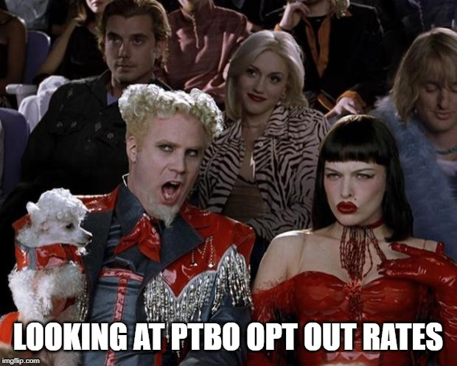

Appendix 2: VPUA’s Update

- Job Postings
  - Resume and Application reviews
  - Briefed Director of HR
  - Interviews
  - Reference checks
  - Candidates selected and accepted
  - Employment contracts
- TUNA Representative Meeting
- OSAP Campaign with OUSA
  - Working group formed
  - Civil action ideas researched
- LGBTQ+ Think Tank
- Students with Disabilities Paper Consultations
- ORD Meeting
- Advocacy Initiatives Plan for 2019/20
- TDSA Anniversary Plans
- IG Campaign with Hema
- Region of Durham Project
- Transit Letter
- DCSI Meeting

Appendix 3: VPCL’s Update

- Honestly, all I’ve been doing is orientation stuff…
  - E-mail external companies who wish to donate to our swag bags
    - Keeping track of who replies, follow up to replies and non-replies
    - As a thank for donating, they can set up a booth to advertise.
      - ^organizing and figuring out what this looks like, keeping track, layout
  - Movie night: Landmark theatre on Friday
    - Booking, pricing, bus stuff, (possible full membership option?)
  - Residential Give-Away Bags
    - Planning what to buy, order and include
  - Give-away Day:
    - Ordering and deciding what items to give away
    - ^LOTS OF RESERCH BEING DONE TO FIND BEST DEAL

- Student Jobs Positions
  - Advertising, Interviews, Decisions, References Calls, Final Call Made!!!

- Been receiving/ picking up items for Swag Bags

- Instagram Campaign during Opt-Out Period

- Agenda stuff!!

Appendix 4: Operations Manager Update

Month: July 2019
Banked Hours Update
President: Under 35
VPUA: Under 35
VPCL: Under 35
OM: Over 35

Update:
- Vacation for 1 week
- Worked on Student Agendas- visits to Staples, work on file, phone and email correspondence with Staples reps
- Financial work

Appendix 5: Performance Evaluation Remodel Proposal

OVERVIEW
The executive team of 2018/19 was tasked with re-evaluating the performance appraisal methodology and bonus method. The following is a finalized proposal which will also be seen at the Human Resources committee for input.

GOALS
1. To develop a more meaningful performance metrics tool that both aids in an employee’s ability to grow and in growing the organization.
2. Evaluate the use of bonuses and the effectiveness of utilizing them to influence
performance.

FINDINGS
The Operations Manager completed extensive research and presented a number of options to the Board in April 2019. These research and options were reviewed by the new executive team in July.
In previous years, performance evaluations were completed by all executives for each other. On occasion, conflict would arise between executives based on the reviews so the model changed to only the Operations Manager and the evaluated executive. For employees, the model remains only the Oversight Executive and the evaluated employee would complete the reviews. This lessened the opportunity for animosity between reviewer and reviewee, however reviewees still felt adversarial during the evaluation and that the method did not feel helpful for either the reviewee or the corporation. There were also some concerns for the mental health and wellness of the participants involved. For the last review of the year, the reviewee and the reviewer created the comments and ratings together. This felt much more cooperational and was an overall less negative experience for all involved. To limit the adversarial tone that previous reviews had set and to have the performance review be meaningful and impactful for the employee it should be a “two-way conversation, with both sides contributing” (Thompson 2018 ). It was also noted in the research that “In order to be
meaningful, progress reviews should occur as one part of an ongoing dialogue between
managers and employees. Formal reviews are an opportunity to celebrate earned success, reflect on experience, recalibrate goals and start fresh, but they should never be a substitute for everyday feedback and coaching .” (Wigert 2017)

RECOMMENDATIONS
New Performance Method
Considering the research and in the interest of honouring the mental health and wellness of all participants involved in the process, we propose that a goal setting and a rated value review system be implemented. It was also noted that terminology like “Performance Evaluations” can set an adversarial tone for an already stressful interaction. Instead it is recommended that the term “Progress Reviews” (Wigert 2017) be used to more effectively communicate the intent which is a non-judgemental update on success and shortcomings. For the remainder of this document the proposed method will be referred to as Progress Reviews. The advantages of a rated value and goal based review are that because the employee creates a part of how they are being evaluated they have a vested interest and intrinsic motivation to succeed. The article 10 Tips for Effective Employee Performance Reviews recommends that “ You want an employee who is motivated and excited about his ability to continue to grow, develop, and contribute. Aim for performance review meetings in which the employee talks more than half of the time. ” (Heathfield 2019) By also having a set of standard values to rate against, we can ensure the basic principles of the corporation are upheld as well as being able to hold all employees accountable to the same areas of responsibility. By combining the two methods of review we can achieve a balance between employee motivation and maintaining the corporation’s principles. Some disadvantages of this method could be that without limitations, the review could become quite lengthy. As well, without clear instructions and rating systems, there could be confusion on
how to complete the review or what areas to focus on for improvement. “ During preparation and goal setting, you need to make how you will evaluate the employee’s performance clear. Describe exactly what you’re looking for from the employee and exactly how you will assess the performance.” (Heathfield 2019) By setting maximums and minimums on the amount of goals to work on at once, as well as setting clear values, and rating systems for both we can work to mitigate these issues.
We propose 6 values based on our Letters of Patent and mission principles statements from www.mytdsa.ca. Those values are:
- Provides a high level of assistance to students through advocacy and services which gives students a greater sense of empowerment and encourages involvement in University affairs, which shall assist in the development of University pride.
- Provides support to students so that they can pursue academic excellence through events and workshops that promote academic skills and mental health and wellness.
- Holds Trent University Durham-GTA accountable for providing high quality and diverse education opportunities and upholding the rights in our missions and principles by supporting students in their self advocacy, participating in University committees and being available to students and advocating on their behalf if necessary.
- Provides an atmosphere in which students can pursue personal and social growth free from discrimination, harassment, and persecution including providing diverse events, workshops, and various other opportunities that enrich students extracurricular lives.
- Encourages and supports student clubs, organizations, TDSA committees, and societies thereby increasing the vitality of student life and the diversity of activities available to students of Trent University Durham-GTA.
- Accountable, dedicated, and holds self to a high level of integrity, so that all students feel comfortable approaching executives or TDSA staff to be their advocate in any matter relating to their education, campus community, or government when pertaining to student affairs.

These values will be rated using the scale:
- Exceeds Expectations- Employee not only embodies all aspects of the value being rated but goes above and beyond the call of duty,
- Meets Expectations- Employee embodies all aspects of the value being rated,
- Improvement Needed- Employee embodies some of the value being rated but could improve in certain areas (be sure to include the areas of improvement needed to reach meets expectations),
- Not Applicable- Value does not apply to the position.

Employees will create two goals based on the values and an additional one of which is highly encouraged to be based in professional or personal development in the review and created using the SMART goal setting system. They will then work towards completing these goals throughout their term. If a goal is completed they can create a new goal to work towards for the remainder of their time. Progression towards completion of goals will be tracked at each review with either Not Started, In Progress, or Completed.

We propose to keep the current timeframes for review, 3 months, 6 months and 12 months, with the goals being set at the 3 month review and updated at the 6 and 12 month reviews. The same document will be used for each review to allow progression and improvement to be tracked.

It is recommended that the bonus be uncoupled with the progress reviews (see Bonus
Modification). Due to the progress reviews no longer influencing a monetary decision, the content would only require board review in the event that an employee is not completing their duties as assigned or additional concerns. This would require a vote of ⅔ majority of the Board of Directors to view in closed session in respect for an employee or executives right to privacy. All concerns about performance may still be brought forward to the board or Human Resources Committee (formerly disciplinary committee) as needed.

Decision:
Be it resolved that the TDSA extinguish the previous performance evaluation model and replace it with the new progress review model which includes a value and goal-based rated system.

Bonus Modification
Previously a bonus was given upon successful completion of performance evaluations, with a sliding scale based on the average rating across all reviews. This model has resulted in misuse, an atmosphere of distrust, and can create animosity between evaluator and evaluatee. The unclear direction as to oversight responsibilities has also left organizational stakeholders (such as the board) in uncomfortable positions of trying to determine equitability based on interpretation instead of well-researched fact.
In an effort to honour the original intent of the bonus method (encourage continued productivity through an executive or staff’s tenure) and with hopes to improve the transition process for incoming staff and executives, we recommend modifying the bonus to be measured based on completion of a fulsome transitional training package and experience. There will be set documents to be included, if all required documents are included the employee would receive their bonus. The amount of bonus may also be subject to change. We are asking the board to postpone discussion on the bonus amount to when there is a full comprehensive look at the impact this may have on an employee’s overall earnings (note that bonuses are considered taxable supplemental incomes) The criteria by which transition materials would be assessed will be provided at the next board meeting.

Decision:
Be it resolved that the TDSA modify employee bonuses from performance review completion to successful transitional training package checklist completion.

Applicable Policy Updates
The Vice President of University Affairs and President of TDSA are currently undergoing a high level review of the TDSA bylaws and policies. The Policy for Performance Reviews will be updated in line with the high level policy updates and will be brought for approval at a later date.

REFERENCES
Thompson , Christina . “17 Performance Review Templates to Motivate Employees”. Quantum
WorkForce. https://www.quantumworkplace.com/future-of-work/17-performance-review-templates
-to-motivate-employees . 2018. Web.
Heathfield, Susan M. “10 Key Tips for Effective Employee Performance Reviews” . The Balance
Careers. https://www.thebalancecareers.com/effective-performance-review-tips-1918842 / 2019.
Web.
M ann , Aannamarie. Wigert, Ben. “Give Performance Reviews That Actually Inspire Employees”
Gallup.
https://www.gallup.com/workplace/236135/give-performance-reviews-actually-inspire-employees.
aspx . 2017. Web
Appendix 6: OUSA Campus Visit - Board Particulars

Scheduled for Monday September 23rd, 2019

Need to schedule a board meeting for that day if possible to ensure OUSA can present
- Is this feasible? Need to know immediately if not possible so we can potentially reschedule OUSA visit

Need to book a space in a high traffic area for OUSA to have a booth to engage student body
- Ideas or suggestions? Held in bottom of great hall last year and appeared to function well.

The Research & Policy Analysts connect with the Advocacy Commissioner, but invitation for other directors with policy interest to connect (E-mail VPUA!)

Appendix 7: TDSA Committee Member Selection Process

At this time, the TDSA does not have a set procedure instructing how committees are to be formed (aside from election committee). Traditionally, the executives have filled the committees. Thanks to our recent restructure, we can now evaluate the process by which committee members are selected with more input from the board.

Option One: Chair of the Committee Selects and Executive Committee Reviews
VPCL advertises the opportunity on TDSA social media with applicable director email. The director selects from applicants and submits to the Executive Committee for oversight. If the Executive team has concerns, forwarded to HR Committee for review and the board if necessary.

Concerns: Equitable representation of diverse student population difficult to assess as one person.

Option Two: HR Committee Selects and Chair of the Committee Reviews
VPCL advertises the opportunity on TDSA social media with the HR Director email.

HR Committee forms to review all applicants and sends final list to the Chair of the applicable committee. In the event of concerns, Chair of the applicable committee brings forward to the board.

Concerns: Huge workload for HR Committee and HR Director; no oversight before going to the board.

Option Three: Fight Club.
We can’t talk about this option.

Appendix 8: External/ Trent University Committee Options

Senate | Current member | Location | Amount | Link to description
Academic Planning & Budget (AP&B) | Rayna Porter | PTBO | as needs be | https://www.trentu.ca/vpacademic/committees-policies/academic-planning-budget-committee
Committee on Undergraduate Petitions (CUP) | Rayna Porter | PTBO | as needs be | https://www.trentu.ca/registrar/records-registration/academic-petitions
Cyclical Program Review (CPRC) | Rayna Porter | PTBO | as needs be | https://www.trentu.ca/vpacademic/committees-policies/cyclical-program-review-committee
Library Advisory | Jade Gauthier | PTBO | as needs be
Teaching & Learning Advisory | Hema Tikaram | PTBO | as needs be
Teaching Awards | Hema Tikaram | PTBO | as needs be
Undergraduate Academic Policy (UAPC) | Rayna Porter | PTBO | as needs be
Undergraduate Studies (USC) | Rayna Porter | PTBO | as needs be
Advisory
Environmental Advisory Board (EAB) | Nicholas Ryan | PTBO | as needs be
Nature Areas Stewardship | Nicholas Ryan | PTBO | as needs be | https://www.trentu.ca/natureareas/welcome/nature-areas-stewardship-advisory-committee
Honorific & Wayfinding Campus Names | Nicholas Ryan | PTBO | as needs be
Facilities & Grounds | Nicholas Ryan | PTBO | as needs be
Durham
Caasc | Nick Ryan Rayna Porter BoD and one student at large | Durham | as needs be | https://www.trentu.ca/currentstudents/cassc-committee-and-subcommittee-documents-and-minutes

TDSA Board of Directors Meeting September 23rd, 2019

Present: Nick Ryan, Hema Tikaram, Aleah Symons, Nathan Barnett, Jamila Alleyne, Rayna Porter, Mackenzie Prine, Bonnie Caruana, and Scott Boulton

Absent: Lindsay Gammon and Karina Mahabir

Proxies: Sigfrid Belemsaga (proxy given to Nick Ryan) and Lynch Alcala-Hao (proxy given to Aleah Symons)
Procedural Items:
- Call to Order at 10:17am
- Chairs Remarks
  - Make sure you are raising your card if you have questions, meeting will be long with bylaws and can have a second meeting to get through what we don’t get through today, no interruptions please
- July and August meetings minutes/action items (Appendix 1)
- Read off Action Items from Minutes
- Approval of Minutes
Friendly Motion to approve July and August minutes
No oppose
Motion passes
- Call for New Business
  - Rayna will have to excuse herself partway through meeting
- Approval of Agenda
Motion to Approve the Agenda
Motioned by Nick
Seconded by Hema
Motion passes, no oppose
- Declaration of Conflict of Interest
  - Nathan for clubs approval as he is heavily involved in Sense of Belonging which is up for approval
Updates
- Executive Updates (Appendices 2-5)
  - President
    - Fall retreat, ASIST training confirmed for the 19th and 20th, ORD met
  - VPUA
  - VPCL
  - Operations Manager
Discussions/Decisions:
- Clubs Ratification (Appendix 6)
  - 3 clubs to be approved, Sense of Belonging, Business Club, Trent Strength and Wellness (taking over Trent Gainz)
Motion to approve all 3 clubs
Rayna Motions to approve
Hema Seconds
Motion Passes, 1 Abstain, no oppose

- Bylaws (Appendix 7)
  - Over the last 4-6 months, there are some issues with readability, contradiction, and questionable. We’re looking to make them more readable etc. Any approval of these will be pending legal approval, if there are any changes from the lawyer they will be brought back to the Board for re-approval.
  - Reorganized preamble from two other bylaws, preamble does not need to be a bylaw as its more about who we are.
  - Bylaw 1: mission and principles, not changed, much bigger discussion if you want to change this
  - Bylaw 2: defined a member more clearly, changed AGM to GM, member plus will be discussed later this year, should differentiate between who pays the TDSA and who doesn’t. There are legal and financial repercussions to this so not working on that yet. Changed ex-officio to non-voting member.
  - Bylaw 3: affixing our logo, changed to say president has the final say, unless they designate it to another VP. Head office changed to somewhere on the Trent University GTA campus. Officer are people who get paid by the corporation. Changed the creation of the officer position to say that the board can create a new position but they must have a job description. Instruments are legally binding documents, re-worded. Do you want chair as singing authority with the bank? President and Operations Manager are Primary, Vice President of University Affairs and Vice President of Campus Life are secondary already.
Friendly motion to remove chair as secondary signing authority
  - Bylaw 4: membership and fees- language of termination added, for example if someone graduates, we cannot raise our fees more then 5% without referendum, university will collect our fees
Rayna exits at 10:36am
  - Changed how surplus of specific fees can be spent, was that it can only be spent on the intended service, not if there are overages they can be spent on similar programs as long as every effort has been made to spend the overage on its intended purpose. Non-compulsory fees are currently only the TDSA membership fee, will look at breaking this down more as the year progresses. Termination and transfer- added in a clause that in case of death or extreme circumstances, a fee can be reimbursed partially or in whole. Executive can be exempt from fee.
Nick steps out to facilitate discussion at 10:47am
  - Wording as is seems reasonable. If they are in the school and using the services should they pay? For example, to assist with their mental health it was recommended previously that executives attend stress busting events. Those events are small, and executives are not always able to attend events. Similar to all students. If an executive attends an event are they not promoting the event or potentially working the event. But what if they are just attending the event for them or for their mental health. Is that not then part of their job description then? Similar to a job training requirement which would not normally be charged to an employee. If most fees are done per credit, how do we charge them? Would we have to figure out a set fee? Should this decision be made at their discretion? If they are not a student, how do you charge? Does a set fee them apply to other students as well? Should we add in who would make the decision and define who is included in the exemption? But if they are not a student they don’t have a choice to pay? Should it be a personal choice? They will most likely not pay then if given the choice? How often will this be used? How much money are we looking at? $150 for single executive, $525 for all three, is all this discussion and future discussion worth it? Should the decision for an exemption be made by the board at the first meeting? Fine as is. Should be an individual choice, as they are not required to pay the fee, and are most likely working at these events, how does the board have the option to make this type of decision. First meeting might be dicey as you will potentially have a brand new board. The fee is not enough to worry about, also executives have very little time to actually participate, their job is to advocate for students. Should we reword to replace “may” with “will”? Then there is no decision by the board. Not sure if time is a factor. Should it be exemption or exception? When you are working and you are in a uniform, you represent the organization, is it not the same for executives? If you are on campus, are you not representing the TDSA as an executive? How would the board decide one person pays the fee and another doesn’t? Going down a bit of a rabbit hole, we should decide either they pay the fee or they don’t.
Hema Calls the question, 2 oppose
  - What about health benefits? It is a separate fee, this fee is just the peer support fee and membership fee
Hema calls the question, 1 abstain
Motion to an A. executive who is not a student pays a fee or B. an executive who is not a student does not pay a fee
A:0 votes
B:5 votes
1 abstention
Motion passes for option B.

Nick re-enters at 11:09am

  - Bylaw 5: changed some wording and titles. Removed a lot of legal terms and conjunctions. Removed the power to make new bylaws and change bylaws and an enact on them until AGM, added in in the amendments section to include only can change and act on changes if it is to follow the law. Should the chairperson have a vote on the executive committee? Jamila declares COI and hands chair off to Nick
Jamila Exits at 11:17am

  - Now there would be 4 people voting, what do you do if there’s a tie? They are not an executive, if we give them a vote does it not make the situation worse, where the chair would feel more like a executive? They should be non-biased. Previous chairs have expressed that they have felt like an executive with the same expectations but with none of the powers. To make them feel like more of an executive should they have a vote. If the chair has a vote on the executive committee decisions do they not now become biased on that issue when it is brought to the board, as they are bound to support that decision regardless of how they voted, and they had a hand in making that decision. Chairs in parliamentary settings are non-voting, whether they have a vote on executive committees some do some don’t some don’t even have the chair on the committee. Are they chairing the committee? No. Is the chair an executive and director? No, they are an officer and a director. Officer are people who get paid and have specific responsibilities, an executive officer which are roles like CFO, COO, CCO etc. and are elected, and there are directors who sit in this room and help make decisions. So, the chair is an officer and a director but not an executive. The OM sits on the committee but does not vote, they are a part of the team, but are not an executive so does not have a vote. Does the chair have a vote on what the executive committee decides on, that is day to day operations, should the chair have a vote on that stuff? In the other student associations, 2 have as chair as voting member of executive committee, 3 do not have the chair on the executive committee, and 2 others have the chair on the executive committee, but they have no voting rights. Executives only head up committees when there is no director to chair them. They do not work in the office day to day and do not know about all the bits and pieces. The chair is only paid a salary that pays for 15 hours a month, so if we keep asking for more do we need to pay them for more hours, will we overwhelm them? What does the executive committee cover? Mostly we cover what happened last week and what we are expecting for this week, formalizing any support systems for the week, mostly information pieces. What do we want at the board meetings, who will present it? What do they vote on then? Small things like re-issuing a stale dated cheque, anything to do with a little bit of money, we are invited to a rally, do we rally students to go. We invite the chair to let them know what we have been doing, keep us accountable, show them what we have been doing with our time, chair is more then welcome to give input on any issue that is brought up. What is the worst thing that could come out of the chair voting? They can have a vote but then are a biased party and have to support those decisions with the board of directors, or they cannot vote or they are not a member at all. We have to remember that a decision made by a committee or board must be supported by all members, in that, regardless of the vote, whatever the majority decides is what all members must then support. If the chair is outvoted, they would have to back that decision up. They would then be compromised or biased. Which side is the chairperson on? Should they be an arbitrator and impartial?
Nathan motions for a vote
All in favour of the chair having a vote at the executive committee level
0 in favour
5 oppose
1 abstain
Motion is defeated

Motion to reconsider
Motioned by Nathan
Seconded by Mackenzie
4 in favour, 2 opposed, 1 abstaintion
Motion passes

Motion that the chair should have a vote on the executive committee
0 in favour
5 opposed
2 abstentions
Motion is defeated

Jamila reenters at 11:36
  - Some items moved around. Policy on how the appointment procedure for a director. 4 options are executive committee appoints, the board appoints, executive committee presents person for board approval, or independent hiring committee comprising of entirely of students at large with a chair to organize the meeting. Could we have an executive on the students at large committee, potentially the president? The president would chair an ad hoc committee already. If the president has already been elected by the student body to have their best interest at hand, why not have executive committee present as the option as all executives were elected to do the same. Also if just students at large they don’t know what happens at the board so may be difficult. Exec present is best compromise with practicality and transparency. Students at large should have the final say, should we not also get more opinions, puts the power in the student body’s hands. Can we scratch the exec appoint option? Is that not what the directors are voted in to do?
Hema calls the question
motion is unanimous
Motion to approve A. executive committee presents director position candidate to board for approval or B. ad hoc hiring committee made of students at large selects vacant director applicant
A: 7
B: 0
No abstentions
Motion A passes

- Board meetings – Tabled until next meeting
Motion to adjourn the meeting
Motioned by Hema
Seconded by Scott
Motion passes unanimously

Meeting adjourns at 11:48am

Upcoming Dates:
October Board Meeting

Appendix 1: Action Items
- February Meeting
- Action Item: TDSA to create a bylaw regarding what guidelines external organizations must adhere to in order for them to run a referendum along side a TDSA referendum or election/byelection. Include stipulations for advertising, consultations, and labelling that separates the question(s) as being asked by the external organization.
- In Progress- Written, needs to go to team 2 for review

- Action Item: TDSA Board of Directors (BOD) to approve any referendum question(s) from external organizations that is run in conjunction with TDSA elections or referendums noting that the BOD is under no obligation to accept the question and that acceptance of the question does not signify support of the question. Add into bylaws/policy
- In Progress- Written, needs to go to team 2 for review

- Action Item: TDSA or Elections Committee will remove any question presented without proper implementation (see above). Add to bylaw/policy
- In Progress- Written, needs to go to team 2 for review

- Action Item: change name of committee in committee policy from Student Clubs Committee to Student Engagement Committee
- Completed, will post when final document from bylaw and policy overhaul has been completed

- March Emergency Meeting
- Action Item: OM to review policies and ensure wording reflects professional working environments and not personal relationships throughout bylaws and policies
- In progress

- Action Item: OM to go through Job Descriptions Policy and ensure that requesting light workloads and leaves of absences are added in to allow executives options if they are feeling overwhelmed
- Not completed, will update in phase 2 of bylaw and policy overhaul

- Action Item: OM to ensure any policies regarding training and meetings to include follow-up emails, as well ensure that all policies concerning committee meetings include the addition of follow-up emails.
- Not completed, will update in phase 2 of bylaw and policy overhaul, will do a meetings procedure as there is no meetings policy

- April Meeting
- Action Item: Work with Jen in regard to appropriate training and types of situations we should look at
- Completed

- Action Item: OM to put together list of training to bring to board
- In progress, now LinkedIn Learning

- Action Item: OM Undergo mediation training on Lynda.com
- Not Completed, now LinkedIn Learning

- Action Item: Outline Lynda training in job description
- Not Completed, will update in phase 2 of bylaw and policy overhaul, now LinkedIn Learning
- Action Item: Create policy concerning when/how to go outside of OM mediation
- Not Completed, will update in phase 2 of bylaw and policy overhaul

- Action Item: Outline timeframe and yearly refresher timeframes in Job Descriptions
- Not Completed, will update in phase 2 of bylaw and policy overhaul

- Action Item: Policy to handle conflict that arises before OM is trained
- Not Completed, will update in phase 2 of bylaw and policy overhaul

- Action Item: Procedure to be created in regard to professional communication and meetings
- Not Completed, will update in phase 2 of bylaw and policy overhaul

- Action Item: include workload in candidate information sessions
- Not Completed, part of elections in Winter Term

- Action Item: Change bylaw to weekly executive meetings, chair or OM to report on execution of meetings
- Completed, will post when final document from bylaw and policy overhaul has been completed, note that this is in policy, not bylaw

- Action Item: Do some research on this type (professionalism and communication) of training and who can perform it.
- Not Completed

- July Meeting
- Action Item: Bonnie to email action items to Jamila, who will send out to Directors
- completed

- August Meeting
- Action Item: Jamila to look at schedules and determine if a board meeting would be possible on that day.
- Completed

- Action Item: All directors to send in ideas via email or visit the office to speak with Nick to put ideas together. (in regard how to choose committee members)
- Not completed

- Action item: Nick to send out Doodle poll in regard to formation of working group to all Directors
- Not completed, waiting until November after we have tried it out a bit

- Action Item: Jamila to send out list again to all directors. Directors are then to send email to executive currently sitting on the committee if they are interested in sitting on that committee by Sept 23rd.
- Completed

- Action Item: Scott and Nick to put together some research and best practices on the topic of proxies.
- In progress

- Action Item: Scott to message directors to see if any others are interested in assisting with the research into proxies.
- Not completed- will do in the upcoming weeks

Appendix 2: President Update
ORINTATION holy
Walksafe mou is a thing will update in meeting
Bylaws again this meeting
So much peer support stuff
Indigenous student concerns and meetings
Trying to fix osap and wifi
Working out a compensation plan for bus passes

Appendix 3: Vice President of University Affairs Update
- Transit Meeting with OTSU & DCSI
  - Transit letter submission
- OSAP Campaign with OUSA continued...
  - Video shoot
  - Letter-writing
- LGBTQ+ Paper continued…
- OUSA obligations
  - Performance appraisals x2
- Policy Analyst and Advocacy Commissioner start work
  - Projects established and meetings
- Orientation week
- Get Involved Week

Appendix 4: Vice President of Campus Life Update
- New Hire Orientation
- Bulletin Board!
  - Made posters
  - Created a template for the weekly calendar
  - Made the first 2 weeks of September
  - “What does TDSA do for you”
  - “Meet the board”
  - Big thank you to Jewel for designing the display case!
- Wrote a blog for Katie about TDSA and getting involved
- Worked in the multi faith room for a week while we got our floors waxed
- Club Training
  - Reviewed club policy
  - Made training PowerPoint
  - Crafted a contract
  - Had training everyday from Sept 9 – 13th
- Received multiple club application packages
- Peer Support Program – Help students when they come into office
- ORIENTATION
  - Swag Bags
    - Continue to email and receive items
    - Put together 300 bags (THANK YOU BONNIE AND NICK)
  - Vendors ally
    - Set up booth, give-away day, quite successful
  - Movie
    - Not as many students had signed up
    - But still had a ton of fun, movie was awesome
- Get-Involved week
  - Created Qualtrics survey
  - Printed sheets for all clubs
  - Did club training
  - Helped Rayna with her OSAP campaign
- Check-ins with Jewel about plans for the year

Appendix 5: Operations Manager Update
Month: September 2019
Banked Hours Update
President: Over 35
VPUA: Over 35
VPCL: Under 35
OM: Under 35

Update:
- Weekly exec meetings held either in person or in digital form with minutes and action items sent out to all parties
- Made July and August Meeting minutes and sent to chair
- So much Academic and Peer Support work- helping student register for courses, showing them myTrent
- Running the store- selling merchandise, books, and tickets, stocking shelves
- Consigning books
- Made book cheques for first 2 weeks of sold books (over 40 cheques for over 70 books sold)
- Completed all progress reviews with Execs and OM
- Orientation- stuffed swag bags, Residence Move in bags made, attended residence move in, helped with setup and takedown of orientation events etc.
- Moved the office around with Nick and Chris
- Posted and started selling lockers- 2/3 sold
- Cleaned the couch and chairs with fabric cleaner
- Updated website with Staff pics and bios, committee info and policy director info
- Held digital meeting for committee focuses
- Updated till with new items
- Helped with indigenous tag, including re-lay up for print, making and attaching the tags, shirts now up for sale $20.50 +HST per shirt
- Started making items on website more accessible
- Monthly financial work
- Worked on conflict training proposal- got final approval/ list from Jen, entered into proposal, worked on policy suggested changes in accordance with action items from April board meeting, should have ready to present for October meeting
Appendix 6: Clubs Approval
What was known as Students Club Committee (SCC) last year, now known as the Student Engagement Committee (SEC), approves any new clubs, de-ratifies existing clubs, approves club expenditure over $500 and enforces all other powers and responsibilities given to it as laid out in clubs policy.
However, since the SEC has not been formed as of yet, I am bringing these club applications to the board to get approved.
The clubs to be approved are:
- Sense of Belonging Stories
- Trent Business Society
- Trent Strength and Wellness* (Formally known as Trent Gains, an orphan club)

Clubs are generally approved if they follow criteria such as:
- Successful completion of package
- Idea seems feasible
- Event ideas and descriptions seem realistic for our campus
- Look at the executives
  - Do you know if they are responsible?
  - Are they executives on other clubs?
- Is the club similar or the same as another existing club?

Thank You,
Hema Tikaram

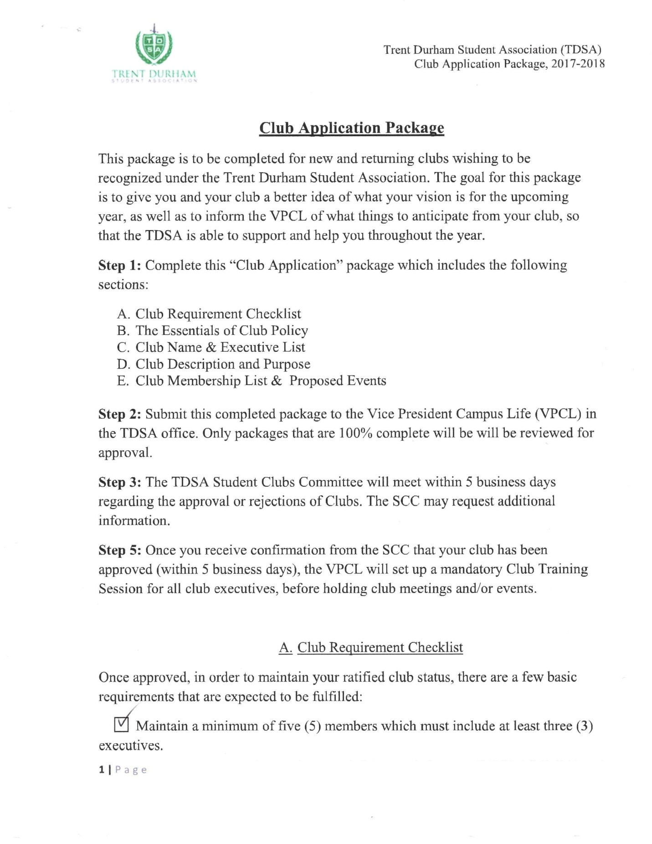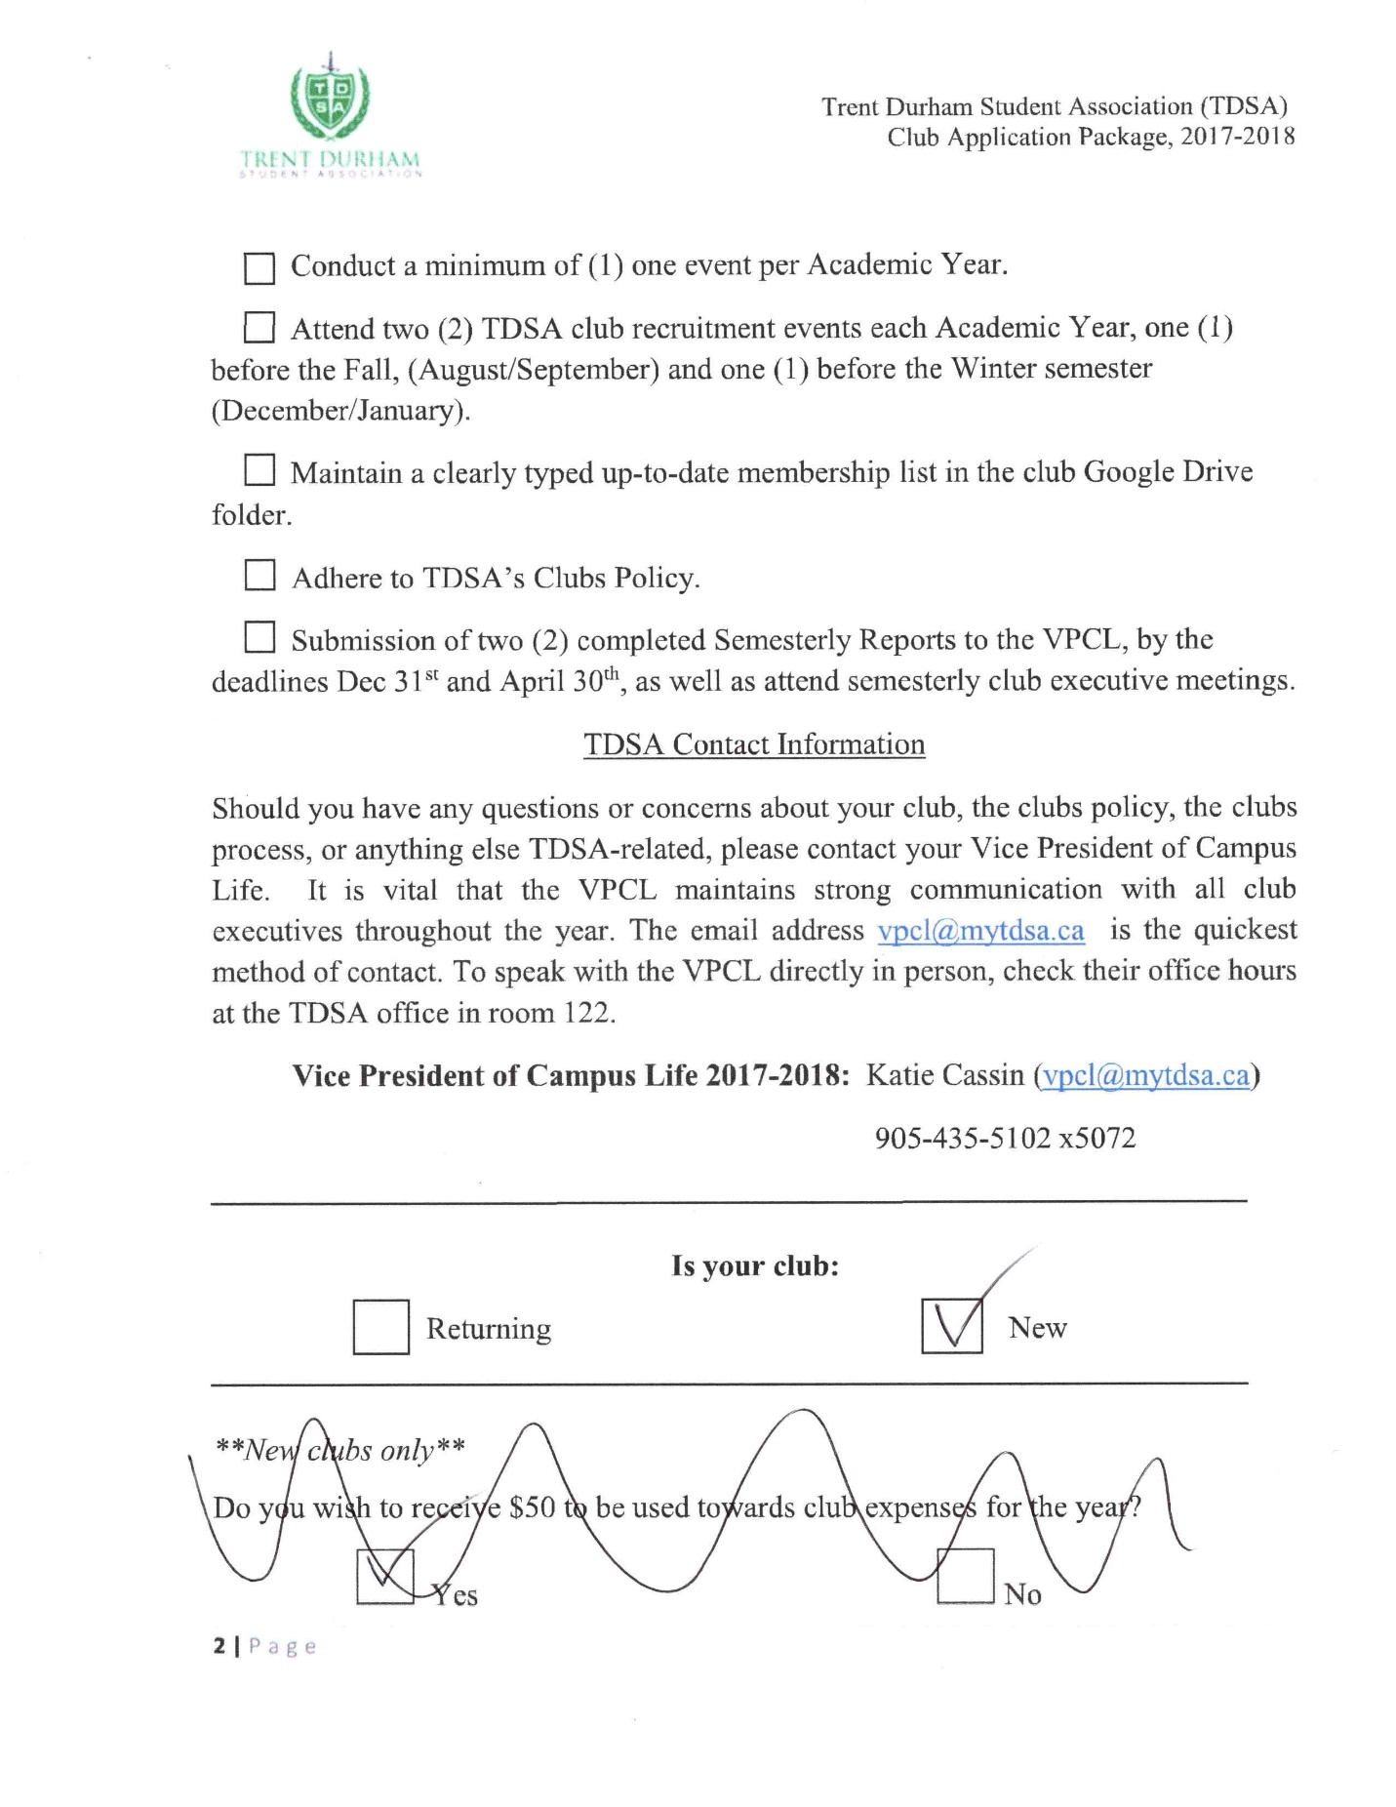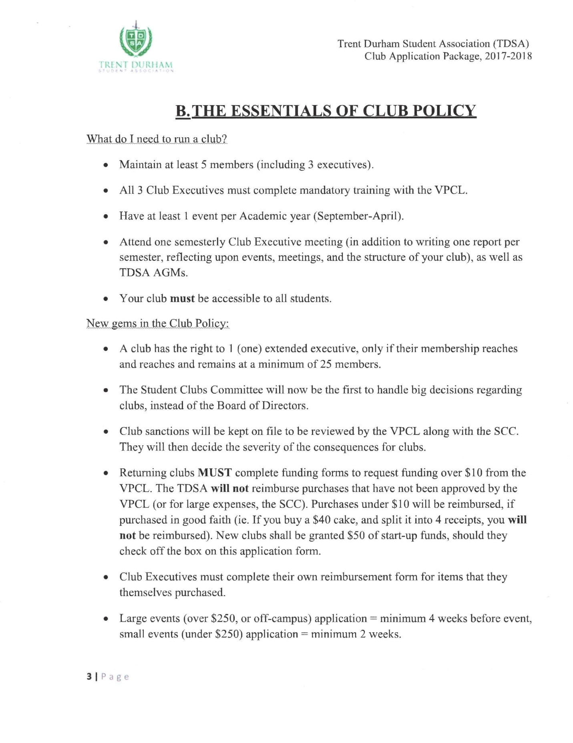

*** Page deleted to maintain student privacy ***
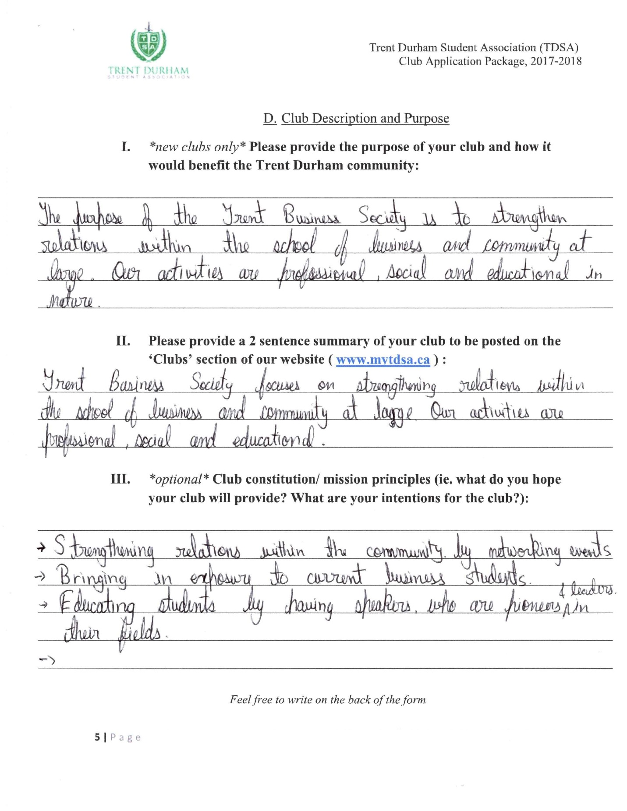

*** Page deleted to maintain student privacy ***
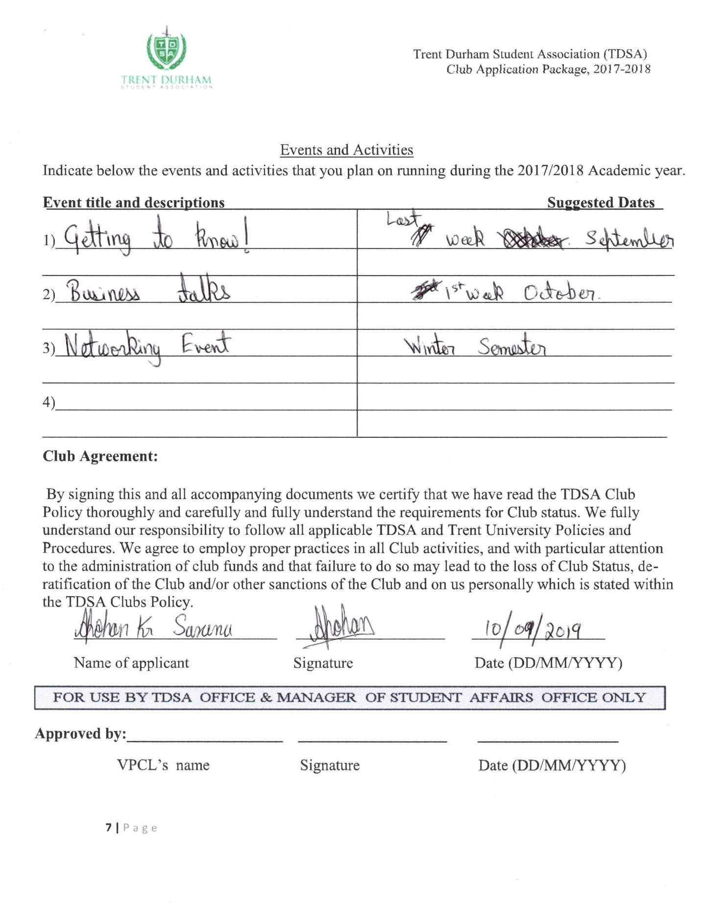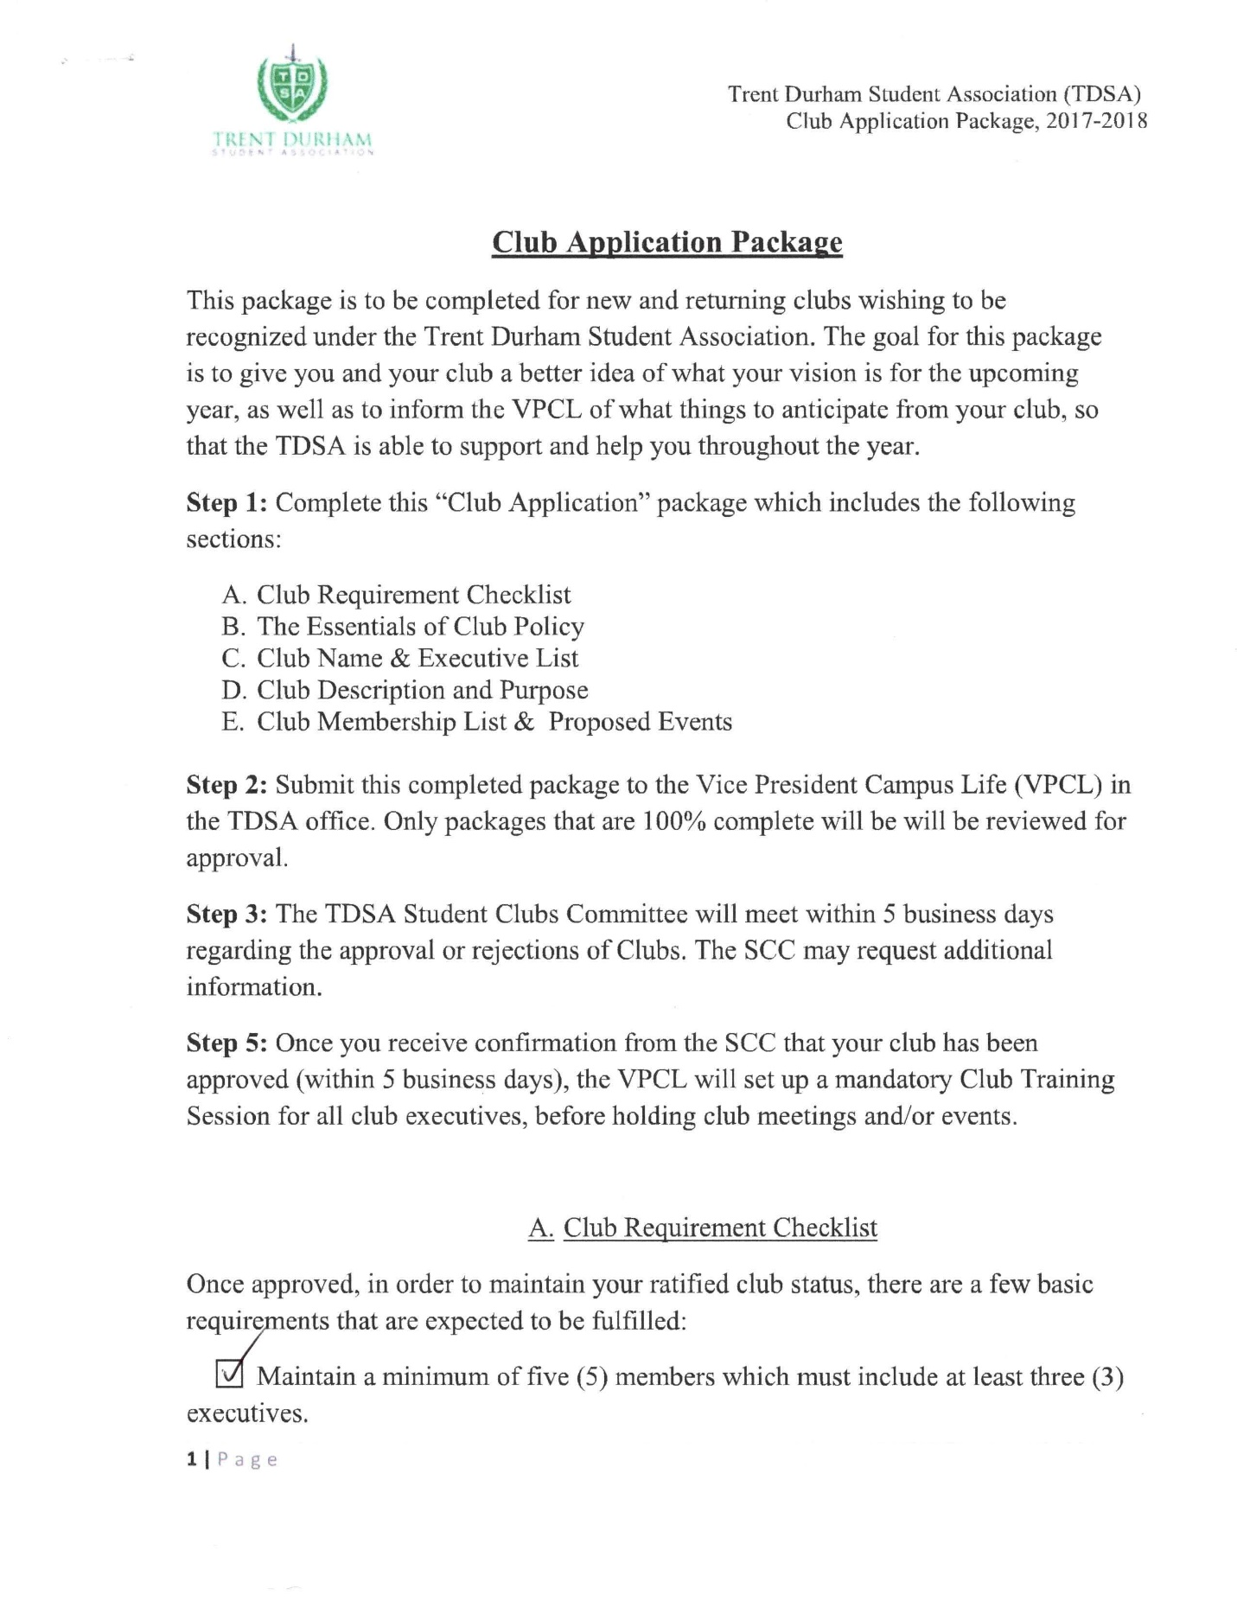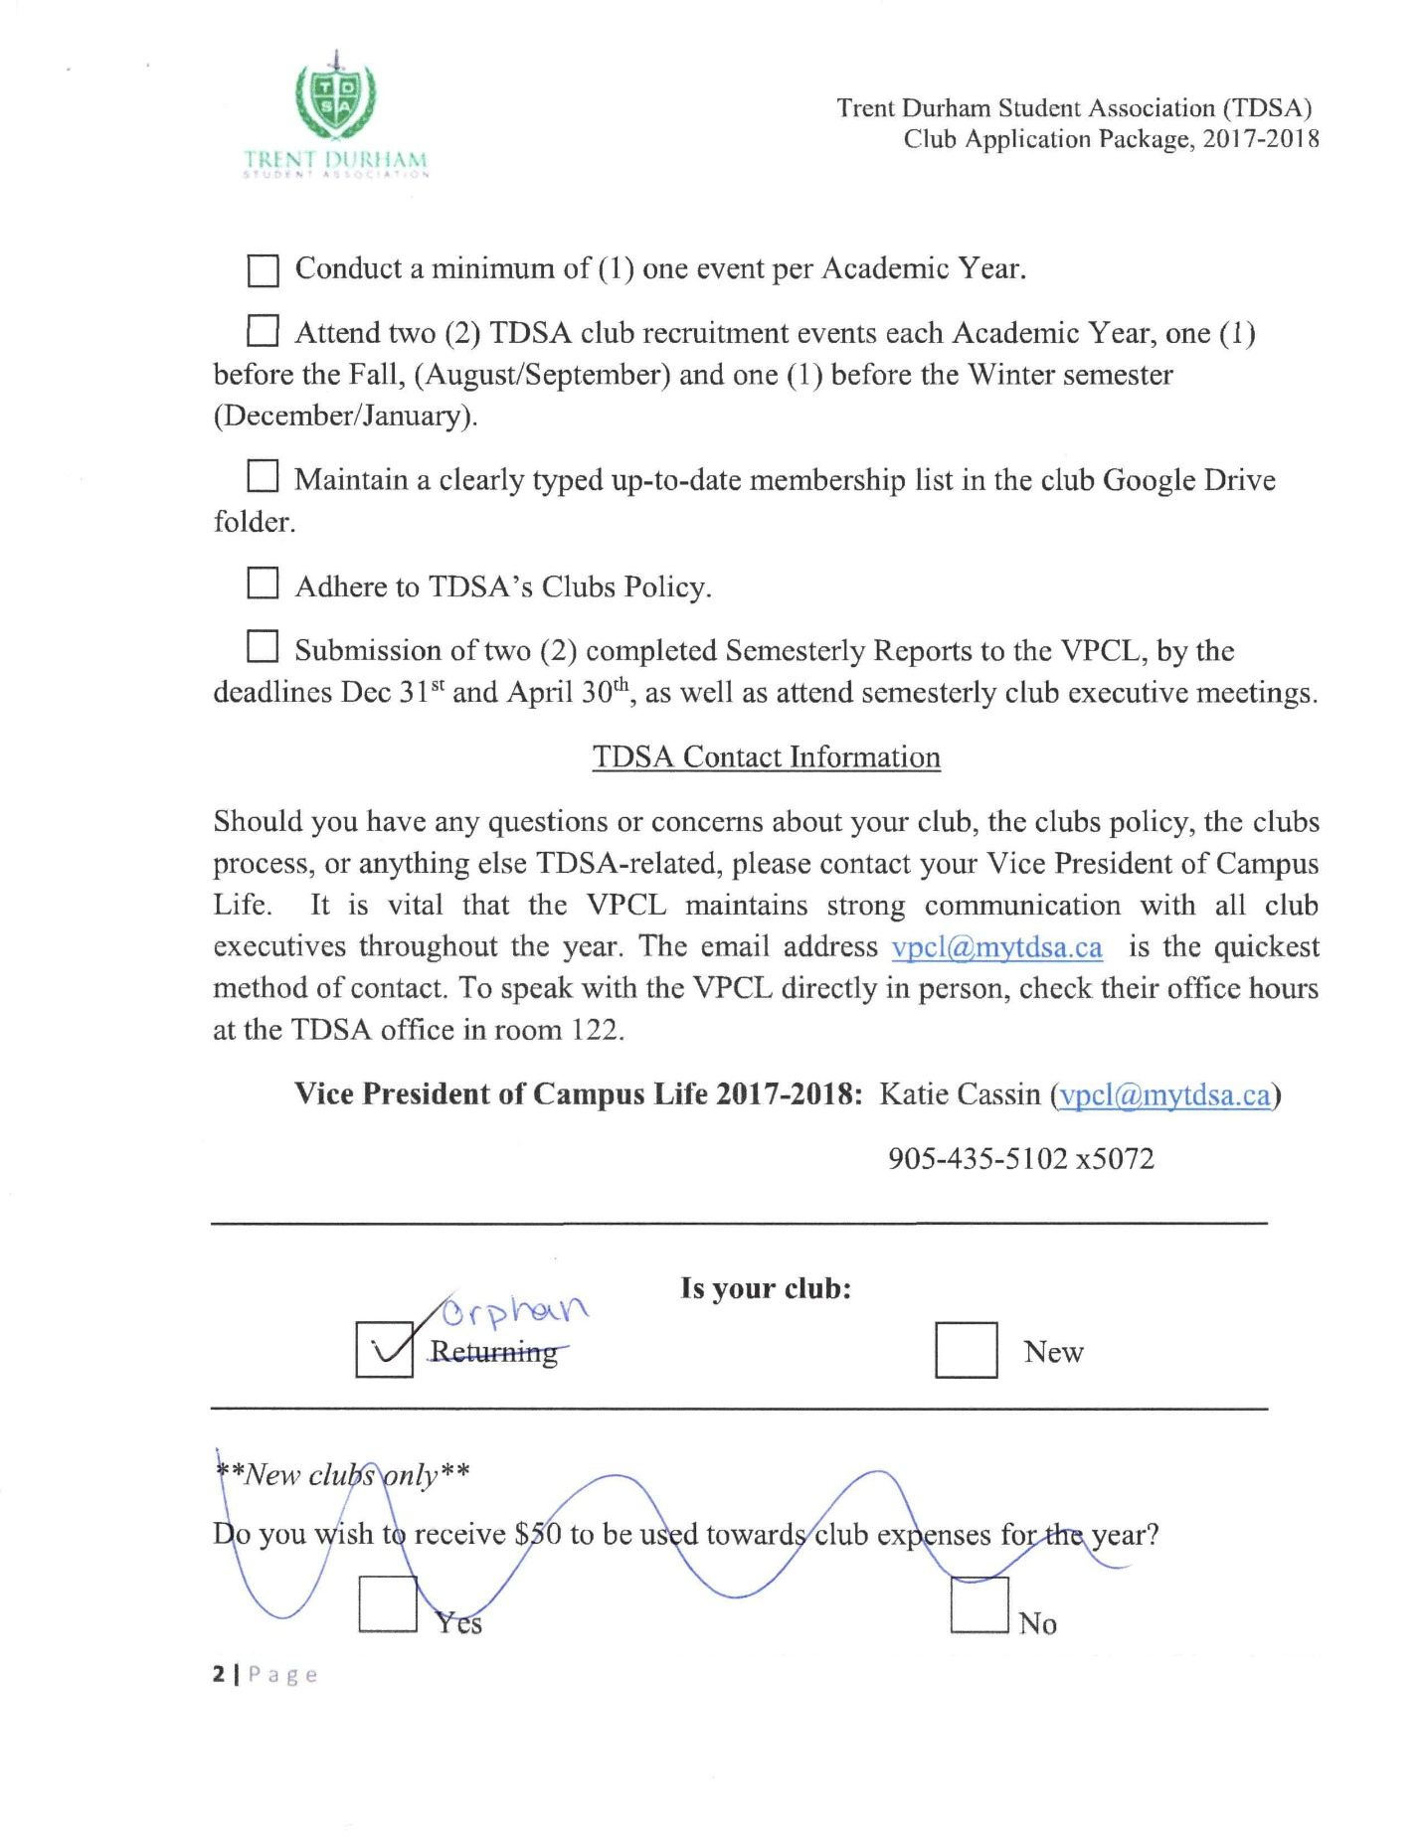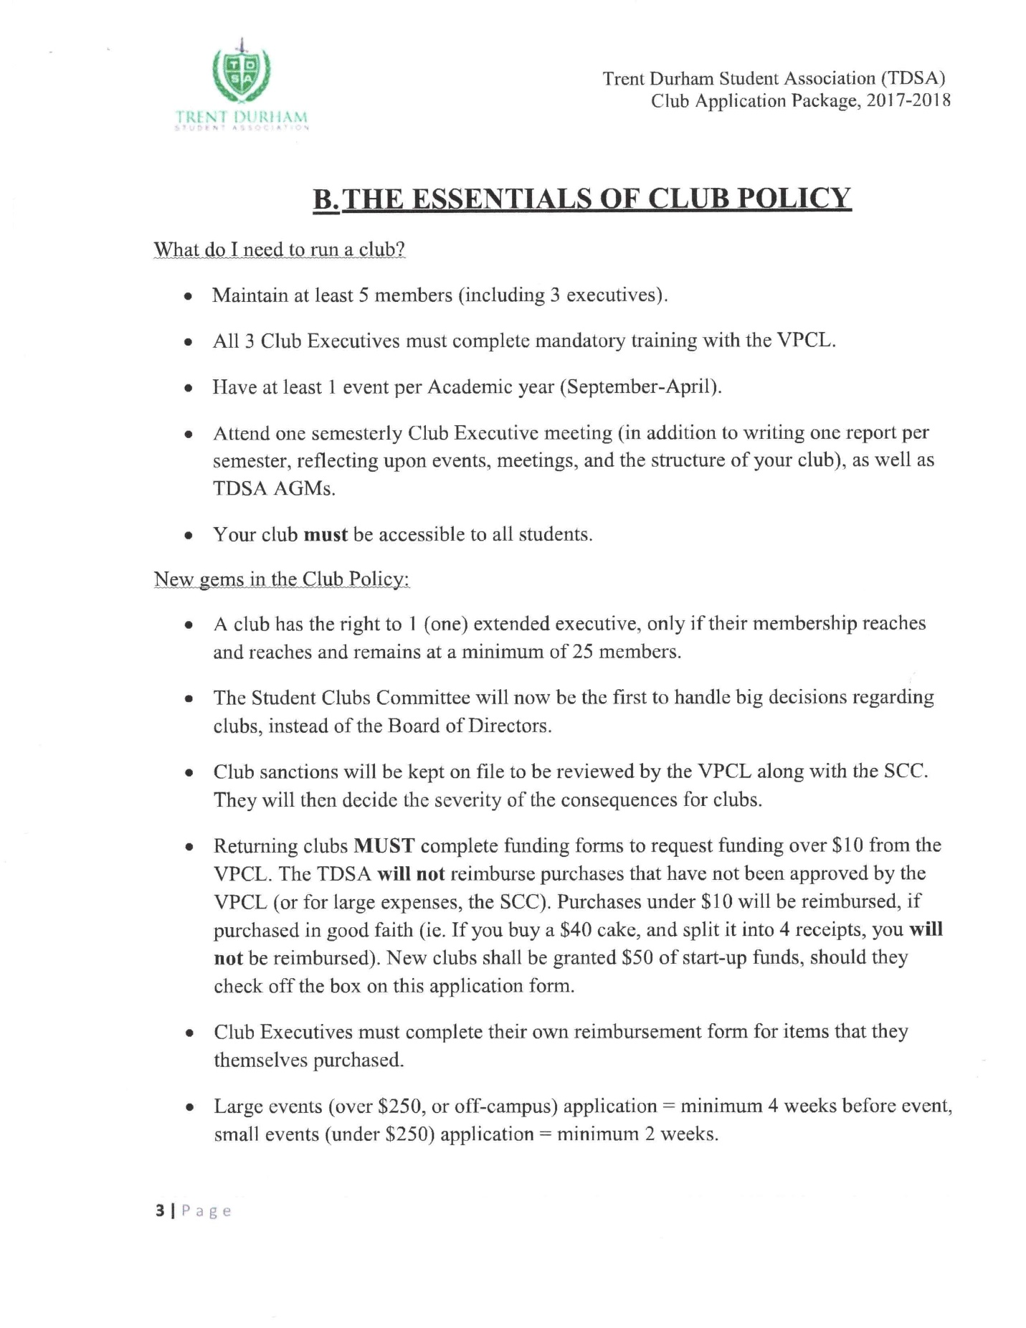

*** Page deleted to maintain student privacy ***
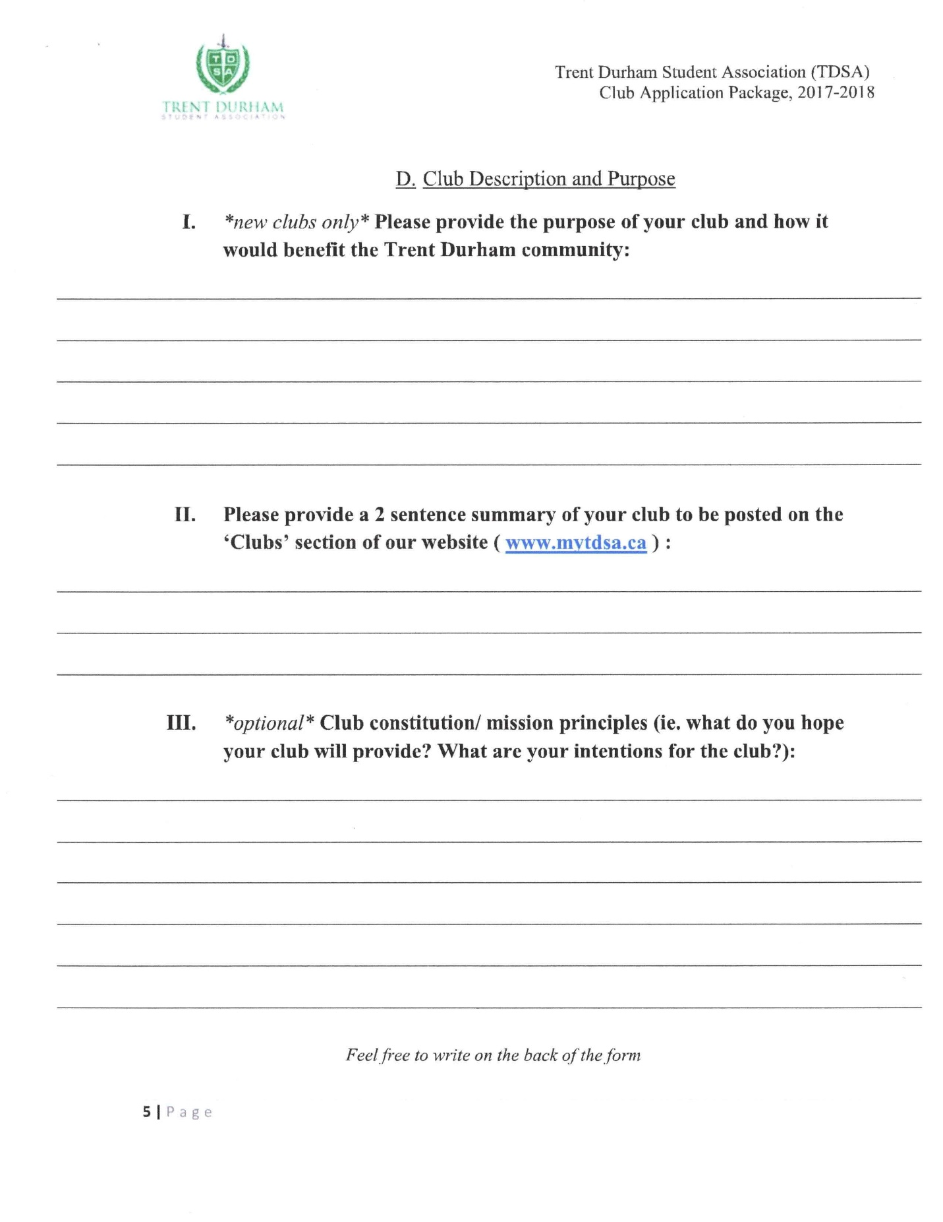

*** Page deleted to maintain student privacy ***

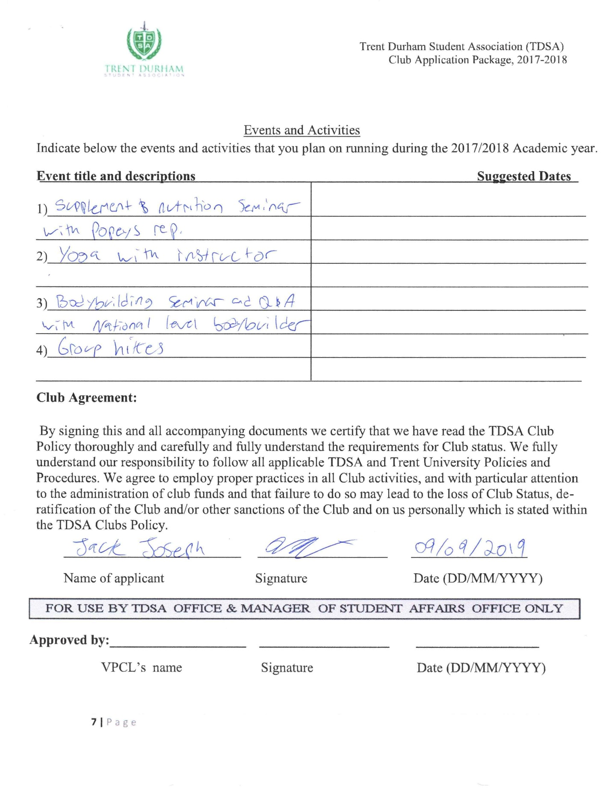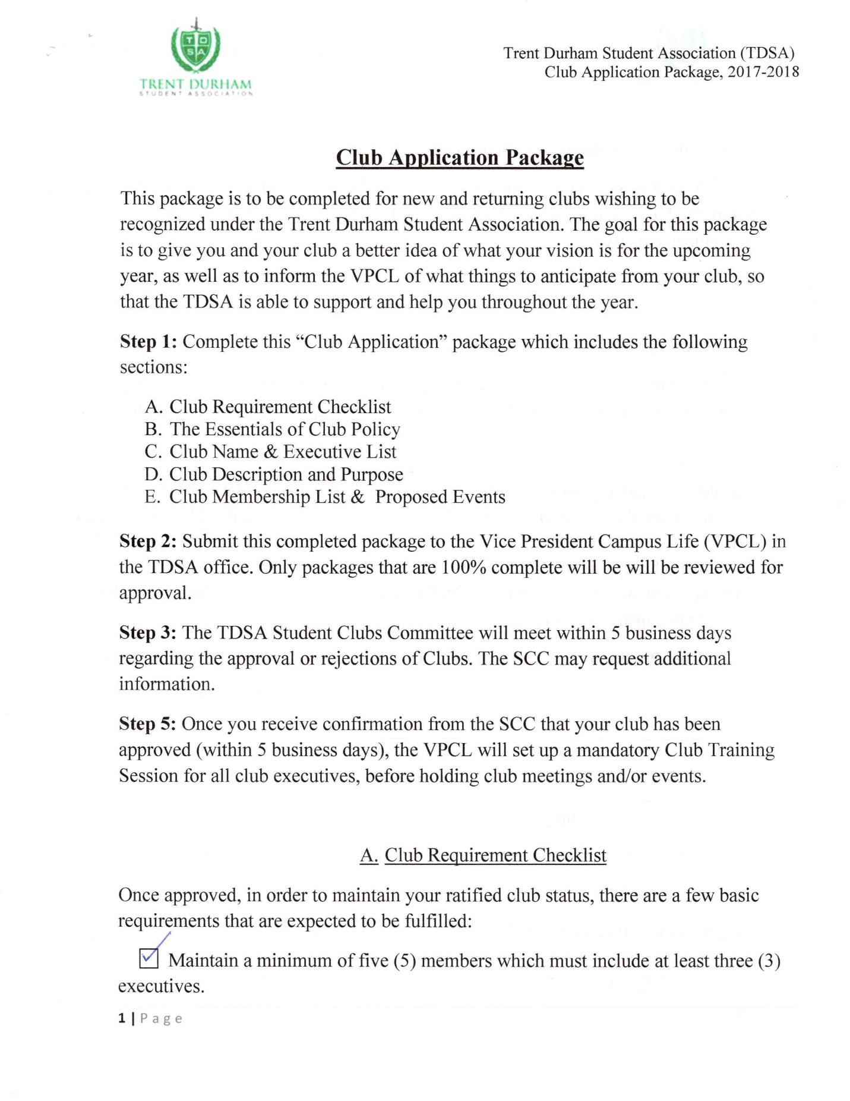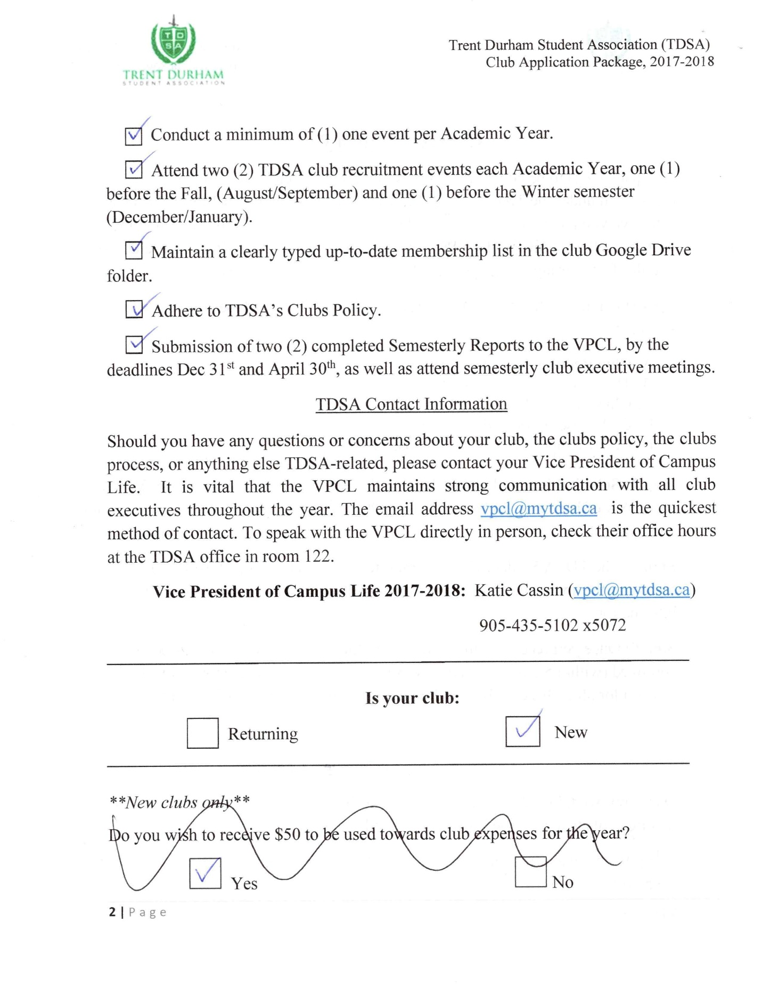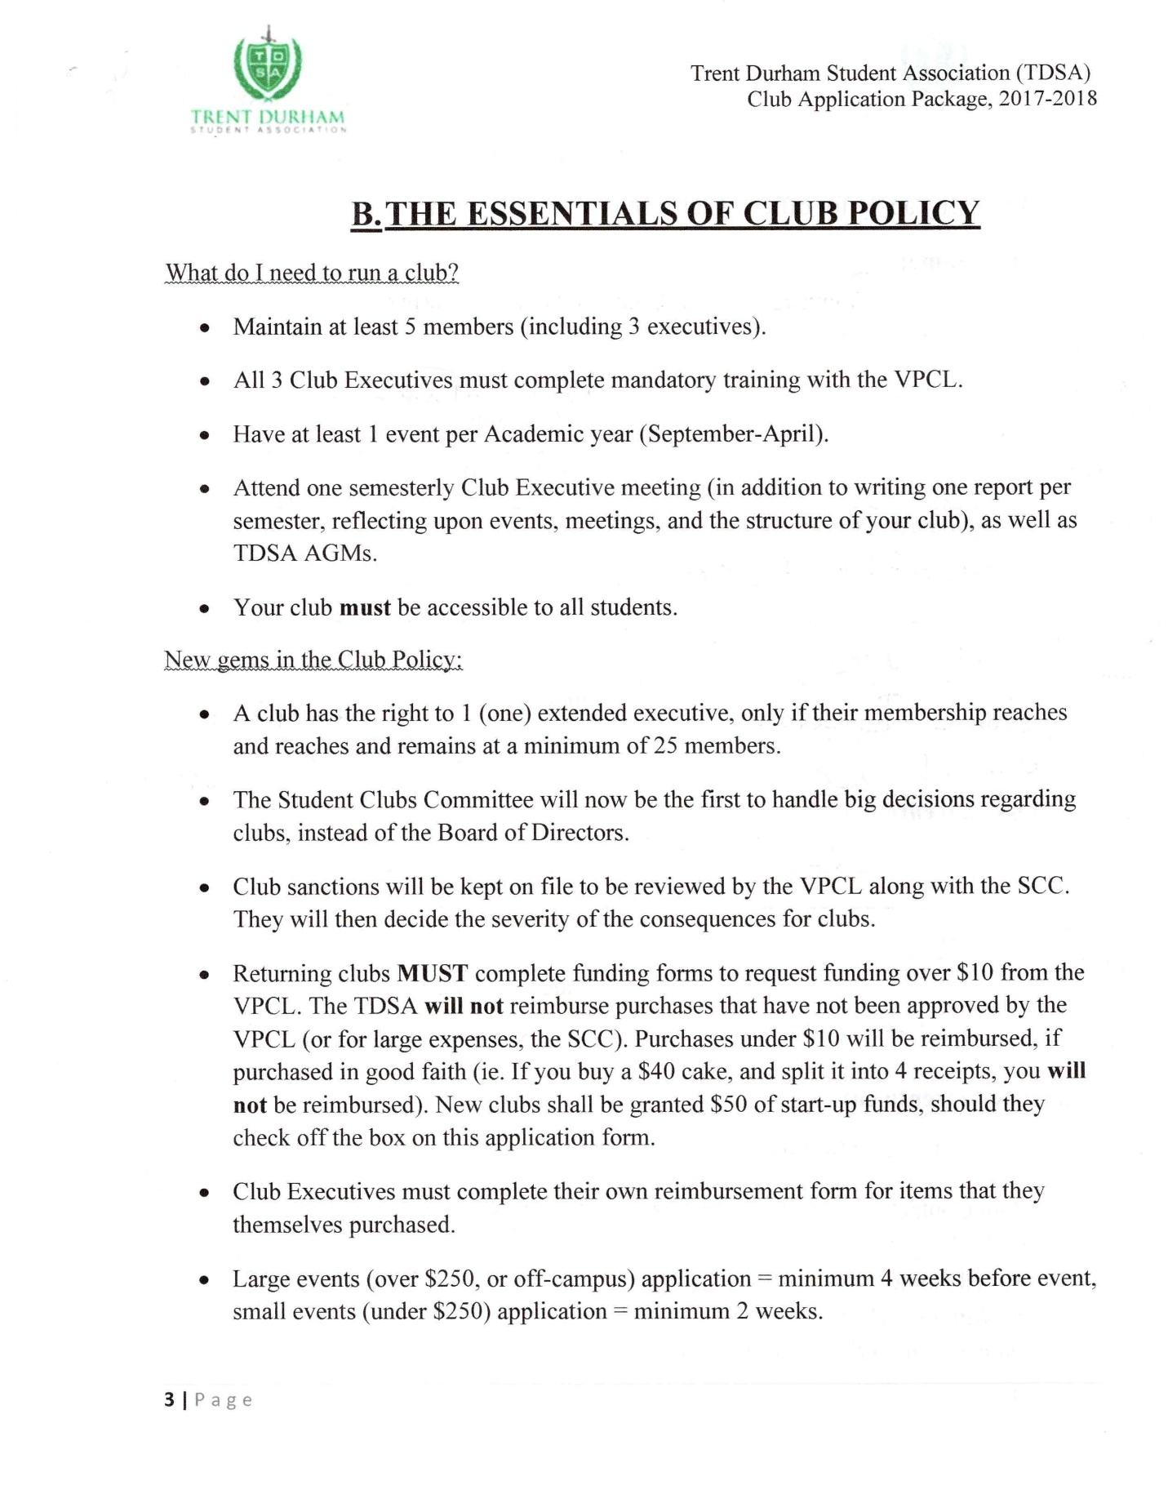
*** Page deleted to maintain student privacy ***
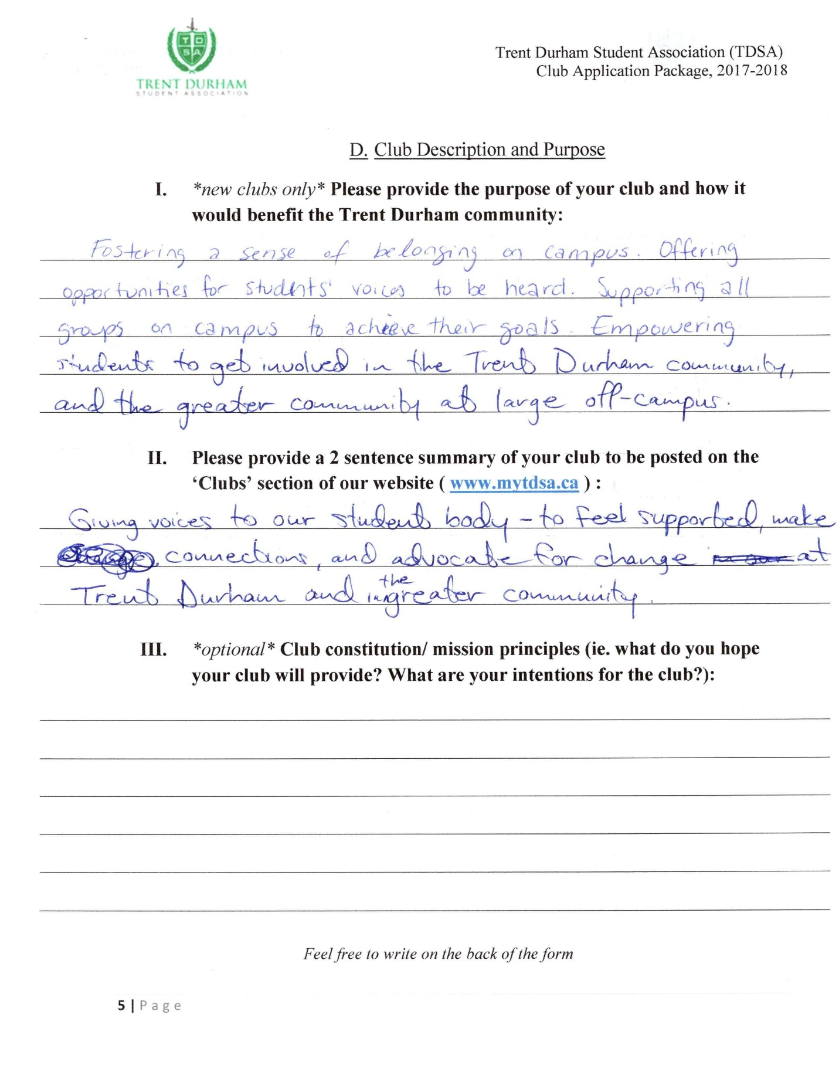

*** Page deleted to maintain student privacy ***
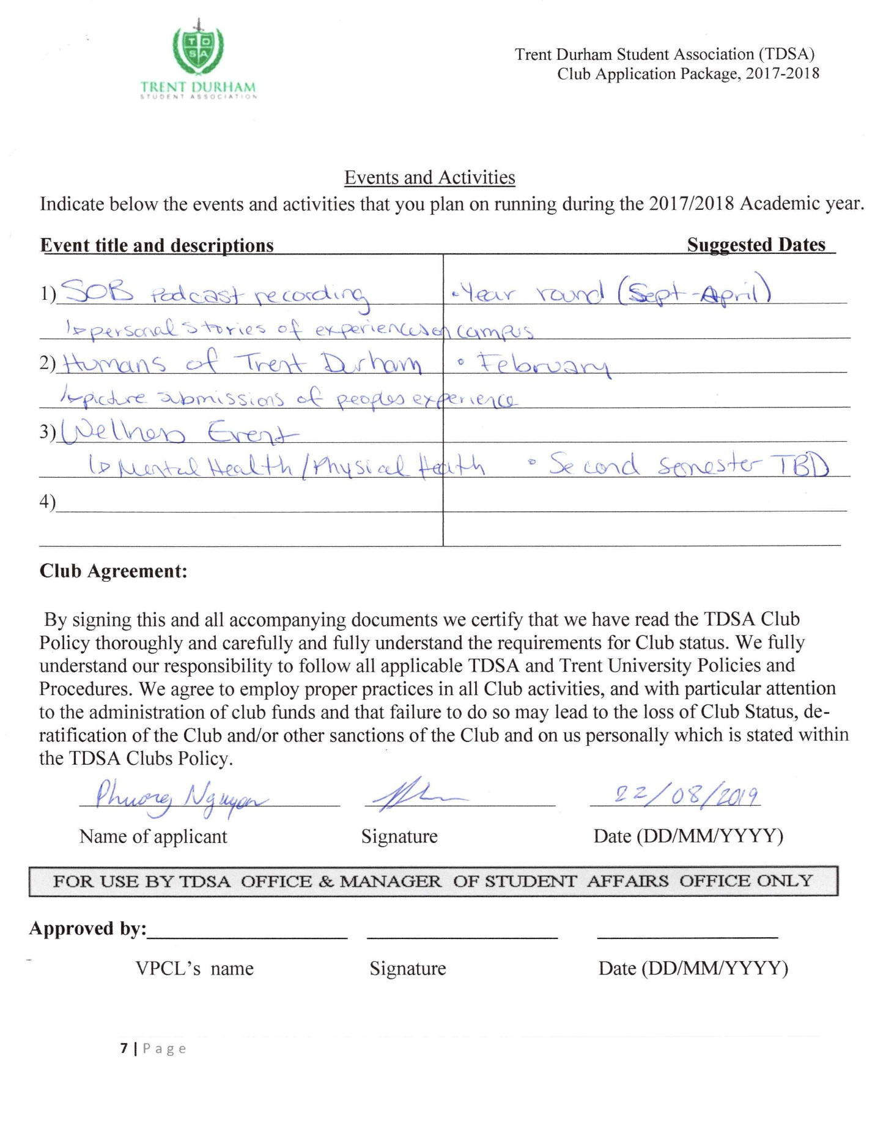
Appendix 7: Bylaw Changes
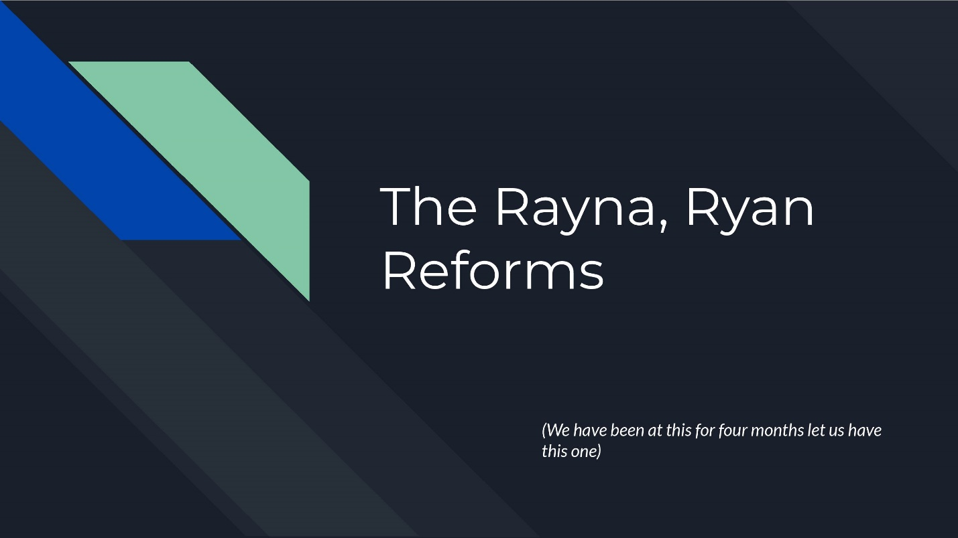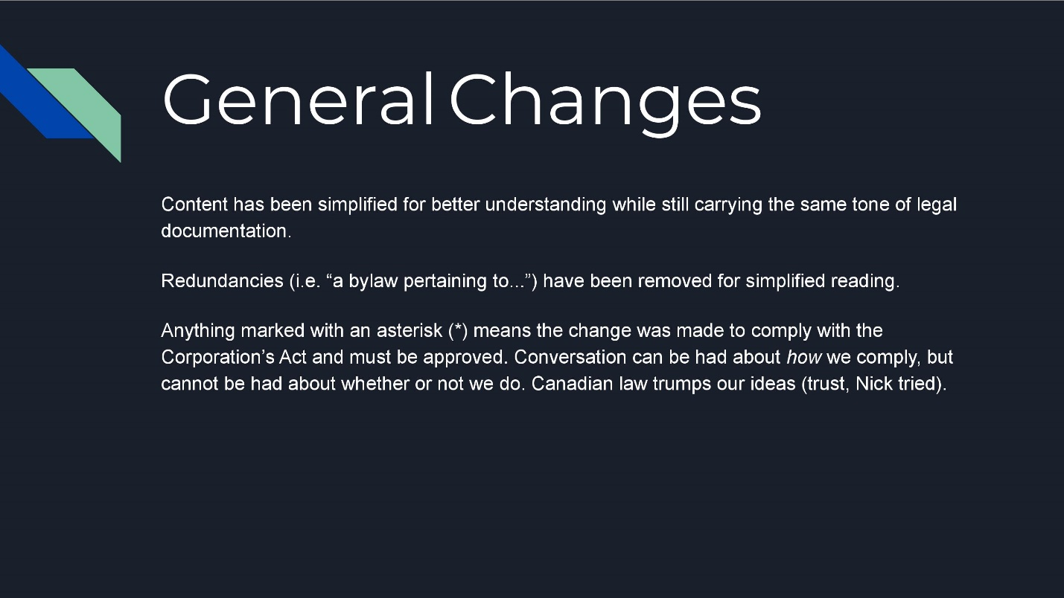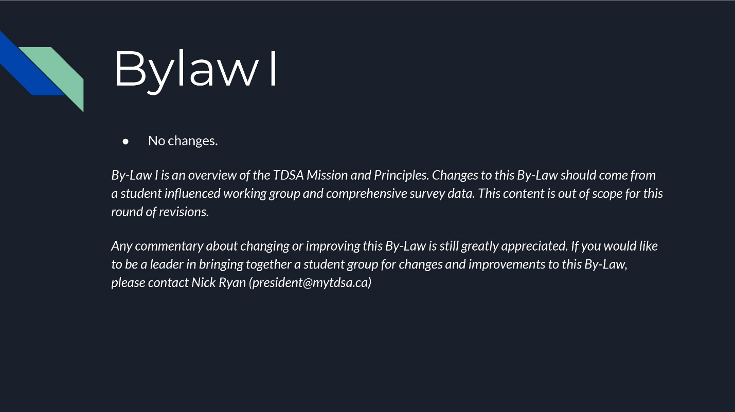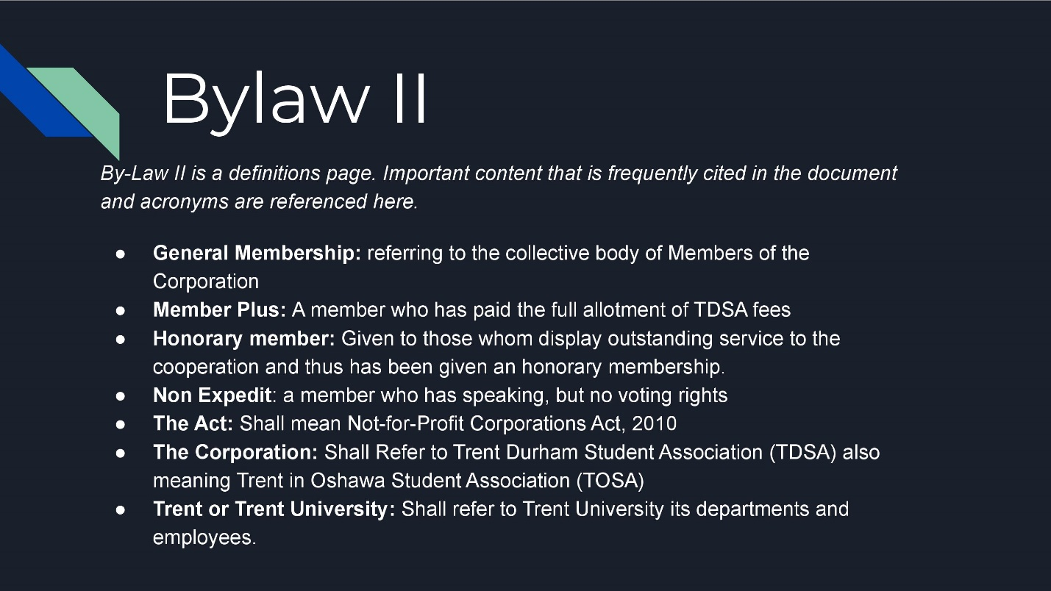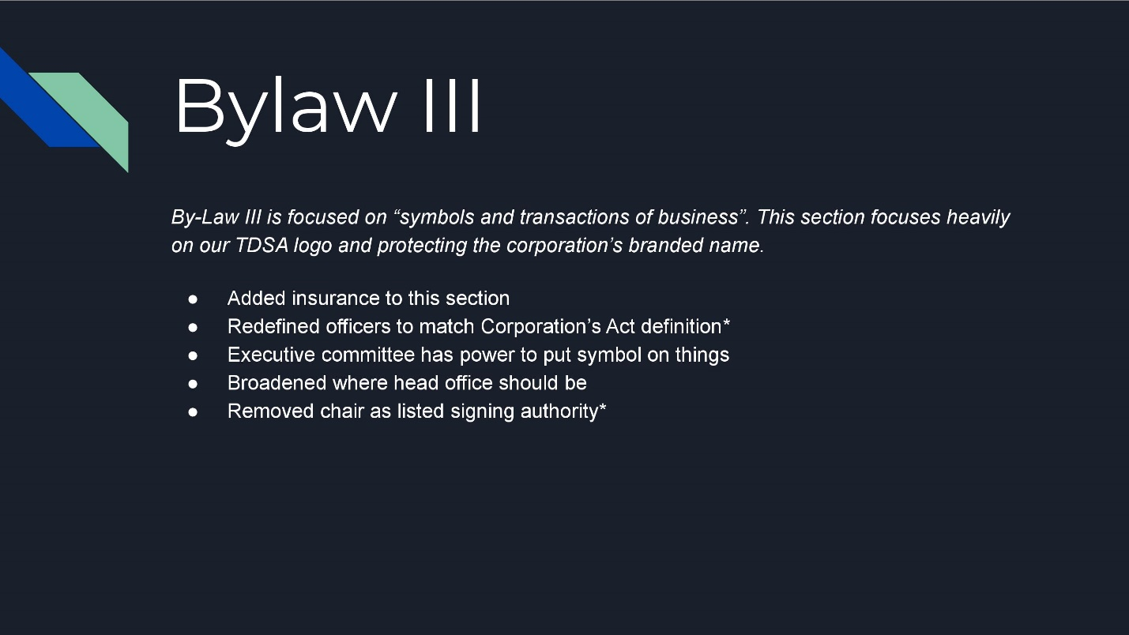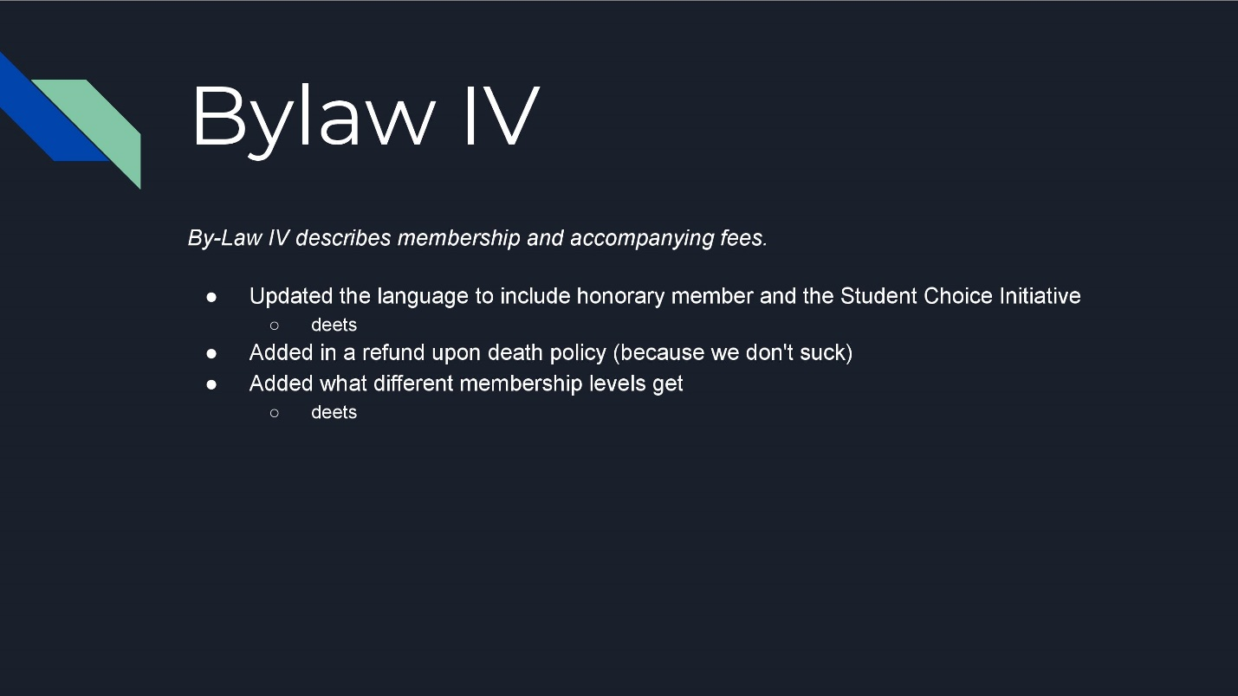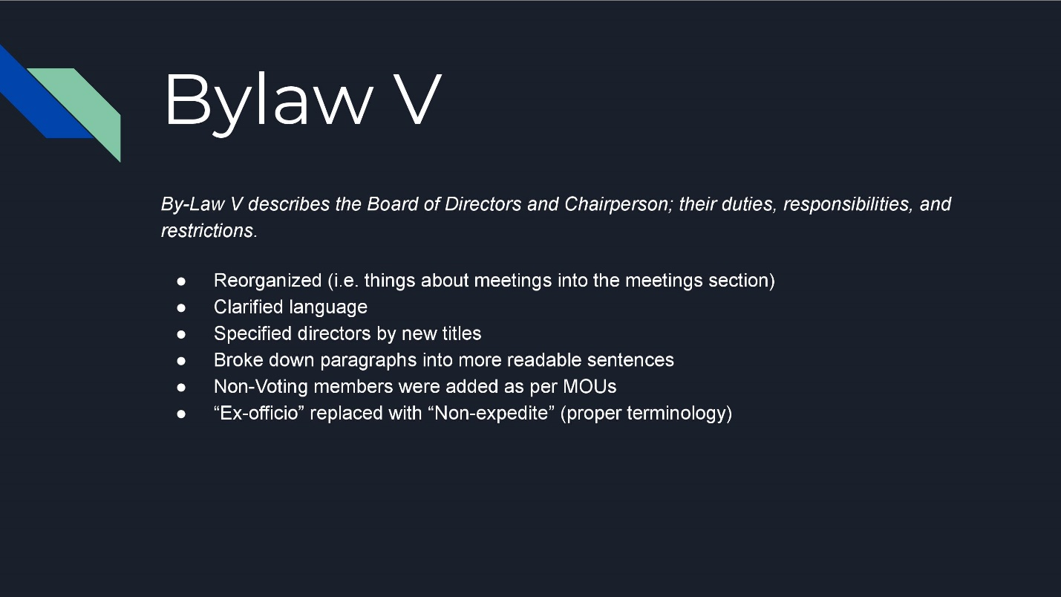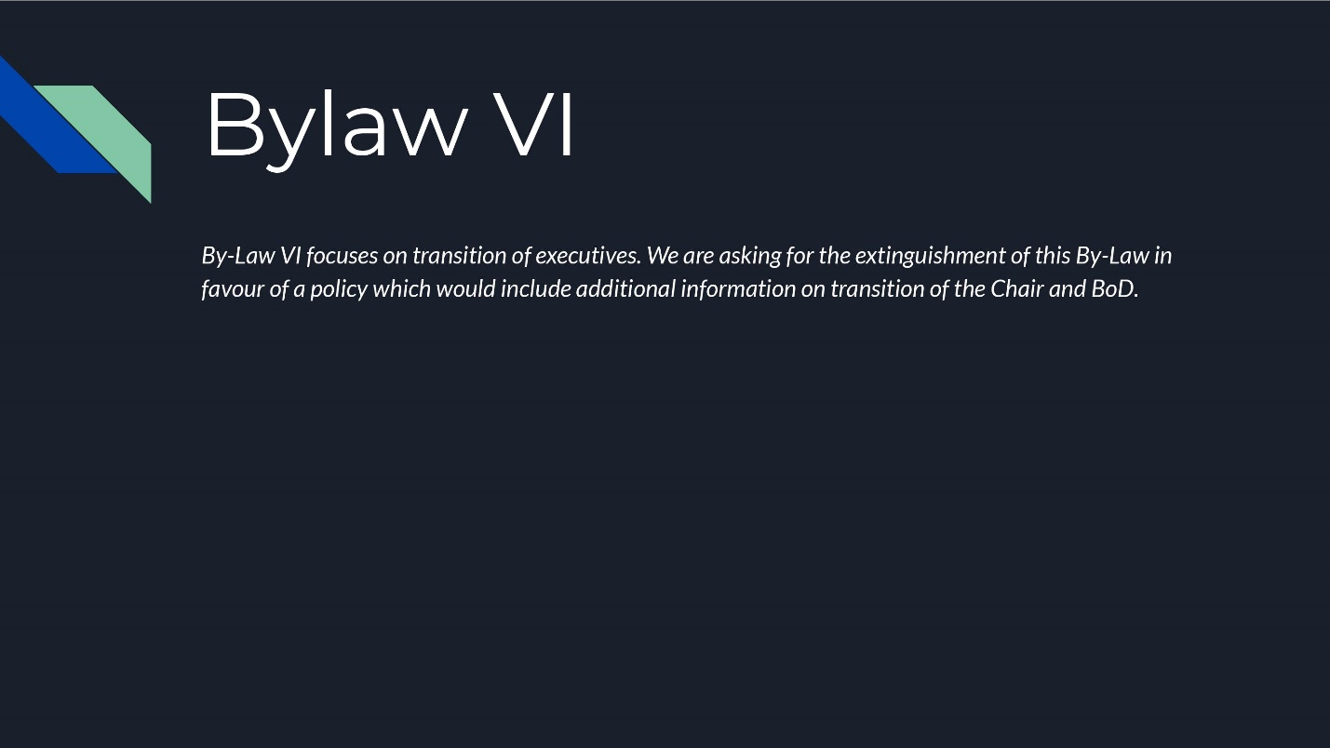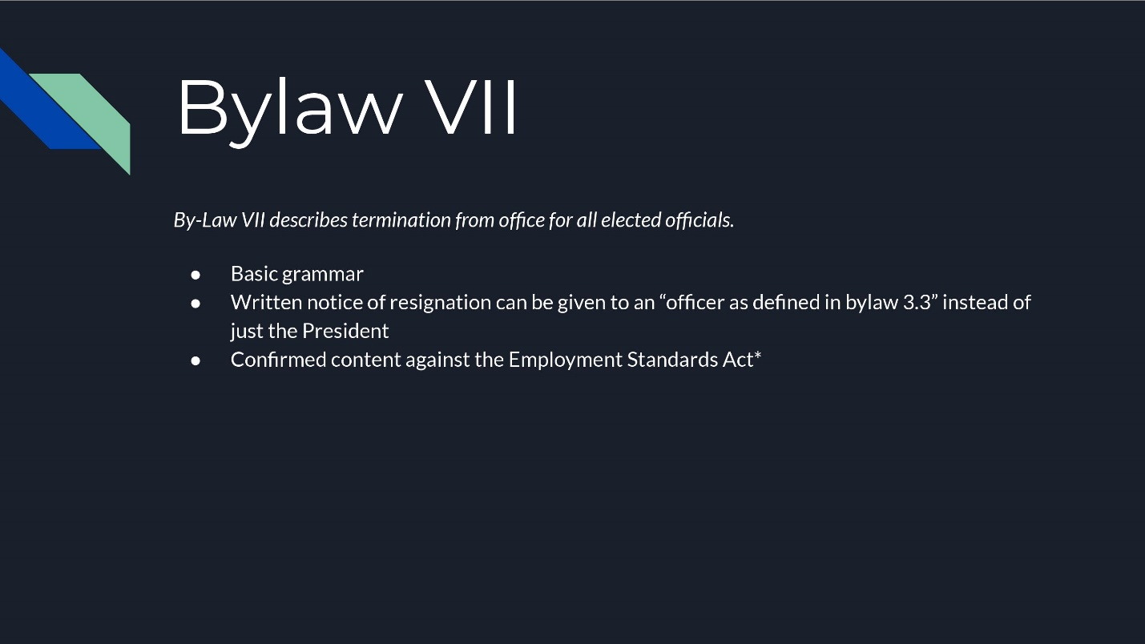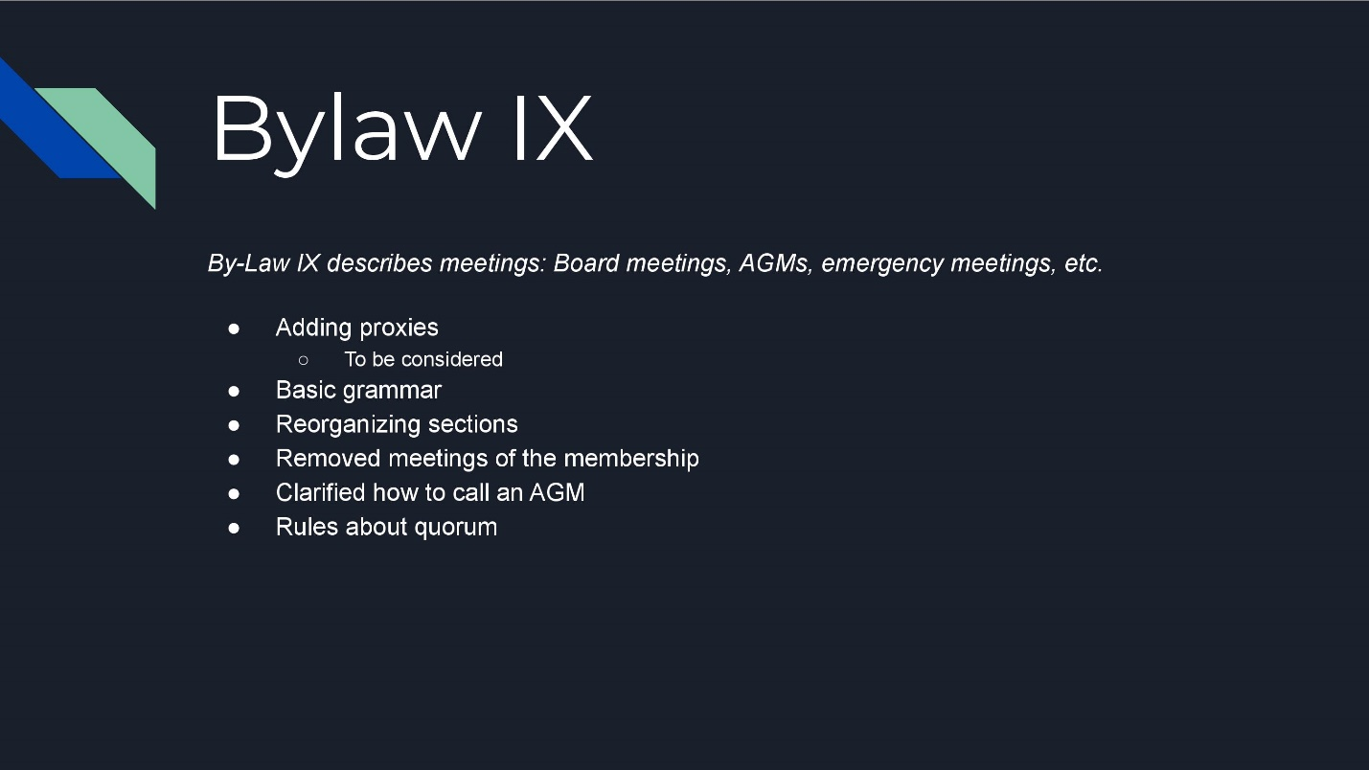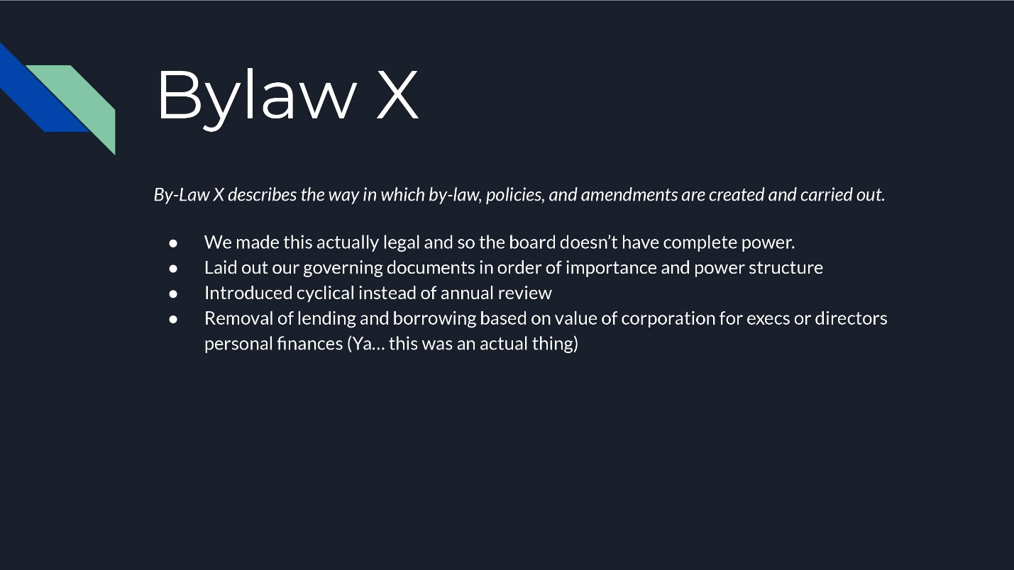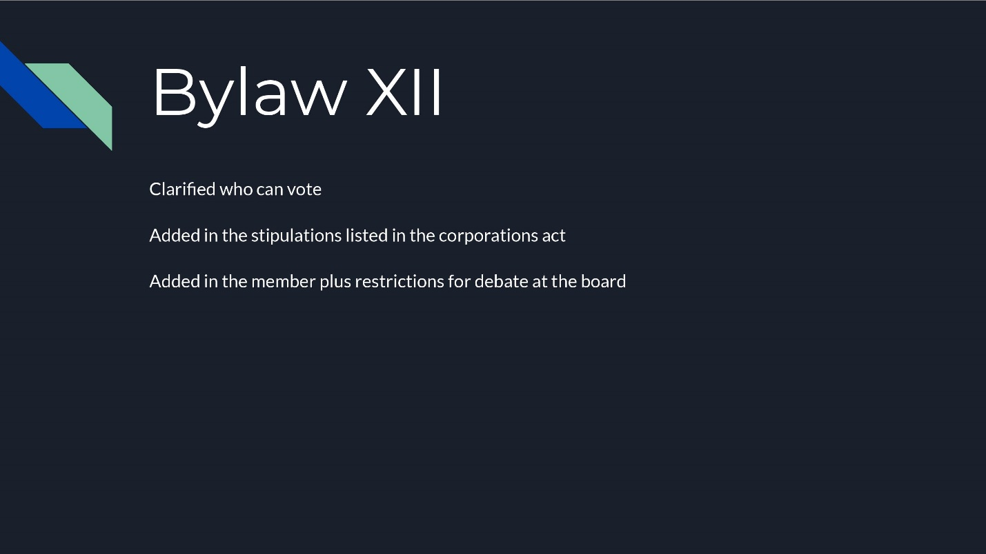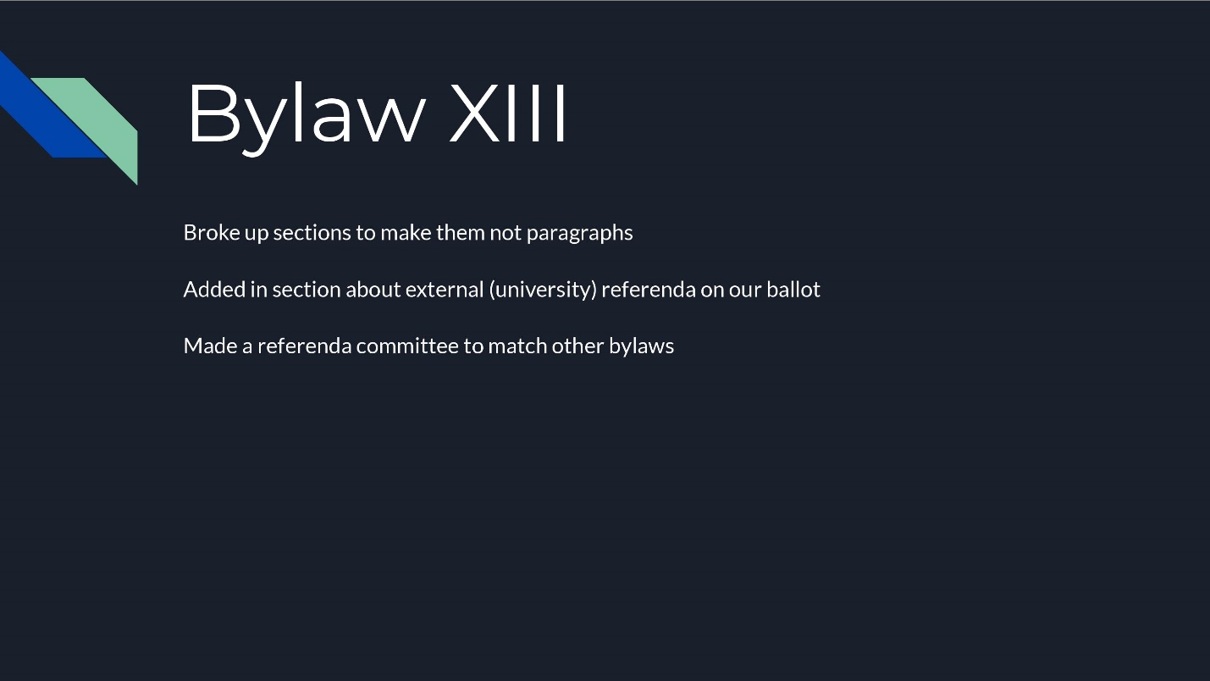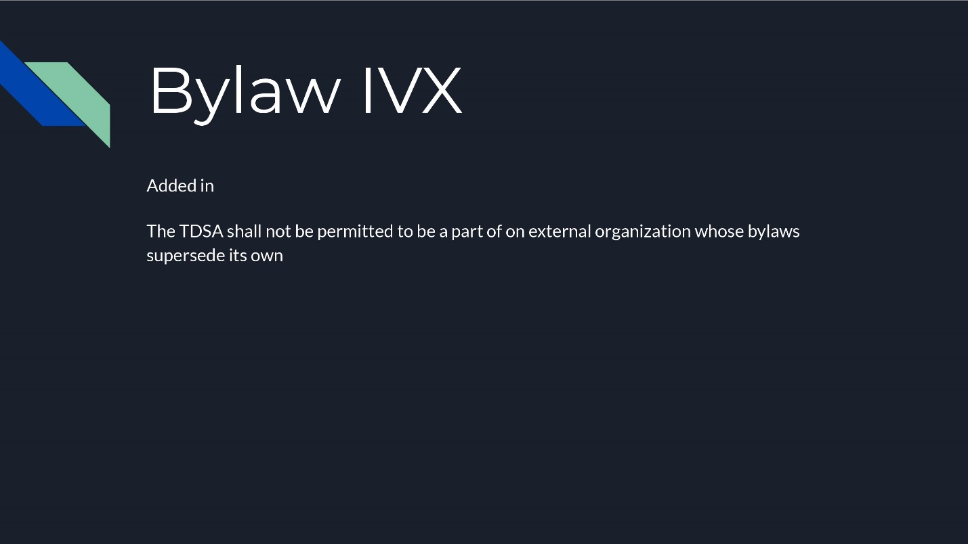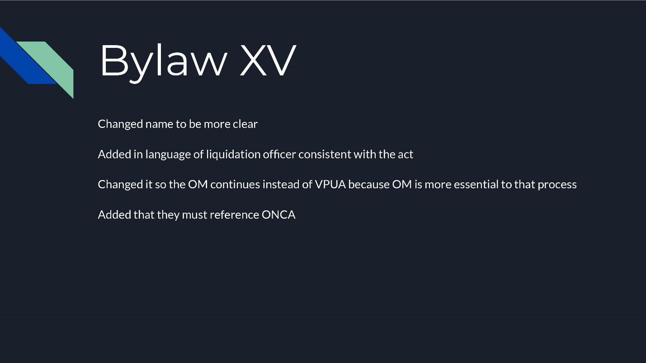

Preamble

    - Trent in Oshawa Student Association doing business under Trent Durham Student Association (TDSA) is a democratically elected student union representing full-time and part-time undergraduate and postgraduate certificate students at the Trent University Durham-GTA campus. The association is non-profit Corporation operating under its own bylaws and policies.
    - The students of Trent University Durham-GTA, in order to establish rights, freedoms, representation and responsibilities of individual students and groups, promote the basic principles of freedom of expression, and freedom from discrimination, do ordain and establish these by-laws and policies for the Trent Durham Student Association.

BY-LAW I: MISSION AND PRINCIPLES

Mission
    - To develop and maintain responsible student government which will promote the interests of the membership of the Trent Durham Student Association;
    - To provide a high level of assistance to our members through representation, advocacy and services;
    - To maximize communication of events, issues, and general information to the membership;
    - To ensure the membership can pursue academic excellence and personal growth free from all forms of discrimination, harassment, oppression and persecution;
    - To encourage and support student clubs, organizations, and societies thereby increasing the vitality of student life and the diversity of activities available to students;
    - To strive for a high level of education for all members of the association;
    - To build and maintain amicable relationships with the membership, faculty, staff, the local community,the institution and all levels of government;
    - To develop and maintain unity and to encourage cooperation among Trent University Durham-GTA students;

Principles
    - The corporation is committed to the following fundamental principles:
      - The right to establish and maintain a democratic student government in which each student shall have an equal right to participate, and with provision for advisory referenda;
      - To be accountable, dedicated, and available to all members of the association so that they feel comfortable approaching the executives to be their advocate in any matter relating to their education, campus community, or government when pertaining to student affairs;
      - The right in the classroom to full freedom of expression, discussion, and inquiry related to the course while respecting the rights and learning experiences of other students, and the right to be evaluated based solely on academic performance;
      - The right to enjoy the same privileges and opportunities as any other student without discrimination or prejudice regarding but not limited to the student’s race, creed, racialized status, sex, national origin, sexual orientation, religious views or affiliations, political views or affiliations, marital status, or condition of disability.
BY-LAW II: DEFINITIONS

    - In camera (Closed session): The Board of Directors may elect to move into a closed session in which only voting board members shall be permitted to overhear discussions or attend meetings during closed sessions, unless invited in my majority vote of the board. Minutes for closed sessions will be recorded but will be kept confidential.
    - General Meeting: Meetings in which all members of the corporation must be extended an invitation.
    - Teaching Weeks: a regularly scheduled week of classes (Monday-Friday) and excludes reading weeks, holidays, and exam periods.
    - Member of the Corporation: Any student registered for a full-time or part-time on-campus, online, undergraduate, postgraduate or English as a Second Language (ESL) program at Trent University Durham-GTA who has paid any part of the TDSA membership or peer support fee shall be a member of the Corporation
    - General Membership: referring to the collective body of Members of the Corporation
    - Member Plus: A member who has paid the full allotment of TDSA fees
    - Honorary member Given to those whom display outstanding service to the cooperation and thus has been given an honorary membership.
    - Non Expedit- a member who has speaking but no voting rights
    - The Act: Shall mean Not-for-Profit Corporations Act, 2010
    - The Corporation: Shall Refer to Trent Durham Student Association (TDSA) also meaning Trent in Oshawa Student Association
    - Trent or Trent University: Shall refer to Trent University its departments and employees.

BY-LAW III: SYMBOLS AND TRANSACTIONS OF BUSINESS

Symbols .
    - The symbols adopted by the Corporation and the by-laws hereof, shall act as the visual symbols or logos representing the corporation or any part thereof and the authority to affix the logo(s) to any documents or objects shall be determined by majority vote of the executive committee.
    - Necessary revisions of the corporate symbol must be passed by a majority vote of the Board It is in the best interest of the corporation to maintain a unified and consistent image to present to its members, the community, the University, and all levels of government.

Head Office
    - The head office for the Corporation shall be the Student Association office(s) located in Durham Region on the Trent University Durham-GTA Campus

Officers
    - The Officers of the Corporation shall be the President, Vice President of University Affairs, Vice President of Campus Life, the Operations Manager, Chair to the Board of Directors and any other officers determined by the membership or Board of Directors.

Execution of Instruments
    - For the purpose of this section, “instruments” include contracts, deeds, mortgages, transfers and assignments of any property of the Corporation, obligations, certificates, and any other documents.
    - Any two of the following persons are required for the signature of instruments: The President, the Vice President University Affairs, the Vice President Campus Life and/or Operations Manager.
Insurance
    - Subject to the provisions of the Act, the Corporation shall purchase and maintain at the very least general liability insurance for the benefit of its directors, officers and/or employees as determined by the Board of Directors.

BY-LAW IV: MEMBERSHIP AND FEES

Membership
    - A Member is entitled to, be a member/executive of clubs or student organizations, attend TDSA events, be opted into the Health Benefits Plan and shall be advocated for by the TDSA.
    - Member Plus: shall be proved a discount at the Rack and Shelf determined by the executive committee and as an information piece to the Board of Directors, be provided discounts to event tickets as determined by the event holder. Shall be eligible to be a delegate at external conferences. Shall be eligible to seek employment and run in elections.
    - Membership shall be valid for the academic year in which the fees are paid and terminates at the end of the year.
    - Honorary Member: An Individual may be granted an Honorary Membership to the corporation by a Majority vote of the Board of Directors and shall receive the following privileges ...[for discussion at the board]
      - Speaking rights at meetings but not a voting right
Fees
Any fees excluding the health benefits plan are subject to inflationary increases by no more the five (5) percent. Membership fee increases exceeding five (5) percent shall be approved by referendum.
    - The Corporation shall have an agreement with the University whereby the University shall collect membership fees as determined by referendum or the Board of Directors and transfer the collected fees to the Trent Durham Student Association.
Non-Refundable Student Ancillary Fees
    - The following fees are collected from the membership for the purposes of administering external services. Said fees shall only be used towards the intended service and are subject to annual inflationary increases not to exceed five (5) percent.
      - Walksafe Fee
      - Peer Support Group Fee
Non-Compulsory Fees)
    - TDSA Membership Fee
    - Members of the Corporation(excluding online) are automatically covered under TheaTrent Student Benefits Plan student benefit plan. The membership possesses the right to opt-out of the student benefit plan, subject to a deadline set by the health care provider and associated administrative costs.

Termination and Transfer
    - The interest of a member in the Corporation is not transferable and ceases to exist upon death or cancellation of membership. Membership ceases upon withdrawal, suspension, rustication, or debarment from the University, or upon ceasing to be qualified for membership pursuant to the bylaws herein, or upon failure to pay the annual membership fee. The membership fee is non-refundable and non-transferable. Exceptions for the membership fee may be made for an Executive.

Refund
    - Upon the death of a student whom is a member of the corporation, the immediate family, or executor of the will of the deceased, may apply for the remainder of their membership and peer support fees to be refunded is determined by the percentage of the term remaining
BY-LAW V: BOARD OF DIRECTORS

The Board of Directors shall manage the affairs of the Corporation. The directors shall act with diligence, honesty and good faith to serve in the best interest of the membership. Directors shall report on the activities of the Corporation on a regular basis to the general membership and to their respective constituencies.

Board of Directors composition
    - The Board of Directors shall be comprised of: Chair (Speaker) Directors, Executive Directors , and Non Expedit Directors.
    - Director positions shall be occupied one (1) person at a time,

Directors
    - Director of Academics
    - Director of Finance
    - Director of Human Resources
    - Director of Student Engagement
    - Director of Policy
    - Director of Health and Wellness
    - Director of Inclusion
    - Director of Community Outreach

Executive Directors
    - President
    - Vice President of University Affairs
    - Vice President of Campus Life

Non Expedit Director
      - Operations Manager (Also acting as secretary)
      - Trent Central Student Association Representative
      - Trent University Native Association Representative
      - Trent Graduate Student Association Representative

Power/Responsibilities of Directors
    - Chair their assigned committee as laid out in Operating policy.
    - Subject to the provisions of this by-law, the Board shall have the final authority on all matters regarding the governance of the Corporation, within the boundaries of the law. The Board of Directors, without restricting the generality of the forgoing, may make regulations to:
      - Governing the practice and procedure to be followed in furthering the purpose of the Corporation;
      - Respecting any matters necessary or advisable to carry out effectively the intent and purpose of this or any other by-law or any revision thereof;
      - Governing the keeping of accounts and records;
      - Governing the payment of accounts and the signing of cheques;
      - Prescribing the forms for the use of the Corporation.

The Board, without restricting the generality of the foregoing, is authorized:
    - To decide on a budget for the operation of the Corporation;
    - To make regulations governing the granting of recognition and/or financial assistance to student clubs, and/or organizations within the Association;
    - To propose amendments or creation of bylaws, and to enact and amend policies consistent with bylaw X. ;
    - To,create new staff positions as it deems necessary for the exercise of its powers; provided that the titles and duties of the new positions are authorized by the Board with a two-thirds (2/3) majority vote
    - By agreement with the Senate and/or Board of Governors to appoint members of the Association to sit on committees of the Senate and/or Board of Governors and other University-wide student/faculty committees;
    - To make regulations governing student elections or referenda held at the University.
Remuneration and Expenses
    - Directors or Non Expedit director shall not receive monetary remuneration, excluding discounts and expensive incurred as part of their duties, though they may receive remuneration for serving as officers or employees or in other capacities.
Be mandated to relinquish any responsibility to do with the event in question by a majority vote should the person in question not be willing to do so themselves.

Chairperson
    - The Chairperson shall preside over meetings of the Board of Directors
    - The Chairperson Speaker shall be a non-voting member of the Executive Committee. In the event of a vacancy, the President shall act as Chairperson until the Board of Directors appoint a suitable member of the Corporation, subject to a majority vote.
    - In the event of a deadlock, the Speaker will break the draw, by voting during board meetings. It shall be unlawful for the speaker to willfully delay the delivery of any such documents,objects , instruments or other such material to the board required for the conduct of the meeting
Length of Term and Date of Transition
    - The official date of transition to the newly elected Board of Directors shall be May 1st of each year. No director shall serve beyond this point with the exception of those re-elected to an additional term by the membership, those whom do not have a replacement elected, and in the case of the necessity to dissolve the corporation as stated in bylaw XV.

Miscellaneous
    - Director voting rights are granted on the condition that they have been duly elected by the general membership, appointed by the executive, or Board of Directors. Ratified directors shall sign a nonbinding agreement indicating recognition of the term of office.

Vacant Director Positions
    - In the event of an executive director vacancy, the Board of Directors shall appoint a suitable Corporation member to fill the vacant position. The President shall act in the capacity of a vacant executive director until the Board of Directors determine a suitable temporary replacement.
      - Should the position of the President become vacant at anytime, it shall fall to the Vice President of University Affairs to act in the capacity of the President.
      - In the event of simultaneous vacancies of the President and Vice President of University Affairs, the Vice President of Campus Life shall act in the capacity of the President until the Board of Directors determine temporary replacements.
      - In the event that all three executive positions become vacant simultaneously, the Board of Directors shall determine temporary replacements.
      - Executive Director vacancies shall adhere to the Elections Policy.
      - In the event of emergency occupancy of more than one role, the director shall only possess one (1) vote at meetings of the membership or the board of directors unless anointed with a proxy vote..
    - The Executive Directors and/or the Board of Directors shall be granted the authority to nominate members of the Corporation to be appointed to vacant non-executive director positions subject to elections policy

BY-LAW VI: EXECUTIVE TRANSITION

A by-law relating generally to EXECUTIVE TRANSITION of the Trent Durham Student Association: BE IT ENACTED as a by-law of the TRENT DURHAM STUDENT ASSOCIATION.

Shadow Executive
    - Upon ratification of the Spring General Election, the shadow executive shall begin a minimum of thirty-five (35) hours of transit ional training with the current Executive holding the relevant portfolio.
    - No member of the Shadow Executive shall have a vote at the meetings of the Board of Directors unless they are currently a voting director.

BY-LAW VII: TERMINATION FROM OFFICE

A by-law relating generally to TERMINATION FROM OFFICE of the Trent Durham Student Association: BE IT ENACTED as a by-law of the TRENT DURHAM STUDENT ASSOCIATION.

Termination and discontinuation
    - Termination and discontinuation shall be defined as removal from office and loss the associated rights and privileges
    - A Director shall cease to hold office as a Director:
      - if the office is discontinued by
        - upon expiry of the term of office;
        - upon giving written notice of resignation to an officer of the corporation as defined in bylaw 3.3 to the President;
      - termination
        - upon successful completion of a petition, subject to the Referenda and Petitions section;
        - upon two-thirds vote of the Directors, excluding the director that is the subject for removal.
          - any terminated director shall be in-eligible for reelection until the conclusion of the next general election.

Grounds for TerminationRemoval
    - Any director, either elected or appointed, may be removed from office for due cause provided that a fair hearing is conducted by the Board as defined in see bylaw/policy herepursuant to the terms and conditions outlined in the bylaws and Operating Policy hereof.
    - Due cause for termination may include, but is not limited to:
      - Dereliction of duty where the director or executive is found to have abandoned their duties as outlined in the by-laws or policies
      - Lack of attendance without notice for two (2) or more meetings of the Board;
      - Any other serious or injurious act to the Corporation or its Mission and Principles.
      - violation of they bylaws or policies of the corporation
    - Pursuant to the by-laws hereof, termination of office shall be defined to mean the removal of the office of director of the Corporation, which includes, but is not limited, to the removal of all rights, obligations and privileges.

BY-LAW VIII: INSURANCE

Contents reconsitiuted into TRANSACTION OF BUSINESS in 2019

BY-LAW IX: MEETINGS

A by-law relating generally to MEETINGS of the Trent Durham Student Association: BE IT ENACTED as a by-law of the TRENT DURHAM STUDENT ASSOCIATION.

Meetings of the Board of Directors
    - There shall be no less than one (1) meeting of the Board of Directors per month in the fall and winter terms of the academic year. A member of the executive committee shall set monthly meetings in accordance to the schedules of the Corporations’ members.
    - Corporation members may attend all director meetings and have the right to speak to any issue on the agenda of any such meeting at the discretion of the chair, except when the Board moves into closed session,
    - Fifty (50) percent plus one (1) shall constitute quorum for meetings of the directors
    - Notice
      - With the exception of emergency meetings, uUnless otherwise defined in the by-laws formal notice for meetings of the Board shall be no less than one (1) week.
Voting
    - All directors of the Board who are duly elected or appointed shall have the right to one vote except where removed in the by-laws or possessing a proxy.
    - Proxy:
      - It is the responsibility of the Chair of any meeting to confirm and record all proxy votes while determining the proxies follow the regulations herein;
        - If the proxy contains an indication as to how the vote is to be cast, the receiver of the proxy must cast the vote in accordance with the direction received.
        - All proxies will be terminated upon the persons arrival at the meeting or the adjournment of the meeting.
    - Board of Director Meetings:
      - Any voting member of the Board of Directors may designate any other Board Director as they deem fit to carry their proxy vote.
      - Any indication of proxy votes prior to the meeting must come in the form of a written communication containing the name of the person providing the proxy as well as the party it is intended to.
      - No one person may hold more than 25% of the voting quorum.
      - If a member must leave the meeting for any reason they may leave a temporary proxy with another present voting member.
    - Annual General Assembly
      - Any voting member of the corporation may petition other voting members to yield their proxy votes.
      - All proxies must be in the form of a written communication indicating the yielding of the proxy, who the proxy is yielded to, and optionally direction as to the nature of the vote either for or against.
      - No one person may hold more than 25% of the quorum in total votes.

Emergency Meetings
    - Any 3 Directors, or the chair or any executive director may request an emergency meeting with due cause that any reasonable individual would deem time sensitive. Requests must be submitted to the chair or president, if both individuals are made unavailable by conflict or circumstance requests must go to the next disinterested executive director as established in reporting structure. Directors must be given 24 hours notice but have the ability to waive that right via a unanimous motion
Meeting Attendance
    - Directors shall make every effort to attend meetings of the Corporation or the Board. In the event that a director is unable to attend, said director must submit written notice no less than twenty-four (24) hours prior to the meeting to the Chair. Said notice is valid for only one (1) meeting unless otherwise authorized by the Board.
Parliamentary Authority
    - Director meetings shall be governed by the most recent version of Robert’s Rules of Order enforced at the discretion of the chair. In instances where Robert's Rules and the bylaws contravene the bylaws take precedence

Annual General Meetings (AGM)
    - There shall be at least two (2) Annual General Meetings of the Corporation, which shall be held in the fall and winter terms of each academic year.
    - The purpose of the AGM’s shall be to present audit reports and/or financial statements and consider proposed by-law amendments. The membership may amend the by-laws provided a fifty (50) percent plus one (1) vote is reached. The membership, at AGM’s does not possess the right to amend organizational policies.
    - All meeting documents will be made available seven (7) days prior to anthe AGM’s. Attendance of anthe AGM’s is open to all members of the Corporation.
    - The President shall act as chair for the Annual General Meetings. The President may delegate the AGM chair responsibilities to another member of the Corporation, subject to the approval of said member. Should the president be unavailable the vice president of university affairs shall chair.
    - Attendance of the GM’s is open to all members of the Corporation. Quorum for the Annual General Meetings shall consist of twenty (20) members of the Corporation.
    - Members may hold no more than 5 proxies for a meeting and shall not count for quorum
    - Proxies must in writing and presented at the commencement of the meeting
Emergency GM.s
Emergency GM may be called by a majority vote of the Executive Committee with a minium of 5 days notice given to the general public
Emergency GM’s, with the exception of the timeline will be subject to the same regulations as other GM’s

Records
    - the Records of the Corporation shall be under the care and supervision of the Executive Committee, as designated and authorized by the Board of Directors. Said records may be deposited in the Archives of the Trent Durham Student Association as authorized by the Executive Committee or by the Board.
    - All records must be kept for a minimum of 7 years

BY-LAW X: POLICY & BYLAW RESOLUTIONS ,ENACTMENTS and Amendments

There shall be three (3) classes of resolutions recognized by the Corporation.
    - By-laws concern issues that affect the general membership and require approval at an Annual General Meeting.
    - Policy concern issues of administrative and governance affairs. Policies are intended primarily for reference by the Board of Directors, committees, and the staff of the Corporation. Policy may have limited or unlimited temporal reference but may not contravene the by-laws.
    - Procedures Concern the basic functioning of corporation and may be amended at the committee level or by the executive committee.
Amendments
    - The Board of Directors, by a majority vote, may propose amendments to the by-laws to be approved at GA
    - The board may act on the proposed amendments until consideration at an AGM only if the changes are to comply with changes in laws, regulations or changes in the operation of Trent University.
    - Policy amendments in order to be undertaken must first obtain approval at a meeting of the board of directors. The final document must be then approved at a subsequent meeting of the board. Once approved the policy shall be considered enforceable.

    - Any Operating Policy, Governance Policy, and By-law of the Corporation may be reviewed at the request of a member of the Board.
Policies and bylaws of the Corporation shall be subject to a three year cyclical review by the Organizational Review and Development Committee. Said reviews shall be conducted with the purpose of scrutinizing the language, intent, authority, and necessity of new policies and/or by-laws.
BY-LAW XI: FINANCIAL MANAGEMENT

Annual Operating Budget
    - The President, in consultation with the Executive Committee, and where possible, other directors, shall develop an annual operating budget for the Corporation to submit to the Board of Directors for approval no later than June 30th.
    - The budget may be amended by a two/thirds majority vote of the board in the case of changes in provincial law or operations of Trent University.

Expenditure of Funds
    - The Corporation funds shall be administered by the Executives and expended only pursuant to the approved budget and in accordance with the by-laws and policies of the Association.
    - Any expenses that exceed a budget line by more than $1000 must be approved by the Board of Directors.

Borrowing
    - The Board of Directors possess the right to:
      - Borrow money on the credit of the Corporation;
      - Charge, mortgage, hypothecation or pledge all or any of the real or personal property of the Corporation including book debts, rights, powers, franchises and undertaking to secure any securities or any money borrowed, or other debt, or any other obligation or liability of the Corporation.
    - Notwithstanding the foregoing, the Corporation shall not:
      - Borrow money other than from chartered banks, trust companies, credit unions or the University, provided that such restrictions shall not apply to purchase-money obligations;
      - Borrow money that is not fully repayable during a term of one (1) year or less, unless approved by a resolution passed by a two-thirds (2/3) majority vote of the directors.

Lending
    - The Board of Directors may lend money to other organizations, upon request. The conditions of loans made, including length of term and interest rate, shall be at the discretion of the Board of Directors. Notwithstanding the foregoing, the Corporation shall not lend money to individuals for any reason or purpose.
    - Upon approval by the Board of Directors for the lending of money, the President and Vice President of University Affairs shall prepare a written contract outlining the terms and conditions of the loan as approved, to be signed by officers of both parties.

Banking Arrangements
    - The banking business of the Board of Directors, or any part thereof, shall be transacted with such chartered financial institutions or credit unions as the Board may designate. All executives shall be signing officers for all of the banking business of the Board of Directors, or any part thereof.

Fiscal Year
    - The fiscal year of the Corporation shall end on the 30th day of April each year.

Financial Statements
    - Each fiscal year, the Corporation shall require the President to prepare or supervise the preparation of the following financial statements:
      - Balance Sheet;
      - Statement of income and expenses;
      - Statement of Change in Financial Position.
    - The financial statements of the Corporation shall be prepared in draft format for presentation in accordance with the by-laws herein. The final document and the review engagement report shall be presented to the Board of Directors and at an Annual General Meeting.

Accountant
    - The accountant and/or auditor shall present the findings of the financial audit to the membership at a minimum of one (1) Annual General Meeting.

BY-LAW XII: ELECTIONS

The Trent Durham Student Association shall provide a democratic election process and adhere to Election Policy. The membership reserves the right to amend the Elections Policy at an Annual General Meeting (AGM).
The TDSA will hold one General Election in the winter term of each academic year where all members who meet eligibility criteria established by bylaw 12.4 or elections policy have the right to run for all elected rolls in the corporation.
Candidates for election must:
      - Be a member of the corporation at the time of the election
      - Be at least 18 years of age
      - Have not been declared incompetent by a court of law
      - Are not currently bankrupt

Voting
    - Validation of the results is dependent on the participation of no less than five (5) percent of the Corporation members that are deemed on-campus students.
    - All members of the corporation, with the exception of full time staff and those who are not students, have the right to vote in the General Election.
    - Candidates for election must:
      - Be a member of the corporation at the time of the election
      - Be at least 18 years of age
      - Have not been declared incompetent by a court of law
      - Are not currently bankrupt
      - Meet the criteria of being a member plus at the time of the election or have been granted special dispensation from the board of directors

BY-LAW XIII: REFERENDA AND PETITIONS

Purposes of Referenda
    - Referendum of the members may be called for the following purposes:
      - To determine the stance of the membership on issues of major importance;
      - To determine membership in, and commitment of fees and other organizations;
      - To overturn decisions of the Board of Directors;
      - To enact or amend the by-laws of the Corporation;
      - To amend fees set in the by-laws herein.

Initiation of Referenda
    - The membership may initiate a referendum through the presentation of a completed petition to the Board of Directors. Such petition must be signed by not less than ten percent (10%) of the membership to be deemed valid. A petition may state the reason and suggest wording of the question. The format of a petition shall adhere to Operating Policy.
    - The Board of Directors may, at any time, initiate a referendum by a two-thirds (2/3) majority vote of the Board of Directors.

Supervision of Referenda
    - It shall be the duty of the Board of Directors to supervise referenda subject to the general rights, terms and conditions of the by-laws hereof.
    - The board will establish a referenda committee to directly oversee the referenda and report back to the board
    - The committee will consist of the President the operations manager a student at large and one willing board member.

Notice of Referenda
    - Public notice must be issued not less than one (1) teaching week prior to the registration of referendum committees.

Debate of Question
    - If a referendum is called pursuant to the by-laws hereof, whether initiated by the Board of Directors or the membership petition, the Board of Directors shall hold at least one (1) meeting, open to the general membership, for the purpose of debate and discussion of the opposing sides of the issue to be decided by referendum.

Interpretation of Results
    - A majority decision of those votes cast in the referendum shall be binding upon the Board of Directors, provided that the total number of votes cast represents at least ten percent (10%) of the total membership of the Corporation.

Ratification of Results
    - Results of all referenda remain unofficial until such a time that the Board of Directors has by majority vote determine the results are not fraudulent.

Referenda Disputes
    - Any member who believes there may have been an infraction of voting rules may inform the Board of Directors
    - The Board of Directors shall investigate the charge and take such action deemed appropriate. In the event of complaint against the Board of Directors or any member thereof, the infraction shall be referred to the Executives.
    - It is the right of any referendum committee whose position has been determined to have lost by less than five percent (5%), and without specific charge, to request an official recount within two (2) weekdays of the notification of results
External Organizations Referenda and Petitions
      - If an external organization wishes to run a referendum in conjunction with a TDSA initiative the referendum question must be approved by the TDSA Board of Directors by a 2/3rds majority. noting that this vote is not a show of support for the question it merely approves the referendum.
Board of Directors then assumes responsibility for making the student body aware of the question. It is the responsibility of the positive or negative advertising is the responsibility of the external organization

BY-LAW XIV: EXTERNAL ORGANIZATIONS

Membership in External Organizations and united student movements
    - The Board of Directors may seek, maintain, or withdraw from membership in external organizations on behalf of the Corporation subject to this by-law and the by-laws of the external organization of which the Corporation is a member.
    - The Corporation may be a member of such provincial and/or federal student organizations as determined by the membership through referenda, or as the by-laws of the organization determine. Withdrawal from external Unified Student Movements requires approval at the AGM or referenda.
    - The TDSA shall not be permitted to be a part of on external organization whose bylaws supersede its own

BY-LAW XV: Permanent Discontinuation of Business

Wind Down Time Frame
    - The President and the Operations Manager will have their contracts extended for 30 days and will be appointed the liquidating officers of the cooperation ensuring The Act is followed and the assets of the corporation are distributed in accordance with The Act, and these bylaws.
Responsibilities
    - All TDSA assets shall be donated to non-profit organizations that represents similar TDSA views/goals.
    - The liquidating officers will work with the university to ensure that the essential services of the TDSA are replaced by the university.
    - All documents containing students personal information will be turned over to the appropriate entity or destroyed.

15. Conflict of Interest
    - This policy applies to the following individuals:
        - Directors of the Corporation, as defined in Bylaw 5;
        - Officers of the Corporation as defined in Bylaw 3.3;
        - TDSA volunteers;
        - At-large members of TDSA committees; and
        - Agents and representatives of the TDSA.
    - Where it is unclear as to whether a conflict of interest exists, it is incumbent upon the individual to consult with their supervisor, the Chair of the board/committee or the President of the corporation and disclose the particulars.
    - It is recognized that a conflict of interest differs from a bias and that Directors are obligated to recognise their own bias and act in the best interests of the corporation..
    - A conflict of interest arises where the private or personal interests of an individual are sufficient to influence or appear to influence the objective exercise of their duties or where an individual has or appears to have an opportunity to use their authority, knowledge, or influence derived from their position to improperly benefit the individual or another person. This would include:
      - Where the private or personal interests of an individual conflict with the interests of the TDSA; and/or;
      - Where the individual has a financial interest in a third party that is doing or is seeking to do business with the TDSA and/or;
      - Participating in the hiring, appointment, or promotion of a family member, including a spouse, parent, in-law, sibling, child, or stepchild.
    - A conflict of interest arises if gifts, gratuities, or favours of any kind are exchanged between an individual and any individual or company whose relationship with the TDSA involves the individual’s sphere of responsibilities.
      - Cash payments in any amount must not be accepted or given as a gift or favour under any circumstances.
      - This policy does not apply to incidental gifts and other benefits that are below a value of thirty dollars ($30) and that are received as a result of general business practices.
    - Once a conflict of interest is disclosed and the ruling of the officer is made, the nature of the conflict it will be noted for the minutes and the individual at the discretion of the officer may:
      - Abstain from the vote;
Be mandated by majority vote of the board/committee to abstain from the vote;
      - Leave the proceedings with the understanding that the board will make every reasonable effort to be expedient in their business as to not place undue stress on the individual in question.
    - If the board deems it absolutely necessary for the continued operation of the meeting, the individual may:
      - Be mandated, by a majority vote of the board/committee, to abstain from the vote;
      - Be mandated to leave the proceedings by majority vote of the board/committee with the understanding that the board will make every reasonable effort to be expedient in their business as to not place undue stress on the individual in question;

Email Vote sent to all directors on September 26, 2019

Hello All,
As many of you have been made aware in my opinion many aspects of our current disciplinary policy are cumbersome, problematic and do not serve the interests of the corporation. SO HERE IS A NEW ONE.

Due to the serious nature of the topics discussed in the documents I believe this document can not wait until the next meeting of the board of directors. I am purposing that this document be approved until it can be represented in the next board meeting.

Please review and vote by 5pm tomorrow.

NOTE THAT THIS WILL BE APPROVED UNTIL OCT 31st 2019

Policy No. 13 Discipline

Preamble
TDSA is committed to the practices of restorative justice and people-focused solutions. In all its efforts, the TDSA will place the mental health of its members in high regard and priority and will seek to meaningfully correct instances of unacceptable job performance, absenteeism, unprofessional actions,/ unprofessional activities or other employee related actions or problems.

Reporting
The reporting structure shall be as follows: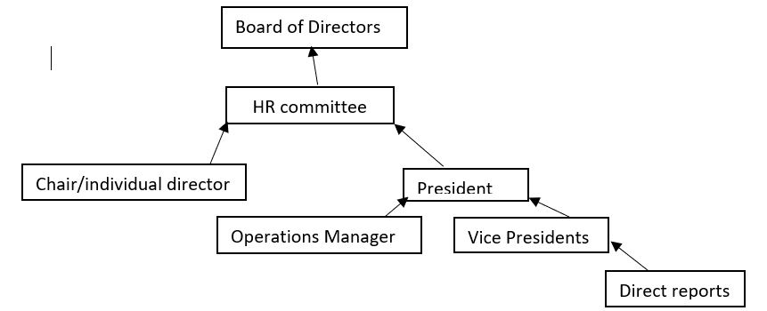

If for whatever reason the immediate report is an interested party or unavailable,, party complaints may be sentlodged to the next highest available party in the structure.
Powers
All entities will have the power to issue verbal or written warnings to those whom report to them.
The board, subject to a 2/3^{rds} vote, may terminate or impose what sanctions or requirements they see fit on any elected official or full time staff provided said action is consistent with the law.
The executive committee, subject to a majority vote, may remove or impose what sanctions or /requirements they see fit to student employees provided said action is consistent with the law.
The HR Committee shall be permitted to engage an external investigator where required to conduct a fact-finding investigation in relation to any alleged misconduct outlined in the particulars of a complaint at any time.
Steps:
The following steps are advised, but depending on the severity of the incident may be circumvented:
- Informal conversation with corrective steps
- A verbal warning
- A written warning
- Suspension or possible termination
Termination
Termination of employment is warranted for serious misconduct. Serious misconduct includes, but is not limited to,
- theft,
- violence,
- fraud,
- misrepresentation regarding credentials and/or previous employment experience,
- bodily risk to persons,
- intimidating or belittling others,
- and/or actions that severely damage Trent Durham Student Association’s reputation.
All disciplinary actions must follow employment standards act guidelines and adhere to all other relevant legislation
Termination of the Operations Manager is subject 2/3-majority vote by the board and strict adherence to the employment standards act.
Communications
All warnings, sanctions and terminations must be communicated to either the board of directors or the Human Resources committee
The chair of the human resources committee shall make every reasonable effort to keep all parties informed of progress of the investigation up to and including emails every 72 hours to make sure those involved are kept informed and to allow the parties to be directed to any mental health resources should they be needed.
Human Resources Committee Procedure
The Chair of the Board of Directors shall act as the Chair of the HR Committee. If the Chair is an interested party, their duties shall pass down to the President, then the Vice President of University Affairs then the Vice President of Campus Life then HR director. The Chair of the HR Committee is then responsible for forming the committee.
Conflict of interest
If one of the members of the HR Committee has submitted, is cited in, or the subject of, the complaint in question they shall be considered an interested party and shall be relieved of their duties on said committee by the Chair for the duration of the proceedings.
If there is an interested party on the HR Committee, the committee shall replace said party with a disinterested Board Member or member of the corporation.
Upon the receipt of a complaint the Chair of the HR committee shall:
Immediately contact the HR committee and establish a meeting at the earliest time a majority can attend and notify the Operations Manager that a meeting has been called.
In that first meeting the committee will establish:
- if an investigation is warranted; if not, see No investigation below;
- if any parties involved need to be placed on paid leave of absence without access to corporate emails or documents for the best interest of the corporation;
- ensure a summary of the report which is conscientious of anonymity and safety is distributed to the HR committee and those mentioned in the complaint;
- ensure the process is completed with the utmost care and consideration of the mental health of all individuals involved to every reasonable extent;
- determine whether legal or law enforcement consultation is required.
No Investigation
If no investigation is required, the committee should refer the matter to the Operations Manager or other party for mediation or conflict resolution.
CONDUCT OF INVESTIGATION
a. Once a decision has been made to initiate an investigation, the HR Committee shall promptly notify the party whose conduct is in question.
b. The party shall be entitled to respond to the allegation in writing or orally.
c. Trent University employees including, but not limited to Student Services Manager and Student Life Coordinator may act as a resource to any parties involved in the investigation
The Human Resources Committee may consult with a lawyer or law enforcement in the process. It is particularly recommended if allegations are serious.
HR Committee Considerations
a. Upon determining the necessity of an investigation, the HR Committee should investigate the conduct of the member in question such investigation should include:
i. Determining and meeting with witnesses if relevant;
ii. Meeting with the party whose conduct has been the subject of complaint.
b. Considerations when determining appropriate level of discipline:
i. Previous record of party,
ii. Whether or not the incident is isolated;
iii. Whether or not the member was provoked;
iv. Seriousness of the offense; and
v. Other mitigating factors (age, disability, illness, etc.).
c. Other considerations:
i. To the extent possible all investigations shall be kept confidential.
The final decision reached by the HR Committee must be presented to the parties affected within 48 hours of the decision being made unless a recommendation that requires the Board is determined.
Appeals of HR Committee Decisions
Should a party wish to appeal a complaint, they may do so within 10 calendar days of the decision to the Board. Should they at that point still wish to appeal they must submit a written report to a disinterested board of director within 10 days of the decision.

- In the event any member of the corporation believes an Executive is inadequately fulfilling the duties outlined in the job descriptions, a member of the corporation may submit a written report to the board of directors for review. Further details of Executive termination are outlined in TDSA Bylaw VII. The Board of Directors shall decide all appropriate forms of disciplinary action, subject to 2/3-majority vote.
6 yes 0 no 1 abstain, 3 no response by deadline
Vote passes

Email Vote sent to all directors October 8th, 2019

Hello All,
As has been talked about in a couple meetings we are going over the bylaws. I have been in contact with the lawyer employed by the TCSA and he has agreed to look over the bylaws for legality and comment for between 650 and 800 dollars.

I purpose that we use the special events budget to pay for this.as this has 7500 left and is a one time expense perfectly suited to this project line..

I would also STRONGLY recommend to this board that if they go forward

MOTION: Be it resolved that the TDSA board of Directors allow the president to use up to $800 of the special project line to employ the services of Joe Grant LLF Lawyers LLP

WHERE AS: The bylaws of the TDSA have never been reviewed by a lawyer and any revision there of should be looked over by a legal professional

Please respond to this email by the end of the week.

8 yes, 0 no, 2 no response by deadline
Vote passes

TDSA Board of Directors Meeting October 30th, 2019

Present: Scott Boulton, Lindsay Gammon, Shannon Fiedler, Sigfrid Belemsaga, Nathan Barnett, Lynch Alcala-Hao, Mackenzie Prine (exits at 7:37pm), Aleah Symons, Karina Mahabir, Jamila Alleyne, Nick Ryan, Hema Tikaram, Bonnie Caruana, Rayna Porter (enters at 7:13pm, exits at 8:02pm)
Absent: none
Procedural Items:
            - Call to Order at 6:40pm

- Land Acknowledgement
              - We respectfully acknowledge that we are on the treaty and traditional territory of the Mississauga Anishnaabeg. We offer our gratitude to the First Nations for their care for, and teachings about, our earth and our relations. May we honour those teachings.

- Chairs Remarks
  - New representative from TGSA, Shannon Fiedler.
  - Raise your card if you have something to say

- September meetings minutes/action items
- Read off Action Items from Minutes (Appendix 1)
Motion to approve
Motioned by Nick
Seconded by Lynch
Motion Approved, 1 abstain

- Call for New Business
  - Amend Title at top of Agenda to Board of Director Meeting
  - Add Land Acknowledgement as item before Employment Policy

- Approval of the Agenda
Friendly motion, 1 abstain

Updates
- Executive Updates (Appendix 2-5)
  - No questions
- Board member updates
  - TDSA Cares: met with some people already, another meeting tomorrow
  - Academics: Meeting is next week, looking to meet with services and find out best way to tackle students concerns and build better relationship between students and University, please send interested students to Sigfrid

Action Item: Bonnie and Hema to advertise Academics Committee on social medias
  - Finance: met just before this meeting. Went over budget, looking good
  - Student Engagement: Looking for date to meet. During the times when we are advertising like during Get Involved Week can we advertise better, including the Qualitrics sign ups? Hems is working on this already, on Executive Committee action items. Do you want a board as well? Yes something visual.

Action Item: Executives to create a trifold Board for all committees for Get Involved Week

  - HR: met 4 or 5 times already. Some more stuff came up over reading week and will be addressed in the next week.
  - Aleah: working on a project, the food shelf in the hallway. Waiting for a while for approval, going to have more details to work out details
  - ORD: Met 3 times, bylaw and policy review

Discussions/Decisions:
- Bylaw Approval Item Retraction (Appendix 6)
  - In response to the request from the Board and ORD, bylaws are at a lawyer for review. Lawyer has asked for Letters of Patent for should be done soon. Until we have the finalized copy from the lawyer pulling the item from the agenda as it was left unfinished last meeting.

- Operations Manager Conflict Training Proposal (Appendix 7)
  - Last year mandated that the OM undergo Conflict Mediation Training. Was determined to be out of scope but conflict resolution was within reach. Provided a list of training and pared down to a completable training list. Also have included suggestions for wording for including it in policies. Anything that is yellow has yet to be determined.
  - Will be taking some Fridays off to make sure I get the training completed in the 6 month deadline.
  - What will be re-occurring training? Re-training every 12 months, total of 2 hours and 15 minutes
  - Would we be paying for any new person to be training and re-trained in these courses every year? Yes. What is the cost? There would be no course cost as the courses are free, but we would have to pay for their time, 19 hours and 31 minutes or salary and 2 hours and 15 minutes or salary on re-training
  - How did you find the parts for policy? Timeframe? Wording?
  - A lot of this can go in job descriptions. Don’t have to add it into the etiquette or transitions. If we put it into the job description it could make it long and also might not fit to have it in there where it should just be responsibilities and requirements to get the job. We are also planning on developing professionalism training which could go into the same section as well as how we are planning on doing transition training from now on.
  - With the issue that occurred within the TDSA last year and an outside mediator was brought in. How could mediation work considering there may be perceived biased? We are not in the position to have a fully trained mediator. More of a policy to help avoid situations getting to the stage where a mediator is required. Can we change the word? It has been changed and addressed in the introduction. Later in the document there is a reference to conflict mediation but it refers to outside sources that people can pursue if they feel more comfortable to do so, instead of the OM.

Motion to approve the training proposal
Motioned by Hema
Seconded by Mackenzie
Motion passes unanimously

- Disciplinary Policy Approval (Appendix 8)
  - Old policy was not good. Used Western and Waterloo’s approaches to discipline. More of a corporation style of document. Establishes a hierarchy of who reports to whom. President would now be responsible for things that happen in the office as per job description. Clearly out lines powers. No one has the ability to issue more then a written warning individually. The President and VP’s alone cannot fire anyone. The Board is ultimately responsible for the goings on.
  - Forgot students on the hierarchy tree

Motion to Amend the hierarchy graphic to add students as the top level
Motioned by Mackenzie
Seconded by Nathan
Motion passes unanimously

Action Item: Add in Trent Durham-GTA students to the top of the hierarchy graphic as well as adding in students and referendum to the powers section

  - Executive Committee subject to a majority vote can remove a student employee. Powers of the board and the HR committee are the same but there is a better reporting structure. Lays out steps that can be taken during the process as recommendations. Lays out what can be considered fireable offenses. Also ensures we follow the Employment Standards Act. Also mandates communication timeframes and content.
  - Is there any consequence if communication is not kept up? Appeals process. Could person do either? Wait until the end and appeal or make a complaint during.
  - Conflict of interest section. What is decided at each meeting and stage. Questions: Is this complaint a disciplinary matter? Can we deal with it? (what outside resources do we need or can we refer the matter to) What information do we need to make a decision? Then chair goes out and gathers information and sets another meeting. What happens if no investigation is required.

Rayna enters at 7:13pm

  - Any mitigating or aggravating factors. Appeals are within 10 calendar days.
  - Are we putting in any contingency or compassion clauses? If any parties are incapacitated the procedure can be suspended? What about extenuating circumstances or traumatic circumstances? “With discretion to the reporting party” can be added to alleviate this.
  - The President can not fire student employees, but has other measures to deal with it, how so? Firing can only be made by the entire executive committee, but VPs and president can give write ups.
  - Why, in the conflict of interest section, is the HR director not listed higher on the list of who takes over as chair of the HR committee in case of COI? Taken from laws. Should HR Director chair the committee outright? Should the President take control of it and then delegate it to another individual at their discretion? Would it be relevant or would the person available be relevant? Currently: Chair of BOD chairs committee but if COI then President assumes role, then VPUA, then VPCL, then HR Director. This is the current reporting structure for the regular board meetings so it was adapted for the HR committee. In general HR director does not chair HR committee, they act as the vice chair. The reasoning behind this would be that there are potentially disciplinary decisions going to that committee and to have a non-paid position making those decisions might not be the most suitable. So as the vice chair they could step in if needed, but the person making the decisions would be a paid member of the corporation typically. Decided at the board last year during referendum discussions. Why did we change disciplinary committee to HR committee? Disciplinary committee has negative connotation and HR has more responsibility now instead of just disciplinary actions. Now has to form to perform other responsibilities so is already functioning if a disciplinary action is needed, instead of ad hoc. HR became a more professional development focus and can meet more often, the first thing that the committee does is not to punish someone, but to further corporation. HR committee looks better on a resume then disciplinary committee.
  - Do we still want the COI structure to be for the HR committee chair to be re-worked? Should HR Director be higher in the structure? Before the President? So, it would be Chair, HR Director, President, VPUA, VPCL.

Motion to amend the Conflict of Interest section for the Chair of the HR Committee to be: Chair, HR Director, President, VPUA, VPCL
Motioned by Mackenzie
Seconded by Lynch
Motion passes unanimously

  - Compassion clause, should we do as an action item to draft and bring to next meeting?

Action Item: Nick to create compassion clause for disciplinary policy and bring to board for November 14 meeting.

  - Are there any issues with the reporting structure? This wold change the reporting structure from equal amounts of power to a hierarchal structure with the President acting as more of a manager. The executives are elected so is it appropriate to give the President oversight and veto on their portfolio and projects. This would give the President a clearer role but is this the best way to accomplish this. Should the President be responsible for what goes on in the office? If that is the case should they not be able to exercise some form of consequences to help ensure the corporation functions properly?

Mackenzie exits at 7:37pm

  - So is the concern that the President would abuse that power, would the HR committee not be called in at the point. This policy would only take into effect if the VP went outside of Bylaw or Policy including Job Description Policy. It could say the President has the authority to make reasonable requests of the Vice Presidents to ensure proper functioning of the office. What is reasonable? And it would be an appeals process to reverse it. Anyone can make a reasonable request of anyone currently, they can choose to do it or not, if it is felt that it is in conflict of our office environment a complaint can be filed with HR Committee. If the President would need to step in should it not be taken to HR anyways? The HR committee can ask things of the executives and the executive can then appeal that decision to the board. With the changes that have been made to Disciplinary Policy and are currently being voted on, the process is much more expedient and if there was an issue it could be reported to HR Committee and it could be rectified fairly quickly. Should we have differentiated titles then, if all executives have similar powers? What does the President even do? Sits on committees, manages budget. Should there be teeth and structure to the job? This would get rid of the ambiguity in who to report to and who to go to with issues. The Presidents role need to have more structure. They should all have more defined roles however should that mean that the President takes on that role. Should it be the OM? Given that we had all the conversations about conflict management training would that not fall in that arena? The OM is not elected by the students, so they should not have jurisdiction over the elected body. As conflict management OM should remain as neutral as possible, and if put in a position of power over the executives that would not be the case. OM is hired by the executives so it would be odd to have that person then become their boss. Giving the President authority over the VPs does not necessarily give the role structure, we have a President because the non-profit act says we have to have one, they are the face of the corporation, not necessarily the oversight for the corporation. Should we research it more to see what other student unions do? What does the research solve? It would give context. We can get feedback on how the system works for each union. Does the policy change the autonomy of the VPs? Only takes effect when policy is broken. But if job descriptions are in policy and the President feels that the VPs are not fulfilling their job descriptions by doing or not doing a certain thing they could then write up the VP, that would then seem as if they can mandate what is in the VPs portfolio.

Action item: Rayna and Nick to research other student unions to determine best practices and outside opinions on hierarchal vs equal system and role of the President.

Motion to table to hierarchy chart until more research is done on President’s role and hierarchal systems
Motioned by Rayna
Seconded by Scott
Motion passes, 1 opposition, 1 abstain

Motion to pass the remainder of the disciplinary policy excluding the hierarchy graphic and the action item of the compassion clause addition
Motioned by Lynch
Seconded by Nick
Motion passes, 1 abstain

- Environmental Advisory Board Seat Available (Appendix 9)
  - There is a spot on the environmental advisory board that meets on the Durham campus and meets twice per semester.

Action item: all interested Directors to email Rayna in regard to sitting on the Environmental Advisory Board

- Presentation of New Director of Policy (Appendix 10)
  - First year international student, experience with boards, student government experience, vocal, expressive, available on campus, brand new to TDSA, new perspective and fresh eyes, also in a lower year so could help with succession. Needs 2/3 majority vote from board. If you were on the committee can you vote? No COI by definition. Do we meet them before hand? Could have but they have a midterm tomorrow.

Motion to approve Taiera McFarlane as Director of Policy for the 2019/2020 year.
Motioned by Scott
Seconded by Lynch
Motion Passes Unanimously

- Secret Santa (Appendix 11)

Rayna exits at 8:02pm

  - Socks exchange. Get a person’s name and then get them socks that fit their personality. Can also fill with candy if you want but not necessary. All members of the board including non-voting members invited. Can also get a pack of socks if you so choose. We can use a program called draw names to make the randomized choices and you get an email with the name of your secret santa. Can do an anonymous doodle poll for all people so you can volunteer to participate. If you say no you don’t have to do it. Poll will have yes or no options. If you say yes you will get an email with further instructions. If you say no you are done.

Action Item: Hema to make doodle poll for participation and send out to all members of the board including non-voting members

- Land Acknowledgement
  - Thoughts on each board member giving the land acknowledgement at the start of the meeting. Can do an anonymous doodle poll to see who is comfortable giving it then assign it for each meeting. Is it ok that other people give it? Yes. As the TUNA rep is it not more fitting that you do the acknowledgment? It would add more value and show more respect if we all do it, less tokenizing. Would switch each time, no one would have to do it if they are not comfortable.

Action Item: Jamila send out an anonymous doodle poll to all members to see who is comfortable giving a land acknowledgement at beginning of each board meeting is and when agenda is sent out the person who is chosen is notified by the Chair. Jamila to send out information to TUNA rep as well.

- Employment Policy (Appendix 12)
  - This changes nothing. It just condenses the 4 policies into one. There will be time to change what it says but this will allow the President to work with the document much easier while editing the policies.

Motion to approve the policy
Motioned by Nathan
Seconded by Aleah
Motion passes, unanimously

Upcoming Events for the week:
Halloween Fun Week October 28-1, 2019
Fall OUSA General Assembly November 1-3, 2019
Remembrance Day November 11, 2019
Board Meeting November 14, 2019 at 6:30pm
Lobby Con November 18-24, 2019
Improv Show Date to be Determined
Improv Meeting Weekly
Fall General Meeting Date to be Determined, sometime in November
Lynch’s Birthday November 4, 2019

Motion to adjourn
Motioned by Nathan
Seconded by Lynch
Motion passes unanimously
Appendix 1: Action Items
- February Meeting
- Action Item: TDSA to create a bylaw regarding what guidelines external organizations must adhere to in order for them to run a referendum along side a TDSA referendum or election/byelection. Include stipulations for advertising, consultations, and labelling that separates the question(s) as being asked by the external organization.
- In Progress- Written, needs to go to team 2 for review

- Action Item: TDSA Board of Directors (BOD) to approve any referendum question(s) from external organizations that is run in conjunction with TDSA elections or referendums noting that the BOD is under no obligation to accept the question and that acceptance of the question does not signify support of the question. Add into bylaws/policy
- In Progress- Written, needs to go to team 2 for review

- Action Item: TDSA or Elections Committee will remove any question presented without proper implementation (see above). Add to bylaw/policy
- In Progress- Written, needs to go to team 2 for review

- Action Item: change name of committee in committee policy from Student Clubs Committee to Student Engagement Committee
- Completed, will post when final document from bylaw and policy overhaul has been completed

- March Emergency Meeting
- Action Item: OM to review policies and ensure wording reflects professional working environments and not personal relationships throughout bylaws and policies
- In progress

- Action Item: OM to go through Job Descriptions Policy and ensure that requesting light workloads and leaves of absences are added in to allow executives options if they are feeling overwhelmed
- Not completed, will update in phase 2 of bylaw and policy overhaul

- Action Item: OM to ensure any policies regarding training and meetings to include follow-up emails, as well ensure that all policies concerning committee meetings include the addition of follow-up emails.
- Not completed, will update in phase 2 of bylaw and policy overhaul, will do a meetings procedure as there is no meetings policy

- April Meeting
- Action Item: Work with Jen in regard to appropriate training and types of situations we should look at
- Completed

- Action Item: OM to put together list of training to bring to board
- In Progress- will be presented at October 30 meeting

- Action Item: OM Undergo mediation training on Lynda.com
- Not Completed, now LinkedIn Learning

- Action Item: Outline Lynda training in job description
- In Progress- outlined additions to policies in proposal

- Action Item: Create policy concerning when/how to go outside of OM mediation
- In Progress

- Action Item: Outline timeframe and yearly refresher timeframes in Job Descriptions
- In Progress

- Action Item: Policy to handle conflict that arises before OM is trained
- In progress

- Action Item: Procedure to be created in regard to professional communication and meetings
- Not Completed, will update in phase 2 of bylaw and policy overhaul

- Action Item: include workload in candidate information sessions
- Not Completed, part of elections in Winter Term

- Action Item: Change bylaw to weekly executive meetings, chair or OM to report on execution of meetings
- Completed, will post when final document from bylaw and policy overhaul has been completed, note that this is in policy, not bylaw

- Action Item: Do some research on this type (professionalism and communication) of training and who can perform it.
- Not Completed

- August Meeting
- Action Item: All directors to send in ideas via email or visit the office to speak with Nick to put ideas together. (in regard how to choose committee members)
- Not completed

- Action item: Nick to send out Doodle poll in regard to formation of working group to all Directors
- Not completed, waiting until November after we have tried it out a bit

- Action Item: Scott and Nick to put together some research and best practices on the topic of proxies.
- In progress

- Action Item: Scott to message directors to see if any others are interested in assisting with the research into proxies.
- Not completed- will do in the upcoming weeks

Appendix 2: President Update
Holy policy its all ready for ORD
Bylaws are off to lawyer
Committee meetings
Human rights
Sexual violence task force
Food services RFP
Housing standards
Student leaders meetings
App committee
Peer support meetings with students
Policy director interviews
Research on new SCI
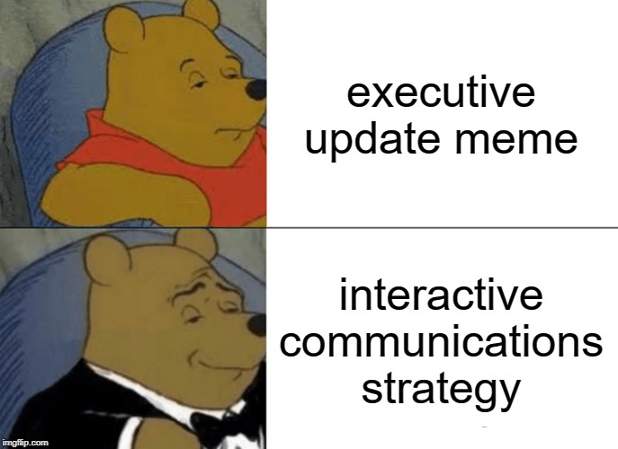
Appendix 3: VPUA Update
- LGBTQ+ Policy submitted and distributed to member schools for input
  - Students Disability & Accessibility Inclusion paper and Ancillary Fee paper now available for review
  - Any students interested in policy review or contributing may come to the TDSA office before October 31 to set up meeting
- OUSA Conference Prep complete
  - Team selected and registered
  - Training complete and pre-meetings scheduled
- NVCI Training
- Federal Election Table Hype
- Published articles for Student Life Blog
- Meetings in Peterborough
  - Began developing student representative guide for all committees with education about how to committee functions, important information, and organizing best use of time
- OUSA Letter-Writing Campaign Wrap Up

Appendix 4: VPCL Update
- Sent out Thank you emails to companies that donated to our swag bags and set up a booth
- On going project of making a TDSA Pamphlet!
  - GOAL: to be completed and ready for Durham Open House (Nov 2nd)
- Interviews for new Policy Director
- Halloween Haunt!
  - Planned and Booked and Advertise
  - Thank you, Bonnie, for research on buses
- Food Services Meeting
  - Attended
  - Read RFP
- Dealt with Club Exec concern
- Mental Health Training
- A TON OF CLUB TRAINING
- HALLOWEEN FAIR
  - Plan, Organize, shop, create…
    - Monday: Movie in Café
    - Tuesday: Cupcake/ Brownie Decorating
    - Wednesday: Hot Chocolate and Diya Painting (Diwali Festival Activity)
    - Thursday: GAME DAY: Poke a Pumpkin, Eyeball Pong, Pumpkin Ring Toss, Candy Guess, Maybe more…
- Received a Ton of funding and event application forms
- Weekly Planning with Jewel for Wellness Wednesday events
- Working on Halloween costume!!
- Send Kate in the marketing department, activities and information for the What’s Happening email
- Contacted THICC about Remembrance Day plan
- Email Clubs for open House participation
- MIDNIGHT MANHUNT PLANNING
  - This year will be consisting of an addition of some new activities
  - Planning (when writing this update, hopefully by the board meeting, I am set)
Appendix 5: OM Update
Month: October 2019
Banked Hours Update
President: Under 35
VPUA: Over 35
VPCL: Under 35
OM: Over 35
Update:
- Weekly Executive Committee meeting held
- Bus research and booking for Haunt trip
- Finished conflict proposal for Board Presentation
- Finished fundamentals of accounting Linked in Learning video
- Worked on referendums document- collection of all previous referendums held by TDSA and the results of said referendums
- Monthly financial work
- Worked on making previous meeting minutes documents on the webpage more accessible (increase font, table of contents, alt text for images etc.)
- Worked on accessibility for webpages- pictures with alt text, accessibility statement at top of all pages etc.
- Attended Skyzone teambuilding event
- Worked with auditor for audit- should have that back by mid November latest
- Went to bank and changed over rolls and bills to different amounts (no more extra $0.05 rolls, more $1 rolls etc.)
- Finished September Minutes
- Peer Support conversations
- Mental Health First Aid training
- Started working on Transition Checklist and proposal with executives
- Posted on Facebook and website
- Added all upcoming tasks to Meister Task to stay better organized
- Cut out leaves for thankfulness tree
- Put together board agenda appendices for October meeting
- Resolved CRA issue

Appendix 6: Bylaw Approval Item Retraction
Due to the fact the bylaws are currently under review by a lawyer per the online vote and wishes of the ORD committee I will be pulling the motion from the agenda for this board meeting

Appendix 7: Operations Manager Conflict Resolution Training Proposal
Operations Manager Conflict Training Recommendation

Background

During the April 2018 Board of Directors meeting the following action items were mandated:
Action Item: OM Undergo mediation training on Lynda.com
Action Item: Outline Lynda training in job description
Action Item: Create policy concerning when/how to go outside of OM mediation
Action Item: Outline timeframe and yearly refresher timeframes in Job Descriptions
Action Item: Policy to handle conflict that arises before OM is trained
Action Item: OM to put together list of training to bring to board
Action Item: Work with Jen in regard to appropriate training and types of situations we should look at

Currently the Operations Manager job description states the following:
Job Description Policy Point C.1.b (13) The Operations Manager will be tasked mediate any interoffice grievances that arise.

Purpose

The purpose of this proposal is to formalize training to be added into the Operations Manager job description including, but not limited to, topics to be trained in, courses or options available for training, timeframes for training to be completed in, and timeframes for updating or redoing the training. The training should be attainable while still being as thorough as possible and provide value to the employees and the corporation.

As conflict can arise in work environments, the executive team should have an internal resource to manage said conflict to try and prevent toxic and hostile work environments. There should be someone to direct the conflict into a more positive space and create a driven workplace where all opinions are welcomed and approached with an open mindset.

Proposal

All changes or additions to policy will be italicized to make them easier to identify.

As of August 8th, 2019 Lynda.com transitioned to LinkedIn Learning.

Any highlighted or ### will be replaced once the wording has been inserted into the appropriate policy.

Mediation is defined as “a dynamic, structured, interactive process where a neutral third party assists disputing parties in resolving conflict through the use of specialized communication and negotiation techniques.”
https://en.wikipedia.org/wiki/Mediation

Conflict Management is defined as “the practice of recognizing and dealing with disputes in a rational, balanced and effective way. Conflict management implemented within a business environment usually involves effective communication, problem resolving abilities and good negotiating skills to restore the focus to the company's overall goals.”
http://www.businessdictionary.com/definition/conflict-management.html

Upon review of the training available on Lynda.com with Jenifer Richardson, it was determined that conflict management training was available and not mediation training. Also it was determined that mediation training is a formal executive certification and requires hours of time and approximately $25,000-$30,000 to complete.

Since the Operations Manager may not appear to be a neutral third party, as per the definition of mediation, due to the proximity with which the Operations Manager works with the executive team and Board members, and the cost and time commitment involved in mediation training, as well as the mandates from the Board of Directors to pursue LinkedIn Learning training, it is recommended that the wording in the Operations Manager job description be changed to reflect this. Hence, for the rest of this document, conflict management will be the term used.

Therefore we recommend that we change Job Description Policy line C.1.b (13) from:

“The Operations Manager will be tasked to mediate any interoffice grievances that arise.”

to instead say:

“The Operations Manager will be tasked with managing any interoffice grievances or conflicts that arise.

If by lack of scope of training of the Operations Manager or in recognition of the comfort of the TDSA Director, Executives or Staff members involved, individuals may seek outside resources as referenced in ### (recommend that this is put into Policy 2: Workplace Etiquette)
### (Into Training and Transition Policy ##?)
Title | Description | Length of Course
1. Course: Conflict Resolution Foundations | Improve your relationships with your coworkers, clients, and managers and find your way through conflict back to cooperation. In this course, negotiation and leadership coach Lisa Gates shares the secrets of effective conflict resolution and reveals simple, repeatable techniques that apply in most business situations. She presents "The Resolution Roadmap," a practical framework for exploring and navigating conflict resolution, including identifying the issue and distinguishing fact from fiction. A scenario helps take you through best practices for opening the conflict conversation, brainstorming solutions, and coming to an agreement. In addition, she shares powerful conflict resolution techniques that can help you enhance your listening skills and reframe problems to find common ground.  Learning Objectives:  Define the "Name, Blame, Claim" cycle.  Distinguish different types of conflict styles.  Recognize contentious tactics.  Identify issues and needs.  Explain how to reframe.  Increase conflict capacity. | 51minutes 13 seconds
2. Course: Managing Team Conflict | When you bring people together, conflict is a natural part of the dynamic. How leaders choose to manage these inevitable disagreements can make the difference between a dysfunctional team and a successful one. In this course, instructor Henna Inam shares strategies and techniques that can help you confidently lead through conflict. Throughout the course, Henna provides direct instruction, exercises, and scenarios that play out common team conflict situations. Discover why team conflict is necessary for success and how to determine whether a conflict is healthy or unhealthy. Review how to resolve style differences, remain both assertive and cooperative in the midst of a conflict, and leverage different conflict management styles to defuse tricky situations.  Learning Objectives:  Explain why conflict can be a healthy process for a group of people.  Describe three types of trust and how to build it among team members.  Summarize how ambiguity can create conflict among team members and how this conflict can be resolved.  Compare and contrast the assertive and cooperative styles of conflict.  Analyze the five types of conflict management styles and assess when it is most appropriate to use each. | 1 hour 10 minutes
3. Playlist: Managing Conflict | Learn the key skills you need to improve your conflict management, negotiation, and communication.  Videos:  Course: Improving Your Conflict Competence with Craig Runde  Learn to respond to workplace conflict more effectively, by managing your emotions and engaging others constructively.  52m 9s  Intermediate  Course: Building Resilience with Tatiana Kolovou  Kelley School of Business professor and professional communications coach Tatiana Kolovou explains how to bounce back from difficult situations, by building your "resiliency threshold," with these training techniques.  41m 25s  Intermediate  Course: Having Difficult Conversations (2013) with Britt Andreatta  Learn how to prepare for and successfully have difficult conversations with employees, managers, and colleagues.  2h 17m  Intermediate  Course: Embracing Change (2014) with Todd Dewett  Discover how to embrace change in your professional and personal life.  11m 34s  Intermediate  Course: Leading Change (2013) with Britt Andreatta  Help your organization embrace change and make sure new initiatives are successful.  1h 42m  Advanced  Course: Learning to Be Assertive with Chris Croft  Management trainer Chris Croft helps you understand how you can interact more successfully with others by being assertive.  54m 21s  Intermediate  Course: Dealing with a Difficult Boss with Todd Dewett  Learn how to navigate a difficult relationship with your boss by understanding your own triggers, managing your responses, and evaluating your options for next steps.  31m 24s  Intermediate  Course: Managing Employee Performance Problems (2013) with Todd Dewett  Discover successful, repeatable scripts to use when employee difficulties arise.  1h 53m  Intermediate  Course: Negotiation Foundations (2012) with Lisa Gates  Demonstrates the skills empowered communicators use to achieve mutual benefit at the negotiation table.  37m 39s  Beginner  Course: Influencing Others with John Ullmen  Learn how to increase your influence and visibility in your organization.  1h 21m  Intermediate  Course: Effective Listening with Brenda Bailey-Hughes  Communications experts Tatiana Kolovou and Brenda Bailey-Hughes help you assess your listening skills and develop more-effective listening behaviors.  1h 8m  Intermediate | 15 hours 6 minutes
4. Course: Communicating with Diplomacy and Tact | Diplomacy is a mindset; tact is a strategy. In this course, communications professor Tatiana Kolovou helps you realize the benefits of communicating with tact and diplomacy in workplace situations. She walks you through four scenarios that you might encounter on an average day, and coaches you through appropriate responses to challenging situations at work. She emphasizes core skills, such as authenticity, empathy, and listening, and shows examples, stories, and facts that bring their importance to life. By taking opportunities to practice at work and in your personal life, you can strengthen this delicate balance of skills and build relationships that can survive difficult interactions.  Learning Objectives:  Recall the core skills involved in diplomacy.  Explore the effects when tact and diplomacy are lacking.  Define the Tact and Diplomacy model.  Differentiate between encoding and decoding.  Differentiate between negative and positive politeness. | 1 hour 5 minutes
5. Course: Persuasive Coaching | Coaching is quickly replacing the performance review in most forward-thinking companies. Persuasive coaching teaches you how to incorporate basic psychological concepts throughout the coaching process to ensure a better, more effective coaching relationship. In this course you can learn core coaching skills, review the coaching process, and understand the psychology of persuasion. Instructor Brian Ahern provides tips to build relationships, enhance trust with your employees, and use feedback and accountability measure to enforce positive behavior changes. Case studies peppered throughout the course show you how to apply those skills in the coaching process.  Topics include:  - Recognize the similarities between business coaching and sports coaching.  - List the differences between pacing and mirroring.  - Identify which element of trust involves rapport.  - Recall how social proof can enhance feelings of trust toward the coach.  - Explain the principle of scarcity. | 43 minutes 7 seconds
6. Course: Compassionate Directness | In any organization, communicating with directness is vital to success. But to build a truly healthy culture, directness must go hand-in-hand with compassion. When you combine these qualities, the result is truly powerful, creating a culture of increased clarity and productivity that also values and respects people's essential humanity. In this course, Arianna Huffington and Joey Hubbard discuss the art of effective, compassionate communication, giving you tools and strategies to be a more honest, kind, and director communicator.  Topics include:  - Recognize the benefit of employees working within a culture of compassionate directness.  - Identify the drawbacks of a culture of directness compared to a culture of compassionate directness.  - Identify the qualities of mindful communication.  - List the components that make up trust in a business environment.  - Recall the positive end result for business operations when a company builds a culture of compassionate directness. | 40 minutes 59 seconds
Total Length of Training Required: 19 hours 31 minutes”

“The training listed in line ### should be completed no later than 6 months from the date of hire or upon update of Policy ## (Training and Transition)”

“The Operations Manager will undergo retraining every 12 months in the following LinkedIn Learning courses:
1. Managing Team Conflict
2. Communicating with Diplomacy and Tact”

“If the training listed in line ### has not been completed by the timeframe set out in ### then TDSA Directors, Executives, and Staff may choose to utilize the Operations Manager, acknowledging that they have not completed LinkedIn Learning courses, but may have previous training that would make them capable of facilitating a conversation, or the member may choose to follow the steps outlined in Line ###.

Seeking Outside Conflict Resolution and Mediation (recommend that this is put into Policy #2: Workplace Etiquette)

TDSA Directors, Executives, and Staff may utilize the following paths in resolving a dispute or conflict:

- Operations Manager: for conflict resolution situations
- Trent University Staff Resource Person: trained staff members who can mediate conversations, for more serious disputes (https://www.trentu.ca/currentstudents/policies-decision-making/student-conduct/student-charter-rights-and-responsibilities#Staff)

If the TDSA Directors, Executives, or Staff member feels that these options are not viable or they have attempted one of the above options but has not received satisfactory results they may then resort to the following options:

- TDSA Disciplinary Policy (###)
- Trent University Charter of Student Rights and Responsibilities Proceedings

Appendix 8: Disciplinary Policy Approval

Policy No. 13 Discipline
Preamble
TDSA is committed to the practices of restorative justice and people-focused solutions. In all its efforts, the TDSA will place the mental health of its members in high regard and priority and will seek to meaningfully correct instances of unacceptable job performance, absenteeism, unprofessional actions,/ unprofessional activities or other employee related actions or problems.

Reporting
The reporting structure shall be as follows:

If for whatever reason the immediate report is an interested party or unavailable,, party complaints may be sentlodged to the next highest available party in the structure.
Powers
All entities will have the power to issue verbal or written warnings to those whom report to them.
The board, subject to a 2/3^{rds} vote, may terminate or impose what sanctions or requirements they see fit on any elected official or full time staff provided said action is consistent with the law.
The executive committee, subject to a majority vote, may remove or impose what sanctions or /requirements they see fit to student employees provided said action is consistent with the law.
The HR Committee shall be permitted to engage an external investigator where required to conduct a fact-finding investigation in relation to any alleged misconduct outlined in the particulars of a complaint at any time.
Steps:
The following steps are advised, but depending on the severity of the incident may be circumvented:
- Informal conversation with corrective steps
- A verbal warning
- A written warning
- Suspension or possible termination
Termination
Termination of employment is warranted for serious misconduct. Serious misconduct includes, but is not limited to,
- theft,
- violence,
- fraud,
- misrepresentation regarding credentials and/or previous employment experience,
- bodily risk to persons,
- intimidating or belittling others,
- and/or actions that severely damage Trent Durham Student Association’s reputation.
All disciplinary actions must follow employment standards act guidelines and adhere to all other relevant legislation
Termination of the Operations Manager is subject 2/3-majority vote by the board and strict adherence to the employment standards act.
Communications
All warnings, sanctions and terminations must be communicated to either the board of directors or the Human Resources committee
The chair of the human resources committee shall make every reasonable effort to keep all parties informed of progress of the investigation up to and including emails every 72 hours to make sure those involved are kept informed and to allow the parties to be directed to any mental health resources should they be needed.
Human Resources Committee Procedure
The Chair of the Board of Directors shall act as the Chair of the HR Committee. If the Chair is an interested party, their duties shall pass down to the President, then the Vice President of University Affairs then the Vice President of Campus Life then HR director. The Chair of the HR Committee is then responsible for forming the committee.
Conflict of interest
If one of the members of the HR Committee has submitted, is cited in, or the subject of, the complaint in question they shall be considered an interested party and shall be relieved of their duties on said committee by the Chair for the duration of the proceedings.
If there is an interested party on the HR Committee, the committee shall replace said party with a disinterested Board Member or member of the corporation.
Upon the receipt of a complaint the Chair of the HR committee shall:
Immediately contact the HR committee and establish a meeting at the earliest time a majority can attend and notify the Operations Manager that a meeting has been called.
In that first meeting the committee will establish:
- if an investigation is warranted; if not, see No investigation below;
- if any parties involved need to be placed on paid leave of absence without access to corporate emails or documents for the best interest of the corporation;
- ensure a summary of the report which is conscientious of anonymity and safety is distributed to the HR committee and those mentioned in the complaint;
- ensure the process is completed with the utmost care and consideration of the mental health of all individuals involved to every reasonable extent;
- determine whether legal or law enforcement consultation is required.
No Investigation
If no investigation is required, the committee should refer the matter to the Operations Manager or other party for mediation or conflict resolution.
CONDUCT OF INVESTIGATION
a. Once a decision has been made to initiate an investigation, the HR Committee shall promptly notify the party whose conduct is in question.
b. The party shall be entitled to respond to the allegation in writing or orally.
c. Trent University employees including, but not limited to Student Services Manager and Student Life Coordinator may act as a resource to any parties involved in the investigation
The Human Resources Committee may consult with a lawyer or law enforcement in the process. It is particularly recommended if allegations are serious.
HR Committee Considerations
a. Upon determining the necessity of an investigation, the HR Committee should investigate the conduct of the member in question such investigation should include:
i. Determining and meeting with witnesses if relevant;
ii. Meeting with the party whose conduct has been the subject of complaint.
b. Considerations when determining appropriate level of discipline:
i. Previous record of party,
ii. Whether or not the incident is isolated;
iii. Whether or not the member was provoked;
iv. Seriousness of the offense; and
v. Other mitigating factors (age, disability, illness, etc.).
c. Other considerations:
i. To the extent possible all investigations shall be kept confidential.
The final decision reached by the HR Committee must be presented to the parties affected within 48 hours of the decision being made unless a recommendation that requires the Board is determined.
Appeals of HR Committee Decisions
Should a party wish to appeal a complaint, they may do so within 10 calendar days of the decision to the Board. Should they at that point still wish to appeal they must submit a written report to a disinterested board of director within 10 days of the decision.

- In the event any member of the corporation believes an Executive is inadequately fulfilling the duties outlined in the job descriptions, a member of the corporation may submit a written report to the board of directors for review. Further details of Executive termination are outlined in TDSA Bylaw VII. The Board of Directors shall decide all appropriate forms of disciplinary action, subject to 2/3-majority vote.

Appendix 9: Environmental Advisory Board Seat Available
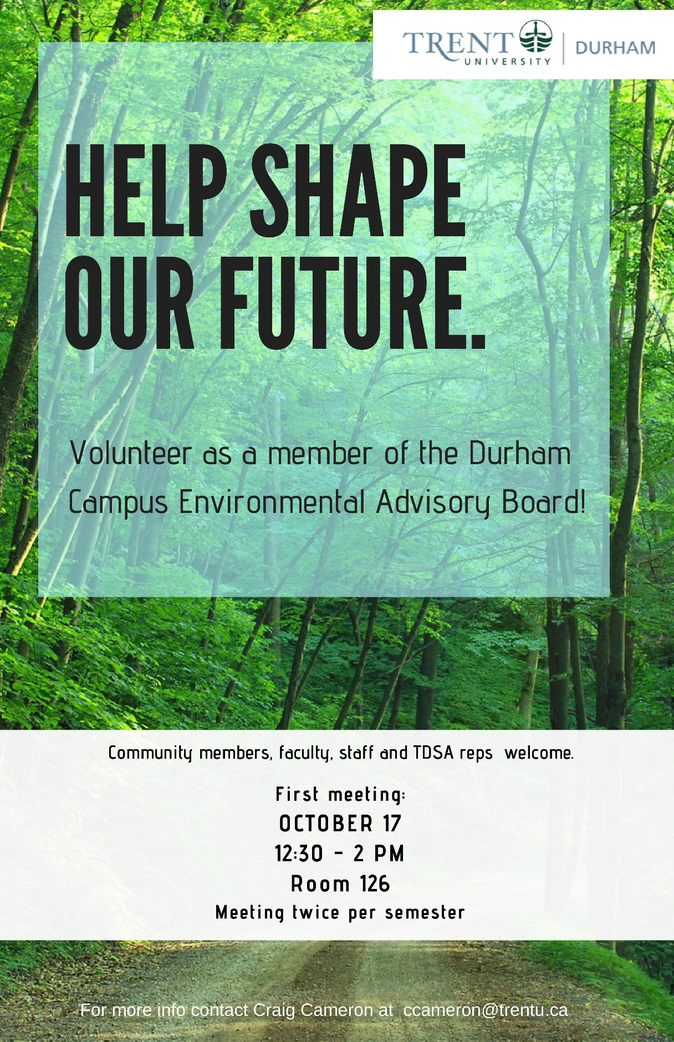
Appendix 10: Presentation of Selected Candidate for Director of Policy
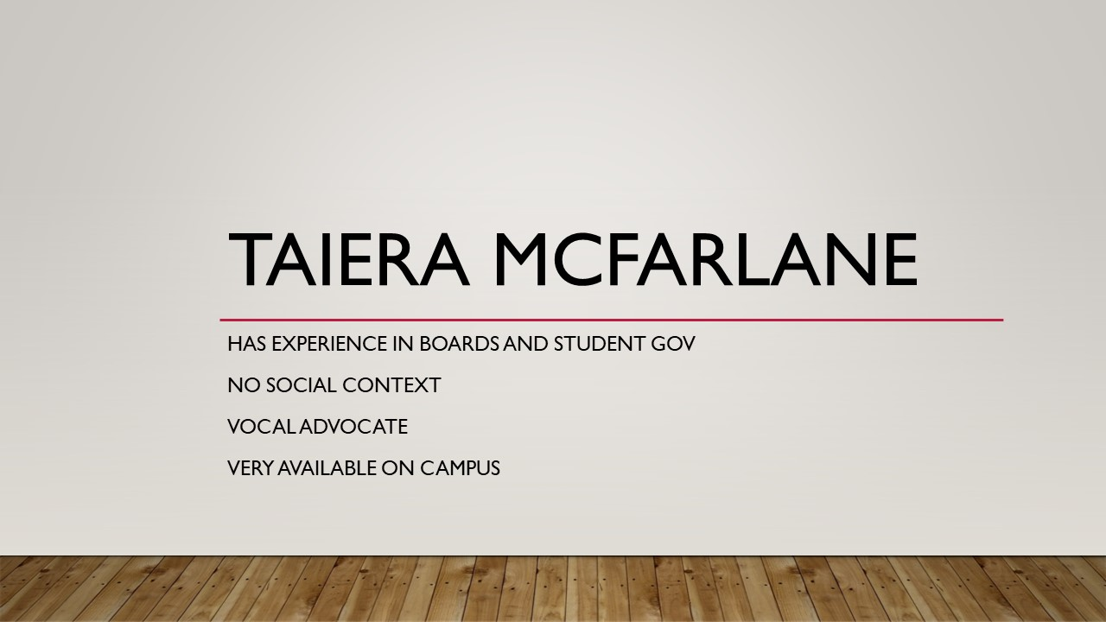
Appendix 11: Secret Santa
Before we know it, the Christmas holidays will be upon us! Rayna and I were talking about doing a board Secret Santa. We know that some people are on a budget but would still love to participate in a fun event. So, we will do SOCKS.
The idea is that everyone will put their name is a box, and you will then select a name (that is not yours), and you will then get them a pair of socks that fit their personality! If you wish to put other little treats inside the socks, that is acceptable as well as totally optional.

Appendix 12: Employment Policy Approval
Please note this draws from and takes the place of polices 4, 5, 14, and 15
Policy No. 4 Executive/Employee Guidelines

Policy No. 4 Employment
4.1 Rate and Hours
Pay Period/Rate
All employees who are not the chair are to be paid bi-weekly by cheque at a rate determined by the positions job description approved by the board of directors
The chair shall be paid monthly at a rate determined in the job description
The hourly rate will be subjected to Consumer Price Index (CPI) on an annual basis, calculated on May 1st of the fiscal year subject to approval by the board.
Probationary Period
All non-elect employees are subject to a three (3) month probationary period with the Trent Durham Student Association. Non-elect employees may be terminated without due cause within the three month period, subject to 2/3-majority vote of the executive committee notice given to HR com
Office Hours
Employees shall strive to maintain consistent office hours and all employees shall log in the start and end time of a daily shift. Any staff member wishing to modify a workweek shall seek approval by the Executive Committee.
Additional Time Commitment
All employees are expected to make allowance for activities that require an additional time commitment, including member campus visits, meetings, conferences, etc. This is considered a normal part of fulfilling the work and responsibilities of the position within the organization and may require the employee to work evenings and weekends. Employees are required to meet these situations with the same commitment, enthusiasm and professionalism expected in the fulfilment of their responsibilities
Flex Time
Employees of the TDSA shall be entitled to take 25% of their hours form home. Any excess of this amount must be agreed to by:
The employees direct supervisor in the case of contract staff or
2/3rds of the executive committee in the case of an executive or the OM
Banked Hours
Overtime hours are not permitted in excess of regular office hours, subject to the job descriptions.
Employees are permitted to bank hours on a weekly basis
Approval of banked time in excess of five hours and the use of banked hours shall fall to the Executive Committee.
Should banked hours exceed 100% of that employee’s work week the employees direct manager or in the case of an executive, the executive committee or the board may mandate the employee utilize said banked hours in line with the needs of the office.
4.2 Vacation, Leaves and Absences
Sick Days
Executive Directors and full-time staff will be eligible for 5 (five) paid sick days.
There is no financial compensation for sick days not used and no accumulation of sick days. Additional vacation time will not be granted for sick days not used in the year.
Vacation Time
In addition to statutory holidays full time and executive employees are entitled to 10 days paid and 10 days unpaid vacation time per contract year. No carry over is permitted for unused vacation time.
Executive Directors may request further unpaid time off subject to approval of the executive committee
Vacation days used successively in groups of two or more must be requested at least two weeks in advance and approved by two other Executives.
Vacation days may not be used during “blackout periods,” which include the month of May and the month of September. Executives shall also consider the needs of the office before using vacation days.
Personal Leave without Pay
Leave of absences without pay may be granted by the Executive Committee for personal reasons of the employee.
Pregnancy and Parental Leave
Leave of absences for pregnancy and parental leave shall be in accordance with the Employment Standards Act (Ontario) and Human Resources Canada-Employment Insurance regulations. All group benefits that the employee is entitled to at the time of the pregnancy or parental leave shall continue during the leave period unless the employee indicates in writing their intention not to return to work.
Employee Bereavement
Any employee shall be granted a minimum of three (3) days of paid bereavement leave to attend the funeral of an immediate family member or close friend(s).
Immediate family and close friend(s) includes:
spouse which includes same sex or common law partner/fiancé́;
mother or father, stepmother, stepfather;
children or step children;
brother or sister, stepbrother or stepsister;
mother-in-law or father-in-law;
aunt or uncle;
grandmother or grandfather;
close friend(s)
Where the funeral occurs outside of the province, bereavement leave shall also include reasonable traveling time, not to exceed seven (7) days. Additional leave may be with or without pay as may be determined by the board of directors. Employees will not be paid for bereavement leave it if falls on a vacation day.
General Student Bereavement
Upon notification of the death of a student, where appropriate, the President of the Trent Durham Student Association shall prepare a letter of condolence to the surviving family. The letter shall be sent to the spouse, the parent(s), or the immediate family of the deceased, depending on the situation
Religious Leave
TDSA will make every attempt to accommodate requests for religious leave. The employee must inform the President and Operations Coordinator of a request for religious leave as early as possible, to ensure adequate staff can act as a temporarily suitable replacement. Requests for religious leave must be made in writing to the President and Operations Coordinator and must include a reason for the request. TDSA employees may take up to two (2) days paid personal leave for the purpose of religious leave. If the TDSA employee requires more than two (2) days, said employee may use vacation leave or unpaid leave for the purpose of religious leave.
Short Term Disability/Illness
In the event a full time employee is absent due to illness or injury the employee shall be granted up to an additional five (5) days paid within the benefit year. A doctor’s report and recommendation shall be submitted to the executives for authorization of additional paid sick leave. The executives shall authorize additional sick time subject to 2/3-majority vote. There will be no accumulation of unused additional sick days, no addition to vacation time, and no financial compensation shall be given.

Court Leave
If an employee is required to serve as a juror or attend as a witness in a legal proceeding, the Trent Durham Student Association will grant the necessary leave of absence. TDSA will pay such employee the difference between normal earnings and the payment received for jury service or a witness/attendance fee, excluding travel, meals and other expenses. If said employee is required to participate as a party, witness or juror in a private matter, the employee may take up to one day with pay, additional days will be subject to Policy 5.10. All TDSA employees shall notify the President and Operations Manager of an issued subpoena or summons, to ensure appropriate accommodations are arranged. TDSA employees will be required to provide proof of absence, including a copy of the subpoena or summons.
4.3 Benefits

Additional Benefits
Executive Directors are also entitled to Health and Dental Benefits
All non-student full-time employees shall be provided access to the applicable student health and dental plan free of charge.
If employees wish to opt in dependence at the expense of the cooperation they must obtain the approval of the president
Professional Development
The Trent Durham Student Association is committed to enhancing the learning and professional development of its employees by exposing them to opportunities outside of the work environment, for the purpose of enhancing and improving job performance.
Any employee of the Trent Durham Student Association may seek approval for a professional development opportunity subject to the approval of the Executive Committee.
4.4 Reviews and responsibilities
Performance Reviews
Performance reviews shall be conducted at four months, eight months, and one year for each member of all employees of the TDSA.
Confidentiality
All employees and elected representatives shall:
Respect and maintain the confidentiality of information gained as a volunteer or employee, including, but not limited to, all computer software and files, the Trent Durham Student Association business documents and printouts, and all volunteer, employee membership, donor and supporter records;
Respect and maintain the confidentiality of individual personal information.
Respect the confidentiality of non-TDSA members. Non-TDSA members shall sign and submit a confidentiality agreement in the event sensitive information is discussed.
The Chair to the Board of Directors is responsible for ensuring the confidentiality agreement is signed by Board of Directors, executives, employees and university liaison.
Accountability
Elected representatives, staff, volunteers, and other members of TDSA are committed to the following principles:
Act with honesty and integrity in accordance with any professional standards, governing laws, and legislation that have application to the responsibilities performed for the Trent Durham Student Association;
Comply with any training or orientation provided by the Trent Durham Student Association;
Adhere to the policies, by-laws and procedures of Trent Durham Student Association and any relevant federal or provincial statues.
Support the positions and decisions of the Board of Directors;
Take responsibility for actions and decisions and follow reporting lines to facilitate the effective resolution of issues;
Ensure the authorities of executive roles are not exceeded;
Respect the opinions of others and treat all with equality and dignity without regard to gender, race, colour, creed, ancestry, place of origin, political beliefs, religion, marital status, disability, age, or sexual orientation;
Promote the mission and objectives of Trent Durham Student Association;
Provide a positive and valued experience for those receiving service within and outside the Trent Durham Student Association.
The executive directors are committed to the following:
Report to the board of directors on a monthly basis or as requested by a 50% plus one vote of the Board of Directors;
Accept assigned duties by the board of directors as determined by 2/3- majority vote of the board of directors in compliance with the job descriptions;
Be administered and regulated by the board of directors;
Documenting daily activities to the board of directors.
To hold the other executives accountable to their job descriptions and the bylaws and polices of the cooperation.
Outside Employment/Responsibilities
Employees may take on additional employment outside of Trent Durham Student Association provided such activity does not interfere with the performance of their responsibilities to Trent Durham Student Association, including additional requests for the employee’s time such as member visits, conferences, travel, etc. All employees that possess additional employment must make the details known to the executives;
Any interference from additional employment outside Trent Durham Student Association will result in disciplinary action, subject to Operating Policy No. 4.4 and/or a request that the employee change the details of their additional employment.
Public Relations
Elected representatives, staff, volunteers, and other members of TDSA shall be committed to accurately conveying the positions, stances, and/or opinions of the board of directors. Public endorsements and/or comments by the Trent Durham Student Association shall reflect the positions, stances, and/or opinions of the Board of Directors determined by 50% plus one vote. The executive directors are committed to obtaining board approval before publicly providing comment on any issues, concerns, and/or recommendations, except when the positions, stances, and/or opinions reflect current policy of TDSA and/or any subscribed external representative groups or fall into the daily operation of the business. If there is a conflict between the board of directors and the policies of subscribed external representative groups, the will of the board of directors shall take precedence.
All TDSA employees and volunteers shall refrain from making comments or performing actions that compromises the political impartiality of TDSA as a corporation.

TDSA Board Meeting November 14th, 2019

Present: Bonnie Caruana, Jamila Alleyne, Nick Ryan, Rayna Porter, Hema Tikaram, Scott Boulton, Sigfrid Belemsaga, Nathan Barnett, Aleah Symons, Taiera McFarlane, Karina Mahabir (on the phone)
Absent: Mackenzie Prine, Lynch Alcala-Hao, Lindsay Gammon, Shannon Fiedler

Procedural Items
            - Call to Order at 6:44pm
            - Land acknowledgement
              - The Trent Durham Student Association would like to acknowledge that we are situated on the native and traditional lands of the Mississauga and Annishinabeg and the land is governed under the Williams Treaty. We are thankful for the teaching and care for of the land. As a history student I have been exposed to more to the dark history surrounding the relationships between the primarily European Settlers and the First Peoples of this land, and it was during my second year of the history programs that I took my first real look into our relationship with the First Nations people and the land that we are currently situated on, and it was here that I began my personal journey to the truth and reconciliation agreement.
            - Chairs Remarks
              - Using Robert’s Rules
  - If you need to ask a question, raise your card, and I will acknowledge you
  - Were all the materials read? Is everyone Ok if we do a summary of each item instead of in-depth? Yes
- October meetings minutes/action items (Appendix 1)
- Read off Action Items from Minutes
Motion to Approve the October 2019 Meeting Minutes
Motioned by Nathan
Seconded by Scott
Motion passes

              - No notes on action items
- Call for New Business
  - No new business
Updates
- Executive Updates (Appendices 2-5)
- Banked Hours: quite a bit of banked hours for executives and OM
- It is the boards responsibility, in conjunction with the President to manage the budget. If an executive can not get banked hours down they may need to be paid out for those hours, so they need to take time off to ensure that we are not paying them out at the end of the year.
- How will the executive curtail the hours? Christmas break will allow each executive to take time from their banked hours. Taking time off here and there. Being more strategic. Only to rely on good faith? If the board is interested in having a strategy presented to them, we can do that. VPUA is taking two days off every week until January. If we don’t see movement on the hours by next board meeting, we can re-visit. Noting that Pres, VPUA, and VPCL are over their 100% allotted hours, and OM is just under 100%. We should have a policy in place to make sure this is clear. We do. The board is left to make the decision on how to handle this. OM updates have brief over and under statements to inform the board. Every board member can see VPUA calendar to keep tabs on out of office time for that position.
- Board Updates
- None
Motion to Approve the Agenda
Motioned by Nick
Seconded by Hema
Motion passes unanimously
Discussions/Decisions
- Compassion Clause for Disciplinary Policy (Appendix 6)
- Clause read out
Motion to approve the adaptation of the compassion clause
Motioned by Scott
Seconded by Rayna
Motion Passes

Motion to allow Bonnie to remain in the room during closed session
Motioned by Rayna
Seconded by Nathan
Motion passes

Motion to move into closed session
Motioned by Rayna
Seconded by Nick
Motion passes

Meeting moves into closed session at 6:59pm
- Bank Visit Summaries – Closed Session
- Draft Audit Review and Approval – Closed Session
Draft audit approved
Closed session ended at 7:35pm

Upcoming Events for the week
Fall GM at Nov 26
Opt-Out Nov 28-Dec 12
Secret Santa on Dec 5 before the Board meeting
Action item: Bonnie to create a google sheet to put in what people want to bring for a potluck for Dec 5 Board meeting
Board Meeting Dec 5
Lobby Con Nov 17-21
Nov 20 Trans Day of Remembrance- One of the Oshawa Public Libraries does an event in the evenings
Motion to adjourn the meeting
Motioned by Hema
Seconded by Nathan
Motion passes

Meeting adjourns at 7:40pm

Appendix 1: Outstanding Action Items
- February Meeting
- Action Item: TDSA to create a bylaw regarding what guidelines external organizations must adhere to in order for them to run a referendum along side a TDSA referendum or election/byelection. Include stipulations for advertising, consultations, and labelling that separates the question(s) as being asked by the external organization.
- In Progress- Written, needs to go to team 2 for review

- Action Item: TDSA Board of Directors (BOD) to approve any referendum question(s) from external organizations that is run in conjunction with TDSA elections or referendums noting that the BOD is under no obligation to accept the question and that acceptance of the question does not signify support of the question. Add into bylaws/policy
- In Progress- Written, needs to go to team 2 for review

- Action Item: TDSA or Elections Committee will remove any question presented without proper implementation (see above). Add to bylaw/policy
- In Progress- Written, needs to go to team 2 for review

- Action Item: change name of committee in committee policy from Student Clubs Committee to Student Engagement Committee
- Completed, will post when final document from bylaw and policy overhaul has been completed

- March Emergency Meeting
- Action Item: OM to review policies and ensure wording reflects professional working environments and not personal relationships throughout bylaws and policies
- In progress

- Action Item: OM to go through Job Descriptions Policy and ensure that requesting light workloads and leaves of absences are added in to allow executives options if they are feeling overwhelmed
- Not completed, will update in phase 2 of bylaw and policy overhaul

- Action Item: OM to ensure any policies regarding training and meetings to include follow-up emails, as well ensure that all policies concerning committee meetings include the addition of follow-up emails.
- Not completed, will update in phase 2 of bylaw and policy overhaul, will do a meetings procedure as there is no meetings policy

- April Meeting

- Action Item: OM to put together list of training to bring to board
- Completed

- Action Item: OM Undergo mediation training on Lynda.com
- Not Completed, now LinkedIn Learning

- Action Item: Outline Lynda training in job description
- In progress- Proposal approved, will update with final approval of policy

- Action Item: Create policy concerning when/how to go outside of OM mediation
- Completed and approved

- Action Item: Outline timeframe and yearly refresher timeframes in Job Descriptions
- Completed

- Action Item: Policy to handle conflict that arises before OM is trained
- Completed

- Action Item: Procedure to be created in regard to professional communication and meetings
- In Progress, will update in phase 2 of bylaw and policy overhaul, looking to design a workshop that OM will deliver

- Action Item: include workload in candidate information sessions
- Not Completed, part of elections in Winter Term

- Action Item: Change bylaw to weekly executive meetings, chair or OM to report on execution of meetings
- Completed, will post when final document from bylaw and policy overhaul has been completed, note that this is in policy, not bylaw

- Action Item: Do some research on this type (professionalism and communication) of training and who can perform it.
- In Progress

- August Meeting
- Action Item: All directors to send in ideas via email or visit the office to speak with Nick to put ideas together. (in regard how to choose committee members)
- Not completed

- Action item: Nick to send out Doodle poll in regard to formation of working group to all Directors
- Not completed, waiting until November after we have tried it out a bit

- Action Item: Scott and Nick to put together some research and best practices on the topic of proxies.
- Completed

- Action Item: Scott to message directors to see if any others are interested in assisting with the research into proxies.
Not completed- will do in the upcoming weeks

- October Meeting
- Action Item: Bonnie and Hema to advertise Academics Committee on social medias- In Progress

- Action Item: Executives to create a trifold Board for all committees for Get Involved Week- Not completed

- Action Item: Add in Trent Durham-GTA students to the top of the hierarchy graphic as well as adding in students and referendum to the powers section- Not Completed

- Action Item: Nick to create compassion clause for disciplinary policy and bring to board for November 14 meeting.-In Progress

- Action item: Rayna and Nick to research other student unions to determine best practices and outside opinions on hierarchal vs equal system and role of the President. -In Progress

- Action item: all interested Directors to email Rayna in regard to sitting on the Environmental Advisory Board

- Action Item: Hema to make doodle poll for participation and send out to all members of the board including non-voting members- In progress

- Action Item: Jamila send out an anonymous doodle poll to all members to see who is comfortable giving a land acknowledgment at the beginning of each board meeting and when agenda is sent out the person who is chosen is notified by the Chair. Jamila to send out information to TUNA rep as well.- In progress, poll sent out

Appendix 2: President’s Update
GA for three days
Many, many bank visits
Food services RFP
Policy review and research
Peer support meetings
Meetings with managers re foodbank
Meetings with Scott re various issues on campus
Welcome dinner with dean and local politicians and stakeholders
Introduced new Bod and did training
SVPTF meetings

Coming up
Lobby con
Lawyer getting bylaws back
GM
SVPTF work

Appendix 3: Vice President of University Affairs’ Update
- OUSA 50th General Assembly
  - Three days of policy research, writing, and information sharing with TDSA President, Director of Inclusion, and student at large plus other OUSA member schools
  - Two Spirit and LGBTQ+ Students Policy paper passed
    - Authored by VPUA and Director of Inclusion plus Brock delegate and Laurentian delegate
  - Students Disability & Accessibility Inclusion paper passed
  - Ancillary and Incidental Fees paper passed
  - Next papers selected:
    - International Students
    - Sexual Violence Prevention and Response
    - Rural and Northern Students
  - Consultation on the new papers to begin December 2019
- Meetings in Peterborough
  - Further development on student representation guide
- Environmental Advisory Board Working Group developed
- CICMH's Central Eastern Region Forum at OntTech with President
- Tried to take time off…

Appendix 4: Vice President of Campus Life’s Update
So, this is a short turn-around, but here it is…
- Club stuff:
  - Training
  - Event Bookings
  - Funding forms
- Attended Open House
- Working on Pamphlet
- Usual emails
- Sent doodle to everyone on the board about secret Santa

From the last update to now, I focused a lot on Hallo-week and making sure that everything went as smooth as possible.

Appendix 5: Operations Manager’s Update
Month: November 2019
Banked Hours Update
President: Over 35
VPUA: Very Over 35
VPCL: Over 35
OM: Under 35

Update:
- VPUA took time off during week of 3-9 to get hours down
- Completed some financial videos on Linked In Training
- 1 Exec meeting missed during Halloween week
- Bank appointments
- Usual financial work
- Book cheques created and all students emailed
- Cleaned office
- Worked on transition documents
- Got graduation gowns dry cleaned for grad photos
- Peer support work
- Started research on professionalism training
- Posted on Facebook and website including promo item for accessible meeting minutes
- Participated in Midnight Monster Mash Event
- Finance meeting
- Read through draft audit materials
- Made meeting minutes for October board meeting
- Sent out action items to all board members

Appendix 6: Compassion Clause Addition to Disciplinary Policy
If at any point during the disciplinary process, either the complainant or respondent are unable to continue participating due to extenuating circumstances or undue hardship, the validity of which will be determined by the Chair of the Human Resources Committee once they have been disclosed, the deadlines laid on in the above policy may be suspended or adapted to accommodate the affected individual.

TDSA General Meeting November 26, 2019

Procedural Items:
- Call to Order at 3:07 pm

- President Update
  - Created 5 Possible Student Choice Initiative budgets
  - Worked on complete overhaul of TDSA bylaws and policy
  - Working on overhaul of procedures
  - Consulted on Trent App creation
  - Established relationship with the new Dean, Dr. Scott Henderson
  - Worked on custom agenda sponsored by local partners
  - Attended OUSA General Assembly and Lobby Conference
  - Completed First aid and ASIST training
  - Facilitated peer support appointment around academic and peer support
  - Walk Safe fee investigation and creation of Memorandum of Understanding between the TDSA and University
  - Food Services Committee and review of Request for Proposal for new provider
  - Worked on investigating new banking services provider
  - Ordered new merchandise for the Rack and Shelf

- Review of the Current Budget

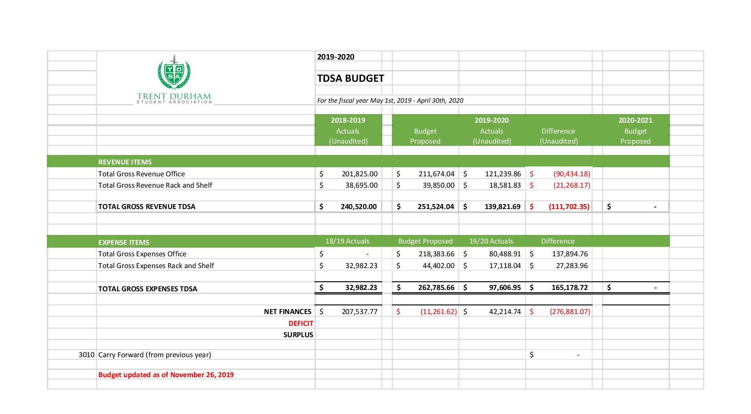
- Vice President of University Affairs Update
  - Document scanning and transitional work
  - Remodeled office
  - Joined OUSA Steering Committee and was elected as Vice President of Human Resources and Admin with OUSA
  - Worked with OUSA to make general assemblies more inclusive
  - Developed advocacy asks to bring back to TDSA, Trent University, and Queen’s Park
  - OSAP campaign- Thank you for your stories!
  - Brought OSAP campaign and stories to Queen’s Park
  - Also brought forward Sexual Violence Prevention issues, Student Mental Health advocacy, and preparing students for the workforce to Queen’s Park MPPs
  - Policy consultation with more upcoming in the new year
    - Focusing on International Students, Rural and Northern Students, and Sexual Violence Prevention
  - Sat on Trent Sexual Violence Prevention Task Force Committee
    - Working with local partners to make sure there is a Durham focus
  - Sat on Trent University Senate and many sub-committees to represent Durham-GTA student voices
  - Ran mock election to raise awareness of Federal Election

- Vice President of Campus Life Update
  - Settled in and went through past emails and documents
  - Read and made changes to Club Policy
    - Going to the Board of Directors for approval
  - Made changes to forms and applications to update to correct contact info
  - Created a database of external companies and who to contact with notes
  - Created new bulletin board designs
    - New one coming for next semester
    - Looking to have a new board every month
    - Doing a lot of prep work to ensure this is feasible
  - Read through by-laws and helped form changes
  - Sat on some Trent University committees
    - Read through material and attended meetings in Peterborough
  - Received Mental Health First Aid and First Aid CPR C training
  - Made and presented club training to all Club Executives
  - Went through club applications, funding, and event forms
  - Attended and helped run various Orientations
    - September Orientation: many swag bag requests to companies
    - Organized Movie Trip
    - Organized Vendors Ally and Giveaway Days
  - Hired Student job positions
  - Worked with TDSA Ambassador on wellness activities
    - Halloween Week Fair
    - Body Positivity
    - Wellness Wednesdays
  - Made a pamphlet for TDSA
  - Planning for next semester
    - Frost Week- Giveaways
    - Bell Let’s Talk
    - Multicultural Week
    - Semi Formal

- Meeting Adjourned at 3:30pm

TDSA Board Meeting December 5th, 2019
Present: Mackenzie Prine, Karina Mahabir, Hema Tikaram, Nick Ryan, Sigrid Belemsaga, Scott Boulton, Nathan Barnett, Aleah Symmons, Lindsay Gammon, Bonnie Caruana, Jamila Alleyne
Absent: Rayna Porter, Lynch Alcala-Hao, Shannon Feildler, Taeira McFarlane
Procedural Items

  - Call to Order at 2:17pm

  - Land acknowledgement by Aleah
We respectfully acknowledge that we are on the treaty and traditional territory of the Mississauga Anishnaabeg. At Trent Durham we recognize our close friendship with the Mississauga of Scugog Island First Nation and we offer our gratitude to the First Nations for their care for, and teachings about, our earth and our relations. May we honour these teachings.
  - Chairs Remarks
    - Make sure you are raising your card it you have questions or want to speak
  - November 14, 2019 Meeting Minutes Approval
Motion to approve the November 14, 2019 Meeting Minutes
Motioned by Hema
Seconded by Nick
Motion passes unanimously

- Review of Action Items (Appendix 1)
- No questions or updates

- Call for New Business
- Formation of elections committee as new number 15
- Closed session Operations Manager job description update as new number 17

- Approval of the Agenda
Motion to approve December 5 Meeting Agenda
Motioned by Hema
Seconded by Nathan
Motion passes

- Conflict of Interests
Bonnie for item #17
Sigfrid for item #13
Scott for item #13
Aleah for item #13
Updates

- Executive Updates (Appendices 2-5)
- No questions

- Board Updates
- Finance committee has met again, ORD has met again. SEC has not had any meetings as having difficulties getting everyone together. Jamila and Mackenzie to meet to strategize about how to resolve this
- Academics- the way the committee is structured everyone has to have something for their major, if they don’t have anything I cant do anything. Makes it difficult to know what to do. Can we come up with a list of directives? Have come up with some, misleading portion of academic calendar for Accounting specialization and taking the CPA accreditation, need 4 other courses. Some can be but unsure if all can be.
Action Item: Sigfrid find out if the 4 courses needed to qualify for the test are available at Trent. If they are, executives to advocate at a senate committee for the courses to be added into the academic calendar. If they are not, executives advocate at Senate committee for that information to be included or to remove the wording about CPA accreditation from the academic calendar

Action Item: All directors to write a little blurb about what their committee worked on or is still working on to pass on to next director.

Discussions/Decisions

- Motion to add wording to Executive Job Descriptions (Appendix 6)
- Approval
- In response to an action item from last year. Went through other student union job descriptions and workshopped the following to add to all executive job descriptions:
- Everchanging and fast paced work environment
- High Stress Environment
- 2 different clauses, does not change what we do or rate of pay, but informs people considering taking the role
Motion to approve the addition of the two clauses to executive job descriptions
Motioned by Scott
Seconded by Nathan
Motion passes

Action Item: Nick to update all executive job descriptions with the approved additions

- Change in Policy 4: Employment and Employee Guidelines (Appendix 7)
- Approval
- An update for personal leave without pay. (Motion and section from appendix 7 read out). Will allow us to plan around personal leaves. Board will have information if need to appoint temp person to fill executive role. Replacement will know how long to expect to be in role
- Should we include extensions? Would they go through the process again? Does the time stack? Ex. If an executive is gone for 4 weeks then asks for another 6, is that now considered over 8 and applicable for a replacement? The board can decide in any case and any timeframe and should depend on the position and time of year. Add in if leave of absence will extend more then 8 weeks or the duties of the job require a temporary replacement can be appointed
Motion to approve an amendment: If the leave meaningfully affects the functioning of the office the executive committee may appoint a temporary replacement
Motion is friendly

- Should we add in something about when to notify the board if requests are made or approved? Hr committee?
Amend to include “The board will be informed of any approved absences and the length of time expected to be absent”
Motion is friendly

Motion to call the question
Motioned by Scott
Seconded by Nick
Motion passes

Motion to approve the policy changes
Motion passes

Action Item: Nick to make approved changes to policy 4 including amendments
- Change to Clubs Policy in regard to fundraising (Appendix 8)
- Approval
- Noticed that clubs can donate money to causes that are not verifiable so want to add in wording to correct this (motion from appendix 8 read out)
- What happens if the VPCL doesn’t agree with the stance? Next item on the “to do” list is appeals procedure. If the charity is legitimate and follows our missions and principles should be fine. Could a student run a pro-life event? Does not violate our mission and principles statement and protected under freedom of speech act at Trent. If a VPCL rejects it, then can appeal to SEC committee, then to board, then to Trent. We abide by Trent policies in order to receive our levy funds.
Motion to approve the outlined additions to clubs policy
Motioned by Nick
Seconded by Hema
Motion passes, 1 abstention

Action Item: Nick to update clubs policy to include the approved motion regarding club fundraising

- Change to Clubs Policy in regard to increasing the minimum member amount (Appendix 9)
- Approval
- We are expanding. Now looking to increase number from 5 to 10 as we are getting more students and clubs should represent more student.
- Amend motion to state 10 instead of 8
- Does the 10 include the 3 executives of the club? Yes
- When would the clause start to be enforced? As soon as approved.
- What if an existing club drops below 10 members? This would only apply to new clubs that are looking to form.
- By making the number a drastic jump before the building opens that it will deter people from trying to start a club? No, the original policy and number was put in place when we only had 800 students and we have double that now.
- Do current club applications fill out the minimum or do they exceed the minimum? Most only do minimum, but some fill out the whole page.
- A lot of clubs are founded around an event and once the event happens the club dies. If the club is larger it tends to live longer and will be more stable.
- We don’t want a club of 5 people taking the same budget as a club of 20 people. But what if the 5 people want to organize an event that helps everyone on campus.
- If there was a group of people who wanted to organize an event we have other avenues such as special projects and small events funding. This is more to ensure that clubs are longer lasting and we are not de-ratifying so many clubs because the organizers have graduated

Motion to call the question
Motioned by Scott
Seconded by Nathan
Motion passes, 2 abstentions

Motion to approve the policy changes
Motion passes, 2 abstentions

Action Item: Nick to update clubs policy with the approved number of students needed to start a club

- Election Committee Formation
- Formation process- board to appoint a chief electoral officer, deputy chief electoral officer, and a board member to sit on committee, then election committee recruits students at large to sit on committee, come back in January and tell board the committee so they can approve (found later that this information was incorrect, board does not need to approve elections committee as per elections policy), then electoral trustee appointed. According to elections policy the Chief electoral is offered to the President first, the VPUA second, and then a board member. Nick accepts the Chief electoral officer appointment. Being that the VPUA is not present, the deputy chief electoral officer is opened up the board members at large. The role of that office is that they are cc’d on every email that is sent and received, and should the chief electoral officer no longer be able to perform their role the deputy would take over. Will have to attend approximately 2-3 meetings. Any volunteers? Scott volunteers. Accepted. Board member at large position, who picks helps pick the student at large members and is called upon for any infractions or appeals. Karina volunteers. Accepted.
Motion to approve all three positions
Motion passes, 3 abstentions

- Board Swag (Appendix 10)
- Approval
- Originally did not have any money allocated to board swag, but the board has worked very hard and it is a great marketing piece and we are celebrating our 10th anniversary so as a show of thanks to all the hard work that you have done. It won’t be to the level of previous year but it is important to do something. Looking to take some money out of the teambuilding line to fund all or a portion of some different items. (options read out from appendix 10)
- What would the logo look like? 2 options. One to include name and position and one to include 10 year logo. Logo in production. Enamel Pins? (lots of interest and mumbling)
Action Item: Bonnie to look into enamel pins with vendors. Investigate pricing for just TDSA logo and TDSA logo with different titles.
- Would we get all get to pick something different? No, we would all have to decide on one item. If it would cost you money you do not have to order.
- (Nick shows the options on the screen)
- Could we get sizes to test? Yes
Vote for different options
T-Shirt: 3, Long Sleeve: 2, Jacket: 6

- Could we get sizing for both options of the jacket? Can ask vendors.
- Can we move upcoming events up before we move into closed session (general consent)
Upcoming Events for the week

Last day of classes December 4th
Improv Show December 5th at 6pm
Exams December 6th to 18th – Good Luck Everyone!!!!
First day of classes for Winter Semester January 6th
December 13th- Massage lady giving free massages 3:30pm-6:30pm provided by TDSA
Motion to move into closed session
Motioned by Hema
Seconded by Nick
Motion passes
Meeting moves into closed session at 3:07pm

- Operations Manager Job Description Update
- Closed Session, Approval

Motion to approve adding ‘has access to the health benefits plan and the option to add a single dependent.’
Motion passes, 3 abstentions

Motion to end close session
Motioned by Nick
Seconded by Hema
Motion passes

Closed Session ends at 3:14pm

Motion to adjourn
Motioned by Karina
Seconded by Mackenzie
Motion passes

Meeting adjourns at 3:15pm

Appendix 1: Outstanding Action Items
- February Meeting
- Action Item: TDSA to create a bylaw regarding what guidelines external organizations must adhere to in order for them to run a referendum along side a TDSA referendum or election/byelection. Include stipulations for advertising, consultations, and labelling that separates the question(s) as being asked by the external organization.
- In Progress- Written, needs to go to team 2 for review

- Action Item: TDSA Board of Directors (BOD) to approve any referendum question(s) from external organizations that is run in conjunction with TDSA elections or referendums noting that the BOD is under no obligation to accept the question and that acceptance of the question does not signify support of the question. Add into bylaws/policy
- In Progress- Written, needs to go to team 2 for review

- Action Item: TDSA or Elections Committee will remove any question presented without proper implementation (see above). Add to bylaw/policy
- In Progress- Written, needs to go to team 2 for review

- Action Item: change name of committee in committee policy from Student Clubs Committee to Student Engagement Committee
- Completed, will post when final document from bylaw and policy overhaul has been completed

- March Emergency Meeting
- Action Item: OM to review policies and ensure wording reflects professional working environments and not personal relationships throughout bylaws and policies
- In progress- Document created with suggestions and given to President, comments debated and added into working library document

- Action Item: OM to go through Job Descriptions Policy and ensure that requesting light workloads and leaves of absences are added in to allow executives options if they are feeling overwhelmed
- In progress- written, presented for approval in appendix 9

- Action Item: OM to ensure any policies regarding training and meetings to include follow-up emails, as well ensure that all policies concerning committee meetings include the addition of follow-up emails.
- In progress- Document created with suggestions and given to President, comments debated and added into working library document

- April Meeting

- Action Item: OM Undergo mediation training on Lynda.com
- In Progress- 3 videos completed

- Action Item: Outline Lynda training in job description
- Completed- will need to add to library document

- Action Item: Procedure to be created in regard to professional communication and meetings
- In Progress, will update in phase 2 of bylaw and policy overhaul, looking to design a workshop that OM will deliver

- Action Item: include workload in candidate information sessions
- In progress- part of elections in Winter Term

- Action Item: Do some research on this type (professionalism and communication) of training and who can perform it.
- In Progress

- August Meeting
- Action Item: All directors to send in ideas via email or visit the office to speak with Nick to put ideas together. (in regard how to choose committee members)
- Not completed

- Action item: Nick to send out Doodle poll in regard to formation of working group to all Directors
- Not completed, waiting until November after we have tried it out a bit

- Action Item: Scott to message directors to see if any others are interested in assisting with the research into proxies.
- Voided- Lawyer addressed in his comments of bylaws

- October Meeting
- Action Item: Bonnie and Hema to advertise Academics Committee on social medias- Completed

- Action Item: Executives to create a trifold Board for all committees for Get Involved Week- Not completed

- Action Item: Add in Trent Durham-GTA students to the top of the hierarchy graphic as well as adding in students and referendum to the powers section- Not Completed

- Action Item: Nick to create compassion clause for disciplinary policy and bring to board for November 14 meeting.-Completed

- Action item: Rayna and Nick to research other student unions to determine best practices and outside opinions on hierarchal vs equal system and role of the President. -In Progress

- Action item: all interested Directors to email Rayna in regard to sitting on the Environmental Advisory Board- Completed

- Action Item: Hema to make doodle poll for participation and send out to all members of the board including non-voting members- Completed

- Action Item: Jamila send out an anonymous doodle poll to all members to see who is comfortable giving a land acknowledgment at the beginning of each board meeting and when agenda is sent out the person who is chosen is notified by the Chair. Jamila to send out information to TUNA rep as well.- completed

- November Meeting
- Action item: Bonnie to create a google sheet to put in what people want to bring for a potluck for Dec 5 Board meeting- Complete

Appendix 2: President’s Update

Compassion fatigue training
Asist training
Remembrance day ceremony
Took some days off. Didn’t help banked hours sorry folks
Reviewed bylaws with the lawyer and attempted to schedule follow up
Policy review and changes with OM
LOBBY CON
Worked with that whole….. SCI being no more thing
Worked on next round of student training
Working on those hours
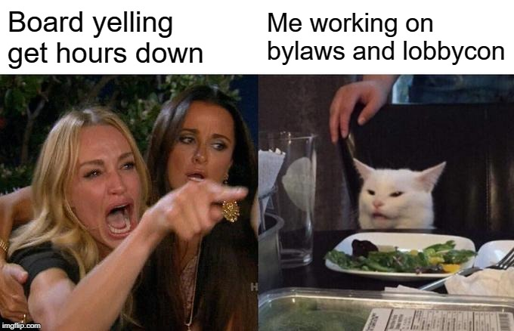

Appendix 3: Vice President of University Affairs’ Update

- Student Advocacy Week (November 17 - 21)
  - OUSA met with over 50 MPPs and numerous stakeholders
- Teaching and Learning Dinner Reception (November 27)
  - Speech and coordinating
- Student Leaders Reception
  - Held by President Leo Groarke in Peterborough - connected with others on Peterborough campus
- Proposal for the 900 bus stop relocation (WB Thornton x King)
  - Connected with city counsellor about next steps
- Peer Support Program review
  - Action plan developed
  - Best practice sharing with 9 other student associations
  - Policy and procedure outlined
  - Consultation with counselling support on campus TBD
  - Training and certification done for all office staff pending
    - If interested in training, please contact
- January Mental Health Awareness campaigns developed
  - Mental Health Mondays with Director of Health and Wellness coming up
- February advocacy to focus on gender-based harassment and violence in collaboration with the Trent Durham Women’s Support Group and the Vagina Monologues
  - Action plan outlined
- OUSA policy papers TBD
  - Consultation for International Students paper and Rural and Northern Students Paper to begin in January
    - If you are interested in participating in this consultation, please contact
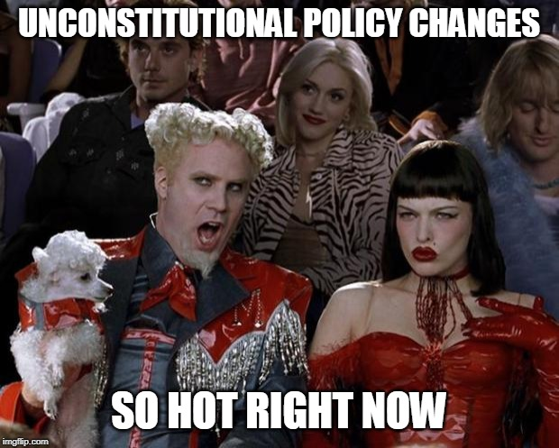

Appendix 4: Vice President of Campus Life’s Update

So, this is also a short turn around, but here we go..
- RSVP and attended the Teaching Dinner
- Fall General Assembly
- Campaign Meeting
- Food Services Meeting
- Planning for opt-out activities to run
- Talked with Kate about posting our events on MyTrent
- Wellness Activities with Jewel.
- Finally finished the TDSA PAMPHLET

Planning my Life for Winter Semester:
Frost Week:
- 12 Hours of giveaways/ Ideas
- Double check budget (Im doing extremely well)
Bell Let’s Talk:
- Gave Jewel to champion this initiative
- Helped to Craft letter to give to companies for donations
- Ideas for giveaway items
Multicultural week:
- Ideas to run for the week
- Talked to some food vendors
Semi-formal:
- I decided a theme!
- Making Pinterest boards for inspo
Bulletin Boards:
- Jan: Mental Health awareness
- Feb: Elections
- I want to have these ready to go so I can put it up

Appendix 5: Operations Manager’s Update

Month: December 2019
Banked Hours Update
President: Over 35
VPUA: Over 35
VPCL: Over 35
OM: Under 35

Update:
- Executive meetings held
- Helped research replacement NVCI training options
- Attended Events Meeting
- Attended Remembrance Day Ceremony
- Watched some conflict management videos
- Reconciled credit card reports
- Read over lawyer bylaw documents and commented
- Started a board and exec training ideas document based on professionalism and conflict management videos
- Completed board minutes from November board meeting
- Research on CFIB and started questions document for second bank visits
- Attended First Responder to Sexual Assault and Abuse Training
- Started researching and reading guidelines for mental health in the workplace and peer support group guidelines
- Took some time off to get banked hours down

Appendix 6: Motion to add wording to Executive Job Descriptions

To: The 2019-20 Board of Directors
From: President
Date: December 5th, 2019
Re: Employment and Job Description Policy

Be it resolved that: The Board of Directors approve the addition of “Ever changing and fast passed work environment” and “high stress environment” into each of the executives job descriptions
Whereas: The previous board requested this be included in job descriptions
Whereas: These are by in large accurate

This addresses a portion of the following action item:

OM to go through Job Descriptions Policy and ensure that requesting light workloads and leaves of absences are added in to allow executives options if they are feeling overwhelmed

Appendix 7: Change in Policy 4: Employment and Employee Guidelines

To: The 2019-20 Board of Directors
From: President
Date: December 5th, 2019
Re: Policy number 4

Be it resolved that: The Board of Directors approve the replacement of the “Personal Leave without Pay” section of policy #4 with the following wording “Leaves of absence may be requested to and approved by executive committee majority vote or direct supervisor. Requests must come in written form with generalities as to why and approximate length of absence. If the leave exceeds more than 8 weeks the executive committee may appoint a temporary replacement subject to HR best practice”
Whereas: The existing wording is very vague and very executive focused
Whereas: The new wording contains approval mechanisms and reflects more the day to day working environment

To further address and complete the action item:
OM to go through Job Descriptions Policy and ensure that requesting light workloads and leaves of absences are added in to allow executives options if they are feeling overwhelmed

Appendix 8: Change to Clubs Policy in regard to fundraising

To: The 2019-20 Board of Directors
From: Vice President Campus Life
Date: December 5th, 2019
Re: Clubs Policy

Be it resolved that: The TDSA board of directors add a section 17.10.8 in clubs policy under the title fundraising stating the following
Clubs seeking to fundraise must have the cause approved by the VPCL.
The VPCL must ensure the cause does not violate TDSA mission or principles and is deemed to be legitimate
The Club must have the cause for their event advertised publicly at the event in a manner that informs the students where the donation will be made to
Whereas: We currently don’t have any policy on this

Appendix 9: Change to Clubs Policy in regard to increasing the minimum member amount

To: The 2019-20 Board of Directors
From: Vice President Campus Life
Date: December 5th, 2019
Re: Clubs Policy

Be it resolved that: The Board of Directors change the minimum amount of people to start a club from 5 to 8
Whereas: We are expanding, and the minimum requirements should do so as well,
Whereas: Larger clubs involve more of the student body.

Appendix 10: Board Swag

Citing the importance expressing our gratitude and increasing interest in our upcoming election we have been researching a variety of swag items. Keeping in mind our financial constraints and appreciation of the board we have come up with the following items:

Item | Approximate cost to board member | Approximate cost to TDSA per item
T-Shirt | $0 | $15
A short sleeve t-shirt with the TDSA logo and text to indicate that it is our 10th anniversary. Forget Green in colour.
Long Sleeve Shirt | $5 | $15
A long sleeve with the TDSA logo and text to indicate that it is our 10th anniversary. Forget Green in colour.
Jacket | $20 | $15
A fleece jacket with the TDSA logo and text to indicate that it is our 10th anniversary. Forget Green in colour.
Letterman Jacket | $70-$330 | $0
Still investigating this, but can be ordered later if needed

The total cost for TDSA will not exceed $270, which would be allocated from the marketing budget.
The intention is that all board members agree on one option, then that option is ordered (depending on what option is chosen either all members or those who order will get the item).
The letterman jacket can be ordered on top of the other options and does not need consensus to be ordered (it is included here as an information piece only).

TDSA Board Meeting, January 29th, 2020
Present: Bonnie Caruana, Jamila Alleyne, Nick Ryan, Rayna Porter, Hema Tikaram, Lindsay Gammon, Shannon Fiedler, Taeira McFarlane, Sigfrid Belemsaga, Aleah Symons, Scott, Boulton, Nathan Barnett, Lynch Alcala-Hao
Absent with Regrets: Karina Mahabir
Absent: Mackenzie Prine
Procedural Items
- Call to Order at 7:11pm

- Land acknowledgement by Sigfrid
- We respectfully acknowledge that we are on the treaty and traditional territory of the Mississauga Anishnaabeg. We offer our gratitude to the First Nations for their care for, and teachings about, our earth and our relations. May we honour those teachings.

- Chairs Remarks
- If you are not aware of something or are not comfortable in your knowledge of an item do not vote yes because the consensus is voting yes, if you want to vote no vote no, if you are unsure in any way abstain

- December 5th, 2019 Meeting Minutes Approval
Motion to approve
Motioned by Nathan
Seconded by Nick
Motion passes unanimously

- Review of Action Items (Appendix 1)
- No questions or comments

- Call for New Business
- Add Conflict of interest section as item number 10
- Add Board Swag as Item number 15
- Move bank proposal to closed session, move to Item 16
Motion to approve changes to the agenda
Motioned by Rayna
Seconded by Nick
Motion passes unanimously

- Approval of the Agenda
Motion to approve the agenda
Motioned by Hema
Seconded by Lynch
Motion passes

Updates
- Executive Updates (Appendices 2-5)
- How is everyone doing mentally? Good, thank you for asking. Executives have gotten to take time off and got many hours taken from banked time

- Board Updates
- No comments from board
Action Item: Can all board members send Jamila what direction their committee has taken? What worked? What didn’t work? Non-voting representatives welcome to respond as well.
- Conflict of Interest
- None declared
Discussions/Decisions
- Bylaw Referendum Question (Appendix 6)
- Approval
- In order for bylaws to change we must present them at an annual general assembly or a referendum. Proposing that it go to a referendum as all bylaws have been changed.
- Notable changes: No longer able to give proxies. Can no longer impeach at the board, board can approve if it is to go to referendum.
- Any changes or concerns?
- Bylaw 15 should be removed as it is a joke bylaw and the third point says to remove it
Motion to Remove Bylaw 15
Motioned by Nathan
Seconded by Rayna
Motion passes as friendly
- 1.2.1.(4)- gender identity missing. Instead can we refer to Ontario Human Rights Code?
Motion to remove the discrimination descriptors and instead say “the right to enjoy the same privileges and opportunities free from any ford of discrimination or prejudice as defined by the Ontario Human Rights Code.”
Motioned by Rayna
Seconded by Scott
Motion passes, 1 abstain

- 3.1.1 (symbols section)- no picture, should be attached as an appendix, add in
Motion to amend the wording to “the symbol found in Appendix 1, Figure 1”
Motioned by Rayna
Seconded by Scott
Motion passes

- 4.1.1.2- academic year? Defined as May to April? If someone graduates in January are they still members if they are no longer paying fees? If they are not on campus they are not using the resources so are not as big of a drain. Add as either a definition in definition section or in this particular section?
Motion to add in Academic Year definition of September 1-August 31 subsequent year
Motioned by Scott
Seconded by Nathan
Motion passes unanimously

Action item: change Clubs Policy wording to reflect Fall and Winter Semesters instead of Academic Year

- 4.1.1.8- request change death to extenuating circumstances? Death is more appropriate, in line with University Policy. Extenuating circumstances might be too vague and might change the wording enough that the lawyer might not have approved it. withdrawn
- 9.1.1.7.b- remove optional direction and make direction of the vote mandatory. This is just for general meetings not board meetings.
Motion to remove the word optional “…and the direction as to the nature of the vote either for or against”
Motioned by Rayna
Seconded by Scott
Motion passes

- 9.1.1.17- same as 9.1.1.7.c, remove it. Some wording is not repeated. One section describes general meetings and one describes emergency general assemblies
Motion to remove annual from annual general assembly, to therefore read General Assembly
Motioned by Rayna
Seconded by Hema
Motion passes unanimously

Motion to change the references to Proxies in the Emergency General Meetings to match the General Assembly
Motioned by Nick
Seconded by Hema
Motion passes, 1 abstention

Action Item: Change all references to GM to General Meeting, look for other acronyms

- 11.1.1.5- What does it mean? board of directors can borrow money on behalf of TDSA. Need to have it
- 13.1.1.9- 10% of the total membership? Anyone paying the TDSA fee on the Trent Durham campus.
Motion to call the question
Motioned by Scott
Seconded by Hema
Motion passes

- Motion is to approve the bylaw question to be put forward to referendum, requires 2/3 approval.
Motion that recognizing the changes and implementation minus formatting that is to come that these bylaws including the changes are presented to the students.
Motioned by Rayna
Seconded by Scott
Motion passes unanimously

- Referendum question- Would you like them locked down for 3 years, 5 years, or none at all.
- 4 and 5 are Membership and Fees Bylaw and Board of Director Bylaws. Allows us to adapt our fee structure and change our board as needed. Lawyers are expensive, bylaws are fairly flexible and bare bones, can grow and expand within them.
- We should have a lawyer look over them if we make any changes. Seal for three years unless the board of directors request a change and approve the budget of obtaining a lawyer?
- 5 years seems good. Provides stable groundwork for future boards.
- Should there be a bylaw about a lawyer? If changes are minor, do we need one, could we use a legal aid? Policy might be better? Proposal seems appropriate due to administrative hassle of re-doing bylaws.
- Change Bylaws and Enactments Bylaw 10: should the board of directors wish to amend any of the bylaws the board must seek the appropriate level of legal representation corresponding to the sizes and scales of the change.
- Should also change 1.1.8 cyclical review timeframes to match whatever is approved
Motion to add into Bylaw 10 “Should the Board of Directors wish to amend these By-laws, they must seek the appropriate level of legal representation as decided by the Board of Directors.”
Motioned by Nick
Seconded by Nathan
Motion passes unanimously

- What about financial aspects of obtaining a lawyer? Leave it to the future board to decide
- Should we vote on 3 or 5 or no years?
Option motion: 1- 3 year cyclical review, 2- 5 year cyclical review
Motioned by Nick
Option 1: 3 votes, Option 2: 5 votes, 1 abstention
Option 2 passes

Motion to separate the policies aspect of 1.1.8 from bylaws
Motioned by Nathan
Friendly motion passes

Hema Exits at 8:10pm

- Would you like to put a specific date instead of 5 years? September 1st or April 30th, 2025.
- September 1st might be better as then they have the 3 months to get everything in order to present.
- May 1st of April 30th pose problems, but would allow for time to work on them over the slower months. Even if they are locked they can still be worked on, but cannot be approved or enacted upon until September 1.
Hema returns at 8:15pm
- Change language from review to changed.
Motion to call the question
Motioned by Nick
Seconded by Hema
Motion passes, 1 oppose
Motion to approve the referendum question “BIRT the membership of the Trent Durham Student Association pass the following bylaws to govern the Trent Durham Student Association.
BIFRT, with the exception of bylaws 4 and 5, the bylaws be locked for changes until September 1st, 2025.”
Motioned by Nick
Seconded by Hema
Motion passes, 2 abstain

- Special thanks to Nick for all his hard work on the bylaws

- Food Bank Referendum Question (Appendix 7)
- Approval
- Any questions? Motion is read from the appendix.
- Do we need to state what a sunset clause is or if it is unsure to remove the wording? Sunset clause is a termination on a fee or contract giving it limited temporal reference. Gives students better control. 3 years means students will vote in 1st year and 4th year so it does not leave living memory. Have also included a budget in the proposal. Discretionary budget allows for wiggle room if there is an opt out option. $0.70 per credit equals $3.50 per full time student.
- Everyone is welcome to use the pantry. So, we should be aware that it is not just for student use.
- Leave it as is. Serves both those who can understand and those who don’t.
- Comma could put us into legal trouble. Does the word meaning clarify that? Cyclical conversation, should we vote?
Motion to remove “will have the sunset clause meaning that the fee”
Motioned by Rayna
Seconded by Lynch
Motion passes, 1 oppose, 1 abstain

Motion to approve “Be it resolved that the Membership of the Trent Durham Student Association approve the initiation of a $0.70 per credit fee in order to facilitate the creation and maintenance of a food bank on campus associated with Feed the Need Durham and maintained by trained TDSA staff.
Be it further resolved that this fee will be voted on again in the 2023 electoral cycle and every three years subsequently.”
Motion Passes, 1 oppose

Motion for a recess
Motioned by Nathan
No seconder
Motion fails

- Board Reference Letters Proposal (Appendix 9)
- Approval
- Motion is read from the appendix.
- As we have changed the board of director roles into more professional and substantive roles we wanted to reward the directors with official recognition. Directors will produce a letter by end of March. President will verify and create letter following template, then president and chair will sign off and present at April board meeting. Helps corporation track projects and stats. Good for job applications, volunteering, grad programs etc.
- As we don’t have an MOU for non-voting reps for this letter but each executive could do so if requested by the non-voting rep.
- As a non-voting representative do you still want a report? Non-voting reps are under no obligation as we have no ability to enforce it, but you may request it and undertake that under your own prerogative. This would only apply to TDSA board members.

Motion to call the question
Motioned by Scott
Seconded by Nathan
Motion passes, 1 oppose

Motion to approve “Be it resolved that the TDSA require its Directors of the Board to produce an end of year report by the March Board of Directors Meeting.
Be it further resolved that the TDSA adopt the reference letter incentive program for the Directors of the Board and that this letter will be informed by their end of year report.
Be it further resolved that the Board of Directors approve the following form letter as a template for all reference letters to be issued for the purposes of the reference letter incentive program.”
Motioned by Hema
Seconded by Nathan
Motion passes

- Board Rack and Shelf Discount Timeframe (Appendix 10)
- Approval
- Board of Directors get a discount at the Rack and Shelf. When does it end?
- Makes sense to be only their term, easier to verify. It’s a thank you for their service, they would no longer be serving.
- Life time, if they remember where we are then they deserve a thank you.
- What is someone wins and then drops out? If it sonly for term that solves this.
Motion to call the question
Motioned by Hema
Seconded by Nathan
Motion passes

Motion to approve that the discount is only valid during the time of that the Director Serves
Motioned by Nick
Seconded by Lynch
Motion passes, 1 oppose

- Board Swag
- Jacket that was picked out at last meeting was not the quality we were wanting, the embroidery for the ¼ zips was more expensive then desired. Looking to get the full zips screen printed. It will cost you nothing. Screen printing name and position and 10 year logo. The original quote included non-voting reps and employees as well as directors. Pins cost was quite high, so we settled on this. 10 year logo on front on one side, then title and name on opposite front or sleeve.
- Options for placement should be all the same. Execs can choose or you can choose.
- Cost efficient, should all be the same for marketing
- Would you like an email vote?
- Can we get it done today?
Motion to have a Non-formal vote to allow for non-voting reps to vote as well
Motioned by Rayna
Friendly Motion passes

Motion to call the Question
Motioned by Scott
Seconded by Hema
Motion passes

- Chest and sleeve, or logo and title stacked on chest, logo and title (not understandable)
- Logo pulled up on email, logo would all be in green
- Bonnie tries on sample
- Only have small, medium, and large
Option 1: Logo on left Chest and title on left Sleeve, Option 2: Logo on left chest and title directly underneath, Option 3: Logo on left chest and title on right chest
Option 1: 6, Option 2: 3, Option 3: 2, 2 abstentions
Option 1 passes

- Recommendation for next year not to have the gift voted on at the board.
Motion to Recess
Motioned by Nick
Seconded by Rayna
Motion passes
Meeting recessed at 8:58pm

Meeting resumed at 9:07pm

Motion to move into closed session and have Bonnie remain in the room
Motioned by Nathan
Seconded by Hema
Motion passes

Meeting moves into closed session at 9:08pm

- Bank Proposal (Appendix 8) - Closed Session
- Approval
Motion to approve “Be it resolved that the TDSA switch its banking services to Scotiabank.
Be it further resolved that the TDSA switch its POS service from Moneris to Chase.
Be it further resolved that the TDSA give the Operations Manager and President
leave to negotiate a new credit card plan that will be most beneficial to the
corporation subsequent to approval by the Finance committee.
Motion passes

Closed session ends at 9:21pm

Upcoming Events for the week
Elections:
- Nominations January 27-31, 2020
- Campaigning February 3- 13, 2020
- Voting February 10-13, 2020
- Results February 14, 2020
Bell Let’s Talk day – January 29, 2020
Mental Health Week – January 27-31, 2020
Black History Month Event – End of February
Still We Rise Event – presented by African Black and Caribbean Association- Feb 4, 3-4pm
Multicultural Week - Last week of February
Mental Health Strategy Meeting, Room 160 - February 3rd
Bridges out of Poverty Training, Oshawa Library- Feb 6th
- Elections: President and Vice Presidents must be appointed, so we wrote it into bylaws, but we would like to give the incoming executives their letters of mandate officially in the February Board Meeting, like a swearing in. Just for the executives as they are the ones who must be legally appointed. Thoughts?
- Cool idea, creates excitement. Can meet new team.
- Could we extend it to the board of directors? Would take a lot of time? Good to meet people.
- Executives in Feb, Board in April after their training? History of appointing positions in that time as well.
- Can they be handwritten? Font? Scott can calligraphy. Don’t want to set a precedence.

Motion to Adjourn
Motioned by Nick
Seconded by Nathan
Motion passes
Meeting adjourns at 9:27pm

Appendix 1: Outstanding Action Items
- February Meeting 2019
- Action Item: TDSA to create a bylaw regarding what guidelines external organizations must adhere to in order for them to run a referendum along side a TDSA referendum or election/byelection. Include stipulations for advertising, consultations, and labelling that separates the question(s) as being asked by the external organization.
- Completed- at Board for Decision in January Meeting

- Action Item: TDSA Board of Directors (BOD) to approve any referendum question(s) from external organizations that is run in conjunction with TDSA elections or referendums noting that the BOD is under no obligation to accept the question and that acceptance of the question does not signify support of the question. Add into bylaws/policy
- Completed

- Action Item: TDSA or Elections Committee will remove any question presented without proper implementation (see above). Add to bylaw/policy
- Completed

- Action Item: change name of committee in committee policy from Student Clubs Committee to Student Engagement Committee
- Completed, will post when final document from bylaw and policy overhaul has been completed

- March Emergency Meeting 2019
- Action Item: OM to review policies and ensure wording reflects professional working environments and not personal relationships throughout bylaws and policies
- In progress- Document created with suggestions and given to President, comments debated and added into working library document

- Action Item: OM to go through Job Descriptions Policy and ensure that requesting light workloads and leaves of absences are added in to allow executives options if they are feeling overwhelmed
- Completed

- Action Item: OM to ensure any policies regarding training and meetings to include follow-up emails, as well ensure that all policies concerning committee meetings include the addition of follow-up emails.
- In progress- Document created with suggestions and given to President, comments debated and added into working library document

- April Meeting 2019

- Action Item: OM Undergo mediation training on Lynda.com
- In Progress- 3 videos completed

- Action Item: Outline Lynda training in job description
- Completed- will need to add to library document

- Action Item: Procedure to be created in regard to professional communication and meetings
- In Progress, will update in phase 2 of bylaw and policy overhaul, looking to design a workshop that OM will deliver

- Action Item: include workload in candidate information sessions
- In progress- part of elections in Winter Term

- Action Item: Do some research on this type (professionalism and communication) of training and who can perform it.
- In Progress

- August Meeting 2019
- Action Item: All directors to send in ideas via email or visit the office to speak with Nick to put ideas together. (in regard how to choose committee members)
- Not completed

- Action item: Nick to send out Doodle poll in regard to formation of working group to all Directors
- Not completed

- October Meeting 2019

- Action Item: Executives to create a trifold Board for all committees for Get Involved Week- completed

- Action Item: Add in Trent Durham-GTA students to the top of the hierarchy graphic as well as adding in students and referendum to the powers section- Completed

- Action item: Rayna and Nick to research other student unions to determine best practices and outside opinions on hierarchal vs equal system and role of the President. -completed

- December Meeting 2019

- Action Item: Sigfrid find out if the 4 courses needed to qualify for the test are available at Trent. If they are, executives to advocate at a senate committee for the courses to be added into the academic calendar. If they are not, executives advocate at Senate committee for that information to be included or to remove the wording about CPA accreditation from the academic calendar

- Action Item: All directors to write a little blurb about what their committee worked on or is still working on to pass on to next director, due by March meeting. – In Progress to formalize- see appendix 9

- Action Item: Nick to update all executive job descriptions with the approved additions- Complete, to be posted

- Action Item: Nick to make approved changes to policy 4 including amendments- Complete, to be posted

- Action Item: Nick to update clubs policy to include the approved motion regarding club fundraising- Complete, to be posted

- Action Item: Nick to update clubs policy with the approved number of students needed to start a club- Complete, to be posted
- Action Item: Bonnie to look into enamel pins with vendors. Investigate pricing for just TDSA logo and TDSA logo with different titles.- In progress

Appendix 2: President’s Update

So. Many. Elections. Prep
Committee done
Packages done
Dates set.. mostly
Prepared referendum questions
Prepared bank proposal
Prepared board reference letter
WL exchange
College meetings
Updated finances and signed cheques
Nominations week
Candidate info sessions

Appendix 3: Vice President of University Affairs’ Update

- Bell Let’s Talk Support for Hema
  - Connected with Good2Talk reps and Peterborough liaison
  - Connected with AIDS Committee for collaboration idea (shout out to Nathan)
- Sexual Violence Prevention and Response Policy Paper Think Tank
  - Outlined policy
  - Research pack
  - Written PCRs and outlined body text
  - E-learning about Human Trafficking complete to inform policy
  - Consultation requests sent out to community members
    - Met with DRPS Victim Services
- Rural/Northern Student and International Student Paper consultations
  - Anonymous google form in progress
  - Consultation dates and link to book a consultation are complete
    - Promotion to begin in February
- 900 bus stop relocation (WB Thornton x King)
  - More emails to City Councillor Derek Giberson with no response
    - Have reached out to Hailey Wright to assist with arranging a meeting
    - Reached out to DRT directly
- Peer Support Program reviewed
  - Form developed
  - Connected with Director of Health and Wellness about next steps and developing a committee and defining Director role
  - Policy and procedure to ORD in March
  - Consultation with counselling support on campus in progress
  - Training and certification for OM TBD
  - Conference to evaluate content set for January 27th
- February advocacy to focus on gender-based harassment and violence in collaboration with the Trent Durham Women’s Support Group and the Vagina Monologues
  - Connected with TDWSG about event
- Sexual Violence Task Force initiatives
  - Developed next steps with President and Manager of Student Affairs
- Released statement regarding Dec 8th incident
  - Compiled student complaints
  - Followed up with Dean and admin
  - Have had a TDSA member present for any organized weekend events (i.e. NVCI Training)
- Committee for Undergraduate Petitions
  - Currently evaluating process by which this functions in comparison to other universities
  - Developing a student-focused How To guide
- OUSA Student Association Autonomy interim policy paper released
- Two Spirit and LGBTQ+ policy paper released
  - Released statement which was picked up by CTV London
- Next Semester schedule now updated and available in VPUA Calendar
- Reduced banked hours as requested by the board
  - Developed a schedule for reduction back to 30 hour limit by January 30
- Ordered new dry erase whiteboard for VPUA desk (also CL)
  - This is updated every Monday; if you cannot access my calendar, please see the whiteboard
- VP HR & Admin obligations for OUSA
  - Performance Appraisal and preliminary research into new PA system
  - Review of the By-Law and Operating policies to identify opportunities for environmental sustainability, human equity, and larger ethics within OUSA
- Developed “Winter Semester Planning Day” with Bonnie for execs and student staff
  - Included evaluating previous semester successes and gaps
  - Mapped out expectations for the rest of the term
- Interview Blog for OUSA submitted
- Environmentally-Friendly New Year’s Resolutions week long table
  - Handed out reusable cups and eco-pens while building environmentally friendly resolutions with students using the SMART model
  - 102 resolutions total!
- CICMH Webinar Dec 10th and Dec 17th
- CICMH Training Day January 27th in Guelph
- Community Based Research Centre collaboration
  - Efforts to get more projects to Durham campus
- Cleaned the office extensively
- IMPORTANT NOTE: Student Exam Season meant an increase in complaints and requests from the student body
  - Recognizing this as an issue for executives for many years, consultation was had with exec team about salary compensation for future executives
    - Potential conversation at Finance Committee for future exec team

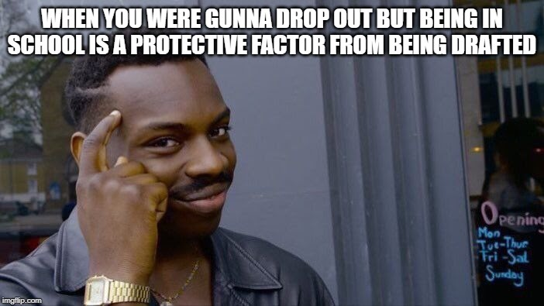

Appendix 4: Vice President of Campus Life’s Update

- Alcohol process for improv club
- Booked in the massage lady
- Working documents with Jewel of upcoming projects
- Collecting membership lists from clubs
- Building Campaign Meeting
- Completed the pamphlet (Thank you bonnie for printing)
- Finished Qualtrics survey for clubs and committees
- Meeting with Trent Women Support Group
- Sunshine Bags for bell lets talk
- Frost day/ Giveaway day
- Transition Package
- Post the Marketing and Communications Assistant
  - Rolling Interviews
- Doing the School thing
- Receiving Club forms
- Performance review
- Bell Lets Talk Connects and Planning
- Chose date for Semi formal and Multicultural Week
JUST PLANNING FOR ALL THE THINGS
Appendix 5: Operations Manager’s Update
Month: January 2020
Banked Hours Update
President: Under 35
VPUA: Over 35
VPCL: Under 35
OM: Under 35

Update:
- Usual financial work
- Final meetings with banks
- Food pantry meetings
- Rack and Shelf Work
- Meetings with downtown BIA about student discount and event
- Created 10 year logo
- Watched some conflict resolution video
- Researched Peer Support Program including watching a webinar
- Pulled old books and notified all people
- Progress reviews completed with President, VPUA, and VPCL
- Team Planning day to plan out this term
- Cleaned up office
- Attended January Orientation
- Peer Support with students (academic, accessibility, computer help)
- Notified expired locker contracts
- Completed Bank Proposal with President
- Created ad for Rack and Shelf
- Exec meetings held and minutes sent out
- Completed December Meeting Minutes
- Created book cheques, email, and monetary requisitions
- Contacted vendors about store items
Appendix 6: Bylaws Referendum Question

Be it resolved that the membership of the Trent Durham Student Association pass the following bylaws to govern the Trent Durham Student Association.
Be it further resolved that with the exception of bylaws 4 and 5 the rest of the bylaws be locked for review for 3 or 5 years
https://docs.google.com/document/d/1q1CxPn_mTAtOmcM2e4eekaf-Bc9GSiKF8BgUI5t9C9c/edit

Appendix 7: Food Pantry Referendum Question

History
In the fall semester of 2019 three social work students worked to establish a food bank on campus sighting food insecurity as the primary motivating factor. During the four months of which the food pantry was active it saw very wide usage. During the month that numbers have been kept the TDSA has, from its own stores, contributed 131 items (83 food, 48 toiletries). This has been on top of donations, including one very sizable one, form outside sources. This showed that there was a great need for this service on campus as over 200 items were used in less than one month’s time. Worried about the sustainability under the social work umbrella the group asked the TDSA to consider taking on the food bank.
After consultations with the social workers, data gathering, and looking at the mission and principles of the corporation, the Executives made the choice to formally administer the food bank on campus. In this, the executives have deemed it most beneficial if the TDSA partners with Feed the Need Durham so that the direct cost of buying food is not passed on to students. The requirements are that the TDSA run one food drive a year and maintain trained food service personnel.
This was the history and rational that informed the following referendum question.

Motions
Be it resolved that the Membership of the Trent Durham Student Association approve the initiation of a $0.70 per credit fee in order to facilitate the creation and maintenance of a food bank on campus associated with Feed the Need Durham and maintained by trained TDSA staff.
Be it further resolved that this fee will have a sunset clause, meaning that the fee will be voted on again in the 2023 electoral cycle and every three years subsequently.

Program | Budget
Feed the Need Durham Membership | $200
Food handling and safety training for 2 employees a year | $60
Student employee salary | $2791.51
Discretionary Budget (marketing, grocery assistance, events) | $1000
Total | $4051.51
*fee and budget based off 2019-2020 FTE

Appendix 8: Bank Proposal

**Bulk of Proposal removed as item was moved to closed session.
Motions
Be it resolved that the TDSA switch its banking services to Scotiabank
Be it further resolved that the TDSA switch its POS service from Moneris to Chase
Be it further resolved that the TDSA give the Operations Manager and President leave to negotiate a new credit card plan that will be most beneficial to the corporation

Appendix 9: Board Reference Letters Proposal

Rational
As the board of directors becomes a more professional and outward facing body, the 2019-20 executive felt it important to reward directors of the board for their increasingly professional involvement. Acknowledging that the board cannot receive monetary compensation the executive recommends that the compensation be made in the form of a reference letter.

This letter would be formed by an end of year report submitted by the member of the board in the march meeting. The sitting president would then examine the reports and produce the custom reference letter made from the template bellow.

This ensures by-in from the board as there is now a measurable reward for completing more tasks. The TDSA can better record events and initiatives, as they will stay in our records, and the individual now has a reference for their next job which will assist in the future employment for members of the board.

Motions

Be it resolved that the TDSA require its Directors of the Board to produce and end of year report by the March Board of Directors Meeting.

Be it further resolved that the TDSA adopt the reference letter incentive program for the Directors of the Board and that this letter will be informed by their end of year report.

Be it further resolved that the Board of Directors approve the following form letter as a template for all reference letters to be issued for the purposes of the reference letter incentive program.

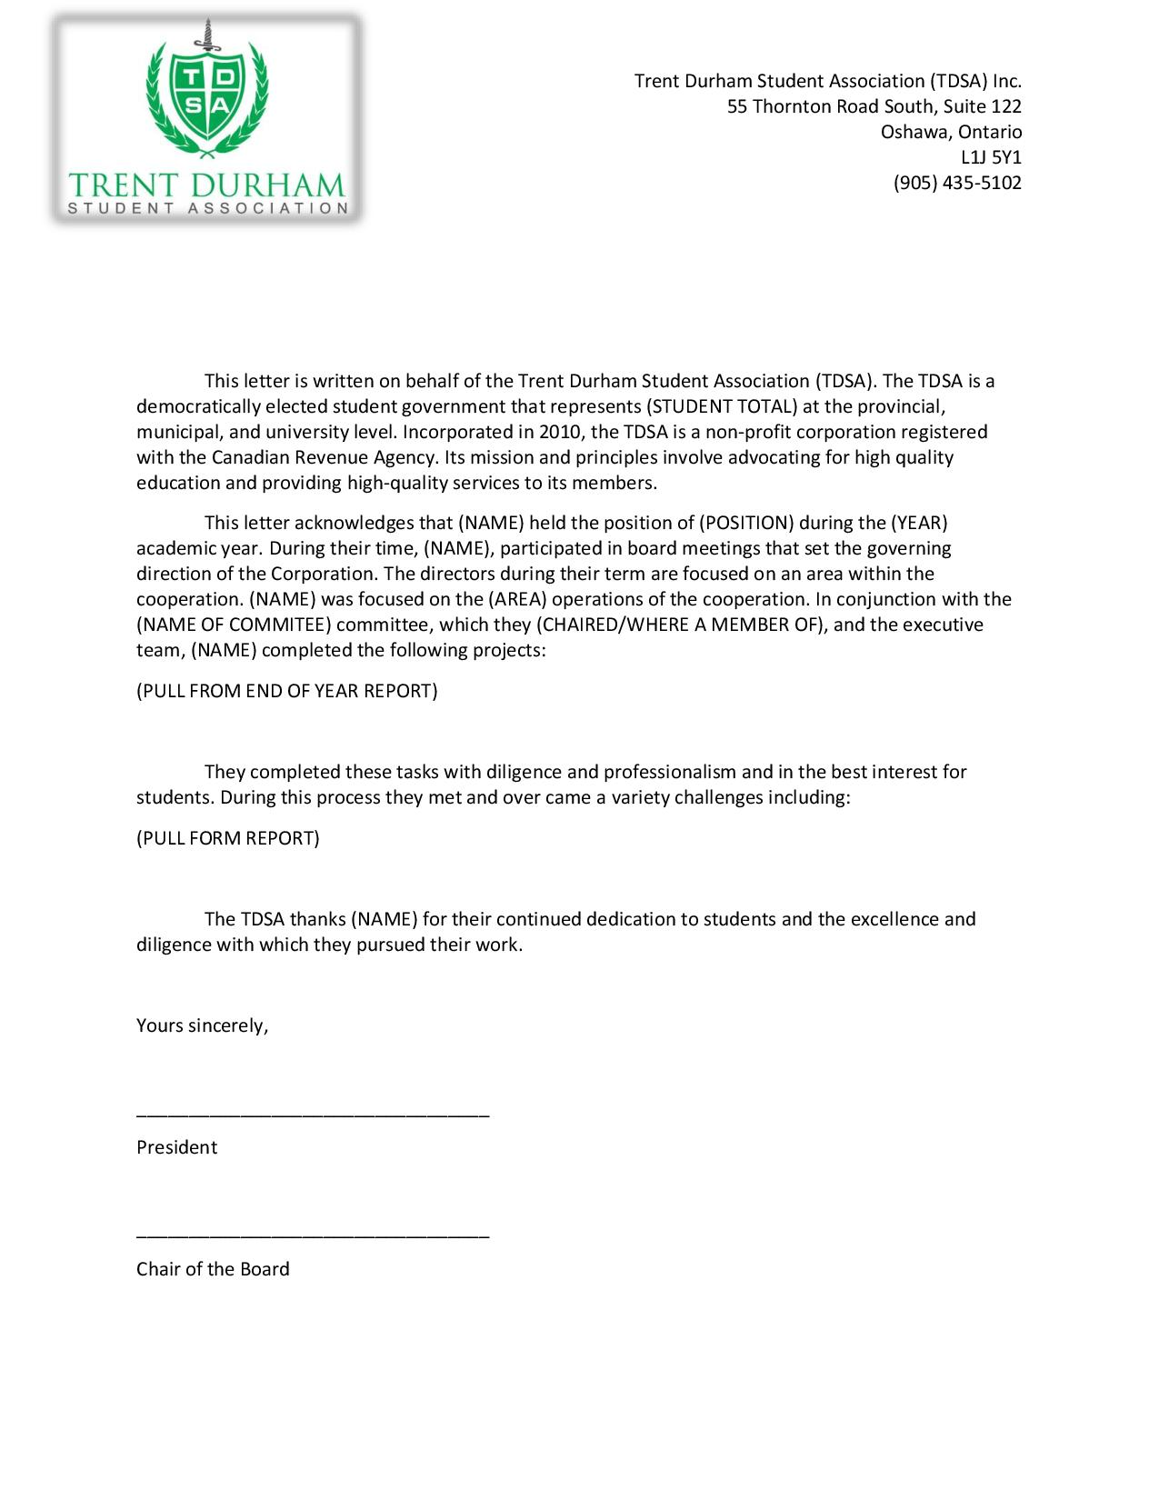

Appendix 10: Board Rack and Shelf Discount Timeframe

Traditionally the board has been able to buy Trent Durham swag form the TDSA store at cost. This incentive is formalized in policy but there is no termination date for the policy. This begs the question, “when does this discount end?”

Option one 1: never
Option two: only for their term
Option three: a set amount of time

TDSA Board Meeting February 26th, 2020
Present: Bonnie Caruana, Taiera McFarlane, Hema Tikaram, Karina Mahabir, Lynch Alcala-Hao, Nathan Barnett, Aleah Symons, Rayna Porter, Nick Ryan, Jamila Alleyne, students in the gallery
Absent with Regrets: Shannon Fiedler and Lindsay Gammon
Absent: Scott Boulton, Sigfrid Belemsaga, Mackenzie Prine

Procedural Items

- Call to Order at 7:12pm

- Land acknowledgement by Nick
- We would like to acknowledge that we are on the treaty and traditional territory of the Mississauga Anishnaabeg. We give thanks for their for their care for, and teachings about, our earth and our relations. May we honour those teachings.

- Roll Call

- Chairs Remarks
- State your opinion, don’t hold back.
- Ask your questions
- Please read all the information before you come to the meeting so you are informed and have questions prepared
- All directors please send me all your info about your committees as requested previously

- January 29th, 2020 Board of Director Meeting Minutes Approval
Motion to approve the January 29, 2020 Board of Director Meeting Minutes
Motioned by Rayna
Seconded by Nathan
Motion passes unanimously

- February 11th, 2020 Emergency Board of Directors Meeting Minutes Approval
Motion to approve the February 11, 2020 Emergency Board of Directors Meeting Minutes
Motioned by Hema
Seconded by Nick
Motion passes

- Review of Action Items (Appendix 1)
- No questions or updates

- Call for New Business
- Closed session- CUPE discussion new #18
- Live Streaming Meetings as new # 14
- Counselling Referendum Discussion new #17
- In the bylaws it denotes that members have speaking rights our meetings, please raise your hands and Chair will recognize you to speak

- Approval of the Agenda
Motion to approve the agenda
Motioned by Lynch
Seconded by Rayna
Motion passes

- Declaration of Conflict of Interest
- Rayna, Hema, Nathan for Election Ratification
- COI to be determined for Proposal for Executive Transition Bonus at time of discussion
Updates
- Executive Updates (Appendices 2-5)
- Nick: see appendix for read out update
Nathan Exits at 7:24pm
Nathan re-enters at 7:24pm

- 900 bus stop relocation- where are you looking to put it? Up to the light for safety reasons. If anyone is looking to give testimonials please get in touch with Rayna. Taeira offers. University looking to change light at Thornton to a formal 3 way light as well.

- Board Updates
- Is there any support anyone needs from the executive team? We want to make sure the next directors have the best start.
- No other comments

Discussions/Decisions

- Election Ratification and Appointment
- Approval
- Clean election, no infractions, no overspending. Some posters left up but nothing too big. Vote pretty conclusive. Ensured with the electoral trustee that the votes stopped at 2pm.
Motion to ratify the 2020 Elections Results
Motioned by Lynch
Seconded by Nick
Motion passes, 3 abstention

Friendly motion to recess to hand out letters to new board members that are present

Meeting recessed at 7:31pm

Meeting resumed at 7:40pm

- Proposal for External Peer Support Training
- Approval
- Research was done for developing the peer support program. Outside accredited training might be best. Trent does offer training but not until into school year when we are already offering support.
- Technically we don’t need training but to make sure we are saying the right things, getting some proper external supports would be best coming form someone already in the field.
- Cost would be too much for everyone to do every year but it would be good to have at least 1 member trained to have institutional training every year.
- Was this posed to Corinn? No, it’s a good thought.
- We have been tracking our peer support interactions through a google form. Operations manager performs a large portion of the peer support. Mostly mental health and academic stress. Making sure that we have proper external resources and liability covering.
- What budget line would this come out of? Either training or personal development but training is overspent. Can always reallocate out of other lines as well
- Have we brought this to Finance Committee? No
- We should double check with Corinn and budget. In the budget we have the money.
- How often would you get the training? Once as far as I know. Follow peer support guidelines and have a mental health professionals present during training.
- How many other organizations recommended this training? 1, others did their own but included large portions of time as supervised peer support, and a lot of money involved as well and determined that this was not feasible for our organization
- We can approve on the condition of Corinn signing off on it.
- How soon in advance do we need to book it? Would be looking for the April training. If had to wait for the September I would just wait for the Trent training.
- Trent training may be free for us but not held until September and we would not have the training for the start of the year, but over the summer we may not have an office. There are 2 classrooms opens that we may be able to relocate to. Trent training is 2 days, run by Robyn Ocean, may be free but unsure. We would have to pull ourselves out of the office in September.
- Can we look into what the Trent training is? We do have that information.
- Can we come back while Bonnie looks for items? Yes
- A weekend of full day trainings plus an additional day during the year. Then in person training. Held on weekend after labour day.
- During orientation week we work a lot then have to attend full day challenging content, might be a lot.
- Based off of the time and considering we are extending o week because of residence. It is not uncommon for people to work 60 hours during o week. This is also the busiest time for books and peer support. Adding training in this timeframe is not fair. Still should get Corinn opinion on other training.
- As for budget we do not have opt outs so we will have more money then expected.
- They do a refresher in January but that would be a long wait

Motion to approve the motion in appendix 7 pending approval from Corinn
Motioned by Nathan
Seconded by Hema
Motion passes unanimously

- Live Streaming of Meetings
- Do a lot of students watch it? Each video gets several hundred views, however we do not know who is watching and for how long. There is not a lot of engagement, some from other student associations. Pros are ultimate form of responsibility. Cons are it’s a big liability.
- Even though students may not watch its good to have the option for transparency and availability
- Might not speak to transparency as we only talk about certain things. Audio quality can be very poor, opens us up to liability especially without procedures. We should be open in the meeting and if we are streaming it might hinder voices or comments. Could we do an update video instead? Many boards have meetings only in closed session.
- Meetings can be lengthy so people probably not going to watch all of it, and audio problems are a real thing. Don’t think we need to have it live streamed, but a quick update Instagram post might be good.
- Accountability exists through the recording. Setup takes a while.
- No previous formal vote

Motion that the TDSA livestream its board meetings on Facebook live
Motioned by Nick
Seconded by Lynch
1 in support, 7 oppose, motion is defeated

- Proposal for Executive Transition and Bonus
- Approval
- Decision on COI? Not before presentation
- previous bonus was founded because executives tend to burnout and not transition in new staff well, it ensured that executives worked until end of year. They were tied to performance reviews. Was difficult to get someone who worked with you a poor performance review and therefore a bad bonus. Conflict arose so we changed it and there were still issues. At the beginning of the year no budget allocated due to previous issues. However, transitioning is one of the more important things executives can do so why not tie the bonus to a transition package? 4 parts consisting of end of year report, peer and personal support section, and position focussed section. 3 sections would constitute 90% of bonus, other 10% is at awarded at the discretion of the board. No specific list of documents just documents that fall into specific categories. It will still be up to the board to determine if the executive fulfilled that category. Total amount is $500 per executive. Goal is to ensure that there is a high-quality transition package for next years executive.
- The board is deciding if they want to make this transition package mandatory, if they want to attach a monetary incentive to completion, how much money you want to award if they do choose to do so, and when they want to initiate it.
- Its up to the board to decide if each section has been completed? Its up tot the board how they want to do it. Should the executives present a checklist to the board to remove subjectivity? By not having a bonus we miss out on an incentive to encourage people to work until the end. Board could request a draft or to see what the executive has to ensure that package is being worked on and would help go toward determining the last 10%. Would also help keep a historical record of what works and what doesn’t. It is extensive and we should incentivise as it is at the end of the year.
- Packages are only for executives? Yes, directors have a full training day but executives are more in depth because they are full time.
- What about burnout? Would money put too much focus on the package and not the overall work of the executive?
- Directors were also offered the opportunity to write a report on what they did to form a reference letter for them, but will also serve as a training piece for incoming directors. It is not recommended that execs start their packages early, even in May when they start which will help avoid burnout. The 10% also helps with the recognition of the overall work. Board positions are new as well so not a lot of background work.

Hema exits at 8:24pm

- Encourage that the board asks to see the package at the 6 month mark to ensure on track and provide feedback if needed.

Hema returns at 8:28pm

- There are languages in the bylaws and job descriptions to ask for reduced work for mental health or other reasons. I would discourage a large portion of the bonus being determined by a non-quantifiable metric. Very bad for mental health of all involved.
- There is a “within reason” wording as well to help with any incoming issues
- Because there is no measurement or checklist on quality could that pose problems?
- 6 month check-in is a good idea, but because of the fluidity of the job it might not be good idea to set a checklist that might not make sense 6 months later. Review would allow execs to keep package top of mind and set expectations.
- At the 6 month mark the board could make specific requests
- The within reason works both ways. Helps for extenuating circumstances on execs part or denial of bonus for board. Should not do partial % as opens it up for debate.
- How do we approach quality? 6 month check in would help this. Should be objective so there is less nitty gritty detail conversation

Nathan exits at 8:45pm

- Should we have a check in at February board meeting as well?

Nathan returns at 8:47pm

Motion to kindly ask the people with conflict of interest to leave the room
Motioned by Lynch
Seconded by Karina
4 in favour, 4 abstains, motion passes.

Nathan, Rayna, Nick, and Hema exit at 8:41pm

- Execs have started working on documents that they will pass on regardless if you give them a bonus or not.
- Where would the money go if no bonus if awarded? Wherever the board decides. Currently there is no budget for bonus. How are they currently getting bonus? They are not. Bonuses were scrapped early this year due to issues last year. We are slated to get more money so we could use that if you approve it. In their contract it says they get a bonus, but they waived at the beginning. They can opt not to take their bonus but that is their decision not ours.
- Motions from proposal read out.
- Would this continue onwards? Yes, it would be added into policy and be enforced going forward.
- Good idea to have the 6 month, do we also want the February check-in? When should it be due? March 31 or March Board Meeting?
- Do you want to approve the incentive amount now as well in the same motion?
- What if we broke up the amount over the check-ins? Ex. In December give $100, in February give another $100 etc. To spread out the incentive. If it doesn’t seem like an obligation would they even bother to complete anything for the December check-in? May penalize someone who works in a different manner, like if someone works best under pressure they may not work on it until the last minute and produce an excellent package in the last month. If there is no incentive to produce by earlier then you may not see what they are working on. Could run the risk of the package being good or bad. Should we play it safe?
- The board can still mandate the executives must produce something for them. It is the boards responsibility to hold the executives accountable. It will be in their job descriptions. If you make them do it and they haven’t finished it they are then punished for not completing.
- If we can look at it ahead of time it might help reduce the final approval meeting length as well.
- Don’t see that giving or losing money as a big penalization. What happens if you mandate them and they don’t get it in?
- Doesn’t the board already decide about 10% which could be in part determined if you made efforts to complete.
- If you mandate the executives and they do not follow through you could then take them through the HR process which includes many penalties up to and impeachment referendum.
- Seems unnecessary. Could just factor in at the end.
- By splitting it up it might make it about the money and not the package. We should discipline if they are not meeting their job descriptions. We are rewarding for completing not necessarily quality
- Can we do an option vote and invite the gallery to give opinion?

Motion to invite the new board members in the gallery to vote on our decision on the transition package and incentive
Motioned by Taiera
No seconder
Motion fails

- Should they vote in the final decision? What if they just give their opinion and then the board can take their perspective into consideration, but the board will form the motion and the board will vote on the final decision?

Motion to allow the gallery to have their input but not include them into the final vote
Motioned by Karina
Seconded by Lynch
Motion passes unanimously

- We have mostly agreed that there will be a package and there will be an incentive. The split seems to be in whether the money is given all at one time or split over time and portions given at the check-ins.
- Gallery vote: Do you want a bonus applied to transition package? 3 for, 1 against, 1 abstain
- Gallery vote: Split the incentive or not? Split: 3, at the end: 2
- Why did you vote this way? Split: incentive throughout the year and keeps it central in thoughts, can lower the dollar amount, mandating could make people defensive
- If you make the denominations too low then you may run in to the same problem of people now taking this seriously. Splitting up $500 may already be too low.
- End: if all together makes for a bigger pot to aim for.
- How would we measure if they get a split incentive?

Motion to call the question
Motioned by Lynch
Seconded by Taiera
Motion passes, 1 opposition

Motion to approve be it resolved that the TDSA Board of Directors approve the suggested Policy additions including the creation of an Executive Completion Incentive Structure based on the successful completion of a Transitional Package consisting of End of Year Report, Peer and Personal Support, and Position Focused documents. There will be a mandatory check in November and a check-in in February and presented at the March Board Meeting. Be it further resolved that the TDSA Board of Directors approve the allocation of a completion incentive to be awarded in full at the end of their term.
Motioned by Lynch
Seconded by Taiera
Motion passes unanimously

- Do we vote on if we should implement this year or next and if we give them a bonus? If you do not vote to have this years executive present any documents they may choose not to present what they have been working on. You could vote to have it take effect this year and waive the check-ins as they have already passed. And then also vote if you want them to get a bonus or not for those documents. Since they already waived their right to a bonus its in their favour to offer it up to them.
- Considering how hard they have all worked already they deserve it. And it will help the next executives transition well. If they are still not wanting the bonus they can still turn it down, but we should not penalize others for 1 persons opinion. Give them the opportunity and see what they make and bring to the table

Motion that we put it out there to the current executives that they present their packages at the next board meeting and waive the check-ins and that the board will them deem if that is a quality package and then they can accept or decline their bonus.
Motioned by Karina
Seconded by Lynch
Motion passes

Motion to approve the allocation of $500 total per executive as a completion incentive, with 30% awarded per completed section and 10% awarded based on the determination of overall performance by the Board of Directors.
Motioned by Lynch
Seconded by Taiera
Motion passes

Motion to recess
Motioned by Aleah
Seconded by Lynch
Motion passes

Meeting recessed at 9:27pm

Meeting resumed at 9:34pm

Karina Exits at 9:34pm

- Counselling Referendum Question Support
- Approval
- Student affairs department will be putting forward a referendum question to students. Question approved at CASSC, which TDSA board members and students sit on.
- National standard is 1 full time counsellor for every 1500 students, we have 1700 students, and the equivalent of 0.67 counsellors. Since we do not have enough counselling on the campus and Trent students tend to use more counselling then other universities, they want a fee to cover more counselling. Do you support a new ancillary fee for counselling of $7.50 per student per term? Part time students are entitled to the same amount of counselling as a full-time student. This will get us another counsellor or more hours for our current counsellors and put us on the road toward the steps model. Should also free up resources for case management. School wants to either publicly support or oppose the question. We need 2/3rd approval either way or no stance.
- As a reminder whatever the corporation stance is you have to stand by that stance even if you don’t agree so please make your opinion known.
- How many people will be on campus next year with new residence? Unsure, potentially up to 2100.
- Will the fee be its own line on the student account? Yes
- Through our Peer Support program we see a lot of students who want counselling and can’t access so it’s a good idea
- Would this lead into more then one counsellor as we grow? What about off hours? No word so far on off hours, but this would increase the hours that our current counsellors are here up to 1.2 counsellors and free up case management for Corinn.
- Yes, we can go to the TDS but there is frequently people in there so more counsellors would be good. And more then 1 is better as sometimes you don’t vibe with a counsellor and then you would have choice.
- We are looking to improve our peer support in the new office space and how to make a more private space. That is not a part of this though.
- Does not guarantee the steps model, but it is on the table for the future including a dedicated person to triage and book appointments. If we support, then it looks good to the university. Peterborough also pays a counselling fee.

Motion to support the University’s referendum question
Motioned by Nathan
Seconded by Rayna
Motion passes unanimously

We thank the gallery for coming out and giving their input on all the topics

Gallery Exits

Motion to move into closed session without Bonnie
Motioned by Nick
Seconded by Rayna
Motion passes

Meeting moves into closed session at 9:52pm

- Closed session- CUPE Discussion
- Approval
- Tabled- will schedule additional meeting to compete discussion

Upcoming Events:
Still We Rise Cultural Show- Feb 28
Multicultural Week- Feb 24-27
Grad Photos- March 3-5
Vagina Monologues- March 6
OUSA General Assembly- March 12-15
TDSA Semi-Formal- March 20
TDSA Board Meeting- March 27

Appendix 1: Outstanding Action Items
- February Meeting 2019

- Action Item: change name of committee in committee policy from Student Clubs Committee to Student Engagement Committee
- Completed, will post when final document from bylaw and policy overhaul has been completed

- March Emergency Meeting 2019
- Action Item: OM to review policies and ensure wording reflects professional working environments and not personal relationships throughout bylaws and policies
- In progress- Document created with suggestions and given to President, comments debated and added into working library document

- Action Item: OM to ensure any policies regarding training and meetings to include follow-up emails, as well ensure that all policies concerning committee meetings include the addition of follow-up emails.
- In progress- Document created with suggestions and given to President, comments debated and added into working library document

- April Meeting 2019

- Action Item: OM Undergo mediation training on Lynda.com
- In Progress- 9 videos completed

- Action Item: Outline Lynda training in job description
- Completed- added to policy

- Action Item: Procedure to be created in regard to professional communication and meetings
- In Progress, will update in phase 2 of bylaw and policy overhaul, looking to design a workshop that OM will deliver

- Action Item: include workload in candidate information sessions
- In progress- part of elections in Winter Term

- Action Item: Do some research on this type (professionalism and communication) of training and who can perform it.
- In Progress

- August Meeting 2019
- Action Item: All directors to send in ideas via email or visit the office to speak with Nick to put ideas together. (in regard how to choose committee members)
- Not completed

- Action item: Nick to send out Doodle poll in regard to formation of working group to all Directors
- Not completed

- December Meeting 2019

- Action Item: Sigfrid find out if the 4 courses needed to qualify for the test are available at Trent. If they are, executives to advocate at a senate committee for the courses to be added into the academic calendar. If they are not, executives advocate at Senate committee for that information to be included or to remove the wording about CPA accreditation from the academic calendar- unsure

- Action Item: All directors to write a little blurb about what their committee worked on or is still working on to pass on to next director, due by March meeting. – remove, Jamila requested again during the January Meeting

- Action Item: Bonnie to look into enamel pins with vendors. Investigate pricing for just TDSA logo and TDSA logo with different titles.- In progress

January 2020 Meeting
- Action Item: Can all board members send Jamila what direction their committee has taken? What worked? What didn’t work? Non-voting representatives welcome to respond as well.
- Action item: change Clubs Policy wording to reflect Fall and Winter Semesters instead of Academic Year- Not complete

- Action Item: Change all references to GM to General Meeting, look for other acronyms- Complete

Appendix 2: President’s Update

**To Be presented at the board meeting
It was the time of elections in the TDSA
With committees at work and candidates at play
Winners were crowed although all ran well
We welcome a new board and the wonderful voice they hold
A board that will brand new and bold

Food was a topic much debated in meetings
A company was chosen although there was no eating
A bold new look with choices plenty
I cant tell you who yet but there will new opportunities many

Colleges again, the topic that never dies
Houses now we will give that a try
Some good and bad with a clearer picture
Will they ever be a permanent fixture

Referendums a plenty as we passed two
A new food bank and bylaws with tones to do
A new referendum coming form the uni with care
In the hopes a new councillor will soon be there

Talks with CUPE and Leo about strikes
Speaking of permanency and benefits rights
A hope for a solution held by all
Ask your questions so I can make a phone call

With this a week off was had with rest a plenty
Learned a song by Old Dominion melody played gently
My hours down as I go about
So bonnie wont have to lock me out

Thank you for reading as I know you do
If you ask me question I will come through.

Appendix 3: Vice President of University Affairs’ Update
- OUSA Policy Papers
  - Draft version of Gender-Based Violence Prevention and Response policy is available along with Rural/Northern Student and International Student Papers
  - If you are interested in providing feedback, booking consultations now
    - Apply now: https://calendly.com/tdsa-vpua/international-student-consultation
  - Anonymous google form in progress
- 900 bus stop relocation (WB Thornton x King)
  - Intent to go through Town and Gown for direct conversation with DRT as City Councillor Giberson still unavailable
- Peer Support Program reviewed
  - Attended CICMH Quality Improvement Conference in Guelph
  - Developed peer support recording form
  - Execs and Operations Manager are regularly recording peer support consultations with data to be analyzed in conjunction with Health and Wellness Director
  - Support space ideas for next year in development
    - Collaborating with Health Promotions around a “zine” project which will also feature promo and student consultation
  - Policy and procedure TBD
  - Training and certification for OM still TBD
- Sexual Violence Task Force initiatives
  - Attended meeting and policy work continues
  - Anyone interested in involvement can contact me
- Community Based Research Centre collaboration continued
- Environmental Advisory Board meeting updates regarding next year initiative for no disposables from caterers
  - TDSA policy to include all clubs and events to be developed following Food Service RFP confirmation
- Transition Package work
- Mental Health Strategy meetings continued
  - Developed more Durham campus goals and requests from the university
- Board of Governors Luncheon
  - Connected with board members and student leaders about initiatives important to Durham Campus
- Board of Governors Meeting
  - Spoke to the importance to have a Durham student represented as a board member and made a public request to support the application submitted by TDSA and TCSA Presidents
- Switched banks
- Sent emails and google calendar dates to incoming VPUA
Upcoming
- OUSA Breakfast Reception at Queen’s Park: February 24th, 2020
  - Mental Health event with COU and CSA
- Consent At Trent: February 27th, 2020 @ 0900 - 1230
  - Happening at Trent Durham Campus: I encourage all who can attend to do so
- Last chance for composite photos March 3rd
  - If you are not graduating or did not have your photo taken last semester, this is your last chance to be featured in the composite. Just show up and tell them you’re with TDSA and your position

Appendix 4: Vice President of Campus Life’s Update
VPCL UPDATE – FEB 2020
- BELL LETS TALK WEEK
- Hired Viviana, Marketing and communications assistant
- Working with the Trent Women Support Group for their Vag Monologue
- Bookings and Applications of all the club’s forms
- Food Services
- Teaching and learning Committee and sub committee
- Multicultural Week
- Semi Planning is underway!
- Semi Committee Formed
- THE REASON IM IN SCHOOL

Appendix 5: Operations Manager’s Update
Month: February 2020
Banked Hours Update
President: Under 35
VPUA: Under 35
VPCL: Under 35
OM: Under 35

Update:
- Watched many hours of videos for Conflict Resolution Training
- Updated website for election
- Attended exec meetings and sent minutes
- Formatting of bylaw document
- Formatting of policy document
- Closed till and performed monthly financial duties
- Peer support
- Attended debate
- Worked on transition proposal
- Completed my review with Nick
- Visited decorator for Semi with Hema
- External peer support training proposal
- Audit corrections and fixes
- CICMH webinar
- Sat in on conflict mediation workshop presented by Chris
- Worked on peer support form with Rayna
- BIA meeting for student event in downtown Oshawa
- Organized meeting to set up new accounts at Scotiabank
- Contacted BMO about transitioning to Scotiabank

Appendix 6: Election Ratification and Appointments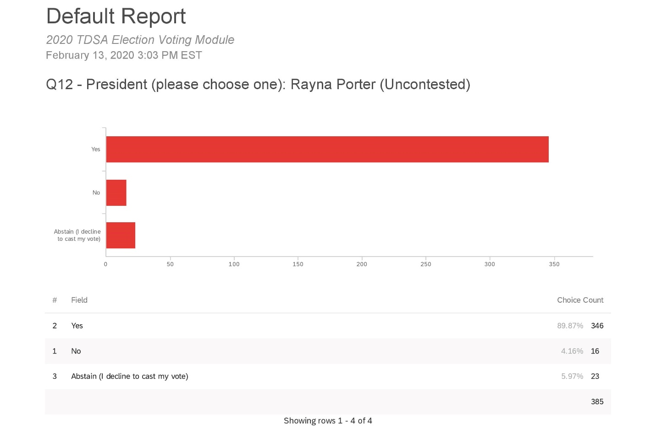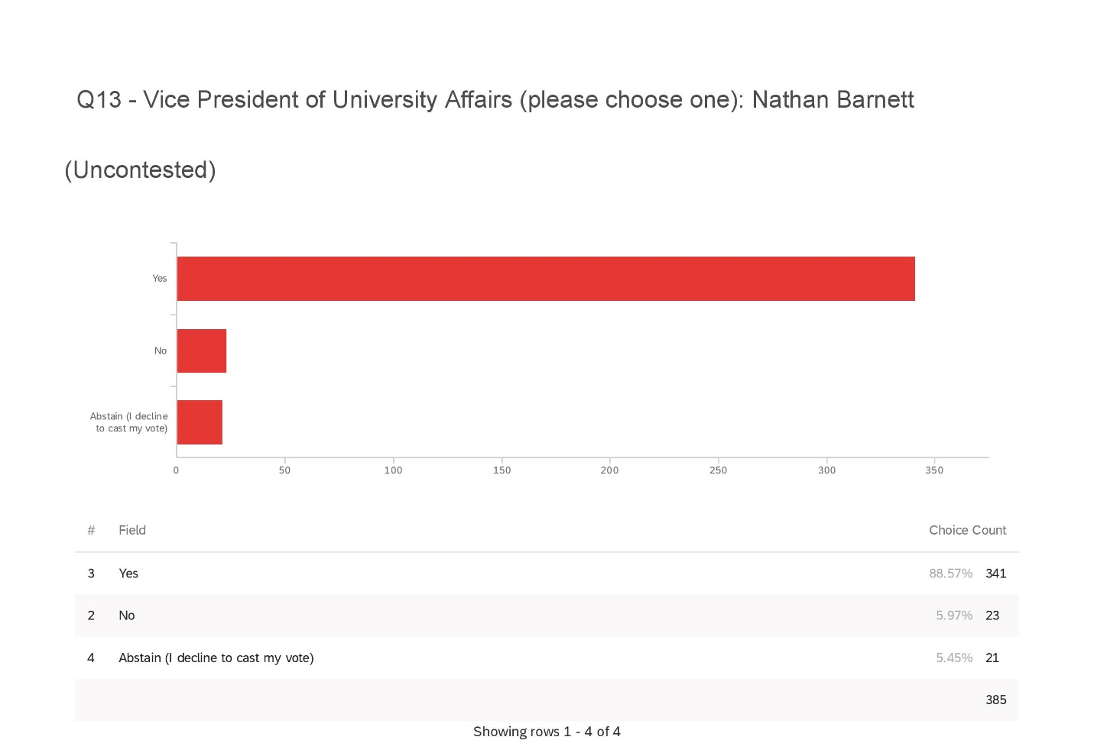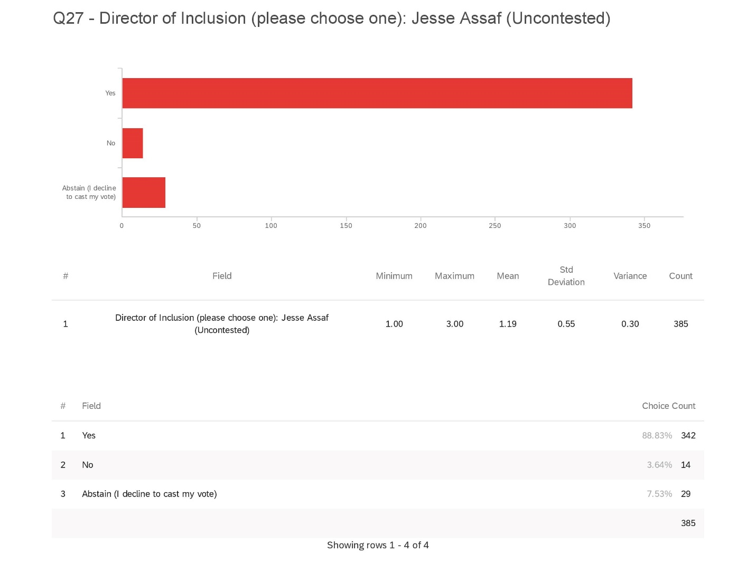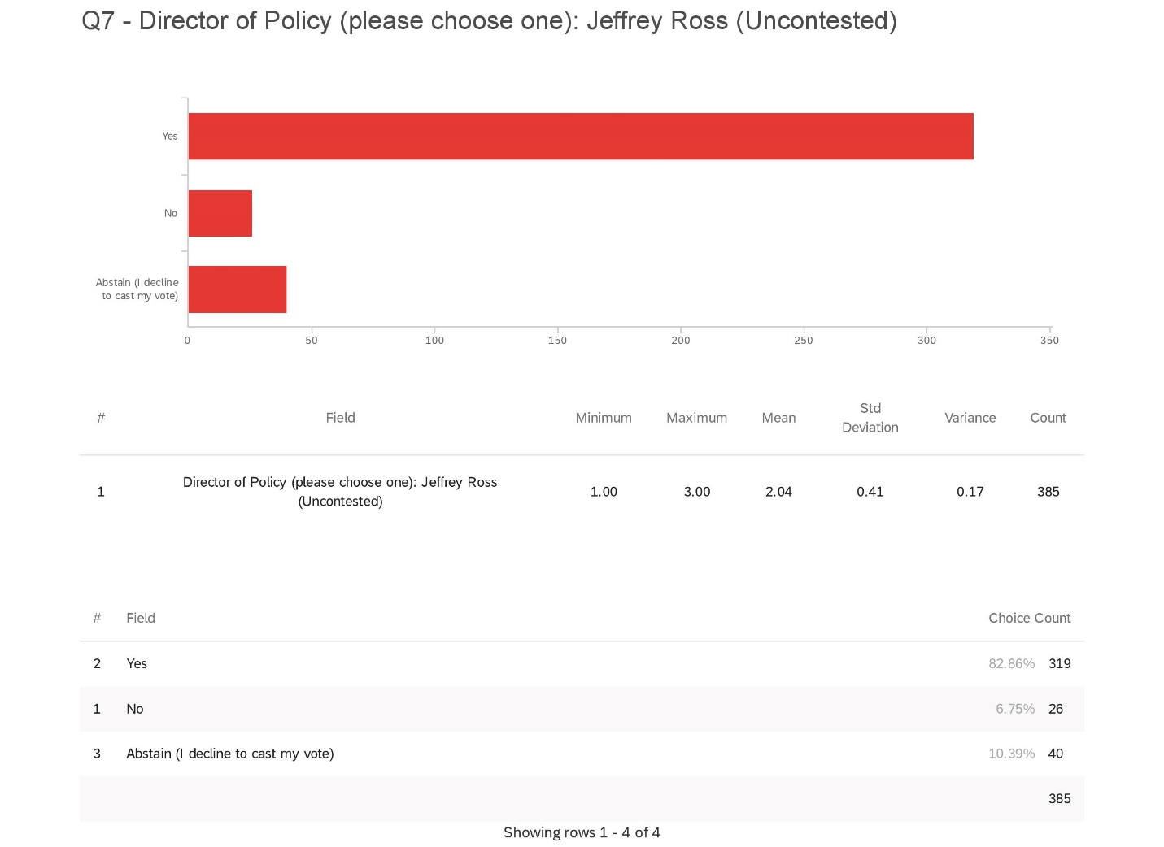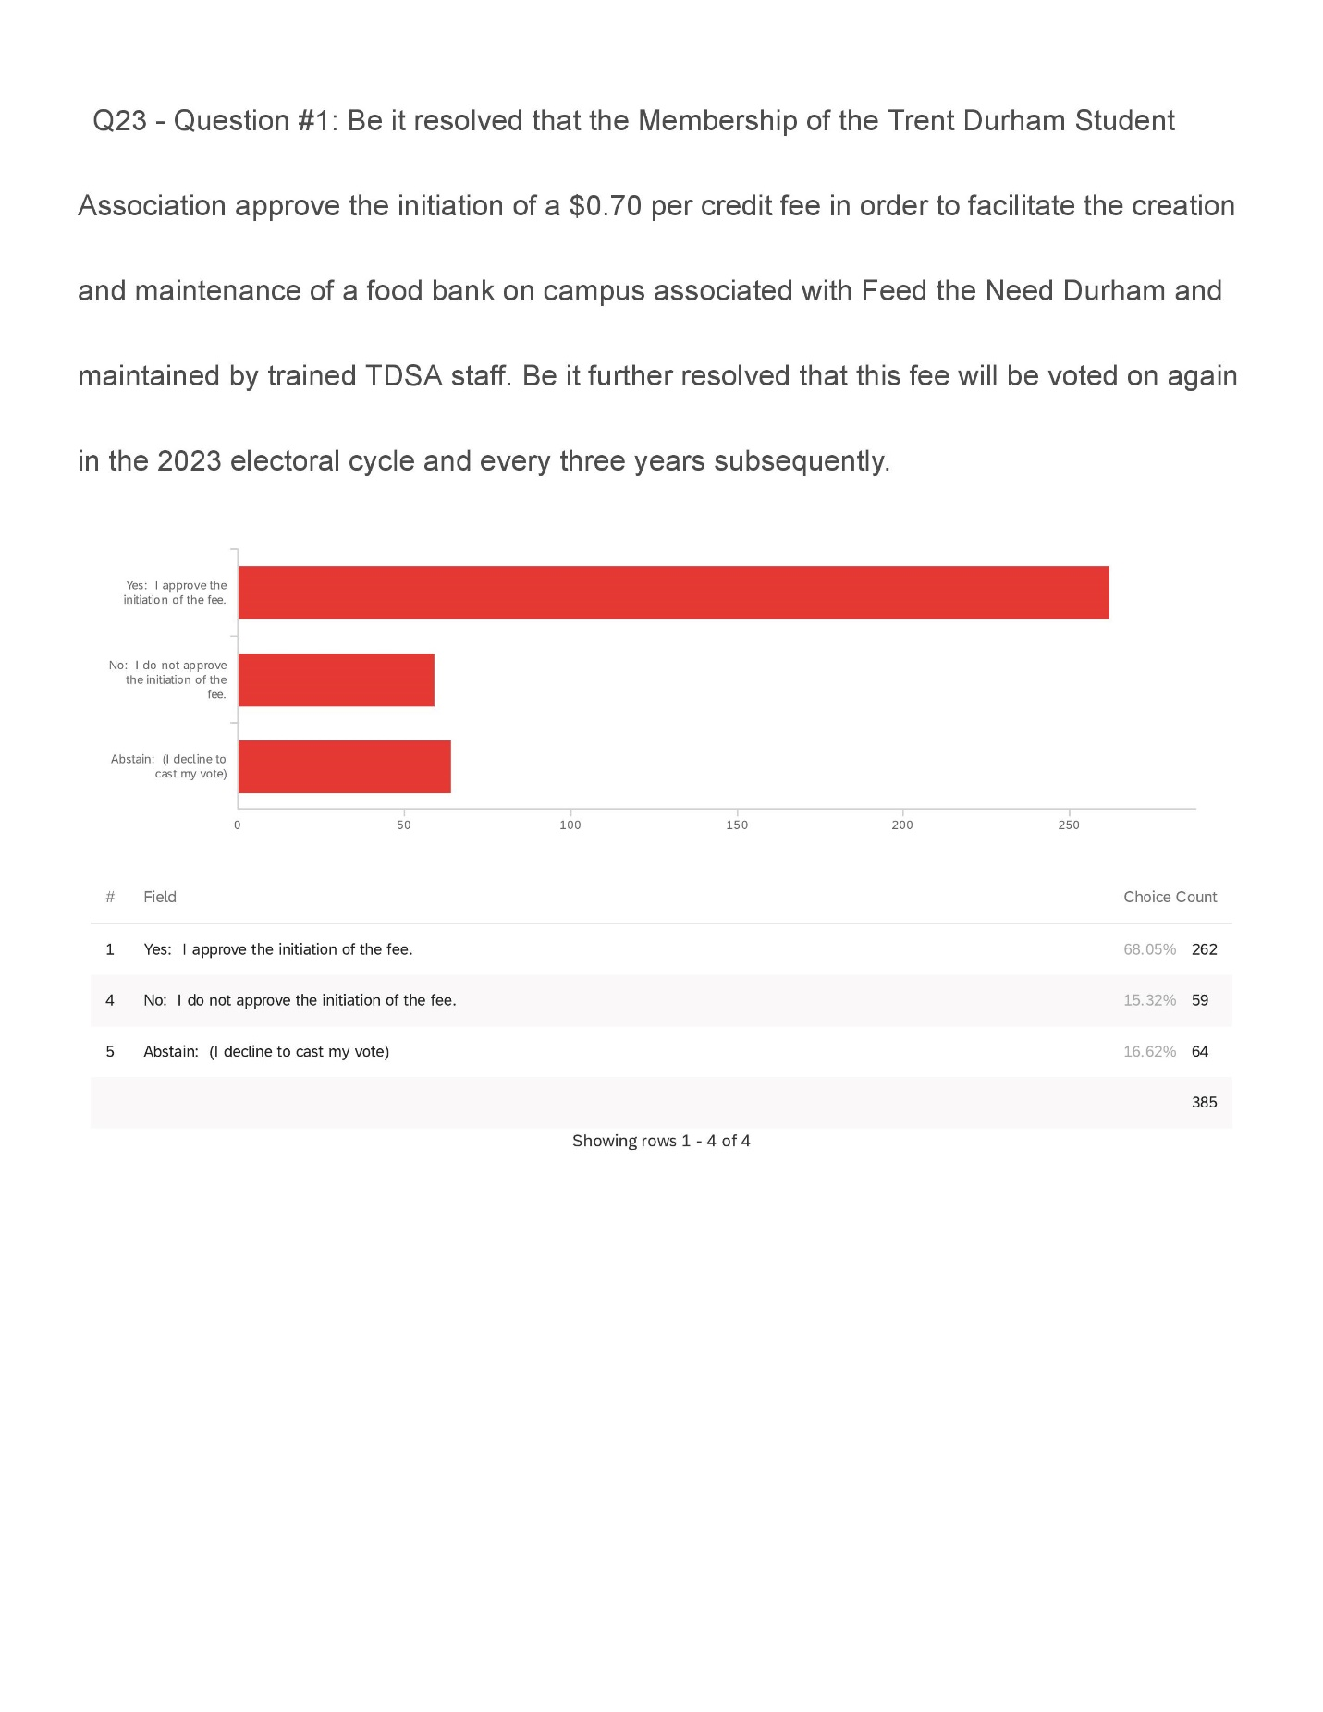
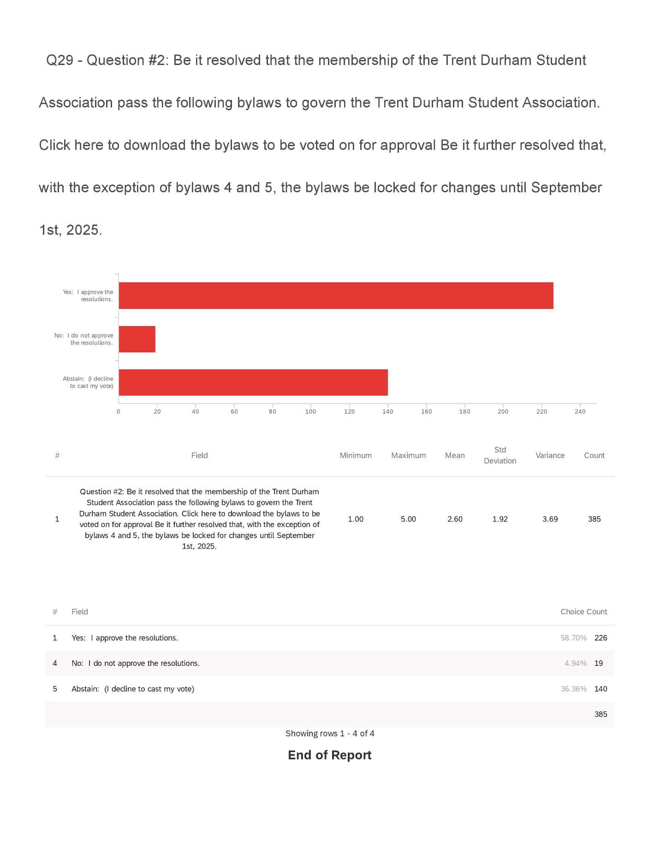
Motions
Be it resolved that the TDSA Board of Directors approve the results of the Winter 2020 elections as presented.
Appendix 7: External Peer Support Training Proposal
Background
As approved during the April 4, 2019, Emergency General Meeting, the TDSA adopted a Peer Support Program funded through a mandatory fee. The program was approved to, among other stipulations:
  - Provide the students at the Trent Durham campus with emergency on site mental health resources
  - Provide trained executive staff, up to and including ASIST training, with drop-in office hours for students in non-life threatening situations
  - To work collaboratively with full-time Trent University Student Services Staff to ensure the Support Group is managed in the healthiest and most supportive way for students
  - Have the President keep in consistent contact with the overseeing staff to regularly monitor the program
  - Specific training standards will be established for the incoming executive at the end of the previous year

Purpose
To give the Operations Manager external training in Peer Support to help facilitate the creation and oversight of the new Peer Support Program offered by the TDSA, including providing insight into what should be included in the training and implementation of an on-campus peer support program.

Proposal
Mental Health Commission of Canada has released “Guidelines to the Practice and Training of Peer Support” (1) to which they recommend all Peer Support Programs follow to ensure the most thorough support possible for the people partaking in the service.

After extensive research and contracting all groups, it has been determined that training offered by the Badge of Life group would be the best fit for this type of training.
In an email response from the trainers, the training is described as follows:

“We developed our curriculum from the Mental Health Commission of Canada Guidelines “Guidelines to the Practice and Training of Peer Support” published in 2013. Attached for your information. It’s an evidence based Canadian document that outlines 17 learning objectives necessary for Peer Support workers in Canada to know before entering into the world of peer support. In addition, we firmly believe that a significant portion of this training should be delivered by a competent mental health professional. As far as we know, we are the only ones who follow the guide precisely and ensure a MHP is with us teaching.”

The training is $400.00 for 2 days of course work in Toronto (Sharon) on April 16-17, 2020 or September 17-18, 2020. (2)

Motions
Be it resolved that the TDSA Board of Directors approve the Operations Manager to attend 2 day Peer Support Training in Toronto (Sharon) on April 16-17, 2020 and incur all related costs including hotel fees, training fees, mileage, meals, and usual hourly wage.

Appendix 8: Executive Transition and Bonus Proposal
Background
The previous bonus model was replaced with a “to be approved” transition training package during the August 13, 2019 board meeting. Historically, TDSA has awarded bonuses based on performance reviews (upwards of $500 per executive and $250 per student employee) with the intent that it would motivate executives to work to their full capacity from day one to end of term. With the current performance review model no longer coming to the board, the function and process of bonuses must be revised.

Purpose
The bonus procedure must be revised as the performance review no longer has board oversight. All bonuses/monetary awards to executives should have board oversight to ensure responsible function of the TDSA and its finances.

The revision must include an objective goal that the executive and the board can clearly assess (reducing the risk of biased decisions) and predict (will happen every year) that is completed toward the end of term and benefits the role and organization.

Proposal
The TDSA 2019/2020 Executives team proposes the creation of a Transition Package Framework. This would be completed by the executives as a mandatory portion of their roles; the completion of which would determine if the executives receive a monetary compensation incentive.

The TDSA office has a poor historical record from executive to executive with little purposeful content to draw from. This puts the corporation at risk for repeat errors, time-consuming documentation gathering trips, and a poor comprehension of failed initiatives or successes. Organizational memory is young, so comprehensive documentation is essential to the success and longevity of this corporation.

A Transition Package would allow the corporation to have a more successful transition between executives. Assigning a bonus to the successful completion of this transition package would honour the labour-intensive work of developing such a document and entice comprehensive development with enough time for the incoming team to utilize it.

The Transition Package Framework would consist of 3 categories: End of Year Report, Peer and Personal Support, and Position Focused Documents. Each category would be worth 30%, with the remaining 10% to be awarded by the Board of Directors based on overall performance. The Transition Package Documents would be completed by March 31 of each year and the Board of Directors would determine if the package has been completed or the executive has made every reasonable effort to complete it in the April Board of Directors meeting

We recommend that there are no specified items that must be included and instead leave the category contents open to allow flexibility year over year.

Below are the documents that can be included as suggested, but not mandatory, inclusions in the Transition Packages:

President

End of Year Report  - University contacts  - Month by month breakdown  - Keys and passwords  - Long term plan  - Fees (current breakdowns)  - Budget | Peer and Personal Support  - Self-care  - Caring for your team  - Team building | Position Focused  - Committee summaries  - Bod Training how to’s  - SCI  - Taxes  - Fees  - Membership  - Bylaws  - Corporations act at a glance  - Best practices  - Conflict Management  - Office Management  - Committee Conduct  - Public Relations

Vice President of University Affairs
End of Year Report  - Contact List for Past External Partnerships  - University Contact List  - Keys and Passwords  - Advocacy Best Practices  - Month-by-Month Expectations | Peer and Personal Support  - Supporting Your Executive Team  - Advocacy Burnout and Resources  - University Resources | Position Focused  - OUSA History and Commitment  - SC Meetings  - Events  - Policy Writing  - Meaningful and Ethical Consultation  - GAs  - Student Advocacy Week  - Advocacy 101  - Past initiatives  - History of success with campaigns  - How to engage students  - Governments: Municipal, Provincial, Federal  - Rough outline  - University Affairing  - History of Trent Durham representation at Peterborough Campus  - Sub-committees explained  - Executive Standards  - Uni VIPs  - Public Relations  - History of Student Unions and Student Advocacy

Vice President of Campus Life
End of Year Report  - Phone Voicemail and Long Distance Code  - Month - month updates  - Passwords and Key Transfer  - Event Summaries  - Contact List | Peer and Personal Support  - Self Care and Avoiding Burnout  - Supporting Your Executive Team | Position Focused  - Clubs  - Forms and Applications  - Training  - Events  - Cashboxes  - Fundraising  - Events  - Booking Events with the University  - Posters  - Canva  - Alcohol  - Social Media and Marketing  - Tips and Tricks  - University Contacts  - Time Sheets  - Email Etiquette  - Shared Google Drive  - Computer Desktop Folders  - Qualtrics How To  - Doodle How To

Cost and Implementation Timeframe
The Executives, noting their Conflict of Interest in this matter, leave the decision of when to start applying this incentive structure (either for the 2019-2020 Executives or for the 2020-2021 Executives) and the total amount available to be determined by the Directors of the Board.

Based on review of the budget, the President recommends this not exceed $500 per Executive. Bonuses should be offered at fair market value; Compensation that is disproportionate to the services rendered would contravene Canadian Income Tax Law.

The TDSA is evaluated by auditors annually and $500 and below has never raised concern during these assessments.

For more insight into fair market value, the board is invited to conduct research using the Canadian Revenue Agency website for charities which gives insight to average pays and compensation (charities are different from non-profits, but executive compensation is similar). Upon assessment, the board will recognize that as all executives are paid less than the first tier of annual compensation ($1 - $ 39,999), bonuses at $500 or less, even at full compensation, would not put any position into the next tier by a wide margin.

Suggested Policy Additions
Additions to Policy No. 21: Transition and Training:

Transition Package
As a mandatory part of their roles, all TDSA Executives are expected to complete a Transition Package including documents that fall into the following categories:
- End of Year Report
- Peer and Personal Support
- Position Focused

Transition Packages will be completed for submission to the board by March 31 of each year.

Completion Incentive
A completion incentive will be awarded to the Executives by the Board of Directors during the April Board of Directors Meeting.

The completion incentive will be awarded if the Board determines that the Executive has completed or has made every reasonable effort to complete each category individually.
Completed categories are worth 30% each, with the final 10% being awarded based on an objective evaluation of overall performance.

The total amount of the Completion Incentive available to be awarded to an Executive is $500 per Executive. This amount is subject to change based on year-to-year budgeting constraints and is not guaranteed to an executive.

In the event that this amount changes or will not be awarded for budget purposes, employees must be notified at least 30 days ahead of the March 31st deadline.

It is also suggested that there is a reference to the transition packages in each of the executive job descriptions such as:

Completion of a Transition Package as described in Policy 21, line ##

Motions
Be it resolved that the TDSA Board of Directors approve the suggested Policy Additions including the creation of an Executive Completion Incentive Structure based on the successful completion of a Transitional Package consisting of end of Year Report, Peer and Personal Support, and Position Focused documents.

Be it further resolved that the TDSA Board of Directors approve the allocation of $500 total per executive as a completion incentive, with 30% awarded per completed section and 10% awarded based on the determination of overall performance by the Board of Directors.

Be it further resolved that this Policy change takes effect for the 2019/2020 Executives.

OR

Be it further resolved that this Policy change takes effect for the 2020/2021 Executives.

TDSA Board Meeting March 27th, 2020

Present: Nick Ryan, Bonnie Caruana, Rayna Porter, Nathan Barnett, Sigfrid Belemsaga, Aleah Symons, Hema Tikaram, Jamila Alleyne, Karina Mahabir (3:52pm), Scott Boulton (4:09pm), Taiera McFarlane (4:48pm), Lynch Alcala-Hao (5:34pm)
Absent: Lindsay Gammon, Shannon Fiedler, Mackenzie Prine

Procedural Items
- Call to Order at 3:47pm
- Land acknowledgement
- Roll Call
- Chairs Remarks
- If you need anything please let me know
- February 26th, 2020 Meeting Minutes Approval
Karina enters at 3:52pm
- Spelling error needs to be corrected
Motion to approve meeting minutes with spelling error corrected
Motioned by Hema
Seconded by Nathan
Motion passes unanimously

- Review of Action Items (Appendix 1)
- No questions or updates
- Call for New Business
- Chair Compensation #14
- Closed session item- employee compensation #15
- COVID-19 Relief Fund #13
- Approval of the Agenda
Motion to Approve the Agenda
Motioned by Nathan
Seconded by Hema
Motion passes unanimously

- Declaration of Conflict of Interest
- Jamila for Chair Compensation
- Nick, Hema, and Rayna for Transition Packages
Updates
- Executive Updates (Appendices 2-5)
- Hema: March was hectic, first 2 weeks was semi work, then when TDSA shut down it hit me harder then expected, just trying to get back to myself again
- Nick adds: changing rapidly, students now have option to submit pass/fail grade, not advisable as there are negative consequences
Scott enters at 4:09pm
- Any outstanding library fines will not mean you cannot graduate or continue accessing resources, there will also be no new fines accrued
- Drop deadline for courses has been extended
- Board Updates
- Today was the last day to send in your board updates for the reference letter, can also stay on after the meeting to discuss with Nick and Jamila. Also, the only thing we have to hand over to the next year’s Directors.
Discussions/Decisions
- Review of Transition Packages and Bonus Determination (Appendices 7-9)
- Discussion and Vote
- After semi the VPCL would normally focus on transition package, however we had started at the beginning of the year, but I did not get to complete it as was not expecting the situation to have the effect that it did. Was able to complete a fair bit, but would like to ask for an extension of April 10 to complete the rest.
- Rayna’s was not submitted until day of meeting
- Would you like all executives to leave the space? Yes

Nick, Rayna, and Hema exit at 4:16pm

- Did not have enough time to read Rayna’s, and ok with extension for Hema, Nick’s looks good
- Can table the decisions to give yourselves enough time to make a proper decision, can also note if you want any changes and ask them to bring them back, all up to you to decide
- Did we agree how the compensation would be rewarded? Yes, you did offer it up to this years executives
- Must also take into consideration the COVID-19 crisis
- Would like some more time to look them all over, could do all three in April meeting, but we have had Nick’s for a week so we could decide today
- What would you like to do with Nick’s? Looks fine, but hard to judge as we have nothing to compare to. Look at thoroughness, is it lacking in any way or needs clarification in any part? Looks like all information that’s necessary is there, and would have enough info if I was taking on the role. Would you want to ask him to add in pandemic info? Might be useful if something similar happens in the future. What would it look like? Leave it up to him to include what he thinks is vital. Good to include background on situation. Then reassess and vote on all three in April, but Due by April 10 and sent to you all by April 11. Is it nit picking? Also the situation is still developing so might be unreasonable. Transition packages are history for more then just next executive, so might be an important frame of reference. Good to get his point of view. Should vote on all bonuses at one time.

Motion to ask Nick to include information about COVID-19 in his transition package
Motioned by Nathan
Motion passes, 5 for, 0 against, 3 abstain

Motion to have all three transition packages completed by April 10 and sent into Jamila, and for bonuses to be assessed in April meeting
Motioned by Nathan
Motion passes, 5 for, 0 against, 3 abstain

Nick, Rayna, and Hema re-enter at 4:40pm

- COVID-19 Relief Fund
- Discussion and Vote
- With the current situation a lot of students are now in in a very precarious financial situation. Trent has a current COVID fund that has given out about $20,000 to students so far, not going to run out of money currently, but unsure how long this will go on for and might need more. As we are not in the position to get private financial info and decide what financial consequences there are and who should get the money, the ask is to approve $10,000 to be given to Trent if and when the need it. $5,000 from special projects, and $5,000 from what would have been semi-formal budget. Trent will invoice if they need it. Only for Durham students. Will set it aside in our own budget to give the University if they need it.
- $5,000 from special projects fund which currently has $7,500, and $5,000 from semi-formal fund as semi did not run. How did we arrive at this number? As Trent has given away $20,000 to 33 students and the amount given can range from $70-$1500 per student, would rather over shoot then undershoot and run out.

Taeira enters at 4:48pm

- We have a surplus this year and with a lot of our end of year events not running we have a lot of money and should be put to student who paid into it this year. Financial aid will award it not us. Will students know it’s our money? We want to make sure students know we are supporting them. How does it get distributed?
- We will release a presser to let the students know that we have donated the money and release on social media
- We can place whatever stipulations we want but financial aid will not say where the money comes from but can do a heavy press campaign. With the complexity of the situation, financial aid asses each request individually and takes into consideration taxes and OSAP etc.
- Motion typed out in chat function. Nick will get email agreement from Trent University if motion passes.

Motion that the Trent Durham Student Association make $10,000.00 available to the Trent University finance office for the purpose of COVID-19 student relief for Trent University Durham students whereas this money will be made available at the earliest possible time.
Motioned by Rayna
Seconded by Hema
Motion passes unanimously

- Chair Compensation
- Discussion and Vote
- Last year on March 26, 2019 chair started, which was a month early. Was given the portion of the month as chair officially started near end of month. Asking for rest of months pay as worked more many hours in those 4 days, more then was compensated for.
- Has your time been logged hourly since the beginning of the year? No. The position is salary so if you work under 15 hours you are still paid for the full amount, and legally if you only worked a portion of the month you are only able to receive a portion of the pay.
- During the 4 days did you work the 15? Yes, more then that.

Hema exits at 5:07pm
Chair passes to Nick
Jamila exits at 5:08pm

- If the point of a salaried position is that it’s a flat rate would it not make sense to pay her the full amount as she completed the task she was to complete?

Hema enters at 5:10pm

- If we have someone start in the middle of the month they would only get paid for half the month. Is very late and there is no report. Should the request have gone through the HR committee?
- Why is this coming up now? Almost a year later. Understand where she is coming from if she worked a months-worth of work in those three days.
- Disciplinary committee was a lot of work and was very hard so understand where coming from, but as position is salaried the amount of hours is offset by other months where there may not be as many hours worked.
- Was Jamila on the disciplinary committee because she was the chair or was she on it as part of her board volunteer time. If it was part of her job title as a board member then it is not reimbursable. She did act in a chair role in the meetings but unsure if that was as the chair of the board or as a committee member.
- We should be sympathetic to any emotional trauma from the event but as the chair does not report hours they are not held to account for any time the are short or go over unlike executives who report all hours to the board. None of the other positions get this option, if they go over they must find the time to take it off. Last year the VPCL was denied being paid out for hours even though they were very over.
- We don’t have a lot of background information about the situation
- We should not judge character or where someone is coming form if they are not here to defend themselves or refute.
- The way it was paid was fair and considering timing should not pay out.
- There is a lot of uncertainty and not enough information to make a solid decision. Would you like it tabelled? No, there is no option to find out more information because of time and no one can remember. Should make a decision today.
- Is there any information that anyone would want to see and ask Jamila to come back with the needed information? Or is the request untenable at this time?
- Make the call now, was a year ago, so the sooner the better, we don’t have evidence either way and no log of any other month, so vote now.

Motion to pay the chair for the remainder of the March 2019 pay period
0 For, 5 Opposed, 4 abstentions
Motion fails

- We should have a reason on record when it comes to monetary decisions
- Insufficient evidence, and it is not the boards job to find evidence
- Legally because the position is salary based
- Time frame or request

Lynch enters the meeting at 5:34pm

- Banked hours historically are the responsibility of the employee or executive to take off, as well they did not log hours and if there were hours owed to them they would be expected to take time off as with any other employee or executive.
- Time frame reference removed as if there was sufficient evidence we could make the decision and there is no policy that states timeframe limitations.
- *official reasoning wording workshopped*

Motion to adopt the reasoning “Due to the insufficient evidence to the Board of Directors and in compliance with TDSA policy 4.4 "Banked Hours" the Board of Directors has made the decision to uphold the current job description as it is a salary position and would not entitle the employee to the additionally requested compensation.”
Motion passes unanimously

Chair calls a 5-minute recess at 5:50pm

Meeting resumes at 5:54pm

Motion to move into closed session
Motioned by Lynch
Seconded by Nathan
Motion passes

Meeting moves into closed session at 5:55pm

- Employee Compensation- Closed Session
- Discussion and Vote

Motion that the TDSA Board of Directors allow the 2019/2020 executives to award up to $250 bonus to their employees. Whereas COVID-19 impacted their ability to finish their contracted hours
Motion passes unanimously

Motion to adjourn
Motioned by Hema
Seconded by Scott
Motion passes unanimously

Meeting adjourns at 6:08pm

Upcoming Events
None discussed
Appendix 1: Outstanding Action Items
- February Meeting 2019

- Action Item: change name of committee in committee policy from Student Clubs Committee to Student Engagement Committee
- Completed, will post when final document from bylaw and policy overhaul has been completed

- March Emergency Meeting 2019
- Action Item: OM to review policies and ensure wording reflects professional working environments and not personal relationships throughout bylaws and policies
- In progress- Document created with suggestions and given to President, comments debated and added into working library document

- Action Item: OM to ensure any policies regarding training and meetings to include follow-up emails, as well ensure that all policies concerning committee meetings include the addition of follow-up emails.
- In progress- Document created with suggestions and given to President, comments debated and added into working library document

- April Meeting 2019

- Action Item: OM Undergo mediation training on Lynda.com
- In Progress- 9 videos completed

- Action Item: Procedure to be created in regard to professional communication and meetings
- In Progress, will update in phase 2 of bylaw and policy overhaul, looking to design a workshop that OM will deliver

- Action Item: include workload in candidate information sessions
- Compelted

- Action Item: Do some research on this type (professionalism and communication) of training and who can perform it.
- In Progress

- August Meeting 2019
- Action Item: All directors to send in ideas via email or visit the office to speak with Nick to put ideas together. (in regard how to choose committee members)
- Not completed

- Action item: Nick to send out Doodle poll in regard to formation of working group to all Directors
- Not completed

- December Meeting 2019

- Action Item: Sigfrid find out if the 4 courses needed to qualify for the test are available at Trent. If they are, executives to advocate at a senate committee for the courses to be added into the academic calendar. If they are not, executives advocate at Senate committee for that information to be included or to remove the wording about CPA accreditation from the academic calendar- unsure

- Action Item: Bonnie to look into enamel pins with vendors. Investigate pricing for just TDSA logo and TDSA logo with different titles.- In progress

January 2020 Meeting
- Action Item: Can all board members send Jamila what direction their committee has taken? What worked? What didn’t work? Non-voting representatives welcome to respond as well.

- Action item: change Clubs Policy wording to reflect Fall and Winter Semesters instead of Academic Year- Not complete

Appendix 2: President’s Update

Holy Covid 19.
Cleaned up my desk as I probably won’t return
Updated full budget
Worked on planning a whole bunch of training that got cancelled
Policy work
Maintained relationships with senior admin
Used some banked hours.
Helped with semi and food bank… both cancelled.
This is just sad now….. think of puppies
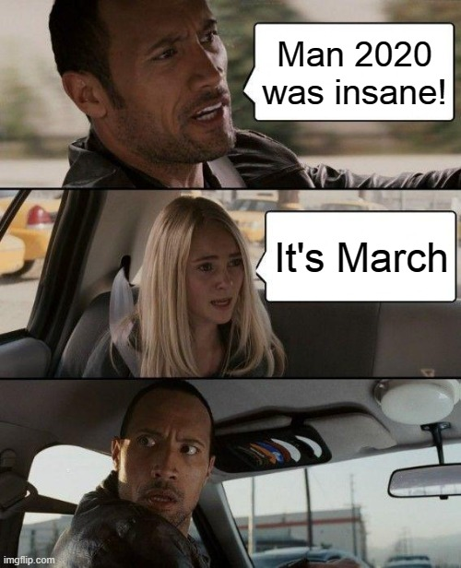
Appendix 3: Vice President of University Affairs’ Update
Current Projects
Peer Support Zine Project
- Partnership with Health Promotions to develop a Trent Durham student-made zine for the peer support group
- Postponed due to COVID-19 precautions
TDSA Food Drive
- Cancelled due to COVID-19 precautions
OUSA Policy Papers: Pending due to COVID-19 precautions
- Student Association Autonomy
- Gender-based and Sexual Violence Prevention and Response
- Northern and Rural Students
- International Students
Look out for these to be passed for April 20th
General Assembly
- Update TBD while we try to navigate a virtual option
COVID-19 Academic Response Assessment
- Distributed to over 35 students
- Results to President for follow-up conversation with the university
- Hopeful these responses will inform an advocacy direction for the TDSA
Committee Updates
Senate (March 10th)
- Teaching awards were handed out in professors’ classes as a surprise by Prof Joel Baetz; Prof Baetz says the surprises were well received. Thanks to those who completed applications for our professors to be recognized.
- Trent University COVID-19 update (now expired as new updates have been released)
CUP
- Not confirmed, but the committee is likely to be suspended for the year due to COVID-19 precautions
UAPC
- Recording of Class Content Policy
  - Policy proposed; lots of edits required
  - Undergraduate Academic Integrity Policy also at the committee table to accommodate the recording aspect
  - To be revisited next meeting
- Registrar/Careerspace – Definitions of experiential learning
  - Meeting ran too long and this was pushed to next meeting
- Next meeting not confirmed
USC
- On hold until March 24th; anticipated to resume through Zoom
CPRC
- March meetings cancelled due to minimal business. None scheduled for April.
AP&B
- On hold
Town and Gown (March 5th)
- Official request made to Durham Regional Transit to move the 900 Westbound Bus Shelter Location at King X Thornton. Intend to follow up after pandemic measures have been lifted.
- City of Oshawa
  - Changes to AirBNB and ride sharing apps to come for Oshawa
  - The city would like to introduce some policies around registration and restrictions. Details to come, but likely on hold during the state of emergency.
  - Tenant information pamphlets from the city now available in the TDSA Office
- Durham Regional Transit
  - 401 bus to be rebranded as a Pulse bus
  - 910 along Thornton extended to Ajax station via Bailey and Victoria and SW Whitby
  - 304 along Windfield farms 7 day/week
  - More expansions planned for September - consider on hold during state of emergency
- OnTech
  - Updates on programming (All cancelled now due to COVID-19)
  - Red light camera coming; no date yet
  - New legal service and insurance upwards of 1500$ coverage for students
- Durham BIA
- Stickers in window for downtown locations
- Talking with SUs and Alumni about an event
    - Intended for October, but planning likely on hold now due to COVID-19
- OTSU
- New executive team elected
- Update on programming (All cancelled now due to COVID-19)
Community Updates
Student Concerns Right Now
- COVID-19

Appendix 4: Vice President of Campus Life’s Update

** Will be provided at the meeting
Appendix 5: Operations Manager’s Update
Month: March 2020
Banked Hours Update
President: Under 35
VPUA: Under 35
VPCL: Over 35
OM: Under 35

Update:
- Finished more Conflict videos, only 1 left
- Printed and sent T4s
- Registered for Scotia Connect and online banking, performed some online direct deposits
- Exec meetings held
- Webinar from CICMH- Alcohol on campus
- Completed credit card comparisons and sent to Finance Committee
- Monthly accounting work
- Researched and made summary about eco-friendly paper for the office
- Worked on exec and board training ideas with Nick
- COVID-19
- Started working from home including emailing all outstanding cheques and bluecross mail for home addresses to forward, and emailed about semi refunds
- Created director and employee exit survey and added in suggested changes
- Worked on agenda for board meeting

Appendix 7: President’s Transition Package

Preamble.

Look I’m not going to act like you are going to read all of this or that this will last past the time that you have read this… oh wait you are Rayna of course you will read all of this.
Still I am going to be really concise and not bore you with the details. This whole
document can be summed up in a few simple lessons. Be the example, leave on time when you can but be the last to leave when you have to be. Be calm, there will be plenty of people freaking out, but publicly at least show concern but always remain collected, again you are the example. Everyone, even those that disagree with you MUST feel comfortable approaching you. As difficult as it may be I found some of my best results were guiding conversation rather than controlling it. And lastly do your homework, you are the President and your word carries a lot of weight, so make sure it means something and again, set the example of doing the readings. Do these things and your year may not be easy but it will be worth it. And always ask for help.

Part 1

Student Choice… What the fractured budget

Overview
Student Choice Initiative (SCI) is a program introduced by the Ontario
Government in 2019 and seeks to make a number of levy fees opt-outable. This
includes student association fees. As problematic as that may seem there are a number
of buckets that can make a fee ‘safe’. These are, broadly:
Athletics and recreation
• Career services
• Student buildings
• Health and counselling
• Academic support
• Student ID cards
• Student achievement and records
• Financial aid offices
• Campus safety programs
Now getting a fee into these categories means that students will not have the choice to
opt-out of the fee and that revenue will be guaranteed. As tempting as it may be to
protect all of the fees, you can't, and shouldn't. There are protected categories and
protecting all of your fees may prove very unpopular with your students.
Protecting Fees (why and how)
How to approve fees.
Ok, there are many steps here so bear with me. You will first have to establish
how much and why. I will be using the example of the peer support group as it is our first successfully protected fee.
Step one: Establishing what the fee is.
This first fee was a ‘survival fee’ (meaning that we needed this fee to insure our
basic services to students would continue) so basically we had to sit down and figure out what we were already doing that would be protected by the new system.
So we first had to establish what the fee would do and how it fits into our current
ways of doing things. In this case, we will use peer support in terms of mental health support. Mental health support are covered under the Student Choice Initiative and we were already doing a lot of support unofficially. By making this process official we could then say that the cost of these services is essential and thus not opt-outable.
How much to charge
So now that we have established what the fee is we have to figure out how much to charge for it. That started with everyone breaking down what they spend time on. For example Operations Manager 25% store 5% cheques 20% peer support
ect. So in this situation the 20% of the OM salary will be eligible to be covered under the Peer Support fee. In this situation we would take the total OM salary and multiply it by 0.20.
48,195.00 x 0.2 = 9639
Therefore, the protected portion of the OM’s salary will be $9639. This process should be repeated for all positions that deal with peer support. Those salaries are then totaled up and that number would be one factor in your final fee calculation.
Next, you must establish a budget for the operations of the service. In this case, peer support includes things like mental health events. Our small events budget basically goes towards mental health-focused events anyway so transitioning that into a new mental health events fee means that too is protected. Same with the orientation fee becoming the transitional support fee.
So taking these operations into account we can add 15,000 onto our total along with 5,470 for 2 student staff and this will give you all you need to calculate the total cost. So the formula is
Total salary x percentage if time spent = Salary the fee can cover (S)
S + operating costs = total cost of the fee
$23,760.20* + $11,550.89* + $13,434.60* + $10,926.59* + $5,470.00** +
$15,000***=$81,792.28
And thus you arrive at the total cost of the fee being $81,792.28
*executive salaries
** student staff
*** operations
Once you have the fees total cost you have to break it down into a per credit fee to be charged to students. You do this by using the full-time equivalent student number (FTE).
This is the number the university uses to predict its budget. The number represents the amount of students we would have if every single student was taking 5 classes. You can get this number from the Manager of Student Affairs (Jen Richardson).
The formula is:

Total cost/FTE/5 (number of full-time credits)
So in 2018-19 when we did this it looked like this
$81,792.28/1155.69/5= $14.15
So, you have arrived at the per-credit cost of the fee. Now, we were uncertain about the life of the cooperation so we asked for $15 and got it approved as a safety measure but I would not recommend this going forward as we are now in a more stable place.
Getting the Fee approved
So now you have the what for and how much. Now its a matter of getting it approved.
Step one
Talk to Jen Ritchardson or Nona Robinson. Tell them what you are planning to do and they will give you an Idea on if the fee will be something the school is willing to make mandatory. If they say no attempt to modify the plan to make it protected but also don't strain the corporations resources and be true to the mission statement.
Step two
Referendum. If you haven't read the bylaws at this point DO IT IMMEDIATELY. ALL OF THEM. WHAT HAVE YOU BEEN DOING?!
Step three
Once the referendum has passed you take that fee to the College and Student Services Committee. This will be the body that will recommend to the board of governors that the fee be mandatory
Step four
Wait until you hear back from the board of governors and once you do you'll have your protected fee for the next academic year. (oh yeah all this will take effect after your term)
WHY
Ok now you know how, but why should you get a fee protected. Basically there are only two reasons you should protect a fee. If a program is providing a direct measurable and public facing service to students or is to protect the staff that make the TDSA function.
Getting a fee mandatory takes the choice away from an individual student and requires a lot of public justification of the fee that could produce negative outlooks on TDSA. So the choice to create a mandatory fee should never be taken lightly. That being said these fees can be tremendously powerful for students it can provide a more stable student association that can provide lower cost services to students.
Do the fee if it will keep TDSA secure and/or provide a service to students.
NOTE: DO NOT OFFER BENEFITS OF MEMBERSHIP, that will make a fee tax
applicable which means a 13% cut off top. Benefits you can have, access to the vote and club membership are the main things you can restrict. NO DISCOUNTS OR
EXCLUSIVE EVENTS

PART TWO Bylaws

This was my baby in my year as you well know Rayna. And as we have discussed the ‘seal’ does not really mean much as any referendum can just undue them. However, I did that because I did not know who was coming next. The logic of the seal was to stop piecemeal changes which is what I spent the better part of 8 months undoing. So with these, let them breathe, switch bylaw 4 and 5 as needed with SCI but for the rest let the mistakes live for a year make note of them and pass them on. So that in future any other person can conduct holistic changes and be spared the confusing hell of tracking 5 years of changes.
file:///C:/Users/President%20TDSA/Downloads/Corporations%20Act,%20R.S.O.%201990,%20c.%20C.38%20(1).pdf
Follow that link for the corporations act once you get the computer but in the meantime here is the link to the law https://www.ontario.ca/laws/statute/90c38
BEFORE CHANGING BYLAWS LOOK AT THIS

PART THREE Committees

As president you will be asked to sit on a lot of them. The following will be my
breakdown of the ones I sit on and my cost benefit analysis on it. Be mindful that you don't have to sit on all of the committees but do enough that would still you know… do your job.

PTBO Committees
Senate: Only active students can be senate representatives aaannnddd I wasn’t one so talk to VPUA.
Presidential Advisory Council on Human Rights, Equity and Accessibility:
This is a committee that will be important going forward as the building but at the
moment it primarily discusses campus wide human rights events on campus.
Would recommend for this body, none of the interior classroom doors are
accessible on the Durham Campus, see about possible funding.
Durham Committees College and Student Services Committee: This committee is in charge of approving new fees in the Durham campus. This has its own fee protocol
https://www.trentu.ca/currentstudents/policies-decision-making/colleges-and-student-services-committee
This is the most serious committee that you will sit on as it has the most direct effect on the lives of your students. It is a majority students and most non-tuition related fees are going through here. The uni will propose most things here so just keep in touch with Jen Richardson and there shouldn't be too many surprises here.
Food Services This will be the body that interacts with the new food provider on campus. The contact will be Mark Murdoch. The main function will be to provide feedback to the vender about the student experience. The venture will be quite large and also have a stake in PTBO so I say hang around the caf to get a bunch to get feedback. I would also suggest delegating this primarily to the VPCL. They deal with catering on campus and most events to provide food so it makes sense that they take the lead. The only reason it should be president is really for the RFP process.
Housing Advisory committee: The body that oversees ALL residences of Trent. This is a super-campus body in that, they actually talk about Durham stuff. We have a residence standard that is approved through this body as well as reps through res dons. This body deals with the housing budget as well as updating fees. It was always a worthwhile trip up when I made it and they are very accommodating with call ins. I recommend you keep this committee as it is very much in the presidential portfolio and will need regular input with the new res. Contacts are Sarah Giddings (organizer) and Shaun McCracken (Durham Rep ish)
Health and Dental: The plan is completely controlled by the TCSA now so feedback will go through Tracy in PTBO. Normally 2-3 meetings a year but this year has been pretty light as we transition to the new plan type.

Part 4. Month by Month

May: as known as planning month. Get used to the space and introduce yourself to all of the people. Get to know your team, work with them on little things. Start working on the budget now, you’ll thank yourself later. Decide how many student employees you'll ask for
June: Start your major project. This is a quiet month and is a great time to get some really good work done on a big project. Also order new swag for the rack and shelf. Get your budget approved
July: Enjoy your last bit of peace and quiet get that last bit of project work done and take some time off to enjoy the sun.
Aug: You work for the CL its orientation time! This is when you prepare the R & S for mass student consumption and start training student employees. Marketing strategy and o week prep is the name of the game.
Sept: ALLLL of the peer support. This is the month of 10 hour days. Take care of your mental health as you will be working a lot for o-week and academic peer support. This is also when your committees all start up. This is also when BoD will start their projects
Oct: A month that is good for finishing up you summer projects with student
consultations. Get some hours down and maintain committee relations. Help Bod with their projects.
Nov: This is mental health month jr. students are super stressed so get ready for peer support and prof complaints. This would be a good time to meet with scott and brush up on dean contact lists.
Dec: Finish first term projects. Form elections com and GO HOME
Jan: This is election prep month, start scouting potential successors. This will also be the time for referendum questions and major asks from the Uni. As well as people will start to become burnt out. Second semester rack and shelf buys and second semester planning
Feb: Everything goes wrong this month. Don't plan too much as elections and random crises will rule the majority of your time.
March: Recovery from February focuses on legacy projects and transition.
April: ALLLL of the training for the new folks and getting ready for your mental transition out of the position.

Long Term Goals and Recommendations

Preamble
The goal of this plan is to provide a long term framework to guide the TDSA through long term growth strategies. This plan is meant to be supervised by the president and the Operation Manager. The timelines are designed to be flexible and this plan should be reviewed annually by the President and Operations Manager for feasibility and implementation steps.

Each of the successive years will be based on the assumption that the previous years goals have been completed and the Student Choice Initiative opt out rates will remain consistent with 2019-20 levels.

Year one 2019/2020
Overall Goals
I Financial stability
II Budgetary Transparency
III Bylaw and Policy Overhaul

Success Criteria
I. Protect 65-70% of the TDSA budget
II. conduct a more fulsome audit and develop a budget with individual line surplus and deficits
III. Have a full and complete bylaw and policy review package passed through the
appropriate channels

Methods of Success
I. Negotiating the protection of the President's salary and the Vice President of University Affairs’ academic portfolio as well
as the compliance fee totaling more that $45,000.00
ONCA compliance
Academic support
II. Develop with the Operations Manager a peer support budget and an operations budget separating the two revenue streams
III. Policies should be reviewed systematically and presented to Organizational Review and Development Committee and then approved at the Board of Directors.
End of year status
The era of student choice has been defeated, if not permanently than temporarily. This combined with very limited spending by VP’s and clubs, COVID-19 shut down and increase in enrollment left TDSA with somewhere in the realm of a $50,000.00 surplus. Some of this is a functional surplus (surplus due to circumstance) but a large portion is a structural surplus (surplus due to consistent factors) Anticipate structural surplus at $40,000.00.
New food bank operations that will mean a new student staff person, and additional duties onto the Operations Manager.
Student choice is defeated temporarily; however, it may come back in the form of legislation. So, this may be a concern going forward.

Threats facing the corporation
There are very limited perceived threats to the corporation. We are in a financially stable position with solid voter turnout. The main threat would come from external legislation, the only meaningful countermeasure to this is active provincial lobbying and the ingenuity of the executive team.

Recommendations
The main focus of this year has been the amount of work the executives do. All executives are consistently over hours. This will only get worse as a residence gets up and running. Thus, it is the recommendation of the 2019-2020 President that the 2020-2021 Board of Directors task the executive team to research the possibility of
A. Hiring a social media/marketing coordinator/resource officer
B. Significantly increase the number of student employees up to and including
another VP or AVP
The peer support program was widely used in its first year with very little actual advertising. In the months we have stats for there was an average of one per day. Expect an increase with residence. This does not include academic peer support which numbers in the hundreds of interactions. Seeing this phenomenon, the 2019-2020 President recommends the 2020-2021 Board of Directors increase the proportion of salaries covered by peer support levy particularly in the case of President and Operations Manager.
Bylaws have been updated with significant edits to policy. No recommendations here.

Year 2 2020-21

Overall goals
I. Residence Integration
II. Expansion of the Policy library
III. Office relocation
IV. Organization reorganization review
V. Adjusting to SCI life

Success Criteria
I. Assist with the establishment of a residence council
II. Work to establish 2 organizational stances
III. Be fully moved into the new space with appropriate logistics and meeting space
IV. Review with outgoing Directors where possible and get feedback on Director job description and produce a report on possible changes to the Board of Directors
V. Assess financial situation, taking into account increased student enrollment, and produce a report to the Board of Directors

Year 3 2022-23
Overall Goals
I. Review Bylaw 4 and 5
II. Review best practices and possible expansion of the Rack and Shelf
III. Conduct a review of campus mental health services

Success Criteria
I. Produce any changes to the Bylaws to a General Meeting for approval
II. Produce a report to the Board of Directors establishing consistent best practices in terms of purchasing, sales trends, and pricing
III. Produce a report concerning campus mental health services to the Board of Directors and submit recommendations to the University.

Budget and Fees.

Current Fees
Peer Support $15.75 per credit (SCI friendly)
Membership $17.99 per credit
Food bank $0.70 per credit
Walk Safe $2.50 per credit (SCI friendly) (transferred, not discretionary)
Health Benefits $285 flat rate (opt outable) (transferred, not discretionary)
The budget is attached.

Mental health and team building

Self care.
The president should always keep their head. And important to that is a self care
routine. Gratefulness and mindfulness are powerful ways to do this. 5 minutes
meditation before or after a big meeting sets one's mind right. Regular sleep, meals and exercise are incredibly hard to maintain but are critical as well to your overall mental health. Your office may have sunlight but mine didn't so going for regular walks in the sun gets you away from chaos for a moment.

Caring for your team.
Support is a critical part of this whole experience. Often you all will be dealing
with people who are a lot more experienced and with a lot more resources. So often shows of support no matter how small go a long way. A close office makes all the difference in trying times, so get to know each other outside work. A beer or an ice cream out builds unity.
Get to know your team and their stressors and how they react to them.
Understanding why your co-workers are upset or acting a certain way goes a long way to humanizing them and mitigating problems. You will also understand how to support them. It could be small gifts or acts of kindness but understanding these things.

Tips and Tricks

Have weekly meetings with Jen, if not more. She is a wealth of knowledge that
will be invaluable for your time in office.
Take small bites, accomplish what you can when you can. Break larger jobs into
small ones and don't be afraid to stop them if they are not worth your time.
The work will never stop so you should. There will always be things to do but be
sure to take care of yourself you will be more successful
Communicate with EVERYONE your power is in knowing things.
Support board efforts, it increases engagement by in and you may just find your
successor.
The most important thing you do in your term is establish who will come after.
STAY OUT OF IT. You gain very little from personal beefs. Always be the mediator it serves you best. Taking sides never works out well.
If you are going to make a choice have a policy or a morality to back it up. If you
can't sight a policy number or moral base don't do the thing.
DO THE READINGS
Support the boards projects, even if you don't see the long term use we are
about experience for students and a board that is involved gets their friends involved
Its ok to not know, its not ok to not find out.
People will fight, you don’t always have to do something just keep an eye
Call, ask, discover, be majorly addicted to knowledge
Trainings are good… but hard to book.
Students will always have choices let them
Sunset clauses are your friend
Most of all, be kind to yourself.

TO DO LIST

The following are things that I recommend that you do.
1. Review the new board sports for which ones are worth it
2. Establish a fee to protect the services that keep us compliant with the
corporations act
3. Conduct a review of the academic support aspect of the Peer support
group
4. Get the new office set up
5. Establish foodbank stats
6. RENEW OUR LOGO EXCLUSIVITY WITH TRENT
7. Renew fee collection agreement if you can find it/think its a good idea.

Appendix 8: Vice President of University Affairs’ Transition Package

** Will be provided at the meeting

Appendix 8: Vice President of Campus Life’s Transition Package

** Will be provided at the meeting

TDSA Digital General Meeting April 8, 2020

Due to the COVID-19 Pandemic and the closure of the University on March 16, 2020 the TDSA was unable to hold a live event for our members to participate in. Instead, the TDSA President, Nick Ryan, and an auditor for MNP LLP, Jonathan Tellis recorded a presentation of the TDSA updates and the result of the audit for 2018/2019 fiscal year. The URL for the presentation can also be found below.
https://www.facebook.com/TrentDurhamSA/videos/673447123453195/

TDSA Board Meeting April 28th, 2020
Present: Hema Tikaram, Jamila Alleyne, Nathan Barnett, Nick Ryan, Shannon Fiedler, Rayna Porter, Sigfrid Belemsaga, Aleah Symons, Karina Mahabir, Lynch Alcala-Hao, incoming board members in the gallery, Taeira McFarlane (enters a 1:43pm), Scott Boulton (enters at 3:07pm)
Absent: Mackenzie Prine, Lindsay Gammon
Procedural Items
- Call to Order 1:06pm
- Land acknowledgement
  - Given by Nick Ryan
- Roll Call
- Chairs Remarks
  - Last meeting
  - After the call for new business Chair will pass to Hema and she will chair except for where she may have conflict of interest at which time Jamila will resume chairing
  - If you are incoming just a reminder that you cannot vote
- March 27th, 2020 Meeting Minutes Approval
  - Any changes? No
Motion to approve the March 27, 2020 Meeting Minutes
Motioned by Nathan
Seconded by Hema
Motion passes unanimously

- Review of Action Items (Appendix 1)
  - Reviewed individually
  - Follow up emails action item: concern that if that is put into a policy it might lead to reprimands so recommend put into a procedure instead, it was also included in the incoming board training.
  - If this is being modified should we vote to modify it? Yes
Motion to approve the change to the action item from a Policy to a Procedure
Motioned by Rayna
Seconded by Nick
Motion passes

  - Professionalism action item: already in policies and bylaws, should be complete
Motion to mark as complete
Motioned by Nick
Seconded by Sigfrid
Motion passes unanimously

  - Clubs policy: can pass onto incoming? Can we force them to do this? Or Extinguish and ask to make it a recommendation for incoming board?
Motion to extinguish item and give as recommendation to incoming VPCL
Motioned by Rayna
Seconded by Hema
Motion passes unanimously

  - Review of proposed extinguished items
Motion to extinguish Action Item: All directors to send in ideas via email or visit the office to speak with Nick to put ideas together. (in regard how to choose committee members)
Motioned by Hema
Seconded by Lynch
Motion passes

Motion to extinguish Action item: Nick to send out Doodle poll in regard to formation of working group to all Directors
Motioned by Rayna
Seconded by Hema
Motion passes unanimously

- Call for New Business
  - Limit on Board Meetings as number 17
Chair passes to Hema at 1:20pm
- Approval of the Agenda
  - Move wage increases to number 16 and the Limit on Board meetings to number 13, so proposed order would be Hours, Fee increase, Time cap, Policy updates, Bonuses, Wages
  - Time cap would be at the end as the person presenting can come in at the end
Motion to have the order be Hours, Fee increase, Policy updates, Bonuses, Wages, Board Limit
Motioned by Nathan
Seconded by Nick
Motion passes unanimously

- Declaration of Conflict of Interest
  - Rayna for Wage Increases, hours overages, review of transition packages
  - Nick for Hours, review of transition package
  - Bonnie for wage increases and hours overages
  - Hema for Transition packages and wage increase
  - Nathan for wage increases
Updates
- Executive Updates (Appendices 2-5)
  - The memes are nice
  - For the President’s second meme, is it a declaration that you plan to impeach or usurp and of the positions for next year? As he will not be a member he will not be able to impeach an executive, as for usurp, it will depend of the size of the force he can amalgamate in his banishment so he cannot give any confirmation on that front.
- Board Updates
  - Could current directors share one thing with the group about their committee?
  - TDSA CARES: focused on getting committee together, only chaired in first half, works best as a piggy bank but need to advertise so students know it exists
  - Academics: focused on forming the committee, was able to get 8 different members from 8 majors, focused on creating relationship with each department, and dealt with a few student concerns, didn’t like that was unable to be a part of every committee that would have liked to join
  - Community: didn’t get to do as much as hoping to do, took on too many tasks, second semester was harder with the current situation
  - HR: heavy HR focus, you will use all of the staff that you are learning it was hard to get the committee involved. HR committee was called upon for a variety of things, but other than when the committee was needed to perform actions, I found it difficult to get the members involved in planning events and getting other students involved
  - Finance: able to meet once a month before school closed, looked over budget, were able to decide which bank the TDSA would switch to, was working on a plan to raise money for the TDSA bursary, also was working on picking a new credit card, no longer pressing, can be decided next year, will check in with current members of finance committee to see if they have any more comments on credit card options before end of year
Discussions/Decisions
- Executive and Operations Manager Hours Overages (Appendix 7)
- Discussion and Vote
  - The office team has been working hard to get all of their hours used up, all banked time used, only vacation time left over
  - Remaining vacation time: President at 33 hours, CL at 11.5 hours, UA 27.4 hours, OM 4.25 hours
  - As there may not be enough time to take it off, the board is being notified as all staff are legally obligated to this time, and it is requested that it is paid out so there is no rollover
  - It was a very trying year and the team worked very hard to get their hours down, the only power is to mandate that the office staff do not work for their last 48 hours, would recommend that the executive stay in their roles and finish out what they need to and get paid out whatever is owed to them
  - No vote required

- Fee Increase (Appendix 9)
- Discussion and Vote
  - TDSA ran a surplus this year and considering the time of uncertainty we are experiencing, recommending not to increase the fees
  - Was there a plan in place to raise the fees already? Each year the board at the end of their term votes to increase the fee up to 5% so the Executive committee comes to the board with a proposal on how to increase that fee.
  - CASSC raised every university ancillary fee with the potential of refunds for services that cannot be given, they take into account increase in costs associated with delivering the service, as we do not see any increased costs in delivering our services other then CPI wage increases, and given where the budget is we do not need to increase to cover the costs. Good PR piece.

Taeira enters at 1:43pm

Motion to not increase the TDSA fees for the 2020/2021 academic year
Motioned by Nathan
Seconded by Nick
Motion passes unanimously

- Policy Updates (Appendix 10)
- Discussion and Vote
  - Policy 4: how we interact with our employees and how we denote out budget, proposing a new structure for the student employees so instead of asking for specific employee titles the executive would ask for a number of student employees

Motion to approve the changes in employees rate section of policy 4
Motioned by Nick
Seconded by Rayna
Motion passes unanimously

  - Changed section that mandates pay to employees to include direct deposit, condensed many policies into 1
  - Leaves and absences section, added in Operations Manager can transfer over 3 days which is inline with what the University does. Must list every person for bereavement, proposing personal leave without pay approval at executive committee with notice to board, condensed some wording, removed statement of belief, removal of documenting daily tasks of executives to the board as it is not best practice

Motion to approve changes as noted to policy 4
Motioned by Nick
Seconded by Nathan
Motion passes unanimously

  - Policy 11: removal of a director which was determined to be illegal, we cannot hold impeachment hearing and have directors remove directors, added language for a recall referendum for the members to recall an elected official either by 2/3 vote of directors, or a petition signed by 10% of the student body

Motion to approve changes to Policy 11 as written
Motioned by Rayna
Seconded by Nathan
Motion passes with 1 abstention

  - Policy 12: petitions were asks of the board and didn’t have any power as the board could veto the petition, any member can bring a topic to the board of directors, petitions are to start a referendum, the board can determine it the petition is illegal or within our powers but the decision will be made in a referendum.

Motion to approve changes as written to Policy 12
Motioned by Nathan
Seconded by Rayna
Motion passes unanimously

  - Training and Transition Policy, unnumbered: used to live in bylaw so removed and put into policy and added current best practices
  - 35 hours of training for incoming executives and are paid current executives rate of pay, current executives can use office hours to train, current executives will create training package

Motion to approve Training and Transition Policy
Motioned by Rayna
Seconded by Nathan
Motion passes unanimously

  - Policy 2 and 3: merging these policies as they are very similar, reducing the clutter and duplication

Motion to approve changes to Policy 2 and 3 as written
Motioned by Nick
Seconded by Rayna
Motion passes unanimously

  - Policy 13 and 9: more inclusive language, adding marginalization into Policy 9, Policy 13 added grounds for termination for deliberate harassment, marginalization and or discrimination
  - Is marginalization the correct work in this context? Friendly motion? No opposition to remove the word marginalization from Policy 13 additions

Motion to approve the changes with noted updates to Policies 9 and 13
Motioned by Rayna
Seconded by Nathan
Motion passes unanimously

  - Policy 6: updated language, removal of unneeded language, added in other reimbursements section added in expense submission process
  - Should we modify the break down of individual meals to an overall limit to not limit how the money is spent. Motion is friendly to amend.
  - Should we define what a travel day is? The VPUA often spends many days on the road and it could become expensive. What about if an executive spends a night away from home?
  - Do we need more research?
  - Remove line about meal allotment, in line with already friendly amendment
  - Need to be careful on how to word the travel day wording

Motion to action item that 5.2.6 be revisited by ORD should the next Policy Director so choose to
Motioned by Rayna
Seconded by Nick
Motion passes unanimously

Motion to approve policy 6 as written and amended
Motioned by Nick
Seconded by Rayna
Motion passes unanimously

  - Policy 10: changes to committee structure for HR committee, reflecting the change to chair of the HR committee to the HR director, added in ad hoc committees, making sure the wording is correct for 9.7.4

Motion that 9.7.4 be amended to reflect the previously approved Human Resources Policy already approved by the board
Motioned by Rayna
Seconded by Aleah
Motion passes unanimously

  - Updated times that Hr committee will meet, added in ad hoc committee section

Motion to approve the changes as written
Motioned by Nathan
Seconded by Karina
Motion passes unanimously

Jamila resumes as chair at 2:30pm

- Review of Transition Packages and Bonus Determination (Sent out previously)
- Discussion and Vote
Friendly motion to have current executives enter a separate breakout room
No opposition
Rayna, Hema, and Nick exit at 2:32pm

  - Upon review of February meeting minutes 30% for end of year review, 30% for peer and personal support, 30% for position focus documents, and 10% overall applying to both years
  - President:
    - end of year report- seemed wholesome, included the requested COVID additions
    - Out of 30% what would you like to give? 30%, friendly motion to award 30% for end of year report for President
    - Peer and personal support- how do we evaluate this? Recommend if you feel like you were in a stressful position that you could support yourself and your team during that time that they would be sufficient.
    - Similar to first section and evaluating the quality of the report? Yes, just each section has a different focus. First section is about knowing what that person did during their year, the second one would you be able to support your own mental health and your team’s mental health with the tips provided, and the third section would you be able to do the job with the information you are provided.
    - Looks good, would recommend full 30%, friendly motion to approve awarding full 30% for second section to President
    - Position Specific Documents- overall agreement that it looks good, friendly motion to approve award of full 30% for final section to President
    - Overall 10% bonus- how did you feel the position did overall, can give a variable 10%
    - Should give full 10%, he put in a lot of effort and support, agree with 10%, friendly motion to award full 10%
    - President is awarded 100% of bonus
  - VPUA
    - End of year report- very thorough, agree very thorough, very detailed, friendly motion to approve 30% for first section for VPUA
    - Peer and Personal- friendly motion to approve 30% for second section for VPUA
    - Position focused- friendly motion to approve 30% for third section for VPUA
    - 10% overall- friendly motion to approve 10% for overall additional bonus section
    - VPUA is awarded 100% of bonus
  - VPCL
    - End of year report- friendly motion to approve 30% for first section for VPCL
    - Peer and Personal Support- friendly motion to approve 30% for second section for VPCL
    - Position specific- friendly motion to approve 30% for third section for VPCL
    - Overall- full 10% friendly motion
    - VPCL is awarded 100% bonus

Executives re-enter at 2:50pm

Hema resumes chair at 2:50pm

Friendly motion to have Hema remain as chair for wages discussion

- Wage Increases (Appendix 8)
- Discussion and Vote
  - Proposed to increase wages by cost of living which is 2.2%, did not raise last year as there was a wage freeze, whereas this year we are in a comfortable position financially and the total cost is low, would be for all paid positions

Motion for Rayna, Nathan, and Bonnie to exit
Motioned by Lynch
Seconded by Aleah
Motion passes, 1 abstention

Nathan, Bonnie, Rayna Exit at 2:53pm

Meagan exits from Gallery at 2:54pm
  - Is this wage increase for the 2020/2021 staff? Yes. If the budget is not in good standing at the end of the year will the wages continue into further years until we decide to change it? These are the wages for the May to April people for next year and what happens to the wages next year will be determined by the Board next year.
  - Surplus is because we got more students then we thought we would have and therefore more fees were collected than expected.
  - Can a board lower the wages? No, if the contract has already been signed you cannot change the wage, but the Board can lower it for the next year’s executives
  - Does it not say in policy somewhere that wages are picked up where the last person left off? Wages are listed in 3 spots in policies Job Descriptions, new additions to Policy 4 which were just approved, and training and transition policy, so currently the incoming VPCL is paid what the outgoing VPCL is paid for their training.
  - Will the board next year look at wages again? (non-verbal response noted). Every year as the year ends there is a question posed as to whether the wages and the fees will be increased. Wages is to keep inline with inflation and fees is to keep inline with increase in costs.

Motion to approve the wage increase
Motioned by Lynch
Motioned by Karina
Motion passes

Meagan, Nathan, Rayna, and Bonnie re-enter at 3:05pm

- Time Limit for Board Meetings
  - It was suggested that there be a time limit for board meetings, “It’s my personal belief that you cannot collaborate efficiently in a meeting for more then 90 minutes at a time, people get tired and unstimulated so when a meeting drags on productivity gets stretched out. Secondly people have obligations other then their board duties and without a time limit on board meetings people may feel compelled to clear their days agenda after the time at which the meeting is schedule and that’s not fair to ask anyone, much less volunteers”, the suggestion is to make all board meeting somewhere in the 90 minute range.
  - This meeting has been already 2 hours, and others have been longer and covered more, if we put a short time limit on it we may never get through anything and may have to meet multiple times in a month, which may be much more difficult and counterproductive
  - Is there already a limit of 3 hours?

Scott enters at 3:07pm

  - Would it be feasible to have more then 1 meeting a month? 90 minutes might not be enough. Maybe 2 or 3 hours maximum, to avoid exhaustion, but could be difficult to book additional meetings. Meetings go on a lot longer because sometimes we go on tangents, so we should work to eliminate this
  - It’s important that we keep board meeting time down as most of the directors are volunteers, and efficacy goes down as meeting length goes on, it is evident that directors get bogged down if things continue too long. Many areas of involvement across campus, and to clear schedule for an afternoon is unfair. Need to make clear to the next board what a board does and what a board doesn’t do. Board should not make options, should only say if good decision or bad decision. If a person is dominating the chair should inform them of this.
  - When we have a lot to discuss 90 minutes might not be enough. I would find it harder to have multiple meetings in a month instead of a long meeting. If we did want a cap, should be at least 2 hours. If someone is exhausted, they have the right to leave the meeting
  - Directors hold the power to ask for a recess or to table a topic. The function of the board varies, we are a working board which means we can craft them together. We tried to move more decisions to committee level but if the committees that do not meet then the board must make the decision. Would 3 hours work, as this is in-line with class times, with recess or breaks? Most other Student Associations with OUSA have long board meetings. OUSA board meetings are 8 hours long. At the third hour we can motion or vote to elongate the meeting if that is the consensus
  - Can we compromise with a 3-hour cap and a mandatory recess at 90 minutes? Fair
  - Was there a previous cap? It was not communicated. There may be a lot of minutiae that may not be communicated for next year. The coming board should know exactly what they are getting themselves into and what is required of them.

Motion to approve that we set a 3 hour cap on board meetings
Motioned by Karina
Seconded by Scott
Motion passes, 2 oppose, 1 abstain

  - Where would a cap live in bylaws or policies?

Motion to amend to any called meeting of the board of directors after 3 hours will have an automatic motion to adjourn , at which point the board of directors can vote down the motion and continue to meet or approve the motion and adjourn

Motioned by Rayna
Seconded by Nick
Motion passes unanimously

Upcoming Events
April 30: Last Day for 2019/2020 Directors of the Board and Executives
May 1: First day of 2020/2021 Board of Directors

Board member award- normally at semi formal the there are three awards that are given out
Most Involved Director was awarded to Karina
Most Involved Student at Large was awarded to Nicholos Nauth
Most Involved Club Executive was awarded to Sigfrid

Heartfelt thank you from the outgoing President to the Directors of the Board

Motion to adjourn
Motioned by Rayna
Seconded by Nick
Motion passes

Meeting adjourns at 3:26pm
Appendix 1: Outstanding Action Items
- February Meeting 2019

- Action Item: change name of committee in committee policy from Student Clubs Committee to Student Engagement Committee
- Completed, will post when final document from bylaw and policy overhaul has been completed

- March Emergency Meeting 2019
- Action Item: OM to review policies and ensure wording reflects professional working environments and not personal relationships throughout bylaws and policies
- Completed, in Policies to go to board for April Meeting

- Action Item: OM to ensure any policies regarding training and meetings to include follow-up emails, as well ensure that all policies concerning committee meetings include the addition of follow-up emails.
- In progress- Document created with suggestions and given to President, comments debated and added into working library document, Nick to Create procedure and include in training packages, bring to board for approval

April Meeting 2019

- Action Item: OM Undergo mediation training on Lynda.com
- Complete

- Action Item: Procedure to be created in regard to professional communication and meetings
- In Progress, will update in phase 2 of bylaw and policy overhaul, looking to design a workshop that OM will deliver, in policy 2, will bring to April board meeting

- Action Item: Do some research on this type (professionalism and communication) of training and who can perform it.
- Completed

- December Meeting 2019

- Action Item: Sigfrid find out if the 4 courses needed to qualify for the test are available at Trent. If they are, executives to advocate at a senate committee for the courses to be added into the academic calendar. If they are not, executives advocate at Senate committee for that information to be included or to remove the wording about CPA accreditation from the academic calendar-
- Completed, advocated at senate and communicated with Director of Academics

- Action Item: Bonnie to look into enamel pins with vendors. Investigate pricing for just TDSA logo and TDSA logo with different titles.-
- completed, not feasible for 2019/2020 year

January 2020 Meeting
- Action Item: Can all board members send Jamila what direction their committee has taken? What worked? What didn’t work? Non-voting representatives welcome to respond as well.
- Completed

- Action item: change Clubs Policy wording to reflect Fall and Winter Semesters instead of Academic Year- Not complete

Proposed Extinguished Action items
Upon review of existing action items, the following items are presented to the Board for possible extinguishment, whereas the Executive Committee, having reviewed them, does not see any merit in them being passed to the next board.

- Action Item: All directors to send in ideas via email or visit the office to speak with Nick to put ideas together. (in regard how to choose committee members)
- Not completed, extinguish

- Action item: Nick to send out Doodle poll in regard to formation of working group to all Directors
- Not completed, extinguished

Appendix 2: President’s Update
Tried to get hours down.
Worked on training with bonnie and Rayna
Worked with university on convocation mix up, fee distribution, emergency planning, ect.
Worked on policy documents
Reached out to students concerning a possibly fraudulent petition
Updated budget
Did #trentinprogress
Wrote news articles
OUSA GA
Reflected on my time with you amazing people
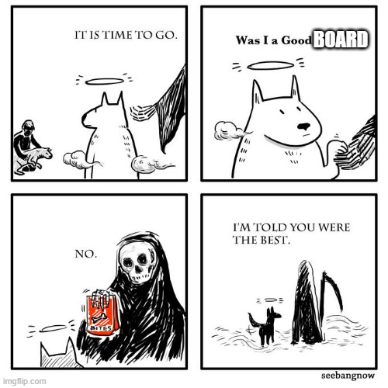

Appendix 3: Vice President of University Affairs’ Update
Current Projects
Peer Support Zine Project
- VPUA-Elect updated; to take on if interest
TDSA Food Drive
- VPUA-Elect updated; to take on if interest
OUSA Policy Papers: Pending due to COVID-19 precautions
- Student Association Autonomy, Gender-based and Sexual Violence Prevention and Response, Northern and Rural Students, and International Students and International Education Papers passed
- Virtual breakout sessions complete
- Virtual plenary complete
General Assembly
- Audit presented by President and Auditor for TDSA Facebook audience
COVID-19 Academic Response Assessment
- Distributed to over 35 students
- Results to President for follow-up conversation with the university
- Updated for clarity and distributed to TDSA membership through socials
- Hopeful these responses will inform an advocacy direction for the TDSA
King X Thornton 900 Westbound Bus Stop
- On hold amidst COVID-19 precautions; looking to revisit with construction planned for Thornton Rd. lights
TDSA VPUA Transition Package
- Complete
Transitioning OUSA Role (SC and VP Admin&HR)
- Final projects complete April 24
Financial Aid Support
- Funds available for students; New application process for summer students pending
No additional projects outstanding.
Committee Updates
Senate (April 7th)
- Trent is still reviewing options for September start in consultation with Public Health officials and COU; Thus far options are:
  - September start with no to minimal impacts on classes
  - September start with in-person classes restricted by size (larger classes moved to online, but smaller ones permitted in-person)
  - September start with remote work moving to October in-person classes
  - Online/Remote classes for full Fall Semester; In-person classes for Winter Semester
Any decisions on this will be heavily informed by best health practices.
- Summer courses are all online/remote delivery with average sign ups
- Convocation will not be happening in June; Lots of discussion around how to celebrate at this time with potential for Trent University’s Durham Campus to have something in the Fall Semester or doubling graduation next year
- International students are expected to be impacted tremendously; Some movement on International Attendance in online courses to count for permanent residence application time so as not to impact some institutions too tremendously (later approved by Federal government)

CUP
- Continuing in online format; Approval to the Registrar's office to expedite COVID-19 requests
This has been an incredibly taxing time for students in ways many could never have imagined. If you or someone you know needs assistance with a course withdrawal, please feel free to reach out for support through the process.
UAPC
- Cancelled (not yet rescheduled)

USC
- Continuing online as usual
- Courses for August scheduling finalized
CPRC
- Meeting April 22nd after agenda posting (update may be provided at board if requested)
AP&B
- Meeting April 23rd after agenda posting (update may be provided at board if requested)
Environmental Advisory Board
- On hold until next semester
Community Updates
Student Concerns Right Now
- Fall Term start (see Senate Update)
- Graduation (See President Update)
- Financial Aid supports (See Current Projects)
- Summer class availability
  - Concerns forwarded to applicable Department Chairs and asked the Trent Durham Campus Dean directly to follow up
Thank you to everyone for the work you have put into the Student Association this year. This organization is a product of the work students like you put into it. I hope everyone can walk away having contributed to this association in a way they are proud of for years to come.
Appendix 4: Vice President of Campus Life’s Update
- Time off
- Training sessions with New VPCL
  - Brainstorming sessions
- Exec training Sessions with new team
- Chair Training
- I have been fascinated with making TikToks

Appendix 5: Operations Manager’s Update
Month: April 2020
Banked Hours Update
President: 0
VPUA: 0
VPCL: 0
OM: 0

Update:
- Regular financial work
- Ran 3 online socialization events
- Exec meetings held
- Submitted online authorization for CRA access as representative
- Work with Nick on Executive Transition Training
- Work with Nick on Board Transition Training
- Made board meeting minutes
- Completed semi refunds for all those who had provided DD info in time
- Worked with school on plan for lockers
- Made special trips into Oshawa for various business including making a manual Payroll cheque and retrieving mail

Appendix 7: Executive and Operations Manager Hours Overages

**Will be presented at the board meeting to provide the most updated number for vacation hours remaining**

Appendix 9: Wage Increase

To: The 2019-20 Board of Directors
From: TDSA President
Date: April 28th
Re: Wages

Be it resolved that: The TDSA Board of Directors approve an increase of 2.2% to the Executive, Operations Manager, Chair, and Student Employee wages effective 2020-2021 fiscal year in accordance with CPI as calculated by STATS Canada as of December 2019
Whereas: Wages were not increased this year in-light of Student Choice Initiative
Whereas: The corporation is in the financial situation to do so.

Changes in Wages
Position | Current | Proposed | Overall Annual Increase
Executives | $16.80/hour | $17.17/hour | $1642.95
Operations Manager | $27.00/hour | $27.60/hour | $1092
Chair | $216.75/month | $221.51/month | $57.22
Student Employees | $14.45/hour | $14.77/hour | $356.01
Total |  |  | $3148.18

Appendix 10: Fee Increase

To: The 2019-20 Board of Directors
From: TDSA President
Date: April 28th
Re: 2020/2021 TDSA Fees

Be it resolved that: The TDSA Board of Directors approve that the TDSA fees do not increase for the 2020-2021 academic year, and remain at the same rate as the 2019-2020 academic year
Whereas: TDSA will run a surplus this year
Whereas: In this time of uncertainty the TDSA does not wish to financially burden its students

Appendix 11: Policy Updates

Policy Changes are available in the Google Drive document shared with all Directors.
Titles:
presentation copy of Bylaws and Policies for April 2020 Board Meeting
Board copy April 2020 draft

To: The 2019-20 Board of Directors
From: President
Date: April 28th
Re: Policy

Be it resolved that: The Board of Directors approve Policy #4 as written

Be It further resolved that: The Board of Directors approve Policy #11 as written

Be it further resolved that: The Board of Directors approve Policy #12 as written

Be it further resolved that: The Board of Directors approve Training and Transition Policy

Be it further resolved that: The Board of Directors approve Policy #2 and #3 as written

Be it further resolved that: The Board of Directors approve Policy #13 and #9 as written
Be it further resolved that: The Board of Directors approve Policy #6 as written

Be it further resolved that: The Board of Directors approve Policy #10 as writte

